INDOOR AIR QUALITY ASSESSMENT

Pembroke High School
80 Learning Lane
Pembroke, MA

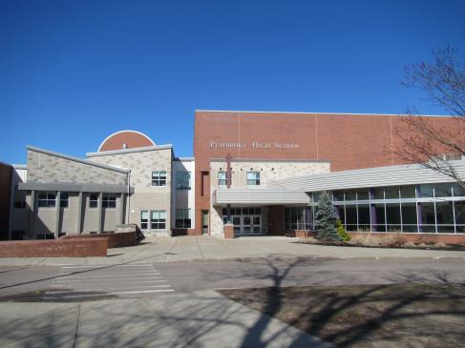

Prepared by:
Massachusetts Department of Public Health
Bureau of Environmental Health
Indoor Air Quality Program
May 2018

Background

Building: | Pembroke High School (PHS)
Address: | 80 Learning Lane, Pembroke, MA
Assessment Requested by: | Justin J. Domingos,  Director of Athletics/Facilities, Pembroke Public Schools
Reason for Request: | General indoor air quality (IAQ) assessment
Date of Assessment: | April 5, 2018
Massachusetts Department of Public Health/Bureau of Environmental Health (MDPH/BEH) Staff Conducting Assessment: | Ruth Alfasso and Cory Holmes, Inspectors, IAQ Program
Date of Building Construction: | Built in 1972, with an addition and renovations in 2005
Building Description: | Brick and concrete multi-story building with a multi-level flat roof and skylights. It contains classrooms, offices and common areas including a gym, cafeteria/kitchen, library and auditorium.
Building Population: | Approximately 900 students in grades 9-12 with a staff of approximately 100
Windows: | Mostly not openable

IAQ Testing Results
Please refer to the IAQ Manual for methods, sampling procedures, and interpretation of results (MDPH, 2015). The following is a summary of indoor air testing results (Table 1).
- Carbon dioxide levels were above 800 parts per million (ppm) in 33 of 106 areas tested, indicating that about one-third of rooms need more fresh air. This is mainly due to the age/condition of mechanical ventilation equipment/software and controls, which is discussed further in the Ventilation section of this assessment.
- Temperature was within or very close to the recommended range of 70°F to 78°F the day of assessment. However, there were many complaints of uneven heating and cooling throughout the building.
- Relative humidity was below the recommended range of 40 to 60% in all areas the day of assessment, which is typical of conditions in New England during the heating season.
- Carbon monoxide levels were non-detectable in all areas tested.
- Fine particulate matter (PM2.5) concentrations measured were below the National Ambient Air Quality (NAAQS) limit of 35 μg/m³ in all areas tested.

Ventilation
A heating, ventilating and air conditioning (HVAC) system has several functions. First it provides heating and, if equipped, cooling. Second, it is a source of fresh air. Finally, an HVAC system will dilute and remove normally occurring indoor environmental pollutants by not only introducing fresh air, but by filtering the airstream and ejecting stale air to the outdoors via exhaust ventilation. Even if an HVAC system is operating as designed, point sources of respiratory irritation may exist and cause symptoms in sensitive individuals.
Fresh air is provided by multiple (twenty-four) air handling units (AHUs) located on the roof. Air from the AHUs is filtered, heated or cooled as needed, and delivered to rooms via ducted supply vents on the ceiling (Picture 1). Air is exhausted from ceiling-mounted exhaust vents (Picture 2).
To maximize air exchange, the MDPH recommends that both supply and exhaust ventilation operate continuously during periods of occupancy. In order to have proper ventilation with a mechanical supply and exhaust system, these systems must be balanced to provide an adequate amount of fresh air while removing stale air from a room. It is recommended that existing ventilation systems be re-balanced every five years to ensure adequate air systems function (SMACNA, 1994). It is unknown the last time these systems were balanced.
Although almost all the temperature readings were within the BEH/IAQ guidelines, many occupants complained about thermal comfort. Controlling temperatures in a large building with variable occupancy is difficult, and more so because many of the AHU and associated equipment dates from the 1970s and is therefore nearly 50 years old. Efficient function of equipment of this age is difficult to maintain, since compatible replacement parts are often unavailable. In addition, fresh air dampers require maintenance personnel to manually adjust fresh air intakes to account for changes in weather. It was also reported by maintenance staff that the software used previously to assist with controlling the HVAC system is obsolete. Thus, manual control of the system is required, which is a significant use of maintenance resources. According to the American Society of Heating, Refrigeration and Air-Conditioning Engineering (ASHRAE), the service life for the various components of the HVAC system is between 20 to 30 years, assuming routine maintenance of the equipment (ASHRAE, 1991). Despite attempts to maintain the equipment, the optimal operational lifespan of this equipment has been exceeded.
There are several fume hoods located in science classrooms (Picture 3). Such equipment should be tested and calibrated on a regular schedule to ensure they are functioning properly.

Microbial/Moisture Concerns
Water-damaged ceiling tiles were observed in some areas (Pictures 2, 4, and 5; Table 1), which indicate leaks from the building envelope or plumbing system. Some of the water damage was reportedly due to recent leaks from pipe breaks over the winter. Following these recent leaks, it was reported that facilities staff and a flooding restoration contractor dried wet materials and removed materials that could not be dried within the 48-hour period recommended by the US EPA to prevent mold growth (US EPA 2008). Other stained tiles resulted from historic roof leaks, particularly in locations below rooftop AHUs. Roof repair work has been conducted and additional repairs are ongoing. Stained and missing tiles should be replaced once leaks have been repaired.
In general, due to the open space above the suspended ceiling (called a ceiling plenum), most stained tiles dry before they have an opportunity to become mold-colonized. The PHS has one room with tiles that have a dark stain that may be microbial growth (Picture 5). These tiles should be removed/replaced and the area above inspected for additional signs of microbial growth and cleaned as necessary.
Sinks were observed in some classrooms. One of the sink faucets was dripping and could not be turned off. The science lab rooms have many sinks each, most of these are reportedly non-functional and some have reportedly leaked in the past. In addition to the potential for leaks from broken sink fixtures and piping, the drains for these sinks are likely to develop dry traps which can allow sewer gases into occupied areas. Until the sinks can be either repaired or removed, the sinks should be examined periodically for leaks and the drains should be moistened with water to ensure a sealed trap. In addition, porous materials were found stored under sinks, which is a moist environment; items stored there may become water-damaged or colonized with mold.
Refrigerators were observed in carpeted areas (Picture 6; Table 1). Carpeting under refrigerators and water dispensing equipment can become moistened and soiled leading to odors and microbial growth.
Indoor plants were observed in a few areas (Table 1). Plants can be a source of pollen and mold, which can be respiratory irritants to some individuals. Plants should be properly maintained and equipped with drip pans and should be located away from air diffusers to prevent the aerosolization of dirt, pollen and mold. An aquarium was observed with standing water (Picture 7), which can be a source of microbial growth and odors. Aquariums and terrariums should be properly cleaned/dried when not in use.
Some of the doors to the outside had missing or worn out door sweeps (Picture 8) which can allow unconditioned air and pests into the building. Doors to the outside should be well-fitted without gaps.

Other IAQ Evaluations
Exposure to low levels of total VOCs (TVOCs) may produce eye, nose, throat, and/or respiratory irritation in some sensitive individuals. To determine if VOCs were present, BEH/IAQ staff examined rooms for products containing VOCs. BEH/IAQ staff noted hand sanitizers, cleaners/spray bottles, air fresheners, and dry erase materials in use within the building (Pictures 9 and 10; Table 1). All of these products have the potential to be irritants to the eyes, nose, throat, and respiratory system of sensitive individuals. Cleaners were observed to be of different types/manufacturers, which may lead to product interactions with irritating or toxic byproducts. Cleaners used in classrooms should be supplied by the school or compatible. Cleaning products should also be clearly labeled and kept out of reach of children. Scented products such as plug-in air fresheners should not be used.
Many science preparation rooms are equipped with cabinets for the storage of flammable and corrosive chemicals. Many of these appeared to have appropriately-categorized chemicals in well-labeled storage containers inside. However, some flammable and corrosive cabinets contained a variety of items that were disorganized and/or not of the chemical type for the cabinet. For example, as shown in Picture 11, a flammable cabinet contained plastic bags of old batteries, some of which had degraded to the point of leakage along with other unlabeled containers. It is important that flammable and corrosive chemicals be contained in the proper cabinets and that flammable/corrosive cabinets are not used for regular storage. In addition, old alkaline batteries are a corrosion hazard when they degrade. In one cabinet, materials were labeled with chemical formula only (which makes it difficult for emergency responders to identify), and some containers were loosely secured with parafilm, which has allowed the materials to evaporate/dry out and mix within the cabinet (Picture 12). School chemical storerooms should be inventoried and cleaned out regularly to ensure that appropriate reagents are available for the curriculum, while expired and improperly contained materials are safely removed.
The ceramics art room has a kiln, which has a dedicated exhaust system. The exhaust system should be used every time the kiln is operated and for some time afterwards to remove excess heat and pollutants from the room. The ceramics art room is also equipped with an auxiliary exhaust system, but the operation of this system was unclear to the occupants. Specialized exhaust systems need to be functioning when equipment is operating and maintained in accordance with manufacturer’s instructions. Concerns about dust were expressed by occupants of the ceramics art room. Use of clay can leave dusty residues on surfaces which can later become airborne. Use of the exhaust and regular wet wiping of dusts on surfaces will help control airborne dusts. Other potentially volatile or dust-producing art materials used in this and other art classrooms (e.g., Picture 13) should be kept in properly-labeled closable containers and used in well-ventilated areas.
The AHUs are equipped with filters that are reportedly changed one to two times a year. It is recommended that AHUs be outfitted with pleated filters of a Minimum Efficiency Reporting Value (MERV) of 8 or higher, which are adequate in filtering out pollen and mold spores (ASHRAE, 2012). In addition, filters should be changed 2-4 times a year or in accordance with the manufacture’s recommendations.
Some classrooms and offices had personal fans. Some of these had dusty blades (Table 1). Some supply diffusers and exhaust vents were also observed to be dusty (Pictures 1 and 2). This dust can be reaerosolized when the equipment is activated. A few classrooms have portable air conditioners that have filters which need to be cleaned periodically in accordance with manufacturers’ instructions. Portable air purifying units were in use in a few classrooms as well. For best results, units that use high-efficiency particulate arrestance (HEPA) filtration should be used, and they should be located in such a manner as to direct filtered air into the breathing zone rather than either drawing unfiltered air through the breathing zone of occupants or drawing and filtering air at floor level. Air purifiers that create ozone should not be used because ozone is a respiratory irritant.
The exhaust hose of a clothes dryer in the occupational therapy room (A173) was long and twisted (Picture 14), which prevents the unit from exhausting efficiently and may trap lint, leading to a risk of fire. This hose should be reconfigured to be shorter and straighter.
In some areas, items, including books, papers, toys and decorative items were observed on floors, windowsills, tabletops, counters, bookcases, and desks (Picture 15; Table 1), which can make it more difficult for custodial staff to clean. Pencil shavings were observed on some counters (Picture 16; Table 1); this debris can be a source of irritating dusts.
Some classrooms and offices had carpeting. Carpeting should be cleaned annually or semi-annually in soiled high traffic areas as per the recommendations of the Institute of Inspection, Cleaning and Restoration Certification (IICRC, 2012).
Note that the Environmental Protection Agency (EPA) conducted a National School Radon Survey in which it discovered nearly one in five schools had “…at least one frequently occupied ground contact room with short-term radon levels above 4 [picocuries per liter] pCi/L” (US EPA 1993). The BEH/IAQ Program therefore recommends that every school be tested for radon, and that this testing be conducted during the heating season while school is in session in a manner consistent with USEPA radon testing guidelines. Radon measurement specialists and other information can be found at www.nrsb.org and http://aarst-nrpp.com/wp, with additional information at: http://www.mass.gov/eohhs/gov/departments/dph/programs/environmental-health/exposure-topics/iaq/radon.

Conclusions/Recommendations
The conditions noted at the PHS raise a number of IAQ issues. The general building design, age and function of HVAC equipment (AHUs, software and control systems), particularly to introduce outside air and moderate temperature, present conditions that could affect IAQ and lead to health and comfort complaints. Many of the issues identified in this assessment can be addressed in the short term to improve air quality, however issues concerning the HVAC system/temperature controls are likely to need planning and resources to adequately address overall IAQ concerns. In view of the findings at the time of the visit, the following recommendations are made:
- As previously discussed, the age, physical deterioration and availability of parts for the mechanical ventilation system components and controls should be fully evaluated by an HVAC engineering firm to determine the operational lifespan of existing equipment and/or examining the feasibility of repair vs. replacement.
- Operate all supply and exhaust ventilation equipment continuously during occupied periods.
- Check exhaust vents for draw periodically and repair any non-operating vents.
- Consider adopting a balancing schedule of every 5 years for all mechanical ventilation systems, as recommended by ventilation industrial standards (SMACNA, 1994).
- Ensure fume hoods that are in use are calibrated/tested in accordance with applicable regulations and standards.
- For buildings in New England, periods of low relative humidity during the winter are often unavoidable. Therefore, scrupulous cleaning practices should be adopted to minimize common indoor air contaminants whose irritant effects can be enhanced when the relative humidity is low. To control dusts, a high efficiency particulate arrestance (HEPA) filter equipped vacuum cleaner in conjunction with wet wiping of all surfaces is recommended. Avoid the use of feather dusters. Drinking water during the day can help ease some symptoms associated with a dry environment (throat and sinus irritations).
- Ensure roof and plumbing leaks are repaired and replace water-damaged ceiling tiles. Prioritize ceiling tiles with dark staining that may indicate microbial growth, and remove in accordance with EPA guidance to prevent the spread of dust and microbial contaminants (US EPA 2008).
- Repair and maintain classroom sinks including fixing leaks and replacing gaskets to ensure they can be easily shut off. Avoid storage of porous materials and large amounts of materials under sinks. Unused sinks should be periodically monitored and the drains should be moistened to ensure a trap seal.
- Avoid placing refrigerators and water dispensers on carpet; use a waterproof mat or place the appliances in tiled areas.
- Properly maintain plants, including drip pans, to prevent water damage to porous materials. Plants should also be located away from air diffusers to prevent the aerosolization of dirt, pollen, and mold.
- Properly maintain aquariums and terrariums to avoid odors.
- Repair/replace worn door sweeps and monitor for gaps around doors.
- Reduce use of products and equipment that create VOCs and only use in well-ventilated areas. Minimize the use of air fresheners, deodorizers and scented products.
- Keep spray bottles/cleaning products out of the reach of children. Ensure that products are compatible with one another. It is suggested that only school-supplied products be used to avoid product interactions.
- Ensure science chemicals are stored properly, clean out storerooms regularly to remove old outdated chemicals and chemicals that are no longer needed for the current curriculum. Consult Appendix A for more information about chemical storage in school laboratories.
- Properly dispose of batteries.
- Use the kiln exhaust whenever the kiln is in use and for a period of time afterward.
- Ensure the auxiliary exhaust system in the ceramics art room is functioning and maintained in accordance with manufacturer’s instructions. Ensure staff are properly trained/instructed in the proper activation/use of the system.
- Use wet wiping regularly to remove ceramics dust to prevent it from being aerosolized.
- Properly store other art materials and use in well-ventilated areas.
- Change filters for HVAC equipment 2-4 times a year. The MDPH recommends using pleated filters of MERV 8 (or higher), which are adequate in filtering out pollen and mold spores (ASHRAE, 2012), if these can be used with current equipment.
- Regularly clean/vacuum supply/return vents and fans to avoid aerosolizing accumulated particulate matter.
- Clean filters on portable air conditioners and personal air purifiers in accordance with manufacturer’s instructions.
- Clean pencil sharpener debris regularly.
- Consider reducing the amount of items stored in classrooms to make cleaning easier. Periodically move items to clean flat surfaces. Include the nook areas with overhang in periodic cleaning/dusting.
- Clean carpeting annually (or semi-annually in soiled high traffic areas) as per the recommendations of the Institute of Inspection, Cleaning and Restoration Certification (IICRC) including carpeting over heaters. Discard area rugs that are too worn or soiled to be effectively cleaned.
- The school should be tested for radon by a certified radon measurement specialist during the heating season when school is in session. Radon measurement specialists and other information can be found at: www.nrsb.org, and http://aarst-nrpp.com/wp.
- Consider adopting the US EPA (2000) document, “Tools for Schools”, as an instrument for maintaining a good IAQ environment in the building available at: http://www.epa.gov/iaq/schools/index.html.
- Refer to resource manual and other related IAQ documents located on the MDPH’s website for further building-wide evaluations and advice on maintaining public buildings. These documents are available at: http://mass.gov/dph/iaq.

References
ASHRAE. 1991. ASHRAE Applications Handbook, Chapter 33 “Owning and Operating Costs”. American Society of Heating, Refrigeration and Air Conditioning Engineers, Atlanta, GA.
ASHRAE. 2012. American Society of Heating, Refrigeration and Air Conditioning Engineers (ASHRAE) Standard 52.2-2012 -- Method of Testing General Ventilation Air-Cleaning Devices for Removal Efficiency by Particle Size (ANSI Approved).
IICRC. 2012. Institute of Inspection, Cleaning and Restoration Certification. Carpet Cleaning: FAQ.
MDPH. 2015. Massachusetts Department of Public Health. “Indoor Air Quality Manual: Chapters I-III”. Available at: http://www.mass.gov/eohhs/gov/departments/dph/programs/environmental-health/exposure-topics/iaq/iaq-manual/.
SMACNA. 1994. HVAC Systems Commissioning Manual. 1st ed. Sheet Metal and Air Conditioning Contractors’ National Association, Inc., Chantilly, VA.
US EPA. 1993. Radon Measurement in Schools, Revised Edition. Office of Air and Radiation, Office of Radiation and Indoor Air, Indoor Environments Division (6609J). EPA 402-R-92-014. https://www.epa.gov/sites/production/files/2014-08/documents/radon_measurement_in_schools.pdf.
US EPA. 2000. Tools for Schools. Office of Air and Radiation, Office of Radiation and Indoor Air, Indoor Environments Division (6609J). EPA 402-K-95-001, Second Edition. http://www.epa.gov/iaq/schools/index.html.
US EPA. 2008. “Mold Remediation in Schools and Commercial Buildings”. Office of Air and Radiation, Indoor Environments Division, Washington, DC. EPA 402-K-01-001. September 2008. Available at: https://www.epa.gov/mold/mold-remediation-schools-and-commercial-buildings-guide.
Picture 1
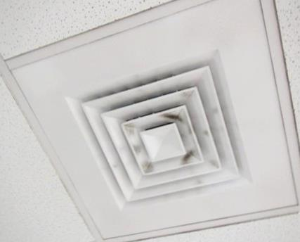
Supply vent, note dust on louvers
Picture 2
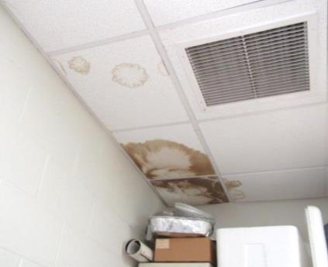
Exhaust vent, note dust on grill and water-damaged ceiling tiles
Picture 3
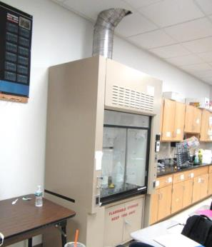
Fume hood
Picture 4
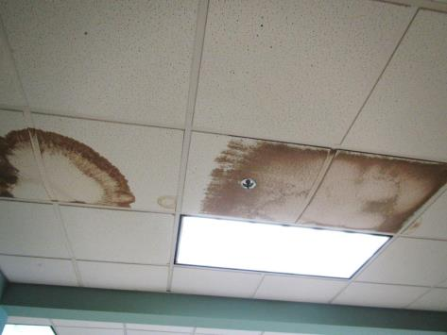
Water-damaged ceiling tiles
Picture 5
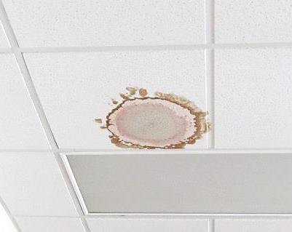
Water-damaged ceiling tile with dark stain
Picture 6
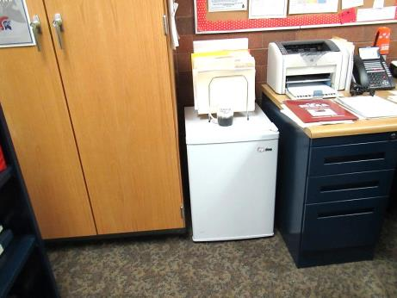
Refrigerator on carpet
Picture 7
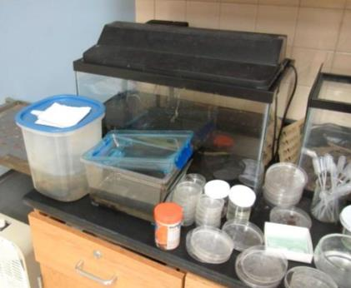
Aquarium with standing water
Picture 8
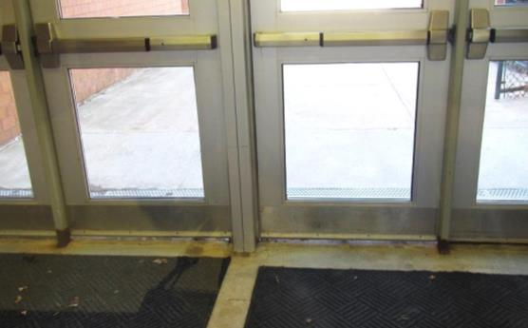
Gap underneath door where sweep is worn or missing
Picture 9
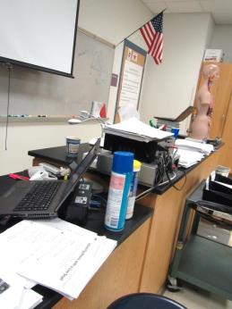
Cleaning products
Picture 10
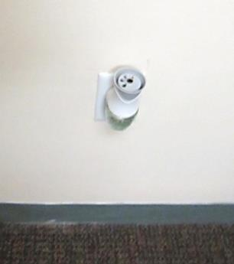
Plug-in air freshener
Picture 11
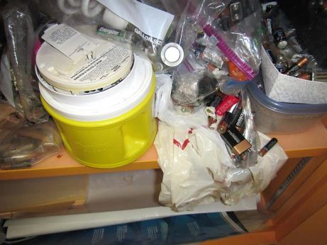
Disorganized items inside a Flammables cabinet including degraded batteries
Picture 12
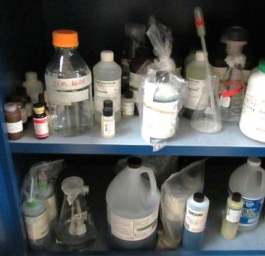
Items in chemical storage locker loosely sealed and labeled with chemical formula
Picture 13
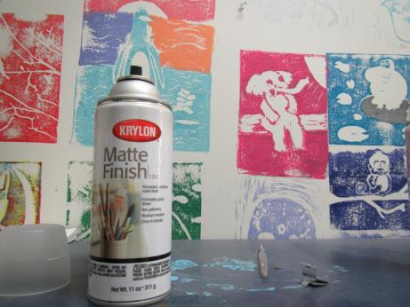
Paint in the art room, note missing cap
Picture 14
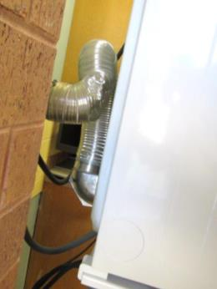
Exhaust hose from dryer is too long and curved
Picture 15
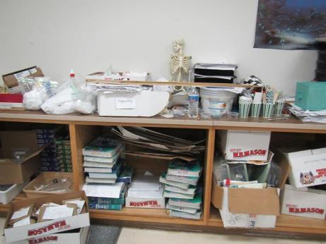
Papers and other items in a classroom
Picture 16
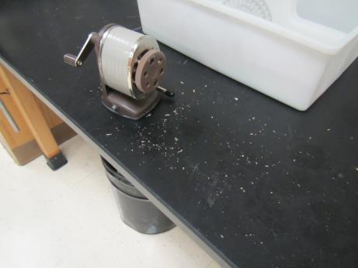
Pencil shavings
Location | Carbon  Dioxide  (ppm) | Carbon Monoxide  (ppm) | Temp  (°F) | Relative  Humidity  (%) | PM2.5  (µg/m³) | Occupants  in Room | Windows  Openable | Ventilation |  |  | Remarks
 |  |  |  |  |  |  |  | Intake | Exhaust
Background | 373 | ND | 34 | 27 | 7 |  |  |  |  |  | Cold, windy
Mrs. Kelly Office | 625 | ND | 74 | 13 | 5 | 0 | N | Y |  | Y | Carpeting
Collum Office | 608 | ND | 72 | 18 | 3 | 1 | N | Y |  | Y | DO
Dr. Hartley Office | 632 | ND | 71 | 18 | 2 | 0 | N | Y |  | Y | PF, DO
Duffy Office | 731 | ND | 71 | 21 | 8 | 2 | N | Y |  | Y | DO, dust/debris on vents, carpeting
Goff Office | 743 | ND | 76 | 12 | 5 | 5 | N | Y |  | Y | DO, vent blocked with cardboard (draft control)- recommend relocating vent, dust/debris on vents
A101 | 793 | ND | 71 | 15 | 2 | 1 | N | Y |  | Y | DEM
A103 | 751 | ND | 71 | 13 | 3 | 2 | N | Y |  | Y | DEM, 1 MT, plush items
A105 | 1035 | ND | 71 | 15 | 2 | 25 | N | Y |  | Y | DEM
Computer Room | 826 | ND | 72 | 15 | 2 | 18 | N | Y |  | Y | Carpet, DEM, body odors, WD CT
A107 | 776 | ND | 71 | 15 | 3 | 1 | N | Y |  | Y | DEM
A109 | 979 | ND | 72 | 16 | 2 | 27 | N | Y |  | Y | DEM, PF - dusty
A112 | 751 | ND | 71 | 13 | 2 | 3 | N | Y |  | Y | DEM, PF
A114 | 749 | ND | 70 | 13 | 3 | 1 | N | Y |  | Y | DEM, door
A119 | 815 | ND | 72 | 16 | 2 | 0 | N | Y |  | Y | DEM
A123 | 637 | ND | 71 | 13 | 2 | 0 | N | Y |  | Y | 3 WD CT, DEM, PS
A125 | 794 | ND | 71 | 15 | 2 | 5 | N | Y |  | Y | Carpeted, portable AC, WD CT
A129 Prep Room | 783 | ND | 71 | 15 | 2 | 0 | N | Y |  | Y | Used batteries in cabinet, some leaking, misuse of corrosive and flammable cabinets
A129 | 650 | ND | 73 | 12 | 3 | 18 | N | Y |  | Y | DEM, paper under sink, science sinks, emergency eyewash and shower
A132 | 625 | ND | 73 | 12 | 2 | 3 | N | Y |  | Y | WD-CT, DEM
A133 | 727 | ND | 73 | 13 | 3 | 15 | N | Y |  | Y | A few sinks, DEM
A134 Science | 634 | ND | 72 | 13 | 2 | 18 | N | Y |  | Y | 2 WD CT, PS, DEM
A134 Prep Room |  | ND |  | 13 |  |  |  |  |  |  | 2 MT, dishwasher
A137 | 692 | ND | 73 | 13 | 2 | 0 | N | Y |  | Y | DEM
A138 | 670 | ND | 73 | 12 | 3 | 8 | N | Y |  | Y | DEM, HS, small room
A139 | 508 | ND | 72 | 10 | 2 | 4 | N | Y |  | Y | DO
A141 Science | 790 | ND | 72 | 15 | 2 | 20 | N | Y |  | Y | 2 WD CT, DEM, clutter
A142 Science | 714 | ND | 71 | 17 | 2 | 19 | N | Y |  | Y | Science sinks, mostly don’t work, DEM, 1 WD CT
A149 | 550 | ND | 75 | 11 | 2 | 20 | N | Y |  | Y | 5 WD CT-rear corner
A151 | 510 | ND | 73 | 11 | 3 | 1 | N | Y |  | Y | DO, aquarium-standing water
A152 | 502 | ND | 72 | 8 | 2 | 0 | N | Y |  | Y | DEM, science sinks, emergency eyewash and shower
A152 Prep Room |  |  |  |  |  |  |  |  |  |  | Sink, dishwasher
A156 | 751 | ND | 71 | 15 | 3 | 24 | N | Y |  | Y | DO, flow hood, 7 WD CT
A157 | 682 | ND | 70 | 14 | 2 | 22 | N | Y |  | Y | DO, flow hood, 7 WD CT-(from Library leak over winter), science sinks, DEM, CP
A173 | 604 | ND | 74 | 13 | 3 | 11 | N | Y |  | Y | Dryer vent-recommend shorten, air purifier, 5 WD CT, plants
A177 | 545 | ND | 70 | 12 | 3 | 15 | N | Y |  | Y | DO
A179 | 452 | ND | 70 | 12 | 5 | 1 | N | Y |  | Y | DO
A201 | 1023 | ND | 72 | 17 | 3 | 14 | N | Y |  | Y | 7 WD CT, DO, dust/debris on vents
A202 | 1203 | ND | 72 | 20 | 6 | 12 | N | Y |  | Y | DO
A203 | 1273 | ND | 72 | 22 | 5 | 16 | N | Y |  | Y | DO, PF, portable AC
A205 | 1142 | ND | 73 | 18 | 4 | 11 | N | Y |  | Y | PF on
A206 | 1300 | ND | 72 | 21 | 4 | 20 | N | Y |  | Y | DEM, dirty floor, HS
A207 | 983 | ND | 72 | 17 | 3 | 13 | N | Y |  | Y | DEM, body odor
A211 | 726 | ND | 72 | 14 | 11 | 13 | N | Y |  | Y | DO, missing light cover, carpeting, ajar CTs, dust/debris on vents
A212 | 915 | ND | 73 | 14 | 5 | 18 | N | Y |  | Y | DO, carpeting, dust/debris on vents
A213 | 860 | ND | 71 | 13 | 5 | 15 | N | Y |  | Y | 3 WD CT, DEM
A215 | 892 | ND | 72 | 14 | 4 | 11 | N | Y |  | Y | DEM, 3 WD CT
A222 | 1272 | ND | 71 | 24 | 4 | 6 | N | Y |  | Y | 5 WD CT, MT, portable AC
A224 | 1674 | ND | 72 | 28 | 3 | 1 | N | Y |  | Y | DO, 3 occupants just left
A225 | 1492 | ND | 73 | 25 | 6 | 3 | N | Y |  | Y | DO, 2 WD CT, ~ 10 occupants just left
A229 Office | 1229 | ND | 74 | 17 | 3 | 0 | N | Y |  | Y | Carpeted, plug-in AF, food
A231 | 793 | ND | 73 | 12 | 3 | 8 | N | Y |  | Y
A232 | 1241 | ND | 73 | 20 | 3 | 15 | N | Y |  | Y | DEM, dirty floor
A233 | 1347 | ND | 74 | 23 | 4 | 12 | N | Y |  | Y | WD CT, MT, DEM
A234 | 1191 | ND | 75 | 19 | 4 | 6 | N | Y |  | Y | Computers, carpet, DEM
A237 | 1264 | ND | 73 | 21 | 5 | 2 | N | Y |  | Y | DEM, portable AC
A247 Art | 741 | ND | 74 | 17 | 6 | 5 | N | Y |  | Y | DO
A256 | 1060 | ND | 73 | 13 | 3 | 0 | N | Y |  | Y | Computers, NC, DEM, PC
A259 | 1149 | ND | 72 | 19 | 4 | 2 | N | Y |  | Y | DEM
A261 | 1479 | ND | 72 | 25 | 4 | 0 | N | Y |  | Y | DEM, tea kettle, items
A262 | 1339 | ND | 72 | 23 | 4 | 20 | N | Y |  | Y | DO, PF
A263 | 2560 | ND | 72 | 34 | 14 | 0 | N | Y |  | Y | 3 WD CT, PF, occupants at lunch
A265 | 1745 | ND | 71 | 27 | 7 | 1 | N | Y |  | Y | DO, 4 WD CT, PF, ~ 12 occupants just left
A266 | 1414 | ND | 73 | 23 | 4 | 0 | N | Y |  | Y | 1 MT, DEM
A267 | 1408 | ND | 73 | 21 | 4 | 18 | N | Y |  | Y | DEM
Assistant Principal Front Office | 583 | ND | 74 | 10 | 3 | 0 | N | Y |  | Y | Carpet, heater and fan
First Floor Offices Main | 612 | ND | 71 | 15 | 2 | 0 | N | Y |  | Y | Carpeted, PC, laminator
Office | 607 | ND | 71 | 16 | 2 | 0 | N | Y |  | Y | Carpeted
Office Storage | 660 | ND | 71 | 19 | 2 | 0 | N | Y |  | Y | Carpeted
Upper Office Mail | 734 | ND | 71 | 16 | 2 | 1 | Y | Y |  | Y | PC, carpeted, 2 WD CT, perfume odor, plant
Ms. LaCroix | 667 | ND | 70 | 17 | 3 | 1 | N | Y |  | Y | Carpeted
Dr. Gallagher | 711 | ND | 70 | 18 | 5 | 1 | N | Y |  | Y | Perfume odor, plugin AF, carpet
In-School Suspension | 828 | ND | 71 | 13 | 3 | 0 | N | Y |  | Y
Library Main | 699 | ND | 72 | 14 | 4 | 22 | N | Y |  | Y | Carpet, 5 WD CT
Small group A | 729 | ND | 71 | 12 | 4 | 0 | N | Y |  | Y | Carpeted, DEM
Library Back Office | 580 | ND | 69 | 17 | 3 | 0 | N | Y |  | Y | NC
Faculty Dining | 630 | ND | 73 | 17 | 4 | 2 | N | Y |  | Y | 4 WD CT
Cafeteria | 933 | ND | 76 | 17 | 4 | ~200 | N | Y |  | Y
Auditorium | 623 | ND | 74 | 19 | 5 | 2 | N | Y |  | Y
Gym | 531 | ND | 69 | 13 | 6 | 20 | N | Y |  | Y
Boys Locker Room | 539 | ND | 70 | 17 | 9 | 0 | N | Y |  | Y
Music Suite
Practice Room A | 518 | ND | 71 | 14 | 6 | 0 | N | Y |  | Y | DO, carpet
Practice Room B | 523 | ND | 71 | 17 | 5 | 0 | N | Y |  | Y | DO, carpet
Guidance Office | 734 | ND | 74 | 14 | 4 | 1 | N | Y |  | Y | Carpet, vents dusty
Barnardi | 729 | ND | 74 | 22 | 4 | 0 | N | Y |  | Y | Carpet, PF, salt lamp
Guidance Conference/Break | 701 | ND | 74 | 14 | 4 | 0 | N | Y |  | Y | Carpet, fridge on carpet, toaster and microwave
Guidance Meerback | 684 | ND | 75 | 14 | 5 | 1 | N | Y |  | Y | Carpet, salt lamp, outside of window is dirty
Guidance Conathan | 704 | ND | 75 | 12 | 4 | 1 | N | Y |  | Y | Dusty vents and wall, items hanging from walls and ceiling
Guidance Shannon | 721 | ND | 75 | 13 | 4 | 2 | N | Y |  | Y | Dusty vents
Guidance Career Center area | 695 | ND | 74 | 12 | 4 | 2 | N | Y |  | Y | Carpet, dusty vents
Administration area | 663 | ND | 75 | 12 | 4 | 0 | N | Y |  | Y | Carpet, PF, PC
Art storeroom | 703 | ND | 72 | 17 | 4 | 0 | N | Y |  | Y | Art storage, NC, items, high ceiling
B109 | 548 | ND | 72 | 5 | 4 | 1 | N | Y |  | Y | NC, guitars
B183 | 1211 | ND | 73 | 24 | 10 | 24 | N | Y |  | Y | PF, DO, carpet
B245 Art | 743 | ND | 72 | 17 | 4 | 1 | N | Y |  | Y | MT for art, songs, dusty vents, water color paints
B251 art | 1048 | ND | 73 | 19 | 3 | 1 | N | Y |  | Y | DEM, NC, class just left
B255 Music keyboards room | 480 | ND | 73 | 6 | 3 | 0 | N | Y |  | Y | Keyboards, NC, open ceiling
B262 | 732 | ND | 74 | 13 | 4 | 3 | N | Y |  | Y
B265 | 645 | ND | 72 | 12 | 4 | 1 | Y | Y |  | Y | NC, carpet
B266 | 714 | ND | 75 | 13 | 4 | 3 | N | Y |  | Y | Partly carpeted
C203 | 792 | ND | 72 | 15 | 4 | 19 | Y | Y |  | Y | NC, sink drips, WD CT with dark stains
C213 | 742 | ND | 73 | 16 | 4 | 1 | N | Y |  | Y | NC, cleaner odors, computers/storage
Girl’s Locker Room |  |  |  |  |  |  |  |  |  |  | Old style ceiling tiles, dark and dusty
Mr. Talbot | 689 | ND | 73 | 12 | 4 | 5 | N | Y |  | Y | Carpet
Ms..L. | 622 | ND | 75 | 12 |  |  | N | Y |  | Y
Music Suite | 584 | ND | 71 | 16 | 5 | 1 | N | Y |  | Y | Carpet, instruments and cases
Nurse | 538 | ND | 74 | 8 | 5 | 2 | N | Y |  | Y | NC
Office/Conference | 612 | ND | 74 | 12 | 4 | 0 | N | Y |  | Y | DEM, carpet
Orchestra office | 602 | ND | 70 | 17 | 5 | 0 | N | Y |  | Y
Work room | 630 | ND | 75 | 12 | 4 | 0 | N | Y |  | Y

The service life is the median time during which a particular system or component of …[an HVAC]… system remains in its original service application and then is replaced. Replacement may occur for any reason, including, but not limited to, failure, general obsolescence, reduced reliability, excessive maintenance cost, and changed system requirements due to such influences as building characteristics or energy prices (ASHRAE, 1991).

