INDOOR AIR QUALITY ASSESSMENT

Penn Brook Elementary School
68 Elm Street
Georgetown, MA

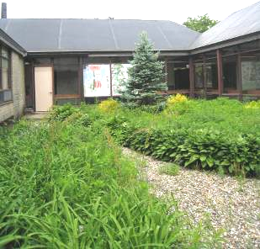

Prepared by:
Massachusetts Department of Public Health
Bureau of Environmental Health
Indoor Air Quality Program
August 2013

Background/Introduction
At the request of Michael Anderson, Facilities Coordinator for the Georgetown School Department (GSD), the Massachusetts Department of Public Health (MDPH), Bureau of Environmental Health (BEH) provided assistance and consultation regarding indoor air quality (IAQ) at the Penn Brook Elementary School (PBES), 68 Elm Street, Georgetown, Massachusetts. On June 6, 2013, Ruth Alfasso, Environmental Engineer/Inspector in BEH’s IAQ Program visited the school to perform an assessment.
The school is a one-story brick structure built in the early 1970s with a sloped, rubber-coated roof. The school contains general classrooms, science classrooms, a computer lab, music room, several resource rooms, library-media center, gymnasium, office space, art room, kitchen and cafeteria. Windows throughout the building are openable. It was reported at the time of the visit that groundbreaking for a new school to replace this one has just occurred, with an opening planned for the Fall of 2016.
This building was previously visited by BEH/IAQ Program staff in 2002, and a report was issued. Appendix A describes actions that were taken in response to the recommendations from that report.
In 2009, the school department contracted with RPF Associates, Inc., to perform a preliminary IAQ survey for the school. Based on their findings, the following observations/recommendations were made:
- Moderate amounts of dust and debris were observed on horizontal surfaces. These should be cleaned using improved housekeeping, including the use of high efficiency particulate air (HEPA) filtered vacuum cleaners;
- Ongoing housekeeping of classrooms should continue;
- Employees should be encouraged to record perceived IAQ problems to aid in diagnosing future problems;
- Visible fungal growth (mold) should be removed by qualified personnel using industry guidelines from the Institute of Inspection, Cleaning and Restoration Certification (IICRC). Porous mold-contaminated materials should be removed while non-porous materials may be cleaned and disinfected; and
- No moisture intrusion was observed during this survey, but any future sources of moisture need to be controlled to prevent microbial growth, including drying any porous moistened materials within 72 hours or discarding them (RPF, 2009).

Methods
Air tests for carbon monoxide, carbon dioxide, temperature and relative humidity were conducted with the TSI, Q-Trak, IAQ Monitor, Model 7565. Air tests for airborne particle matter with a diameter less than 2.5 micrometers were taken with the TSI, DUSTTRAK™ Aerosol Monitor Model 8520. BEH/IAQ staff also performed visual inspection of building materials for water damage and/or microbial growth.

Results
The school houses approximately 500 students in grades 2-5 with a staff of approximately 45. Tests were taken during normal operations at the school. Results appear in Table 1.

Discussion

Ventilation
It can be seen from Table 1 that carbon dioxide levels were above 800 parts per million (ppm) in 16 out of 42 areas tested, indicating suboptimal air exchange in more than one third of areas surveyed during the assessment. Note that some rooms had windows open or had low/no occupancy; with windows closed and greater occupancy carbon dioxide levels would be expected to increase.
Fresh air in classrooms is supplied by unit ventilators (univents) (Picture 1). A univent is designed to draw air from outdoors through a fresh air intake located on the exterior wall of the building (Picture 2). Return air is drawn through an air intake located at the base of each unit where fresh and return air are mixed, filtered, heated or cooled and provided to classrooms through an air diffuser located in the top of the unit (Figure 1).
Univents were found deactivated or obstructed with classroom items in several areas (Picture 3; Table 1). In order for univents to provide fresh air as designed, intakes/returns must remain free of obstructions. Importantly, these units must remain on and be allowed to operate while rooms are occupied. Mechanical ventilation in some central areas, including the library, the cafeteria and the gym is provided by air-handling units (AHUs) located at/above the ceiling (Picture 4).
Note that the univents/AHUs are original equipment, more than 40 years old. Function of equipment of this age is difficult to maintain, since compatible replacement parts are often unavailable. According to the American Society of Heating, Refrigeration and Air-Conditioning Engineers (ASHRAE), the service life for a unit heater, hot water or steam is 20 years, assuming routine maintenance of the equipment (ASHRAE, 1991). Despite attempts to maintain this equipment, the operational lifespan has been exceeded. Maintaining the balance of fresh air to exhaust air will become more difficult as the equipment ages and as replacement parts become increasingly difficult to obtain.
Exhaust ventilation is provided by wall-mounted vents ducted to rooftop motors (Picture 5). Some of the vents that were examined had very low or no draw; many of these vents are located near the sloped roof line, high above the classroom area, so function could not be determined during the assessment. School personnel reported that these motors were replaced recently as a part of an energy savings project. It is possible that control settings for some motors are not on an appropriate operating schedule.
To maximize air exchange, the MDPH recommends that both supply and exhaust ventilation operate continuously during periods of occupancy. In order to have proper ventilation with a mechanical supply and exhaust system, the systems must be balanced to provide an adequate amount of fresh air to the interior of a room while removing stale air from the room. It is recommended that heating, ventilating and air conditioning (HVAC) systems be re-balanced every five years to ensure adequate air systems function (SMACNA, 1994). The date of last balancing was not available at the time of the current visit; however school maintenance staff reported that an energy-saving project had occurred recently at the school, which may have included balancing.
Minimum design ventilation rates are mandated by the Massachusetts State Building Code (MSBC). Until 2011, the minimum ventilation rate in Massachusetts was higher for both occupied office spaces and general classrooms, with similar requirements for other occupied spaces (BOCA, 1993). The current version of the MSBC, promulgated in 2011 by the State Board of Building Regulations and Standards (SBBRS), adopted the 2009 International Mechanical Code (IMC) to set minimum ventilation rates. Please note that the MSBC is a minimum standard that is not health-based. At lower rates of cubic feet per minute (cfm) per occupant of fresh air, carbon dioxide levels would be expected to rise significantly. A ventilation rate of 20 cfm per occupant of fresh air provides optimal air exchange resulting in carbon dioxide levels at or below 800 ppm in the indoor environment in each area measured. MDPH recommends that carbon dioxide levels be maintained at 800 ppm or below. This is because most environmental and occupational health scientists involved with research on IAQ and health effects have documented significant increases in indoor air quality complaints and/or health effects when carbon dioxide levels rise above the MDPH guidelines of 800 ppm for schools, office buildings and other occupied spaces (Sundell et al., 2011). The ventilation must be on at all times that the room is occupied. Providing adequate fresh air ventilation with open windows and maintaining the temperature in the comfort range during the cold weather season is impractical. Mechanical ventilation is usually required to provide adequate fresh air ventilation.
Carbon dioxide is not a problem in and of itself. It is used as an indicator of the adequacy of the fresh air ventilation. As carbon dioxide levels rise, it indicates that the ventilating system is malfunctioning or the design occupancy of the room is being exceeded. When this happens, a buildup of common indoor air pollutants can occur, leading to discomfort or health complaints. The Occupational Safety and Health Administration (OSHA) standard for carbon dioxide is 5,000 parts per million parts of air (ppm). Workers may be exposed to this level for 40 hours/week, based on a time-weighted average (OSHA, 1997).
The MDPH uses a guideline of 800 ppm for publicly occupied buildings. A guideline of 600 ppm or less is preferred in schools due to the fact that the majority of occupants are young and considered to be a more sensitive population in the evaluation of environmental health status. Inadequate ventilation and/or elevated temperatures are major causes of complaints such as respiratory, eye, nose and throat irritation, lethargy and headaches. For more information concerning carbon dioxide, consult Appendix B.
Indoor temperature measurements ranged from 74F to 77F (Table 1), which were within the MDPH recommended comfort range the day of assessment. The MDPH recommends that indoor air temperatures be maintained in a range of 70F to 78F in order to provide for the comfort of building occupants. In many cases concerning indoor air quality, fluctuations of temperature in occupied spaces are typically experienced, even in a building with an adequate fresh air supply.
The relative humidity measured in the building ranged from 45 to 54 percent, which was within the MDPH recommended comfort range in all areas surveyed during the assessment (Table 1). The MDPH recommends a comfort range of 40 to 60 percent for indoor relative humidity.
Note that the outdoor temperature and relative humidity on the day of assessment were measured at 73F and 51 percent, also within the MDPH comfort ranges. Conditions in the building with less temperate outdoor conditions may differ from those measured during the assessment. For example, relative humidity levels in the building would be expected to drop during the winter months due to heating. The sensation of dryness and irritation is common in a low relative humidity environment. Low relative humidity is a very common problem during the heating season in the northeast part of the United States.

Microbial/Moisture Concerns
No water-damaged ceiling tiles or other building materials were observed at the time of the assessment. Many classrooms contained sinks and some were observed to have porous items stored underneath them (Picture 6). The area underneath the sink is a moist environment and items stored there may be subject to chronic dampness due to leaks and condensation, which may lead to microbial growth. In addition, accumulated items under sinks may make it harder to detect leaks.
The sinks in room 24, originally outfitted as a science room, appeared to be dry and not in use (Picture 7). If the drains in sinks that are not used are not capped/blocked, sewer gases can enter occupied spaces. There are also some water fountains/handwash sinks in hallways and restrooms that may no longer be in use (Picture 8), which also allow for similar sewer gas issues. Water sources that are not in use should be properly shut off to prevent leaks and the associated drains should be blocked or capped.
BEH/IAQ staff examined the exterior of the building to identify breaches in the building envelope and/or other issues that could provide a source of water penetration. Several potential sources were identified:
- An exterior door to the cafeteria had damaged/missing weather-stripping. Light could be seen penetrating through spaces underneath the door (Picture 9).
- Plants and shrubbery were observed growing in close proximity to the foundation and univent air intakes along both the outside of the building and in interior courtyards, which can allow moisture and pollen to be drawn into the building (Pictures 10 and 11) and cause water damage to the foundation and exterior.
- Crushed/damaged downspouts were observed (Picture 12); and
- Moss growth on exterior walls was noted, particularly near interior corners indicating chronic dampness, likely due to lack of proper gutters/downspouts and drainage (Picture 13).
These conditions can undermine the integrity of the building envelope and provide a means of water entry by capillary action into the building through exterior walls, foundation concrete and masonry (Lstiburek & Brennan, 2001). In addition, these breaches in exterior areas can provide a means of drafts and pest entry into the building.

Other IAQ Evaluations
Indoor air quality can be negatively influenced by the presence of respiratory irritants, such as products of combustion. The process of combustion produces a number of pollutants. Common combustion emissions include carbon monoxide, carbon dioxide, water vapor and smoke (fine airborne particle material). Of these materials, exposure to carbon monoxide and particulate matter with a diameter of 2.5 micrometers (μm) or less (PM2.5) can produce immediate, acute health effects upon exposure. To determine whether combustion products were present in the indoor environment, BEH/IAQ staff obtained measurements for carbon monoxide and PM2.5.

Carbon Monoxide
Carbon monoxide is a by-product of incomplete combustion of organic matter (e.g., gasoline, wood and tobacco). Exposure to carbon monoxide can produce immediate and acute health effects. Several air quality standards have been established to address carbon monoxide and prevent symptoms from exposure to these substances. The MDPH established a corrective action level concerning carbon monoxide in ice skating rinks that use fossil-fueled ice resurfacing equipment. If an operator of an indoor ice rink measures a carbon monoxide level over 30 ppm, taken 20 minutes after resurfacing within a rink, that operator must take actions to reduce carbon monoxide levels (MDPH, 1997).
The American Society of Heating Refrigeration and Air-Conditioning Engineers (ASHRAE) has adopted the National Ambient Air Quality Standards (NAAQS) as one set of criteria for assessing indoor air quality and monitoring of fresh air introduced by HVAC systems (ASHRAE, 1989). The NAAQS are standards established by the US EPA to protect the public health from six criteria pollutants, including carbon monoxide and particulate matter (US EPA, 2006). As recommended by ASHRAE, pollutant levels of fresh air introduced to a building should not exceed the NAAQS levels (ASHRAE, 1989). The NAAQS were adopted by reference in the Building Officials & Code Administrators (BOCA) National Mechanical Code of 1993 (BOCA, 1993), which is now an HVAC standard included in the Massachusetts State Building Code (SBBRS, 2011). According to the NAAQS, carbon monoxide levels in outdoor air should not exceed 9 ppm in an eight-hour average (US EPA, 2006).
Carbon monoxide should not be present in a typical, indoor environment. If it is present, indoor carbon monoxide levels should be less than or equal to outdoor levels. On the day of assessment, outdoor carbon monoxide concentrations were non-detect (ND) (Table 1). No measurable levels of carbon monoxide were detected inside the building (Table 1).

Particulate Matter
The US EPA has established NAAQS limits for exposure to particulate matter. Particulate matter includes airborne solids that can be irritating to the eyes, nose and throat. The NAAQS originally established exposure limits to PM with a diameter of 10 μm or less (PM10). In 1997, US EPA established a more protective standard for fine airborne particulate matter with a diameter of 2.5 μm or less (PM2.5). This more stringent PM2.5 standard requires outdoor air particle levels be maintained below 35 μg/m³ over a 24-hour average (US EPA, 2006). Although both the ASHRAE standard and BOCA Code adopted the PM10 standard for evaluating air quality, MDPH uses the more protective PM2.5 standard for evaluating airborne PM concentrations in the indoor environment.
Outdoor PM2.5 concentrations were measured at 11 μg/m³ (Table 1). PM2.5 levels measured in the school ranged from 9 to 19 μg/m³ (Table 1), which were below the NAAQS PM2.5 level of 35 μg/m³. Frequently, indoor air levels of particulates (including PM2.5) can be at higher levels than those measured outdoors. A number of activities that occur indoors and/or mechanical devices can generate particulate during normal operations. Sources of indoor airborne particulates may include but are not limited to particles generated during the operation of fan belts in the HVAC system, use of stoves and/or microwave ovens in kitchen areas; use of photocopiers, fax machines and computer printing devices; operation of an ordinary vacuum cleaner and heavy foot traffic indoors.

Volatile Organic Compounds
Indoor air concentrations can be greatly impacted by the use of products containing volatile organic compounds (VOCs). VOCs are carbon-containing substances that have the ability to evaporate at room temperature. Frequently, exposure to low levels of total VOCs (TVOCs) may produce eye, nose, throat and/or respiratory irritation in some sensitive individuals. For example, chemicals evaporating from a paint can stored at room temperature would most likely contain VOCs. In an effort to identify materials that can potentially increase indoor VOC concentrations, BEH/IAQ staff examined rooms for products containing these respiratory irritants.
Classrooms contained dry erase boards and related materials. Materials such as dry erase markers and dry erase board cleaners may contain VOCs, such as methyl isobutyl ketone, n-butyl acetate and butyl-cellusolve (Sanford, 1999), which can be irritating to the eyes, nose and throat.
Hand sanitizer was also found in several areas of the school. Hand sanitizer products may contain ethyl alcohol and/or isopropyl alcohol which are highly volatile and may be irritating to the eyes and nose, and may also contain fragrances to which some people may be sensitive. Other cleaning products were also found in classrooms. Cleaning products contain chemicals that can be irritating to the eyes, nose and throat of sensitive individuals. These products should be properly labeled and stored in an area inaccessible to children. Additionally, an MSDS should be available at a central location for each product in the event of an emergency. Consideration should be given to providing teaching staff with school-issued cleaning products and supplies to ensure that MSDS information is available for all products used at the school and to prevent chemical interactions between janitorial cleaners and cleaners brought in by others.
Laminators and photocopiers were found in the school (Picture 14). Lamination machines melt plastic and give off odors and VOCs. VOCs and ozone can be produced by photocopiers, particularly if the equipment is older and in frequent use. Ozone is a respiratory irritant (Schmidt Etkin, 1992).
In a few areas, tennis balls were found sliced open and placed on chair legs (Picture 15). Tennis balls are made of a number of materials that are a source of respiratory irritants. Constant wearing of tennis balls can produce fibers and off-gas VOCs. Tennis balls are made with a natural rubber latex bladder, which becomes abraded when used as a chair leg pad. Use of tennis balls in this manner may introduce latex dust into the school environment. Some individuals are highly allergic to latex (e.g. spina bifida patients) (SBAA, 2001). It is recommended that the use of materials containing latex be limited to reduce the potential for symptoms in sensitive individuals (NIOSH, 1997). It was reported that the school has been trying to replace tennis balls with glides, which were also observed in some areas (Picture 15). Latex-free glides should be used for this purpose.

Other Conditions
Other conditions that can affect IAQ were observed during the assessment. In many classrooms, large numbers of items were on floors, windowsills, tabletops, counters, bookcases and desks, which provide a source for dusts to accumulate. These items (e.g., papers, folders, boxes) make it difficult for custodial staff to clean. Items should be relocated and/or be cleaned periodically to avoid excessive dust build up. In addition, dust and debris can accumulate on flat surfaces (e.g., desktops, shelving and carpets) in occupied areas and subsequently be re-aerosolized causing further irritation. Some storage areas were also observed to be cluttered with items including boxes, musical instruments, papers and books (Picture 16).
A number of personal fans and exhaust vents were observed to have accumulated dust/debris (Picture 17; Table 1). Re-activated diffusers, vents or fans can aerosolize accumulated dust. If exhaust vents are not functioning, backdrafting can occur, which can re-aerosolize dust particles.
In addition to blockages and dust observed in/around univents, other debris occluding/on univents could become aerosolized. For example, a pencil sharper was observed on a univent (Picture 18). Pencil shavings that settle on/into the univent can be aerosolized when the univent is activated, resulting in eye and respiratory irritation. When the system is operating in the heating mode, such debris could also create odors.
Most classrooms had area rugs (Pictures 19 and 20; Table 1) many of which were observed to be dirty/dusty or debris-covered. School maintenance staff reports that these carpets are brought in at the beginning of each school year and that janitorial budgets do not cover regular cleaning or shampooing of them. Carpets can be subject to moistening and microbial growth, and can harbor dust mites, molds and other allergens. The Institute of Inspection, Cleaning and Restoration Certification (IICRC), recommends that carpeting be cleaned annually (or semi-annually in soiled high traffic areas) (IICRC, 2005). In addition, wall-to-wall carpeting in the library was observed to be worn, and is reportedly original to the building. Since the average lifespan of a carpet in schools is approximately eleven years, consideration should be given to removing/replacing the wall-to-wall carpeting (Bishop, 2002).
Upholstered furniture was also observed (Pictures 19 and 20). Upholstery and plush toys are covered with fabrics that may be exposed to human skin. This type of contact can leave oils, perspiration, hair and skin cells. Dust mites feed upon human skin cells and excrete waste products that contain allergens. In addition, if relative humidity levels increase above 60 percent, dust mites tend to proliferate (US EPA, 1992). In order to remove dust mites and other pollutants, frequent vacuuming of upholstered furniture is recommended (Berry, 1994). It is also recommended that upholstered furniture (if present in schools), be professionally cleaned on an annual basis. If an excessively dusty environment exists due to outdoor conditions or indoor activities (e.g., renovations), cleaning frequency should be increased (every six months) (IICRC, 2000).
Occupant reports of headaches were one of the reasons for the assessment request. Note that one of the changes made during recent energy-saving retrofits was to lighting. Older fluorescent lights were replaced with newer, more efficient fixtures. In general, due to the use of electronic ballasts, , newer lights are less likely to flicker (Newsham et. al., 2004). However, increases in brightness from the new lights may result in increased glare on surfaces including computer screens, leading to eyestrain and discomfort. No flickering of lights was observed during the assessment. If excessive brightness or the experience of glare is reported, lights can be turned off in offices and natural light through windows used when possible.

Conclusions/Recommendations
It was reported to BEH/IAQ staff that there are plans to replace the PBES in the near future; however even if this plan goes forward, a new school would not be available until approximately 2016. For this reason, the resources available to make repairs to the existing school may be limited. As a result, the BEH/IAQ program recommends a two-phase approach. The first consists of short-term measures to improve air quality and the second consists of long-term measures that will require planning and resources to adequately address overall indoor air quality concerns if the opening of the new school is delayed.

Short-Term Recommendations
- Operate all ventilation systems throughout the building continuously during periods of occupancy to maximize air exchange.
- Ensure that all exhaust motors are operating and that day/night settings are properly configured to provide exhaust to all classrooms.
- Remove all blockages/items from the surface of univent air diffusers and return vents (along front/bottom) to ensure adequate airflow.
- Use openable windows to supplement fresh air in classrooms as necessary. Ensure that all windows opened are equipped with intact screens to prevent insect entry. Ensure that all windows are tightly sealed at the end of each day to prevent security issues and freezing of pipes in colder weather.
- For buildings in New England, periods of low relative humidity during the winter are often unavoidable. Therefore, scrupulous cleaning practices should be adopted to minimize common indoor air contaminants whose irritant effects can be enhanced when the relative humidity is low. To control dusts, a high efficiency particulate arrestance (HEPA) filter equipped vacuum cleaner in conjunction with wet wiping of all surfaces is recommended. Avoid the use of feather dusters. Drinking water during the day can help ease some symptoms associated with a dry environment (throat and sinus irritations).
- Refrain from storing porous items or large amounts of items under sinks.
- Properly turn off water to sinks and other fixtures that are not in use. Cap the associated drains to prevent sewer gases and moisture entering into occupied areas.
- Ensure plants, trees and shrubs are located at least five feet away from exterior walls/foundation of the building, particularly those in close proximity to univent fresh air intakes.
- Make repairs to existing gutter and downspout systems to drain water away from the building.
- Replace missing/damaged weather-stripping on exterior doors (e.g., cafeteria) to prevent drafts, moisture infiltration and pest entry. Ensure tightness of doors by monitoring for light penetration and drafts around doorframes.
- Consider providing school-issued cleaning products when they are needed in classrooms to ensure the availability of MSDS information and to prevent chemical interactions. Keep all cleaners out of the reach of children.
- Consider moving the laminator to an area with exhaust ventilation.
- Continue replacing tennis balls on chair legs with latex-free glides.
- Relocate or consider reducing the amount of materials stored in classrooms and storage areas to allow for more thorough cleaning of classrooms. Clean items regularly with a wet cloth or sponge to prevent excessive dust build-up.
- Move pencil sharpeners away from ventilation sources and clean shavings regularly.
- Remove dust from the blades of personal fans, ceiling fans and exhaust vents to prevent re-aerosolization.
- Clean/vacuum area rugs and upholstered furniture to remove dust and debris. If possible, have them professionally cleaned at least once a year. Ensure that rugs brought into the school are clean and free of pet dander, tobacco smoke and other potential allergens.
- Turn off lights that may not be needed and use available natural lighting to reduce glare.
- Consider adopting the US EPA (2000) document, “Tools for Schools”. This document is available at: http://www.epa.gov/iaq/schools/actionkit.html.
- Refer to MDPH’s resource manuals and other related indoor air quality documents located on the department’s website for further building-wide evaluations and advice on maintaining public buildings. These documents are available at: http://mass.gov/dph/iaq.

Long-Term Recommendations
- Examine the feasibility of replacing unit ventilators/AHUs as they are beyond their operational lifespan.
- Consider adopting a balancing schedule of every 5 years for all mechanical ventilation systems, as recommended by ventilation industrial standards (SMACNA, 1994).
- Examine the feasibility of installing additional gutters/downspouts and methods of reducing water pooling on exterior walls to prevent moss growth.
- Have a licensed plumber remove water fixtures that are no longer needed and cap drains.
- Replace carpeting in the library and any other areas that still have original wall-to-wall carpeting.

References
ASHRAE. 1989. Ventilation for Acceptable Indoor Air Quality. American Society of Heating, Refrigeration and Air Conditioning Engineers. ANSI/ASHRAE 62-1989.
ASHRAE. 1991. ASHRAE Applications Handbook, Chapter 33 “Owning and Operating Costs”. American Society of Heating, Refrigeration and Air Conditioning Engineers, Atlanta, GA.
Berry, M.A. 1994. Protecting the Built Environment: Cleaning for Health. Michael A. Berry, Chapel Hill, NC.
Bishop. 2002. Bishop, J. & Institute of Inspection, Cleaning and Restoration Certification. A Life Cycle Cost Analysis for Floor Coverings in School Facilities.
BOCA. 1993. The BOCA National Mechanical Code/1993. 8th ed. Building Officials and Code Administrators International, Inc., Country Club Hill, IL.
IICRC. 2000. IICRC S001. Reference Guideline for Professional On-Location Cleaning of Textile Floor Covering Materials. Institute of Inspection, Cleaning and Restoration Certification. Institute of Inspection Cleaning and Restoration, Vancouver, WA.
IICRC. 2005. Carpet Cleaning FAQ 4 Institute of Inspection, Cleaning and Restoration Certification. Institute of Inspection Cleaning and Restoration, Vancouver, WA.
Lstiburek, J. & Brennan, T. 2001. Read This Before You Design, Build or Renovate. Building Science Corporation, Westford, MA. U.S. Department of Housing and Urban Development, Region I, Boston, MA.
MDPH. 1997. Requirements to Maintain Air Quality in Indoor Skating Rinks (State Sanitary Code, Chapter XI). 105 CMR 675.000. Massachusetts Department of Public Health, Boston, MA.
Newsham, G.R.; Veitch, J.A.; Reinhart, C.F. and Sander, D.M. 2004. Lighting Design for Open Offices. NRC CNRC Construction Technology Update. No. 62, Oct. 2004. http://www.nrc-cnrc.gc.ca/eng/ibp/irc/ctus/ctus-n62.html
NIOSH. 1997. NIOSH Alert Preventing Allergic Reactions to Natural Rubber latex in the Workplace. National Institute for Occupational Safety and Health, Atlanta, GA.
OSHA. 1997. Limits for Air Contaminants. Occupational Safety and Health Administration. Code of Federal Regulations. 29 C.F.R 1910.1000 Table Z-1-A.
RPF. 2009. RPF Associates, Inc. Preliminary Indoor Air Quality Testing Survey, Penn Brook School, RPF Project no. 09.3228. April 18, 2009.
Sanford. 1999. Material Safety Data Sheet (MSDS No: 198-17). Expo Dry Erase Markers Bullet, Chisel, and Ultra Fine Tip. Sanford Corporation. Bellwood, IL.
SBBRS. 2011. Mechanical Ventilation. State Board of Building Regulations and Standards. Code of Massachusetts Regulations, 8th edition. 780 CMR 1209.0
SBAA. 2001. Latex In the Home And Community Updated Spring 2001. Spina Bifida Association of America, Washington, DC.
Schmidt Etkin, D. 1992. Office Furnishings/Equipment & IAQ Health Impacts, Prevention & Mitigation. Cutter Information Corporation, Indoor Air Quality Update, Arlington, MA.
SMACNA. 1994. HVAC Systems Commissioning Manual. 1st ed. Sheet Metal and Air Conditioning Contractors’ National Association, Inc., Chantilly, VA.
Sundell, J., H. Levin, W. W. Nazaroff, W. S. Cain, W. J. Fisk, D. T. Grimsrud, F. Gyntelberg, Y. Li, A. K. Persily, A. C. Pickering, J. M. Samet, J. D. Spengler, S. T. Taylor, and C. J. Weschler. 2011. Ventilation rates and health: multidisciplinary review of the scientific literature. Indoor Air, Volume 21: pp 191–204.
US EPA. 1992. Indoor Biological Pollutants. US Environmental Protection Agency, Environmental Criteria and Assessment Office, Office of Health and Environmental Assessment, research Triangle Park, NC. EPA 600/8-91/202. January 1992.
US EPA. 2000. Tools for Schools. Office of Air and Radiation, Office of Radiation and Indoor Air, Indoor Environments Division (6609J). EPA 402-K-95-001, Second Edition. http://www.epa.gov/iaq/schools/actionkit.html.
US EPA. 2006. National Ambient Air Quality Standards (NAAQS). US Environmental Protection Agency, Office of Air Quality Planning and Standards, Washington, DC. http://www.epa.gov/air/criteria.html
Picture 1

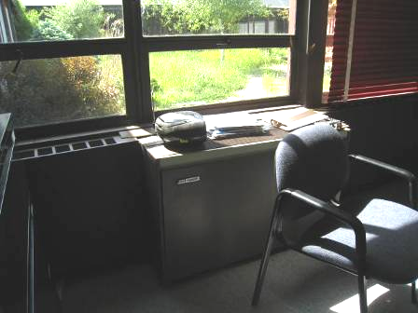

Classroom univent

Picture 2

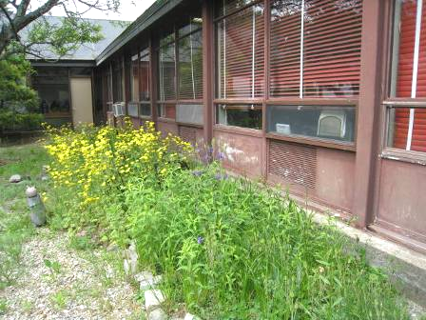

Air intakes for classroom univents (arrows)

Picture 3

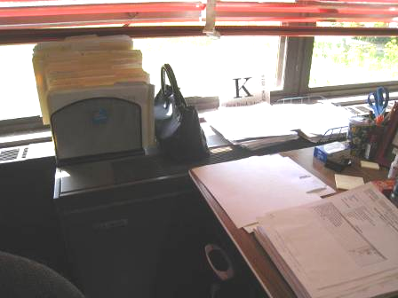

Univent top and front blocked with items

Picture 4

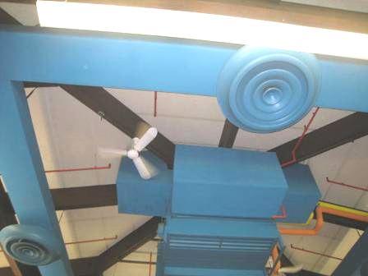

Library supply vents and air handling unit

Picture 5

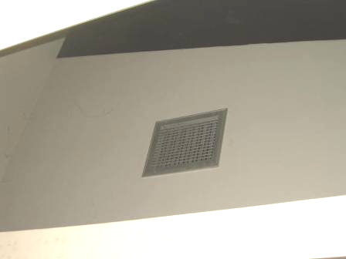

Classroom exhaust vent, high on interior wall below sloped roof

Picture 6

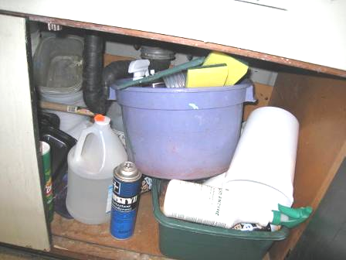

Items and cleaning products stored under sink

Picture 7

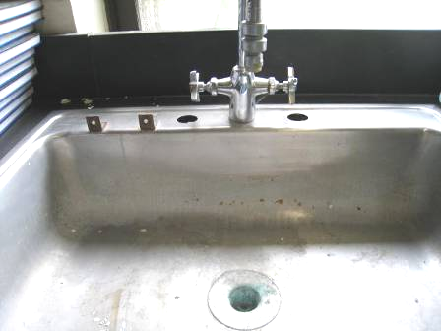

Potentially dry sink in former science room

Picture 8

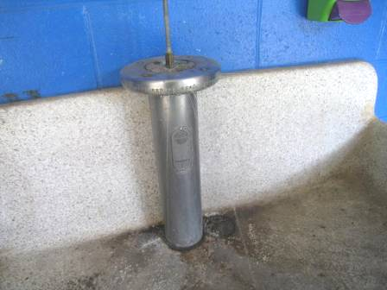

Old-style partially functional sink/fountain in hallway

Picture 9

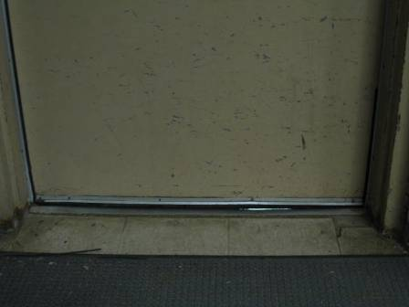

Light visible beneath cafetorium door

Picture 10

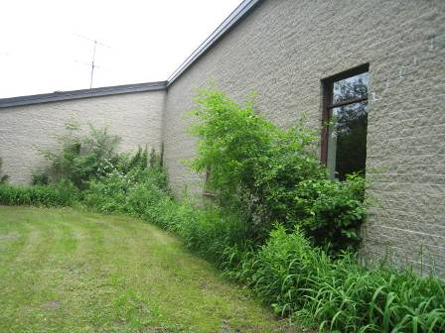

Plants near foundation of building and windows

Picture 11

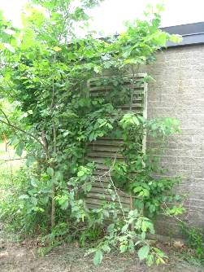

Plants directly adjacent to air intake

Picture 12

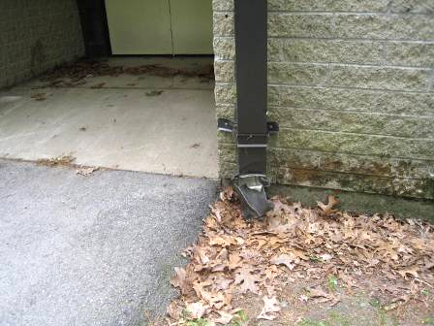

Damaged downspout

Picture 13

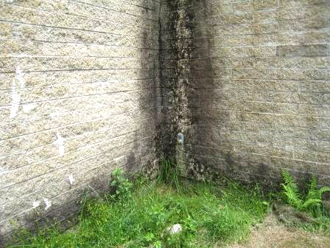

Staining and moss growth along corner/wall indicating chronic dampness

Picture 14

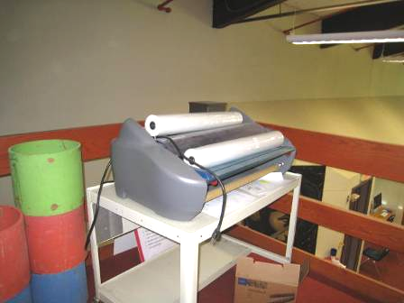

Laminator and laminator plastic rolls in library area

Picture 15

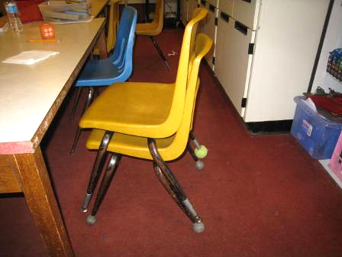

Chair legs with tennis balls and non-tennis-ball glides

Picture 16

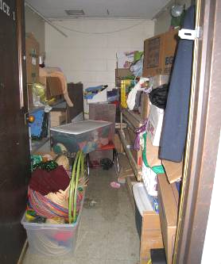

Disorganized storage area

Picture 17

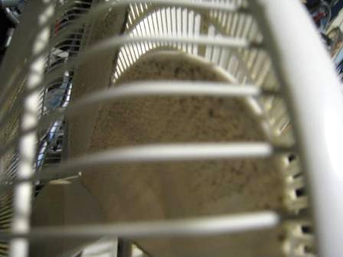

Dusty blades on personal fan

Picture 18

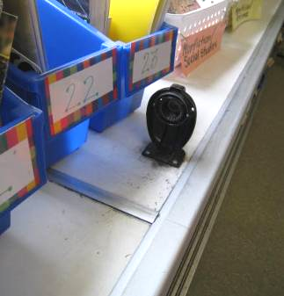

Pencil sharpener and shavings on univent cabinet

Picture 19

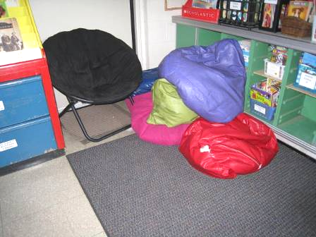

Area rug, cloth-covered chair, and beanbag chairs

Picture 20

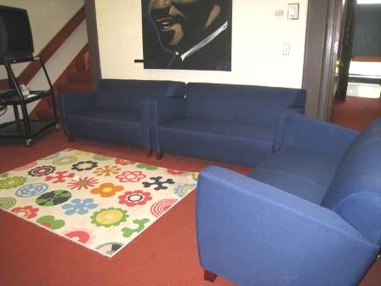

Area rug on carpet and upholstered couches in library
Location/ Room |  | Carbon Dioxide (ppm) |  | Carbon Monoxide (ppm) |  | Temp (°F) |  | Relative Humidity (%) |  | PM2.5  (µg/m³) |  | Occupants  in Room |  | Windows Openable |  | Ventilation |  |  |  | Remarks
 |  |  |  |  |  |  |  |  |  |  |  |  |  |  |  | Supply |  | Exhaust |  | Remarks
Background (outdoors) | 387 |  | ND |  | 73 |  | 51 |  | 11 |  |  |  |  |  |  |  |  |  | Mostly sunny, breezy
Cafeteria | 747-813 |  | ND |  | 74 |  | 53 |  | 11 |  | >100 coming in |  | Y |  | Y |  | Y |  | Light visible beneath door to exterior
Conference Room/Special Ed. | 720 |  | ND |  | 76 |  | 49 |  | 12 |  | 0 |  | Y |  | Y UV off |  | Y |  | Items on UV, DEM
Girls restroom |  |  |  |  |  |  |  |  |  |  |  |  | N |  |  |  | Y off or weak |  | Dusty vents
Guidance | 648 |  | ND |  | 76 |  | 47 |  | 12 |  | 1 |  | Y 1 ajar |  | Y |  | Y |  | DO, items, DEM, soft toys
Gym | 512 |  | ND |  | 75 |  | 49 |  | 13 |  | 0 |  | N |  | Y |  | Y |  | Rubber floor, mats, PF
Gym, Mr. Walsh’s office | 644 |  | ND |  | 75 |  | 51 |  | 14 |  | 0 |  | Y |  | N |  | N |  | DO, PF dusty, CPs, open above to gym
Health | 671 |  | ND |  | 76 |  | 47 |  | 14 |  | 2 |  | N |  | N |  | Y on |  | Fridge, microwave, DO
Library | 621 |  | ND |  | 75 |  | 47 |  | 9 |  | 20 |  | Y open |  | Y |  | Y |  | Wall to wall carpet, 2 CFs, computers
Library loft | 614 |  | ND |  | 76 |  | 45 |  | 9 |  | 2 |  | N |  | Y |  | N |  | Laminator
Library Media production room | 668 |  | ND |  | 76 |  | 47 |  | 10 |  | 0 |  | N |  | N |  | N |  | DO, sunk, CP, carpet
Mr. Crossman | 422 |  | ND |  | 76 |  | 46 |  | 10 |  | 1 |  | N |  | N |  | N |  | Carpet, sink, PF, DO, a few TBs, storage in adjacent room has many cardboard boxes on the floor
Mrs. Harrington | 1035 |  | ND |  | 76 |  | 49 |  | 16 |  | 18 |  | Y open |  | Y UV |  | Y |  | Carpet, DEM, plant, plush toys
Mrs. Leonard | 646 |  | ND |  | 75 |  | 49 |  | 12 |  | 1 |  | Y |  | Y |  | Y |  | DEM
Mrs. O’Neil | 581 |  | ND |  | 75 |  | 50 |  | 12 |  | 8 |  | Y open |  | Y on |  | Y |  | PF on, area rug has debris
Music storage | 945 |  | ND |  | 76 |  | 50 |  | 16 |  | 25 |  | Y |  | Y |  | N |  | Storage items, very crowded
Principal | 629 |  | ND |  | 76 |  | 47 |  | 13 |  | 0 |  | Y |  | N |  | Y off |  | DO, 2 AP, area rugs, food, items
Reading | 636 |  | ND |  | 75 |  | 48 |  | 12 |  | 0 |  | N |  |  |  | Y off |  | Empty of furniture/padded walls
Reading, rear | 600 |  | ND |  | 75 |  | 50 |  | 12 |  | 0 |  | N |  | N |  | Y dusty |  | Mats, new GW wall, items, fridge and microwave, 2 DO
Reception area | 595 |  | ND |  | 74 |  | 50 |  | 14 |  | 10 |  | N |  | Y |  | Y |  | CF, fridge, microwave, PC, ceiling-mounted fan coil unit, PC
Teacher’s lounge | 643 |  | ND |  | 75 |  | 47 |  | 12 |  | 0 |  | Y |  | N WAC only |  | Y |  | Fridge, microwave, food, DO, WAC (off)
1 Art | 577 |  | ND |  | 76 |  | 49 |  | 11 |  | 21 |  | Y 1 open |  | Y UV off |  | Y |  | Items on UV, porous items under sink, CP, area rug
2 Mrs. Christopher | 1129 |  | ND |  | 76 |  | 53 |  | 13 |  | 21 |  | Y |  | Y UV on |  | Y |  | PF, sink, DEM, area rugs, beanbags
Practice 2 | 1014 |  | ND |  | 76 |  | 49 |  | 15 |  | 0 |  | N |  | N |  | Y |  | Florescent bulb fixture missing cover
4 | 484 |  | ND |  | 75 |  | 51 |  | 11 |  | 2 |  | Y open |  | Y UV |  | Y |  | Area rugs, DO
5 | 525 |  | ND |  | 75 |  | 48 |  | 12 |  | 1 |  | Y open |  | Y UV |  | Y |  | DO, PF
6 | 599 |  | ND |  | 75 |  | 49 |  | 13 |  | 2 |  | Y open |  | Y UV |  | Y |  | DEM, DO
7 | 819 |  | ND |  | 76 |  | 50 |  | 14 |  | 25 |  | Y open |  | Y UV on |  | Y |  | Laptops, DO, area rugs, hand sanitizer
8 | 1398 |  | ND |  | 76 |  | 53 |  | 13 |  | 21 |  | Y |  | Y UV |  | Y |  | Area rug – dirty, PF on DEM
9 | 708 |  | ND |  | 75 |  | 47 |  | 12 |  | 4 |  | Y open |  | Y UV |  | Y |  | PF dirty
10 Ms. Seddon | 1032 |  | ND |  | 76 |  | 53 |  | 12 |  | 0 |  | Y open |  | U UV on |  | Y |  | 2 PF, small area rug
11 Mrs. Mangino | 1018 |  | ND |  | 76 |  | 52 |  | 18 |  | 1 (others gone 45 minutes) |  | Y open |  | Y UV on |  | Y |  | Area rug, PF on
12 | 1150 |  | ND |  | 75 |  | 50 |  | 15 |  | 26 |  | Y |  | Y UV |  | Y |  | Area rugs
16 | 1456 |  | ND |  | 76 |  | 54 |  | 14 |  | 21 |  | Y open |  | Y UV |  | Y |  | DEM, DO, area rug
17 | 1352 |  | ND |  | 76 |  | 53 |  | 14 |  | 18 |  | Y open |  | Y UV off |  | Y |  | Hand sanitizer, items on UV, area rug, fridge, microwave
18 | 1025 |  | ND |  | 77 |  | 50 |  | 19 |  | 21 |  | Y open |  | Y UV |  | Y |  | Items on UV, 2 PF, area rug
19 | 1488 |  | ND |  | 77 |  | 53 |  | 14 |  | 20 |  | Y |  | Y |  | Y |  | PF, DO, area rug
20 | 699 |  | ND |  | 76 |  | 50 |  | 16 |  | 20 |  | Y open |  | Y UV |  | Y |  | 2 PF – dusty, area rug, items on UV
21 | 833 |  | ND |  | 76 |  | 50 |  | 15 |  | 21 |  | Y open |  | Y UV |  | Y |  | PF on, area rug, items on UV
22 | 908 |  | ND |  | 77 |  | 47 |  | 11 |  | 25 |  | Y |  | Y UV on |  | Y |  | DEM, DO, items on UV
23 | 794 |  | ND |  | 76 |  | 47 |  | 10 |  | 21 |  | Y |  | Y UV on |  | Y |  | Area rug, DO, PFs, hand sanitizer
24 (old science room) | 704 |  | ND |  | 76 |  | 46 |  | 11 |  | 0 |  | Y |  | Y UV on |  | Y |  | Area rug, items on UV, PF, 6 dry/unused sinks
25 | 737 |  | ND |  | 76 |  | 47 |  | 11 |  | 20 just entered |  | Y |  | Y UV |  | Y |  | DEM, 2 CF, area rug
26 | 662 |  | ND |  | 76 |  | 47 |  | 9 |  | 18 just entered |  | Y |  | Y |  | Y |  | Area rug

Actions on MDPH Recommendations, Penn Brook Elementary School, Georgetown, MA

The following is a status report of action(s) taken on recommendations made in the 2002 MDPH IAQ report (in bold) based on reports from maintenance staff, and BEH/IAQ staff observations. It is important to note that school administrative and facilities staff have turned over since the 2002 report was issued, therefore some information may be incomplete.

Short-term measures:
- Develop a clear line of communication between the maintenance department and school personnel for prompt remediation of temperature and/or ventilation concerns/complaints. This can be done by establishing a written request system administered by a single responsible person. Classroom occupants should report temperature extremes immediately to school administration/maintenance and refrain from deactivating equipment.
- Action: A written request system was not demonstrated during current site visit.
- To maximize air exchange, the BEH recommends that both supply and exhaust ventilation operate continuously during periods of school occupancy independent of classroom thermostat control.
- Action: Supply and exhaust systems are reported to be on and functioning during school occupancy, but some units were found turned off or inoperable.
- Consider having the ventilation system balanced by an HVAC engineer every five years (SMACNA, 1994).
- Action: The date of last balancing was not available at the time of the current visit; however school maintenance staff reported that an energy-saving project had occurred recently at the school, which may have included balancing.
- Remove all blockages from univents to ensure adequate airflow. Clean out interiors of univents regularly.
- Action: School maintenance staff report that teachers are regularly informed that univents should remain unobstructed to function properly but that blockage of univents still occurs. Some univents were found blocked during current visit.
- For buildings in New England, periods of low relative humidity during the winter are often unavoidable. Therefore, scrupulous cleaning practices should be adopted to minimize common indoor air contaminants whose irritant effects can be enhanced when the relative humidity is low. To control for dusts, a high efficiency particulate arrestance (HEPA) filter equipped vacuum cleaner in conjunction with wet wiping of all surfaces is recommended. Avoid the use of feather dusters. Drinking water during the day can help ease some symptoms associated with a dry environment (throat and sinus irritations).
- Action: School maintenance staff report that HEPA vacuuming equipment is used in the school.
- Remove plants from univents. Ensure plants have drip pans. Examine drip pans periodically for mold growth and disinfect with an appropriate antimicrobial where necessary. Discard decaying plant matter and potting soil in teacher’s lounge.
- Action: School staff report that plants are discouraged indoors and only a few were noted during the current assessment. No decaying plant materials were observed in the teacher’s lounge.
- Remove plant growths against the exterior wall/foundation of the building to prevent water penetration.
- Action: School staff report that plants are removed and regularly trimmed back from the sides of the building. However, some plants along the sides of the building were observed during the current assessment, including in direct contact with air intakes.
- Clean exterior walls and univent air intakes of moss and debris.
- Action: Moss and staining were observed on exterior walls during the current visit in locations indicated in the 2002 report. School staff report that this material is cleaned/removed regularly but reoccurs.
- Relocate bird feeder in Picture 16 away from classroom window and univent air intake. Clean area of all bird wastes and disinfect with an appropriate antimicrobial.
- Action: The bird feeder was removed.
- Consider relocating lamination machine in media center office to below exhaust vent. Occupants should ensure exhaust ventilation is activated prior to use.
- Action: A lamination machine was observed in the library loft area which is a less occupied area than the media center; however no local exhaust was present for this machine. School staff report that the laminator is infrequently used.
- Relocate or consider reducing the amount of materials stored in classrooms to allow for more thorough cleaning of classrooms. Clean items regularly with a wet cloth or sponge to prevent excessive dust build-up.
- Action: School staff report that regular cleaning and discarding of material occurs. Excess items were observed in some classrooms and storage areas during the current assessment.
- Change filters for univents, AHUs and AC units as per the manufacture’s instructions or more frequently if needed.
- Action: School staff report that filters are changed twice a year in univents and in accordance with manufacturer’s instructions for other HVAC equipment.
- Seal wall cracks/holes in classroom 26 to prevent the egress of dirt, dust and particulate matter from the wall cavity into occupied areas.
- Action: No holes were observed in the walls of classroom 26.

Long-term measures:
- Based on the age, physical deterioration and availability of parts for ventilation components, the BEH strongly recommends that an HVAC engineering firm fully evaluate the ventilation systems.
- Action: It is unknown if this evaluation was performed, but the school is currently in the process of being replaced, which would eliminate the need for new HVAC components.
- Consider replacing damaged/worn carpeting in the library and principal’s office to prevent the aerosolization of carpet fibers.
- Action: Original carpeting in the library remains.
- Examine the feasibility of increasing mechanical supply and exhaust ventilation.
- Action: It is not known if this study was performed.
- Contact an electrical engineer to reconfigure the control system so that univents and exhaust vents are controlled separately.
- Action: An energy conservation project has reportedly been done recently at the school, which included new motors and controls for exhaust vents.
- Examine the feasibility of installing a gutter/downspout system to parts of the building that lack them.
- Action: It is not known if a feasibility assessment for gutters was performed. No new gutter systems were observed during the current assessment.
- Contact an architectural/roofing firm to examine ways to prevent the accumulation and sliding of snowdrifts from the roof.
- Action: It is not known if this recommendation had been performed. The current assessment was performed outside of the snow season so actions could not be verified.
- Examine the feasibility of replacing or modifying the exterior of univent fresh air intakes to prevent the accumulation of moss and debris.
- Action: It was reported by school staff that univents have been outfitted with screens inside fresh air intakes to prevent the ingress of insects and debris. Moss accumulations were not observed on univent intakes during the current assessment.

The service life is the median time during which a particular system or component of …[an HVAC]… system remains in its original service application and then is replaced. Replacement may occur for any reason, including, but not limited to, failure, general obsolescence, reduced reliability, excessive maintenance cost, and changed system requirements due to such influences as building characteristics or energy prices (ASHRAE, 1991).

