Massachusetts HIV Epidemiologic Profile: Data as of 1/1/2023
Population Report: People Born Outside the United States,
Accessible MS Word Version, optimized for screen reader use
Please note that while the content of this report is the same as the pdf version, the format and pagination have been modified significantly to optimize use with screen readers to ensure access for blind or visually impaired audiences.
Suggested citation:
Massachusetts Department of Public Health, Bureau of Infectious Disease and Laboratory Sciences. Massachusetts HIV Epidemiologic Profile: Data as of 1/1/2023, Population Report: People Born Outside the United States, https://www.mass.gov/lists/hivaids-epidemiologic-profiles Published March 2024. Accessed [date].
Bureau of Infectious Disease and Laboratory Sciences
Massachusetts Department of Public Health
Jamaica Plain Campus/State Public Health Laboratory
305 South Street
Jamaica Plain, MA 02130
Questions about this report
Tel: (617) 983-6560
To reach the Reporting and Partner Services Line
Tel: (617) 983-6999
To speak to the on-call epidemiologist
Tel: (617) 983-6800
Questions about infectious disease reporting
Tel: (617) 983-6801
HIV Data Dashboard
https://www.mass.gov/info-details/hiv-data-dashboard
Requests for additional data
https://www.mass.gov/lists/infectious-disease-data-reports-and-requests
Slide sets for HIV Epidemiologic Profile Reports
https://www.mass.gov/lists/hivaids-epidemiologic-profiles
People born outside the United States make up 17.5% (N=1,224,488/6,984,723) of the total Massachusetts population. Non-US born persons living with HIV infection in Massachusetts are a very diverse group with at least 146 reported countries of birth represented.
HIV INCIDENCE AND PREVALENCE AMONG PEOPLE BORN OUTSIDE THE US
N = 580, 41% of 1,419 new HIV diagnoses from 2019–2021 were among non-US born individuals
N = 7,070, 30% of 23,393 persons living with HIV infection in MA as of 12/31/2021 were non-US born individuals
WORLD REGION OF BIRTH
FIGURE 1. HIV diagnoses among people born outside the United States by sex assigned at birth and world region of birth, Massachusetts 2019–2021
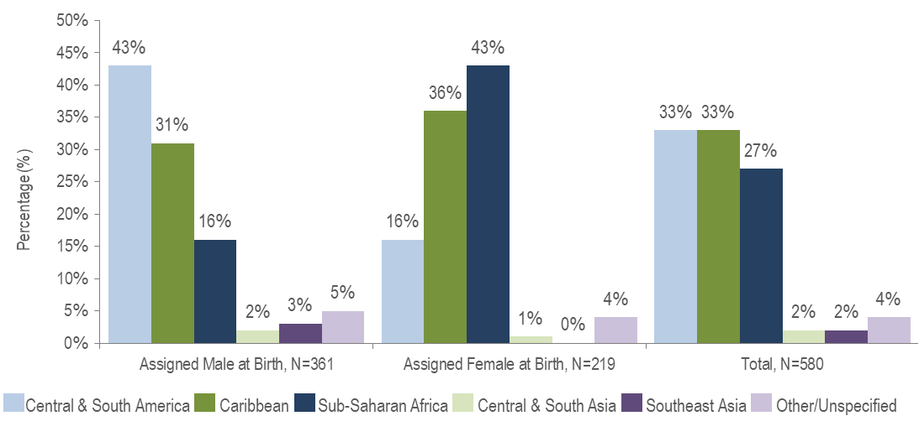

KEY FACT
- People born outside the United States and diagnosed with HIV infection in Massachusetts from 2019 to 2021 were primarily from Central and South America (33%), the Caribbean (33%), and Sub-Saharan Africa (27%).
- There were differences in the distribution of individuals assigned male at birth (AMAB) and individuals assigned female at birth (AFAB) recently diagnosed with HIV infection by world region of birth. The largest proportion of individuals AFAB was from Sub-Saharan Africa (43%), while the largest proportion of individuals AMAB was from Central and South America (43%).
EXPOSURE MODE
FIGURE 2. HIV diagnoses among people born outside the United States by sex assigned at birth and exposure mode, Massachusetts 2019–2021
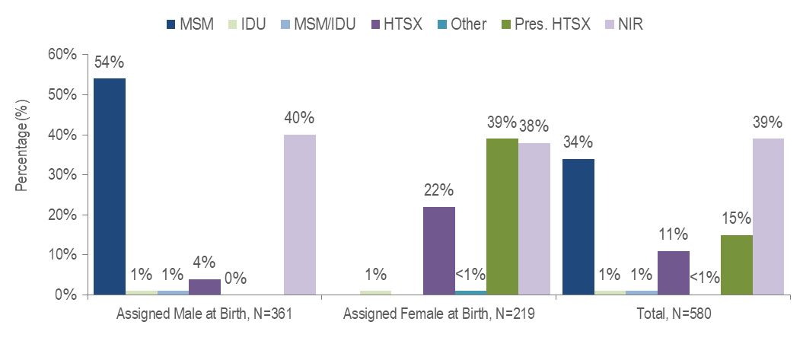
Figure 2 Note: MSM=Male-to-Male Sex; IDU=Injection Drug Use; HTSX=Heterosexual Sex; Pres. HTSX=presumed heterosexual exposure, includes individuals assigned female at birth with a negative history of injection drug use who report having sex with an individual that identifies as male of unknown HIV status and risk; NIR=No Identified Risk

KEY FACTS
- Thirty-nine percent of the 580 non-US born individuals recently diagnosed with HIV infection (2019–2021) did not have exposure mode information reported that met CDC-defined categories, indicating challenges in assigning primary exposure modes for this population.
- Among people born outside the US and diagnosed with HIV infection from 2019 to 2021, MSM (34%) was the most frequently reported exposure mode, although a higher percentage were reported with no identified risk (NIR, 39%).
- Among individuals AMAB born outside the US and recently diagnosed with HIV infection, MSM (54%) was the predominant exposure mode. Presumed heterosexual sex (39%) was the predominant reported exposure mode among individuals AFAB, although a similar percentage were reported with NIR (38%).
RACE/ETHNICITY
KEY FACT
- Non-US born individuals recently diagnosed with HIV infection or living with HIV infection were predominantly black (non-Hispanic) or Hispanic/Latino.
- Forty-six percent of the 580 non-US born people diagnosed with HIV infection from 2019 to 2021 were black (non-Hispanic), 35% were Hispanic/Latino, 10% were white (non-Hispanic), 4% were Asian/Pacific Islander, and 4% were of other or unknown race/ethnicity.
- Among 7,070 non-US born people living with HIV infection on 12/31/21, 52% were black (non-Hispanic), 30% were Hispanic/Latino, 11% were white (non-Hispanic), 6% were Asian/Pacific Islander, and 1% were of other or unknown race/ethnicity.

FIGURE 3. HIV diagnoses among people born outside the US by sex assigned at birth and race/ethnicity, Massachusetts 2019–2021
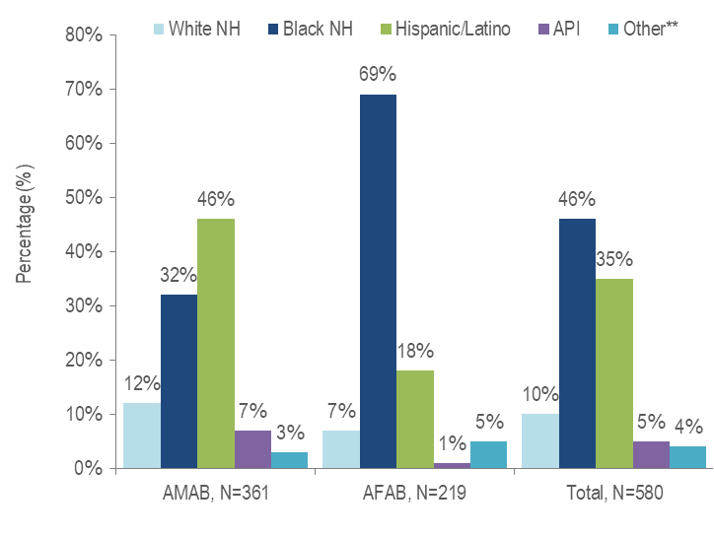
Figure 3 Note: **Other includes more than one race/ethnicity, unknown, and other race/ethnicities (Native American/Alaska Native), API=Asian/Pacific Islander, NH=Non-Hispanic, AMAB=Assigned Male at Birth, AFAB=Assigned Female at Birth
- Among individuals AMAB born outside the US and newly diagnosed with HIV infection in Massachusetts from 2019 to 2021, 46% were Hispanic/Latino and 32% were black (non-Hispanic).
- The majority (69%) of individuals AFAB born outside the US and newly diagnosed with HIV infection in Massachusetts from 2019 to 2021 were black (non-Hispanic).
SEX ASSIGNED AT BIRTH
FIGURE 4. HIV diagnoses by sex assigned at birth and place of birth, Massachusetts 2019–2021
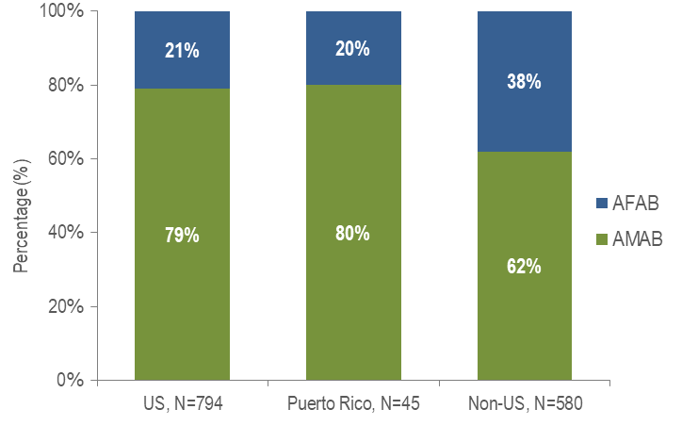
- Thirty-eight percent of non-US born individuals diagnosed with HIV infection from 2019 to 2021 were AFAB, compared to 21% of US born individuals and 20% of individuals born in Puerto Rico.
- Similarly, 40% of non-US born persons living with HIV on 12/31/2021 were AFAB, compared to 22% of US born individuals and 35% of people born in Puerto Rico/US Dependencies. Data not displayed.
TRANSGENDER INDIVIDUALS AND PLACE OF BIRTH
- Fifty-seven percent (N=8/14) of individuals diagnosed with HIV infection from 2019 to 2021 and reported to be transgender were born in the United States and 33% (N=6/14) were born outside the US or in Puerto Rico.
- Sixty-five percent (N=89/138) of persons living with HIV infection on 12/31/2021 and reported to be transgender were born in the United States, 23% (N=31/138) were born outside the US, and 13% (N=18/138) were born in Puerto Rico or another US dependency.

AREA OF RESIDENCE
FIGURE 5. HIV infection diagnoses by Health Service Region and place of birth, Massachusetts 2019–2021
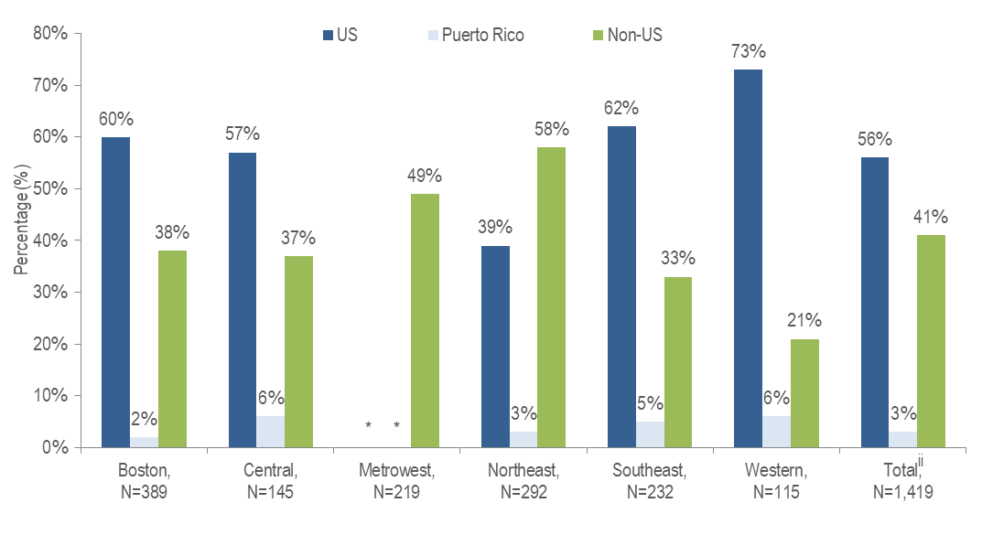
Figure 5 Note: ^{ii} Total includes individuals diagnosed in a correctional facility.
* Values less than five are suppressed for populations less than 50,000 or for populations of unknown size. Additional values may be suppressed to protect privacy

- The Northeast (58%) and Metrowest (49%) Health Service Regions had the largest proportions of individuals recently diagnosed with HIV infection who were born outside the United States.

TABLE 1. Massachusetts cities/towns with the highest percentage of HIV diagnoses among non-US born individuals, 2019–2021
 | HIV Diagnoses Among Non-US Born (N) | HIV Diagnoses Among Non-US Born as Percent of Total HIV Diagnoses (%)
Massachusetts Total | 580 | 41%
Top Cities/Towns
Everett | 26 | 87%
Malden | 24 | 83%
Revere | 17 | 65%
Framingham | 13 | 62%
Lawrence | 24 | 57%
Lowell | 21 | 54%
Lynn | 23 | 54%
Brockton | 31 | 52%
Cambridge | 12 | 48%
Worcester | 39 | 48%
All Other Cities/Towns | 350 | 34%

- Among cities and towns with at least 20 reported HIV diagnoses from 2019 to 2021, Everett and Malden had the highest percentages of HIV diagnoses among people born outside the United States. Over 80% of new HIV diagnoses in each of these cities were among non-US born individuals.

TABLE 2. Countries of birth with the highest percentage of HIV diagnoses among non-US born individuals, 2019–2021

 | HIV Diagnoses by Country of Birth (N) | HIV Diagnoses by Country of Birth as Percent of Total Non-US born HIV Diagnoses (%)
Top Countries
Brazil | 96 | 17%
Haiti | 94 | 16%
Dominican Republic | 70 | 12%
Uganda | 32 | 6%
Cape Verde | 30 | 5%
Colombia | 23 | 4%
Ghana | 23 | 4%
Jamaica | 19 | 3%
Kenya | 19 | 3%
El Salvador | 12 | 2%
Massachusetts Total Non-US Born | 580 | 100%

- Brazil, Haiti and the Dominican Republic accounted for the highest percentages of HIV diagnoses from 2019 to 2021 among people born outside the United States. Combined, these three countries represent the country of birth for 45% of non-US born individuals diagnosed with HIV infection in this time period.

HIV Surveillance Data Source: MDPH Bureau of Infectious Disease and Laboratory Sciences, data are current as of 1/1/2023 and may be subject to change

Data Source: US Census Bureau, 2021 American Community Survey 1-Year Estimates Detailed Tables, Table BO5002, accessed at https://data.census.gov on 6/20/2023
Individuals born outside the US (non-US born) excludes individuals born in the United States, Puerto Rico, American Samoa, Guam, the Northern Mariana Islands, the Republic of Palau, and the U.S. Virgin Islands.
Please consider the impact of the COVID-19 pandemic on infectious disease screening, treatment, and surveillance in the interpretation of 2020 and 2021 data.
Please consider the impact of the COVID-19 pandemic on infectious disease screening, treatment, and surveillance in the interpretation of 2020 and 2021 data
Please consider the impact of the COVID-19 pandemic on infectious disease screening, treatment, and surveillance in the interpretation of 2020 and 2021 data
Please consider the impact of the COVID-19 pandemic on infectious disease screening, treatment, and surveillance in the interpretation of 2020 and 2021 data
Please consider the impact of the COVID-19 pandemic on infectious disease screening, treatment, and surveillance in the interpretation of 2020 and 2021 data
HSR is based on residence at HIV infection diagnosis.
Please consider the impact of the COVID-19 pandemic on infectious disease screening, treatment, and surveillance in the interpretation of 2020 and 2021 data
City/town is based on residence at HIV infection diagnosis.
All Other Cities/Towns includes individuals diagnosed in a correctional facility.
Please consider the impact of the COVID-19 pandemic on infectious disease screening, treatment, and surveillance in the interpretation of 2020 and 2021 data
Please consider the impact of the COVID-19 pandemic on infectious disease screening, treatment, and surveillance in the interpretation of 2020 and 2021 data

