Massachusetts HIV Epidemiologic Profile: Data as of 7/1/2024
Population Report: People Born Outside the United States,
Accessible MS Word Version, optimized for screen reader use
Please note that while the content of this report is the same as the pdf version, the format and pagination have been modified significantly to optimize use with screen readers to ensure access for blind or visually impaired audiences.
Suggested citation:
Massachusetts Department of Public Health, Bureau of Infectious Disease and Laboratory Sciences. Massachusetts HIV Epidemiologic Profile: Data as of 7/1/2024, Population Report: People Born Outside the United States, https://www.mass.gov/lists/hivaids-epidemiologic-profiles Published June 2025. Accessed [date].
Bureau of Infectious Disease and Laboratory Sciences
Massachusetts Department of Public Health
Jamaica Plain Campus/State Public Health Laboratory
305 South Street
Jamaica Plain, MA 02130
Questions about this report
Tel: (617) 983-6560
To reach the Reporting and Partner Services Line
Tel: (617) 983-6999
To speak to the on-call epidemiologist
Tel: (617) 983-6800
Questions about infectious disease reporting
Tel: (617) 983-6801
HIV Data Dashboard
https://www.mass.gov/info-details/hiv-data-dashboard
Requests for additional data
https://www.mass.gov/lists/infectious-disease-data-reports-and-requests
Slide sets for HIV Epidemiologic Profile Reports
https://www.mass.gov/lists/hivaids-epidemiologic-profiles
People born outside the United States make up 18.0% (N=1,263,580/7,001,399) of the total Massachusetts population. Non-US born persons living with HIV infection in Massachusetts are a very diverse group with at least 155 reported countries of birth represented.
HIV INCIDENCE AND PREVALENCE AMONG PEOPLE BORN OUTSIDE THE US
N = 645, 45% of 1,435 new HIV diagnoses from 2021–2023 were among non-US born individuals
N = 7,928, 33% of 24,119 persons living with HIV infection in MA as of 12/31/2023 were non-US born individuals
WORLD REGION OF BIRTH
FIGURE 1. HIV diagnoses among people born outside the United States by sex assigned at birth and world region of birth, Massachusetts 2021–2023
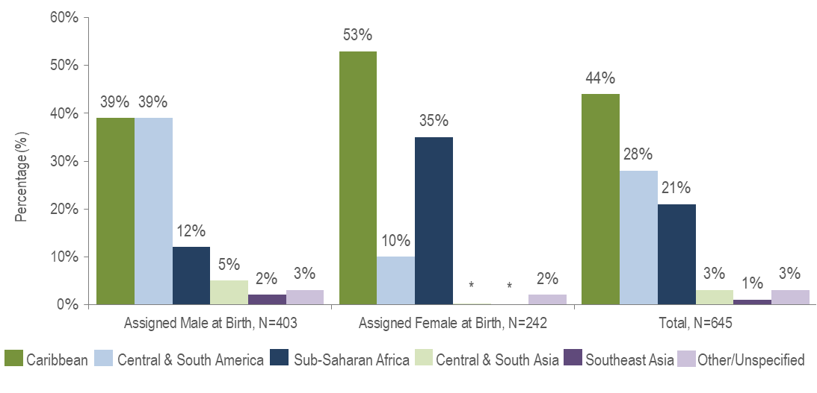
Figure 1 Note: * Values less than five are suppressed for populations less than 50,000 or for populations of unknown size. Percentages do not add up to 100% due to suppressed value.

KEY FACT
- People born outside the United States and diagnosed with HIV infection in Massachusetts from 2021 to 2023 were primarily from the Caribbean (44%), Central and South America (28%), and Sub-Saharan Africa (21%).
- There were differences in the distribution of individuals assigned male at birth (AMAB) and individuals assigned female at birth (AFAB) recently diagnosed with HIV infection by world region of birth. The largest proportion of individuals AFAB was from the Caribbean (53%), while the largest proportion of individuals AMAB was equally from the Caribbean and Central and South America (both 39%).
EXPOSURE MODE
FIGURE 2. HIV diagnoses among people born outside the United States by sex assigned at birth and exposure mode, Massachusetts 2021–2023
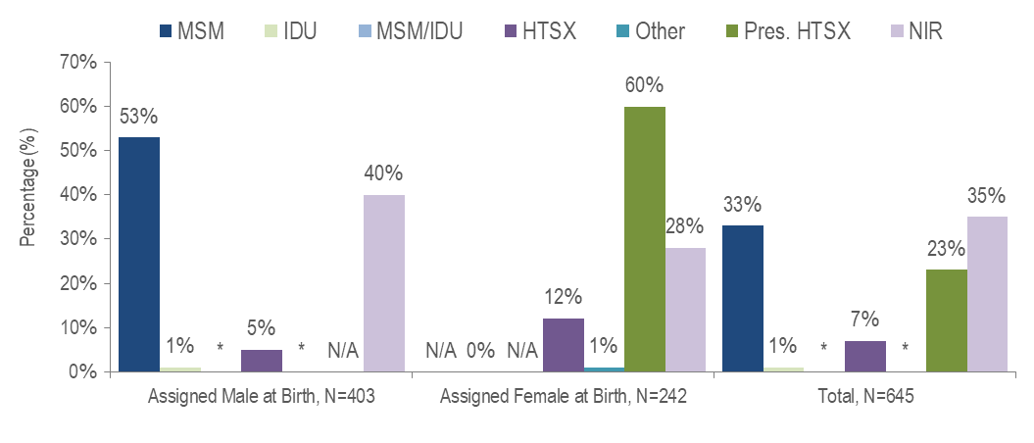
Figure 2 Note: * Values less than five are suppressed for populations less than 50,000 or for populations of unknown size. Percentages do not add up to 100% due to suppressed value. MSM=Male-to-Male Sex; IDU=Injection Drug Use; HTSX=Heterosexual Sex; Pres. HTSX=presumed heterosexual exposure, includes individuals assigned female at birth with a negative history of injection drug use who report having sex with an individual that identifies as male of unknown HIV status and risk; NIR=No Identified Risk; N/A = not applicable
KEY FACTS
- Thirty-five percent of the 645 non-US born individuals recently diagnosed with HIV infection (2021–2023) did not have exposure mode information reported that met CDC-defined categories, indicating challenges in assigning primary exposure modes for this population.
- Among people born outside the US and diagnosed with HIV infection from 2021 to 2023, MSM (33%) was the most frequently reported exposure mode, although a higher percentage were reported with no identified risk (NIR, 35%).
- Among individuals AMAB born outside the US and recently diagnosed with HIV infection, MSM (53%) was the predominant exposure mode. Presumed heterosexual sex (60%) was the predominant exposure mode among individuals AFAB.
RACE/ETHNICITY
KEY FACT
- Non-US born individuals recently diagnosed with HIV infection or living with HIV infection were predominantly Black (non-Hispanic) or Hispanic/Latino.
- Fifty-three percent of the 645 non-US born people diagnosed with HIV infection from 2021 to 2023 were Black (non-Hispanic), 36% were Hispanic/Latino, 6% were White (non-Hispanic), 5% were Asian/Pacific Islander, and <1% were of other or unknown race/ethnicity.
- Among 7,928 non-US born people living with HIV infection on 12/31/23, 51% were Black (non-Hispanic), 32% were Hispanic/Latino, 10% were White (non-Hispanic), 6% were Asian/Pacific Islander, and 1% were of other or unknown race/ethnicity.

FIGURE 3. HIV diagnoses among people born outside the US by sex assigned at birth and race/ethnicity, Massachusetts 2021–2023
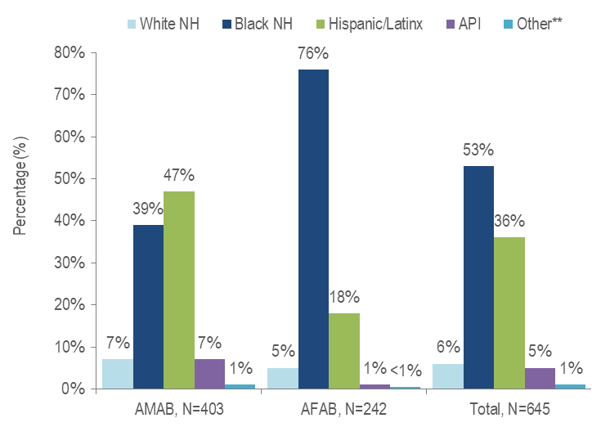
Figure 3 Note: **Other includes more than one race/ethnicity, unknown, and other race/ethnicities (Native American/Alaska Native), API=Asian/Pacific Islander, NH=Non-Hispanic, AMAB=Assigned Male at Birth, AFAB=Assigned Female at Birth
- Among individuals AMAB born outside the US and newly diagnosed with HIV infection in Massachusetts from 2021 to 2023, 47% were Hispanic/Latinx and 39% were Black (non-Hispanic).
- The majority (76%) of individuals AFAB born outside the US and newly diagnosed with HIV infection in Massachusetts from 2021 to 2023 were Black (non-Hispanic).
SEX ASSIGNED AT BIRTH
FIGURE 4. HIV diagnoses by sex assigned at birth and place of birth, Massachusetts 2021–2023
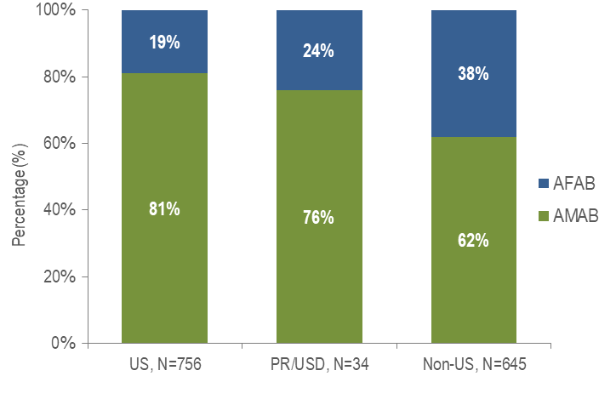
- Thirty-eight percent of non-US born individuals diagnosed with HIV infection from 2021 to 2023 were AFAB, compared to 19% of US born individuals and 24% of individuals born in Puerto Rico/US Dependencies.
- Similarly, 40% of non-US born persons living with HIV on 12/31/2023 were AFAB, compared to 22% of US born individuals and 35% of people born in Puerto Rico/US Dependencies. Data not displayed.
TRANSGENDER INDIVIDUALS AND PLACE OF BIRTH
- Sixty-one percent (N=78/128) of persons living with HIV infection on 12/31/2023 and reported to be transgender were born in the United States, 24% (N=31/128) were born outside the US, and 15% (N=19/128) were born in Puerto Rico or another US dependency.
EXPOSURE MODE AND RACE/ETHNICITY
FIGURE 5. HIV diagnoses among individuals born outside the US by exposure mode and race/ethnicity, Massachusetts 2021–2023
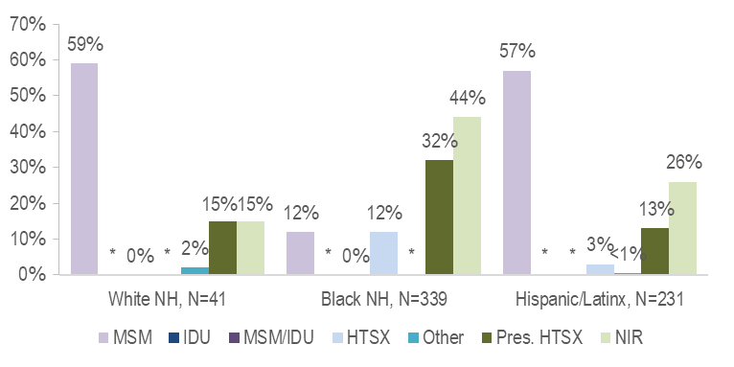
Figure 5 note: * Values less than five are suppressed for populations less than 50,000 or for populations of unknown size. Percentages do not add up to 100% due to suppressed value. MSM=male-to-male sex; IDU=injection drug use; HTSX=heterosexual sex; Pres. HTSX=presumed heterosexual exposure, includes individuals assigned female at birth with a negative history of injection drug use who report having sex with an individual that identifies as male of unknown HIV status and risk; NIR=no identified risk.
- While the predominant exposure mode among White (non-Hispanic) and Hispanic/Latinx individuals born outside the US and recently diagnosed with HIV infection was MSM (59% and 57%, respectively), the largest proportion of Black (non-Hispanic) individuals was assigned no identified risk for exposure mode (44%).
FIGURE 6. HIV diagnoses among individuals AMAB by exposure mode and race/ethnicity, Massachusetts 2021–2023
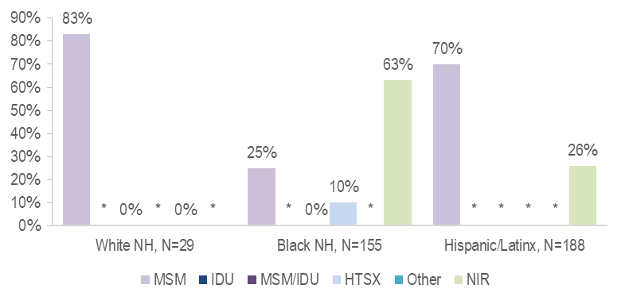
Figure 6 note: * Values less than five are suppressed for populations less than 50,000 or for populations of unknown size. Percentages do not add up to 100% due to suppressed value. MSM=male-to-male sex; IDU=injection drug use; HTSX=heterosexual sex; Pres. HTSX=presumed heterosexual exposure, includes individuals assigned female at birth with a negative history of injection drug use who report having sex with an individual that identifies as male of unknown HIV status and risk; NIR=no identified risk
- MSM was the most frequently reported exposure mode among White (non-Hispanic) (83%) and Hispanic/Latinx (70%) individuals AMAB born outside the US, while NIR accounted for the largest proportion among Black (non-Hispanic) individuals AMAB (63%).
FIGURE 7. HIV diagnoses among individuals AFAB born outside the US by exposure mode and race/ethnicity, Massachusetts 2021–2023
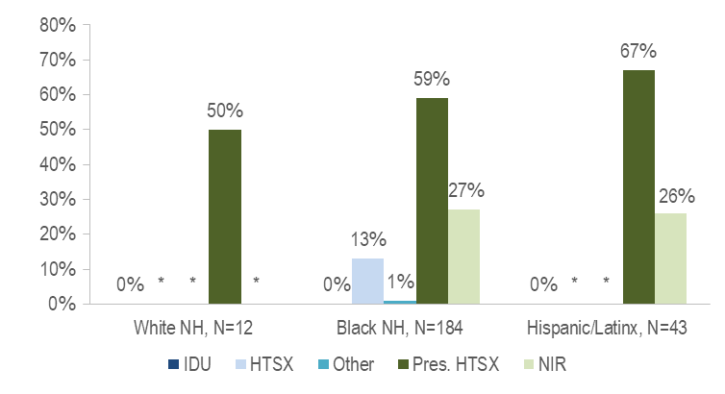
Figure 7 note: * Values less than five are suppressed for populations less than 50,000 or for populations of unknown size. Percentages do not add up to 100% due to suppressed value. IDU=injection drug use; HTSX=heterosexual sex; Pres. HTSX=presumed heterosexual exposure, includes individuals assigned female at birth with a negative history of injection drug use who report having sex with an individual that identifies as male of unknown HIV status and risk; NIR=no identified risk
- Presumed heterosexual sex was the predominant exposure mode among White (non-Hispanic) (50%), Black (non-Hispanic) (59%), and Hispanic/Latinx (67%) individuals AFAB born outside the US and diagnosed with HIV infection from 2021 to 2023.

AREA OF RESIDENCE
FIGURE 8. HIV infection diagnoses by Health Service Region and place of birth, Massachusetts 2021–2023
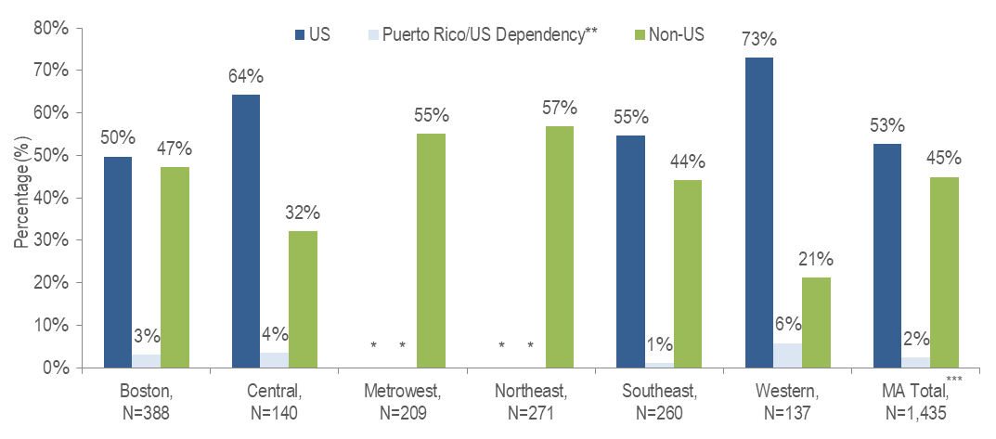
Figure 8 Note: HSR is based on residence at HIV infection diagnosis.
* Values less than five are suppressed for populations less than 50,000 or for populations of unknown size. Percentages do not add up to 100% due to suppressed value
** 94% of individuals diagnosed with HIV infection from 2021–2023 who were born in a US dependency (USD) were born in Puerto Rico (PR).
*** Total includes individuals diagnosed in a correctional facility.

- The Northeast (57%) and Metrowest (55%) Health Service Regions had the largest proportions of individuals recently diagnosed with HIV infection who were born outside the United States.

TABLE 1. Massachusetts cities/towns with the highest percentage of HIV diagnoses among non-US born individuals, 2021–2023
 | HIV Diagnoses Among Non-US Born (N) | HIV Diagnoses Among Non-US Born as Percent of Total HIV Diagnoses (%)
Massachusetts Total | 645 | 45%
Top Cities/Towns
Brockton | 59 | 79%
Chelsea | 16 | 76%
Everett | 16 | 76%
Malden | 22 | 76%
Lawrence | 24 | 69%
Framingham | 14 | 64%
Lowell | 24 | 56%
Lynn | 21 | 48%
Boston | 156 | 44%
Worcester | 27 | 39%
All Other Cities/Towns | 266 | 37%

- Among cities and towns with at least 20 reported HIV diagnoses from 2021 to 2023, Brockton, Chelsea, Everett, and Malden had the highest percentages of HIV diagnoses among people born outside the United States. Over 75% of new HIV diagnoses in each of these cities were among non-US born individuals.

TABLE 2. Countries of birth with the highest percentage of HIV diagnoses among non-US born individuals, 2021–2023

 | HIV Diagnoses by Country of Birth (N) | HIV Diagnoses by Country of Birth as Percent of Total Non-US born HIV Diagnoses (%)
Top Countries
Haiti | 197 | 31%
Brazil | 92 | 14%
Dominican Republic | 71 | 11%
Cape Verde | 39 | 6%
Colombia | 27 | 4%
El Salvador | 17 | 3%
Ghana | 15 | 2%
Kenya | 13 | 2%
Nigeria | 12 | 2%
Uganda | 12 | 2%
Massachusetts Total Non-US Born | 645 | 100%

- Haiti, Brazil, and the Dominican Republic accounted for the highest percentages of HIV diagnoses from 2021 to 2023 among people born outside the United States. Combined, these three countries represent the country of birth for 56% of non-US born individuals diagnosed with HIV infection in this time period.

HIV Surveillance Data Source: MDPH Bureau of Infectious Disease and Laboratory Sciences, data are current as of 7/1/2024 and may be subject to change

Providers may use this number to report individuals newly diagnosed with a notifiable sexually transmitted infection, including HIV, or request partner services. Partner services is a free and confidential service for individuals recently diagnosed with a priority infection. The client-centered program offers counseling, linkage to other health and social services, anonymous notification of partners who were exposed and assistance with getting testing and treatment. For more information, see: https://www.mass.gov/service-details/partner-services-program-information-for-healthcare-providers)
Data Source: US Census Bureau, 2023 American Community Survey 1-Year Estimates Detailed Tables, Table S0501, accessed at https://data.census.gov on 9/26/2024
Individuals born outside the US (non-US born) excludes individuals born in the United States, Puerto Rico, American Samoa, Guam, the Northern Mariana Islands, the Republic of Palau, and the U.S. Virgin Islands.
Please consider the impact of the COVID-19 pandemic on infectious disease screening, treatment, and surveillance in the interpretation of data from 2020 to 2023.
Please consider the impact of the COVID-19 pandemic on infectious disease screening, treatment, and surveillance in the interpretation of data from 2020 to 2023
Please consider the impact of the COVID-19 pandemic on infectious disease screening, treatment, and surveillance in the interpretation of data from 2020 to 2023
Please consider the impact of the COVID-19 pandemic on infectious disease screening, treatment, and surveillance in the interpretation of data from 2020 to 2023
Please consider the impact of the COVID-19 pandemic on infectious disease screening, treatment, and surveillance in the interpretation of data from 2020 to 2023
94% of individuals diagnosed with HIV infection from 2021–2023 who were born in a US dependency (USD) were born in Puerto Rico (PR).
Please consider the impact of the COVID-19 pandemic on infectious disease screening, treatment, and surveillance in the interpretation of data from 2020 to 2023.
Please consider the impact of the COVID-19 pandemic on infectious disease screening, treatment, and surveillance in the interpretation of data from 2020 to 2023.
HSR is based on residence at HIV infection diagnosis.
Please consider the impact of the COVID-19 pandemic on infectious disease screening, treatment, and surveillance in the interpretation of data from 2020 to 2023
City/town is based on residence at HIV infection diagnosis.
All Other Cities/Towns includes individuals diagnosed in a correctional facility.
Please consider the impact of the COVID-19 pandemic on infectious disease screening, treatment, and surveillance in the interpretation of data from 2020 to 2023
Please consider the impact of the COVID-19 pandemic on infectious disease screening, treatment, and surveillance in the interpretation of data from 2020 to 2023.

