INDOOR AIR QUALITY ASSESSMENT

Pepperell Town Hall
1 Main Street
Pepperell, MA

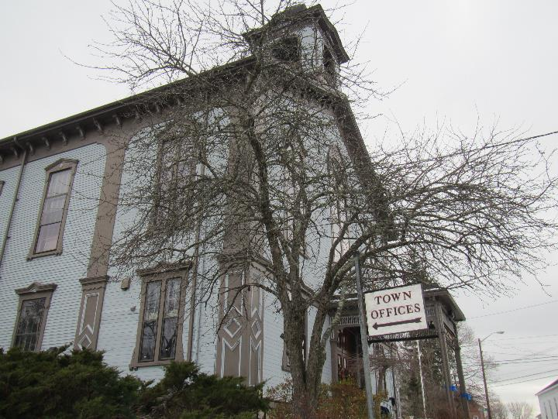

Prepared by:
Massachusetts Department of Public Health
Bureau of Environmental Health
Indoor Air Quality Program
January 2020

Background
Building: | Pepperell Town Hall (PTH)
Address: | 1 Main Street, Pepperell, MA
Reason for Request: | General Indoor Air Quality (IAQ) assessment
Date of Assessment: | January 10, 2019
Massachusetts Department of Public Health/Bureau of Environmental Health (MDPH/BEH) Staff Conducting Assessment: | Ruth Alfasso, Environmental Engineer/Inspector, IAQ Program
Building Description: | Victorian-style building from the late 1800s with a sloped shingled roof and clapboard siding. It has two stories with an upper level
Building Population: | Approximately 12 employees and regular visits from the public
Windows: | Openable

This building was visited previously in 2003. The report from that visit is available on request.

Methods
Please refer to the IAQ Manual for methods, sampling procedures, and interpretation of results (MDPH, 2015).

IAQ Testing Results
The following is a summary of indoor air testing results (Table 1).
- Carbon dioxide levels were below the MDPH guideline of 800 parts per million (ppm) in all but one of the areas assessed.
- Temperature was within or close to the lower end of the recommended range of 70°F to 78°F in areas assessed apart from unoccupied areas which were significantly below.
- Relative humidity was below the recommended range of 40% to 60% in all areas assessed which is typical of the heating season.
- Carbon monoxide levels were non-detectable in all areas assessed.
- Fine particulate matter (PM2.5) concentrations measured were below the National Ambient Air Quality Standard (NAAQS) level of 35 μg/m³ in all areas assessed.

Ventilation
A heating, ventilating, and air conditioning (HVAC) system has several functions. First it provides heating and, if equipped, cooling. Second, it is a source of fresh air. Finally, an HVAC system will dilute and remove normally-occurring indoor environmental pollutants by not only introducing fresh air, but by filtering the airstream and ejecting stale air to the outdoors via exhaust ventilation. Even if an HVAC system is operating as designed, point sources of respiratory irritation may exist and cause symptoms in sensitive individuals. The following analysis examines and identifies components of the HVAC system and likely sources of respiratory irritant/allergen exposure due to water damage, aerosolized dust, and/or chemicals found in the indoor environment.
The assessment results indicate that the building is receiving adequate fresh air for the occupancy in the building. Note that many areas had low occupancy, which can reduce carbon dioxide levels. To maximize air exchange, the BEH recommends that a mechanical ventilation system operate continuously during periods of occupancy. Without the system operating as designed, normally occurring pollutants cannot be diluted or removed, allowing them to build up and lead to IAQ/comfort complaints.
The building is supplied with fresh air from an air handling unit (AHU) located on the lower level. Air is supplied to occupied areas through vents from exposed ductwork (Picture 1) or the ceiling (Picture 2). Return vents return air to the AHU. There are radiators for supplemental heating and, in some areas, window/wall-mounted air conditioners for additional cooling (Picture 3). There are also vents in the attic level room (Picture 4). It is unclear whether these are attached to an existing mechanical system. They are mostly blocked with plastic.

Microbial/Moisture Concerns
Water infiltration and water damage was noted in several areas of the building. According to the Health Director, a contractor evaluated the Town Hall roof in early 2019 and determined that the main roof needs replacement within five years along with the membrane roof sections. In addition, the contractor reported that more urgent short-term work is needed to stop leaks in some areas including over the vault.
The upper level was formerly a large meeting room/stage and is currently used for storage. The ceiling between this room and the roof is in very poor condition (Pictures 5 and 6). Windows are also in poor condition in this area and do not close completely (Picture 7).Water damage and pest infiltration (squirrels) have been reported.
Water-damaged ceiling tiles are present in other areas (Pictures 8 and 9) which may be due to building envelope leaks (e.g. damaged/missing flashing or window sealant) or leaks from the plumbing system. The dark staining on the ceiling tiles shown in Picture 9 may be mold colonization. Water-damaged ceiling tiles should be replaced after a leak is repaired or when colonized with mold.
Clapboards on the exterior of the building are deteriorated in some areas (Picture 10). Bricks in the area of the lower level vault also show signs of deterioration and efflorescence (Picture 11).
Odors were reported in several areas of the building, including the Selectmen’s office area. Occupants of this area reported that in the past a strong musty odor had been present and a source not identified. A slight odor of hand sanitizer was noted in the outer office during the assessment, but the musty odor described was not present at the time of the assessment. Reportedly, the odors are strongest during wet weather. There is material around the wall-mounted air conditioner in this office that may be porous (Picture 3). This should be checked and replaced if necessary with a non-porous material that forms a tight seal.
A musty odor was also reported to occur in the Board of Health office when the air conditioning system is turned on during the summer. Musty odors from air conditioning are frequently due to mold or bacterial growth on the cooling coils often related to inefficient condensate drainage. The equipment should be thoroughly cleaned prior to the next cooling season.
The furnace room is located on the same hallway as several offices, including the Board of Health office. Odors from this room have been reported. The room has a rough rock wall (Picture 12) and is below grade which contributes to moisture issues. There is also a sump with pump in this room (Picture 12); an air-tight cover should be used to prevent odors from the sump. Weather-stripping can be used to further seal the door between this room and the hallway so long as adequate combustion make-up air is available.
The vault on the lower level has a floor drain (Picture 13). This drain should be sealed to prevent sewer gases or backups into the space. Because of this, and because of the potential for condensation on the floor, items stored here should be on raised shelving or pallets.
The US Environmental Protection Agency (US EPA) and the American Conference of Governmental Industrial Hygienists (ACGIH) recommends that porous materials (e.g., wallboard, carpeting, ceiling tiles) be dried with fans and heating within 24 to 48 hours of becoming wet (US EPA, 2008; ACGIH, 1989). If porous materials are not dried within this time frame, mold growth may occur. Once mold has colonized porous materials, they are difficult to clean and should be removed.
Plants were noted in several areas (Picture 14). Plants should be well maintained, placed only on non-porous drip pans, and kept away from ventilation equipment to prevent the distribution of pollen, mold and odors. Water damage to surfaces from plants was noted (Picture 14). Water dispensers were found on carpet (Picture 15). These appliances can spill or leak and moisten carpeting, so should be placed in non-carpeted areas whenever possible. The refrigerator on the upper level had evidence of a spill (Picture 16). Refrigerators should be kept clean to prevent odors and microbial growth.

Other concerns
Other issues were identified that may contribute to IAQ issues. Dust and debris was found in the building, particularly on the attic level (Picture 7). This material indicates that wood and other materials are deteriorating, and it may be a source of irritating dusts. This debris may also contain waste from pests such as the reported squirrels, other rodents, or birds, all of which can be a source of allergens. Curtains remaining in the attic level are stained with what appears to be bird waste (Picture 17).
Stored materials are present in all areas of the building, including large amounts of paper (Pictures 18 and 19). This material can become damaged due to exposure to temperature extremes and moisture in unconditioned spaces, and may also become harborage/food for pests. Porous materials such as paper should be stored in an organized manner and should be kept off the floor, particularly on the lower level where condensation may occur on the floor during humid weather. Porous items should also be kept away from any area with known or suspected leaks.
Filters on the AHU should be changed twice a year at a minimum. Pleated filters with a minimum efficiency rating (MERV) of 8 of better should be used when possible in equipment as these are effective to remove particles such as pollen and mold spores (ASHRAE, 2012). Window air conditioners, dehumidifiers, air filters, ceiling fans, and personal fans in use in the building should also be cleaned regularly in accordance with manufacturer’s instructions.
Some areas in the PTH are carpeted. Carpeting should be cleaned annually or semi-annually in soiled high traffic areas as per the recommendations of the Institute of Inspection, Cleaning and Restoration Certification (IICRC, 2012). Removal of carpeting in areas that may be subject to condensation should be considered.

Conclusions/Recommendations
The conditions related to IAQ problems at the PTH raise a number of issues. The general building conditions/design, maintenance, and the condition of HVAC equipment, if considered individually, present conditions that could degrade IAQ. When combined, these conditions can serve to further degrade IAQ. Some of these conditions can be remedied by actions of building occupants. Other remediation efforts will require alteration to the building structure and equipment. For these reasons, a two-phase approach is recommended. The first consists of short-term measures to improve air quality and the second consists of long-term measures that will require capital planning and resources to adequately address overall conditions:

Short-term measures
- Maintain the AHU including changing filters regularly. Store unused filters in a clean dry area until needed.
- Consider using window ACs in the fan-only mode during temperate weather for additional fresh air.
- Ensure carbon monoxide detectors are installed in areas where combustion is taking place, such as the furnace room. Ensure they are tested and maintained/replaced in accordance with manufacturer’s recommendations.
- Until the roof can be repaired, periodically inspect areas of known leaks.
- Seal windows and other gaps in the building envelope to exclude moisture and pests.
- Maintain plumbing to prevent leaks.
- Seal around window ACs using non-porous materials.
- Ensure that air conditioning systems are cleaned prior to the beginning of the cooling season to reduce odors.
- If sufficient makeup air is available for the furnace room with the hallway door tightly sealed, use weather-stripping to render that door airtight.
- Equip the sump in the furnace room with a tight-fitting cover.
- Seal the floor drain in the vault.
- Maintain plants and do not overwater. Ensure they are placed on non-porous drip pans that are cleaned periodically.
- Consider moving water coolers to areas without carpeting.
- Ensure refrigerators are kept clean to prevent odors.
- Ensure water-damaged materials are cleaned, replaced, and/or repaired in a manner consistent with the U.S. Environmental Protection Agency’s guidelines (US EPA, 2008).
- Store items in the building neatly and away from any areas with known leaks or water issues, including floors. Use totes, shelves, or cabinets to store items neatly and prevent moistening, dust buildup, and pest harborage.
- Regularly clean dust and debris from surfaces in the building. Flag areas with significant accumulations of dust/debris to check for potential pests, and for future repairs/replacement of wood and masonry.
- Clean the curtains in the upper level (Picture 17), or remove them.
- For buildings in New England, periods of low relative humidity during the winter are often unavoidable. Therefore, scrupulous cleaning practices should be adopted to minimize common indoor air contaminants whose irritant effects can be enhanced when the relative humidity is low. To control for dusts, a high efficiency particulate arrestance (HEPA) filter equipped vacuum cleaner in conjunction with wet wiping of all surfaces is recommended. Avoid the use of feather dusters. Drinking water during the day can help ease some symptoms associated with a dry environment (throat and sinus irritations).
- Vacuum carpeting regularly and professionally clean once or twice a year. Consider replacing carpeting with non-porous flooring in areas subject to heavy foot traffic.
- Refer to resource manual and other related IAQ documents located on the MDPH’s website for further building-wide evaluations and advice on maintaining public buildings. These documents are available at: http://mass.gov/dph/iaq.

Long-term recommendations
- Consult with a building/ventilation engineer regarding the condition and adequacy of mechanical air systems. If the upper level is to be returned to active use, examine the potential for providing adequate fresh air and exhaust.
- Consult with a roofing contractor regarding repairing any remaining roof leaks.
- Consult with a building envelope specialist regarding repair/replacement of windows to increase thermal comfort and energy efficiency of the building.
- Consult with a building envelope specialist regarding refinishing/repointing brickwork and repairing clapboards.
- Overall plans should also be developed regarding use of the building, including current and potential future uses.

References
ACGIH. 1989. Guidelines for the Assessment of Bioaerosols in the Indoor Environment. American Conference of Governmental Industrial Hygienists, Cincinnati, OH.
ASHRAE. 2012. American Society of Heating, Refrigeration and Air Conditioning Engineers (ASHRAE) Standard 52.2-2012 -- Method of Testing General Ventilation Air-Cleaning Devices for Removal Efficiency by Particle Size (ANSI Approved).
IICRC. 2012. Carpet Cleaning FAQ 4 Institute of Inspection, Cleaning and Restoration Certification. Institute of Inspection Cleaning and Restoration, Vancouver, WA.
MDPH. 2015. Massachusetts Department of Public Health. Indoor Air Quality Manual: Chapters I-III. Available at: http://www.mass.gov/eohhs/gov/departments/dph/programs/environmental-health/exposure-topics/iaq/iaq-manual/.
US EPA. 2008. “Mold Remediation in Schools and Commercial Buildings”. Office of Air and Radiation, Indoor Environments Division, Washington, DC. EPA 402-K-01-001. September 2008. Available at: http://www.epa.gov/mold/mold-remediation-schools-and-commercial-buildings-guide.
Picture 1
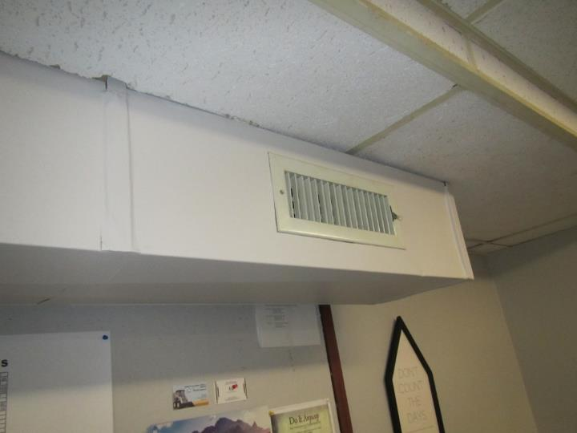
Ductwork with supply vent
Picture 2
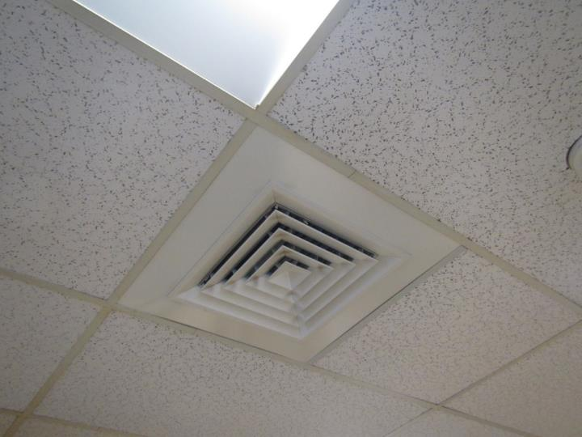
Supply vent in ceiling tile system
Picture 3
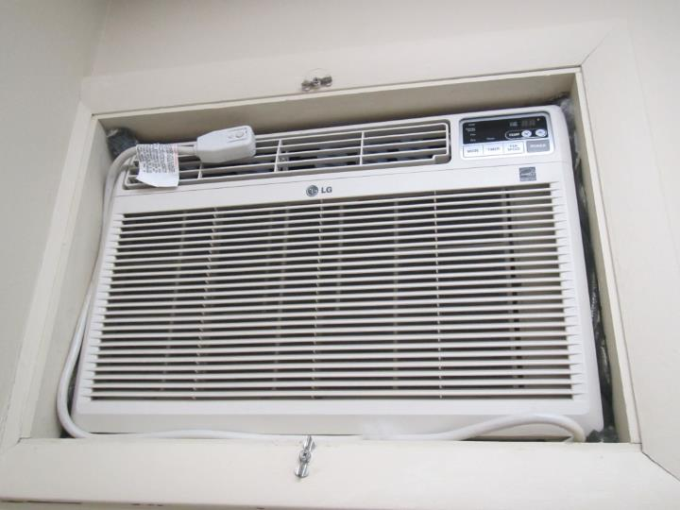
Wall-mounted air conditioner
Picture 4
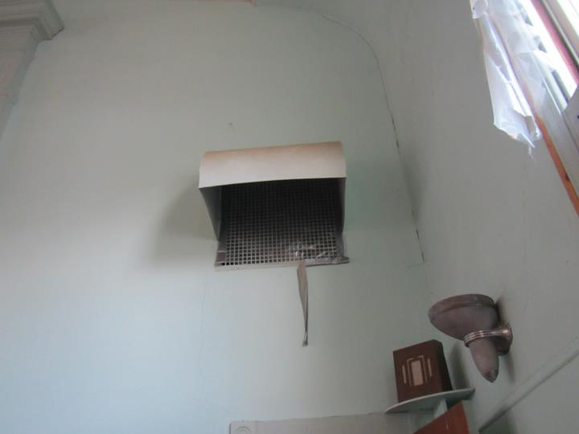
Vent in attic level room with plastic over it, note tape peeling off
Picture 5
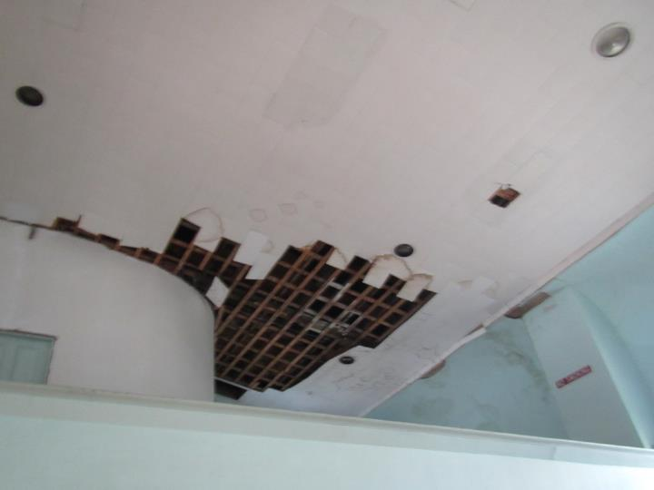
Damaged ceiling in the upper level
Picture 6
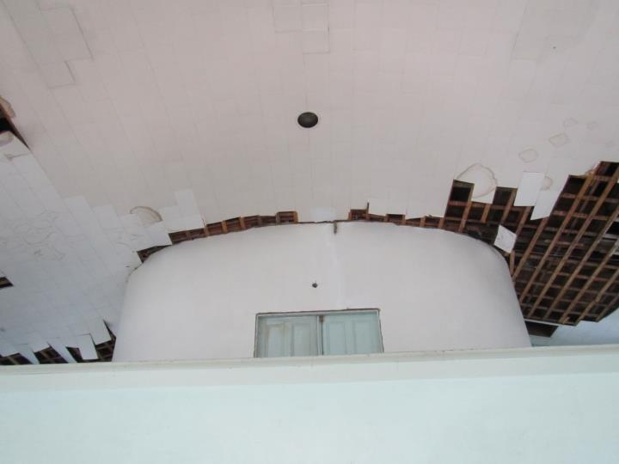
Damaged ceiling next to the cupola on the upper level of the building
Picture 7
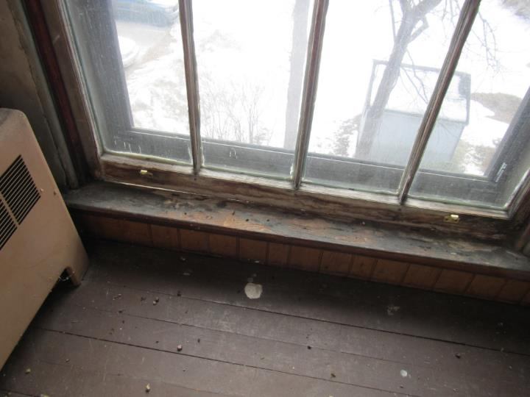
Damaged window
Picture 8
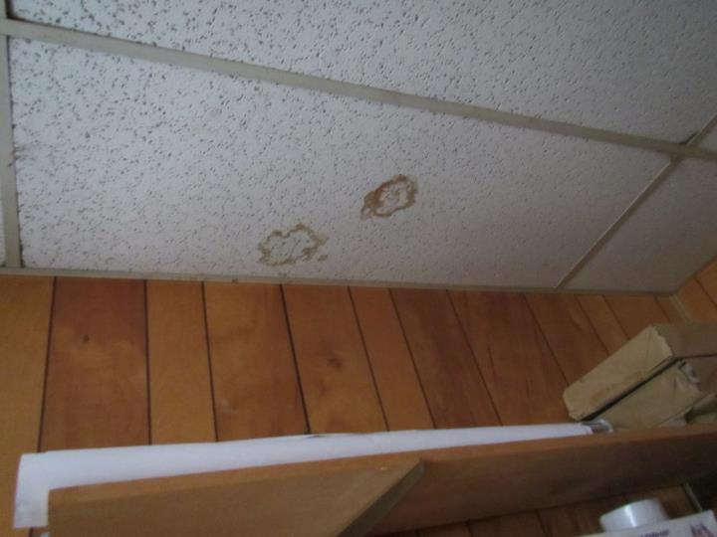
Water-damaged ceiling tiles
Picture 9
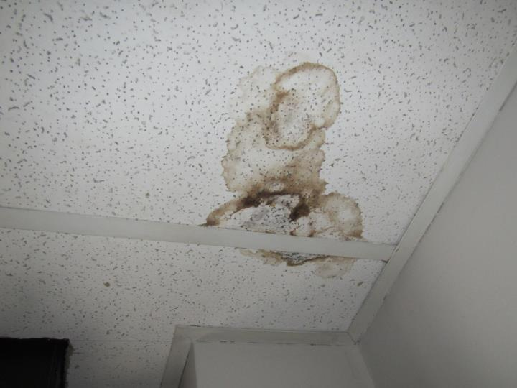
Water-damaged ceiling tiles, dark stains may indicate mold growth
Picture 10
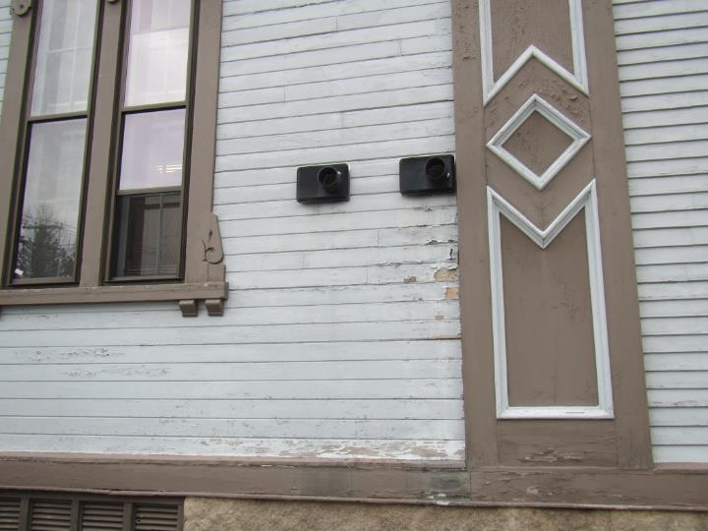
Deteriorated siding
Picture 11
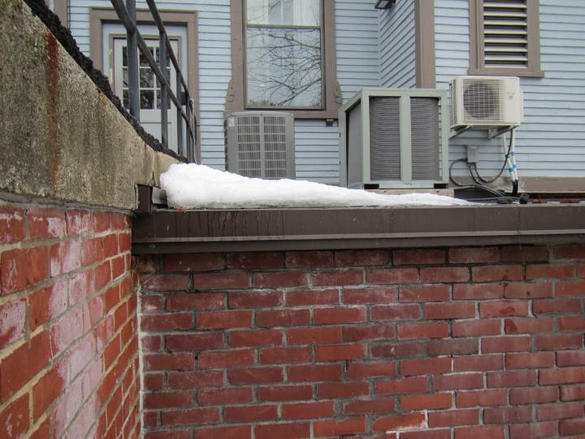
Damaged brick and efflorescence in the area of the lower vault
Picture 12
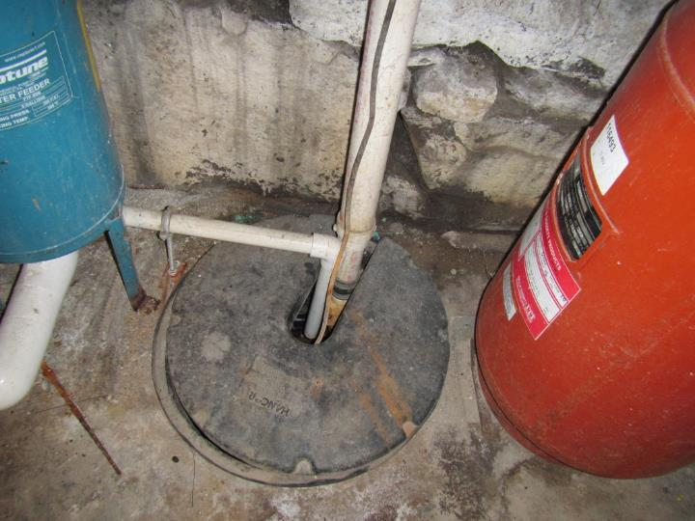
Rock wall and sump with gap in lid in the furnace room
Picture 13
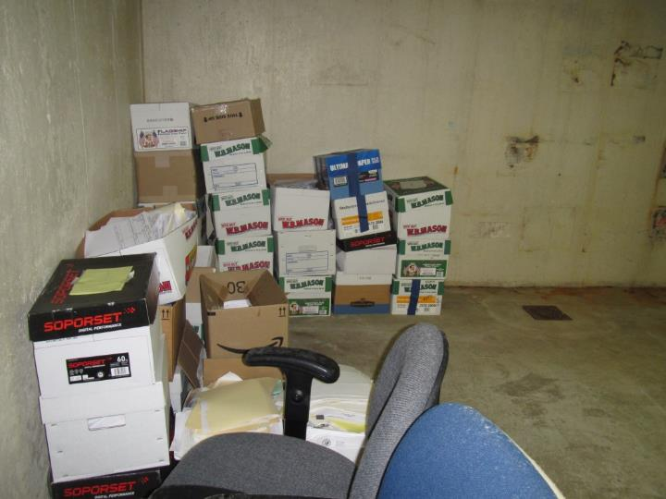
Floor drain and stored boxes in the lower level vault
Picture 14
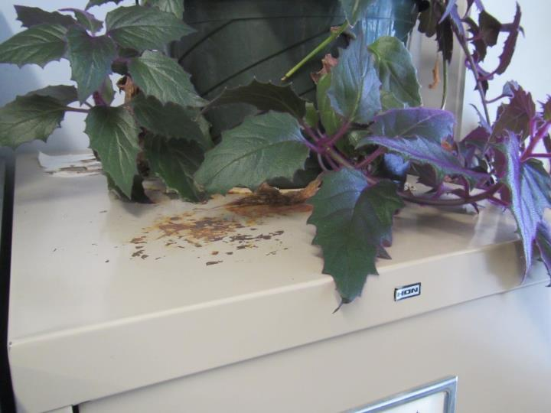
Plant and water-damaged metal cabinet
Picture 15
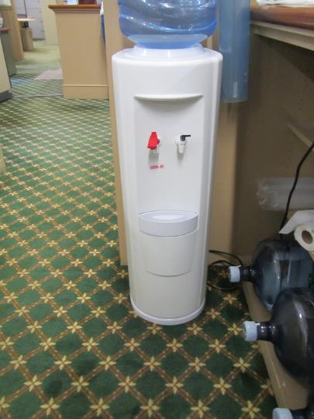
Water cooler on carpet
Picture 16
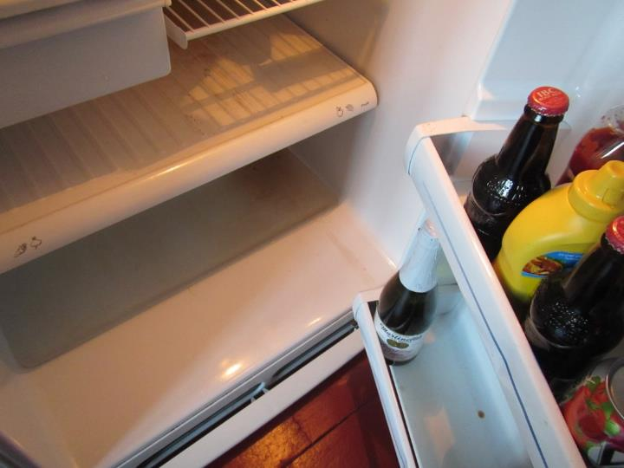
Evidence of spill in fridge
Picture 17
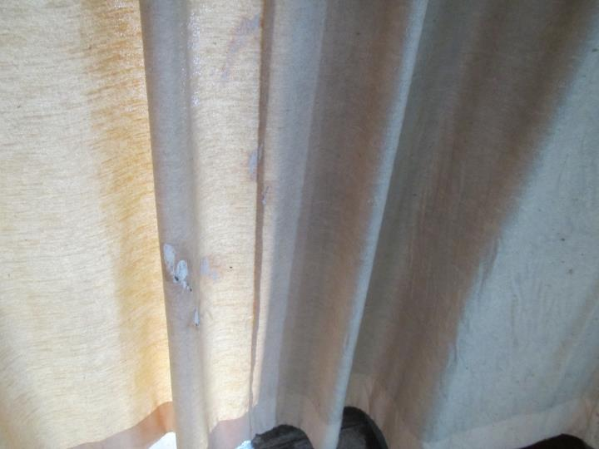
Curtain stained with bird waste
Picture 18
Boxes on the floor of the lower level vault – note floor drain
Picture 19
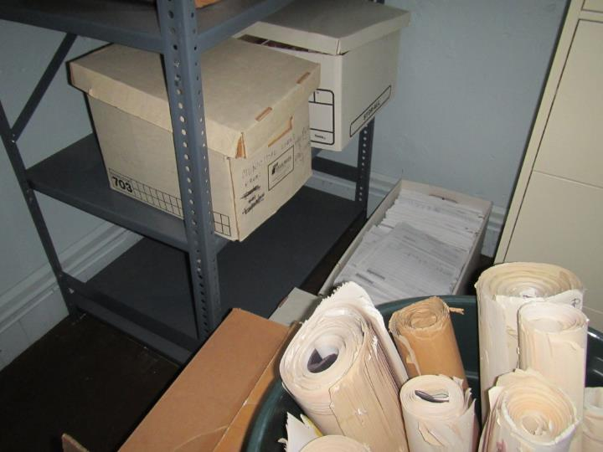
Storage of old files and plans in the upper level

Location | Carbon  Dioxide  (ppm) | Carbon Monoxide  (ppm) | Temp  (°F) | Relative  Humidity  (%) | PM2.5  (µg/m³) | Occupants  in Room | Windows  Openable | Ventilation |  | Remarks
 |  |  |  |  |  |  |  | Supply | Exhaust
Background | 443 | ND | ~32 | 29 | 5 |  |  |  |  | Chilly
Lunchroom (3rd floor) | 944 | ND | 67 | 22 | 3 | 0 | Y | N | N | stoves, microwave, fridge (Spill), no exhaust, small area rug
DPW office | 646 | ND | 67 | 24 | 4 | 0 | Y | N | N | carpet, upholstered furniture
Restroom in DPW office |  |  |  |  |  | 0 | N | N | Y not on
Upstairs open area | 513 | ND | 57 | 19 | 4 | 0 | Y |  |  | Many WD and missing tiles. damaged wood, damaged windows
Public restroom 2nd floor |  |  |  |  |  |  |  |  |  | WD CT
Main room hallway | 732 | ND | 66 | 23 | 5 | 1 | Y | Y | Y | HS, PC, rug
Treasury | 742 | ND | 68 | 27 | 4 | 3 | Y | Y | Y | carpet, plant, CF
Treasury office | 756 | ND | 69 | 24 | 10 | 0 | Y | N | Y | CF, plants
Planning | 767 | ND | 70 | 19 | 3 | 5 | Y | Y | N | CF, plants, carpet
Building department | 705 | ND | 70 | 18 | 6 | 3 | Y | Y | Y | carpet, CF
Town clerk | 694 | ND | 70 | 18 | 4 | 0 | Y | Y | Y
Big copy room | 675 | ND | 70 | 20 | 4 | 0 | Y | Y | Y | big plan printer
Lower level
Restroom | 716 | ND | 70 | 22 | 6 | 0 | N |  | Y | exhaust off
Men’s restroom | 670 | ND | 71 | 23 | 4 | 0 | Y |  | Y | exhaust on
Veteran office | 641 | ND | 71 | 21 | 10 | 0 | N | Y | Y | AF, NC
Furnace room | 657 | ND | 71 | 28 | 3 | 0 | N |  |  | Rock wall
BOH | 636 | ND | 71 | 19 | 4 | 0 | N | Y | Y | NC, plant, fridge
Conference | 632 | ND | 71 | 20 | 28 | 0 | N | Y | Y | carpet
Mail room | 619 | ND | 72 | 20 | 4 | 0 | N | Y | Y | equipment
Vault |  |  |  |  |  |  | N |  |  | floor drain
Town accountant | 642 | ND | 70 | 21 | 8 | 0 | Y | Y | Y | carpet, plants, PF
Inner office | 676 | ND | 70 | 20 | 5 | 1 | Y | Y | Y | WD CT
Administration office | 657 | ND | 71 | 20 | 4 | 0 | Y | N | N | WAC, NC, plants
Town Administrator office | 717 | ND | 71 | 22 | 4 | 0 | Y | N | N | no carpet, odor reports

