ABOUT DTA
Our Mission | The mission of the Department of Transitional Assistance is to assist and empower low-income individuals and families to meet their basic needs, improve their quality of life, and achieve long-term economic self-sufficiency.
DTA is experiencing an unprecedented demand for our services and benefits. We continue to pursue all available tools and resources to help Commonwealth individuals and families purchase healthy food and meet their basic needs. DTA will continue to use available data to drive decision-making and direct our response during the COVID-19 public health crisis.
– Mary Sheehan
Acting Commissioner, Department of Transitional Assistance

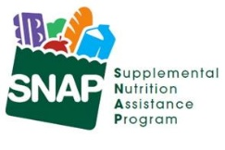  DTA Serves 1 in 7 MA Residents |  | Households Served  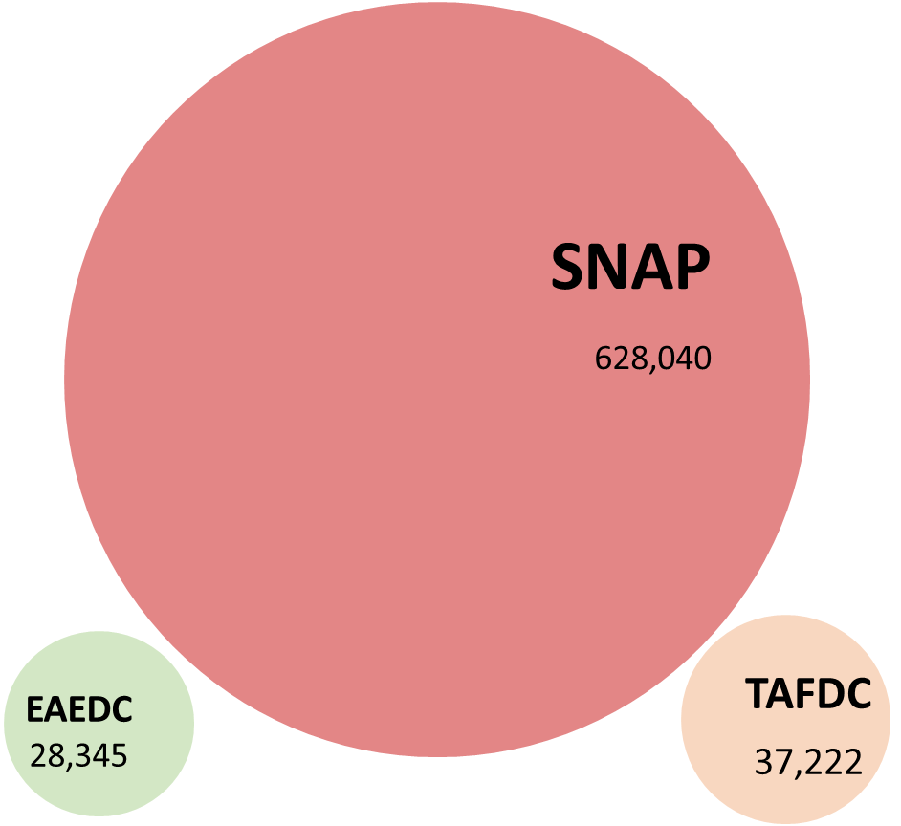  Each bubble’s size reflects the relative size of each program’s caseload
Statewide Facts
- 71% of SNAP households in Massachusetts have gross countable income of less than 100% of the Federal Poverty Level – that’s $18,310 for a household of two
- 28% of SNAP households have at least one child
- 21% of Massachusetts SNAP recipients are age 60 or older
- SNAP clients live in every city & town across the Commonwealth
- 39,708 DTA clients are due for recertification or reevaluation next month.

COVID-19 Facts  - Due to COVID-19, emergency allotments have significantly increased the average SNAP benefits per household.  - Including emergency allotments supplements the average SNAP benefit is $504 per household at the rate of $16 per household per day.  - The average monthly TAFDC grant is $638, and the average monthly EAEDC grant is $399. |  | Client Demographics  - After English, the top 5 languages/language families among clients are Spanish, Haitian Creole, Chinese, Portuguese, and Vietnamese.  - 45% of all clients identify as White, 13% as Black, 5% as Asian, 4% more than 1 race, 33% report no race  - 23% of clients across racial groups identify as Hispanic or Latino.
SNAP ENROLLMENT & QUALITY
SNAP Recipients 1,047,832
SNAP Applications
DTA received 37% more SNAP applications from Massachusetts residents in August 2022 compared to the same period in 2021. As of late July 2022, residents can now initiate a SNAP application simultaneously when applying for MassHealth benefits online.

SNAP Households 628,040
Recipients Age 60+  224,036 | Recipients With a Disability  302,357 |  | Recipients Age 18 or under  341,145
Monthly SNAP Caseload
The number of households receiving SNAP benefits each month in the last four years.
Annual SNAP Caseload
The number of households receiving SNAP benefits in the last five years.
LOCAL OFFICES
Monthly Walk-in Visitors
The number of people who visit our offices each month to use our services.
Reason for Office Visits
The number and percent of reason clients visited our local offices in the month.
ASSISTANCE LINE
Monthly Call Volume
Average daily calls broken down by how the call resolved.
Average Caller Wait Time
The average length of time callers wait to speak to an agent.
Note: The Average Caller Wait Time was recently updated from the prior version which had an error in the calculation
PROCESSING
Average Processing Days for New SNAP Applications
The average number of days to approve a new SNAP application.
Monthly SNAP Churn
The percentage of applicants that were active clients 90 days prior.

Note: The Monthly SNAP Churn rate was recently updated due to a computational error.
PROCESSING
Monthly SNAP Applications Received |  |  |  | 39,201
Monthly TAFDC Applications Received |  |  |  | 6,672
Monthly EAEDC Applications Received |  |  |  | 3,919
Please note that MassHealth applications received include counts from the online Checkbox and Scanned Document.
 | EAEDC ENROLLMENT
 | EAEDC Recipients 28,533 |  |  | EAEDC Households 28,345
 | People receiving EAEDC due to Age (60+)  11,797 |  | People receiving EAEDC due to Disability  16,922 |  | Children (under 18) receiving EAEDC  449
Monthly EAEDC Caseload
The number of households receiving EAEDC benefits in the last two years.
Annual EAEDC Caseload
The number of households receiving EAEDC benefits in the last 5 years.
TAFDC ENROLLMENT
TAFDC Recipients 95,414 |  | TAFDC Households 37,222
Recipients Age 18 or under  64,506 | Child Only Grants  3,043 |  | Recipients who are working  4,435
Monthly TAFDC Caseload
The number of households receiving TAFDC benefits in the last two years.

Annual TAFDC Caseload
The number of households receiving TAFDC benefits in the last five years.

ADDITIONAL INFORMATION
Background |  | Measure |  | Description
 |  | SNAP Recipients |  | This is the number of Massachusetts residents in households that receive Supplemental Nutrition Assistance Program benefits each month.
 |  | SNAP Households |  | This is the number of Massachusetts households that receive SNAP benefits each month.
 |  | Monthly Walk-in Visitors |  | This is the number of people who visited our local offices each month to use our services.
 |  | Reason for Office Visit |  | The number and percent of reason clients visited our local offices in the month.
 |  | Monthly Call Volume |  | Average daily calls broken down by how the call resolved.
 |  | Calls Completed in IVR |  | Average calls that exited at a point in our Interactive Voice Response (IVR) or self-service menu. Likely exit reasons: client self-served successfully; client hung up.
 |  | Calls Unable to Connect |  | Average number of calls that heard a high-volume message and were unable to wait for a live agent.
 |  | Connected to Call Center |  | Average number of calls connected to a live agent.
 |  | Average Caller Wait Time |  | The average length of time callers wait to speak to an agent.
 |  | Average Processing Days for New SNAP Applications |  | The average number of days to approve a new SNAP application.
 |  | SNAP Churn |  | The SNAP program has always and will always realize some level of client churn. However, reducing churn eliminates disruptions in benefits and improves operational efficiency. This is measured by analyzing new applications against the active caseload 90 days previous.
 |  | Recipients with a Disability |  | Active clients who have identified as having any disability.
 |  | EAEDC Caseload |  | This is the number of Massachusetts households that receive Emergency Aid to the Elderly, Disabled, and Children (EAEDC) cash benefits each month.
 |  | TAFDC Caseload |  | This is the number of Massachusetts households that receive Transitional Aid to Families with Dependent Children (TAFDC) cash benefits each month.

