ABOUT DTA
Our Mission | The mission of the Department of Transitional Assistance is to assist and empower low-income individuals and families to meet their basic needs, improve their quality of life, and achieve long-term economic self-sufficiency.

The Department of Transitional Assistance is committed to delivering high-quality services that drive better outcomes for the individuals and families we serve. This performance scorecard reflects our commitment to transparency and accountability, demonstrating how we use data and analytics to track performance, identify opportunities, and continuously improve. Serving one in six Massachusetts residents requires rigor, innovation, and a deeply committed workforce. We value the dedication and expertise of our staff, whose efforts, combined with our ever-advancing use of data, ensure we meet basic needs today while building stronger, healthier communities for tomorrow.
– Michael Cole
Commissioner, Department of Transitional Assistance

  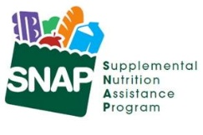  DTA Serves 1 in 7 MA Residents |  | Households Served  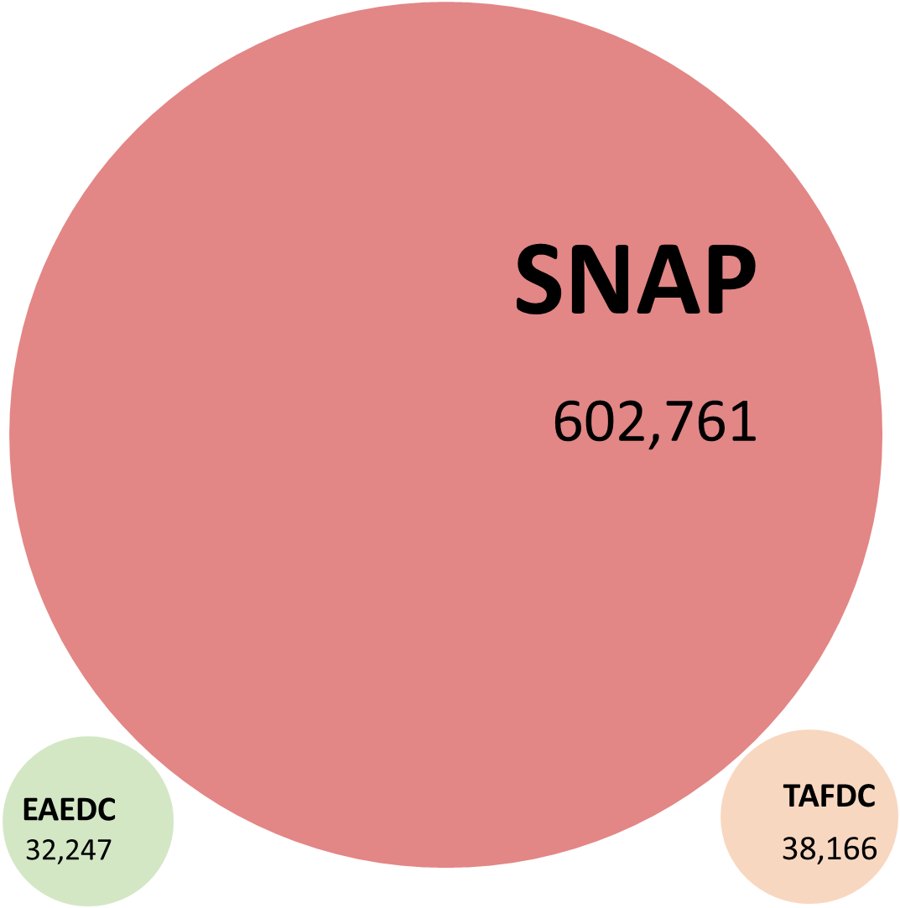  Each bubble’s size reflects the relative size of each program’s caseload
Statewide Facts
- 66% of SNAP households in Massachusetts have gross countable income of less than 100% of the 2026 Federal Poverty Level – that’s $21,640 for a household of two
- 25% of SNAP households have at least one child
- 27% of Massachusetts SNAP recipients are age 60 or older
- SNAP clients live in every city & town across the Commonwealth.
- 54,694 DTA households that are due for recertification or reevaluation next month.
- Of all MassHealth SNAP applications that were dispositioned in January, 22% (952/4,278) were approved.
Benefits Facts  - The average SNAP benefit is $323 per household at the rate of $11 per household per day.  - The average monthly TAFDC grant is $751, and the average monthly EAEDC grant is $486. |  | Client Demographics  - After English, the top 5 languages/language families among clients are Spanish, Haitian Creole, Chinese, Portuguese, and Vietnamese.  - 38% of all clients identify as White, 16% as Black, 4% as Asian, 2% More than 1 race, 39% report no race  - 27% of clients across racial groups identify as Hispanic or Latino.
 | SNAP ENROLLMENT & QUALITY
SNAP Recipients 974,833
SNAP Applications Approval Rate
Of all SNAP Applications Dispositioned in January 2026, DTA approved 46% (14,992/32,6689) of SNAP Applications from Massachusetts residents.
 | SNAP Households 602,761
 | Recipients Aged 60+  260,490 | Recipients With a Disability  307,799 |  | Recipients Aged 18 or under  303,746
Monthly SNAP Caseload
The number of households receiving SNAP benefits each month in the last five years.
Annual SNAP Caseload
The number of households receiving SNAP benefits in the last six years.
 | LOCAL OFFICES
*Monthly Walk-ins Visits
The number of people who visit our offices each month to use our services.
Reason for Office Visits
The number and percent of reason clients visited our local offices in the month.
 | ASSISTANCE LINE
Monthly Call Volume
Average daily calls broken down by how the call resolved.
 | Wait Time (Mins) by Number of Callers during the Time of the Day |  |  |  | *39,000
 | Note: *Total Callers who were connected to speak to our staff during the month.
 | PROCESSING
Average Processing Days for New SNAP Applications
The average number of days to approve a new SNAP application.
Monthly SNAP Churn
The percentage of applicants that were active clients 90 days prior.

 | Note: The Monthly SNAP Churn rate was recently updated due to a computational error.
 | PROCESSING
 | Monthly SNAP Applications Received |  |  |  | 40,670
 | Monthly TAFDC Applications Received |  |  |  | 4,630
 | Monthly EAEDC Applications Received |  |  |  | 3,615
 | Please note that MassHealth applications received include counts from the online Checkbox and Scanned Document.
PROCESSING
Monthly SNAP Households Closed for Income*
*The number of SNAP households closed for earned and unearned income each month in the last five years.

Monthly TAFDC Households Closed for Income*
*The number of TAFDC households closed for earned and unearned income each month in the last five years.

Monthly EAEDC Households Closed for Income*
*The number of EAEDC households closed for earned and unearned income each month in the last five years.

 | EAEDC ENROLLMENT
 | EAEDC Recipients 32,455 |  |  | EAEDC Households 32,247
 | Recipients Receiving EAEDC due to Aged 65+  11,061 |  | Recipients Receiving EAEDC due to Disability.  20,978 |  | Children Receiving EAEDC under Age 18.  417
Monthly EAEDC Caseload
The number of households receiving EAEDC benefits in the last five years.
Annual EAEDC Caseload
The number of households receiving EAEDC benefits in the last six years.
TAFDC ENROLLMENT
TAFDC Recipients 95,663 |  | TAFDC Households 38,166
Recipients Aged 18 or under  64,320 | Child Only Grants  3,156 |  | Recipients who are working  6,046
Monthly TAFDC Caseload
The number of households receiving TAFDC benefits in the last five years.

Annual TAFDC Caseload
The number of households receiving TAFDC benefits in the last six years.

ADDITIONAL INFORMATION
Background |  | Measure |  | Description
 |  | SNAP Recipients |  | This is the number of Massachusetts residents in households that receive Supplemental Nutrition Assistance Program benefits each month.
 |  | SNAP Households |  | This is the number of Massachusetts households that receive SNAP benefits each month.
 |  | Monthly Walk-in Visits |  | This is the number of people who visited our local offices each month to use our services.
 |  | Reason for Office Visit |  | The number and percent of reason clients visited our local offices in the month.
 |  | Monthly Call Volume |  | Average daily calls broken down by how the call resolved.
 |  | Wait Time (Bins) |  | The length of time in minutes callers waited to speak to an agent.
 |  | Calls Completed in IVR |  | Average calls that exited at a point in our Interactive Voice Response (IVR) or self-service menu. Likely exit reasons: client self-served successfully; client hung up.
 |  | Calls Unable to Connect |  | Average number of calls that heard a high-volume message and were unable to wait for a live agent.
 |  | Connected to Call Center |  | Average number of calls connected to a live agent.
 |  | Average Processing Days for New SNAP Applications |  | The average number of days to approve a new SNAP application.
 |  | SNAP Churn |  | The SNAP program has always and will always realize some level of client churn. However, reducing churn eliminates disruptions in benefits and improves operational efficiency. This is measured by analyzing new applications against the active caseload 90 days previous.
 |  | Recipients with a Disability |  | Active clients who have identified as having any disability.
 |  | EAEDC Caseload |  | This is the number of Massachusetts households that receive Emergency Aid to the Elderly, Disabled, and Children (EAEDC) cash benefits each month.
 |  | TAFDC Caseload |  | This is the number of Massachusetts households that receive Transitional Aid to Families with Dependent Children (TAFDC) cash benefits each month.
 |  | Monthly SNAP Households Closed for Income |  | The number of SNAP households that were closed for earned and unearned income during the benefit cycle month.
 |  | Monthly TAFDC Households Closed for Income |  | The number of TAFDC households that were closed for earned and unearned income during the benefit cycle month.
 |  | Monthly EAEDC Households Closed for Income |  | The number of EAEDC households that were closed for earned and unearned income during the benefit cycle month.

