ABOUT DTA
Our Mission | The mission of the Department of Transitional Assistance is to assist and empower low-income individuals and families to meet their basic needs, improve their quality of life, and achieve long-term economic self-sufficiency.

The Department of Transitional Assistance is committed to quality service delivery in the furtherance of the best outcomes for the individuals and families we serve. This performance scorecard is a transparent effort to reflect our performance levels and to serve as our vehicle for continuous improvement. Serving 1 in 6 Massachusetts residents is challenging, and we welcome your review of our efforts in helping these residents secure healthy food and meet their basic human needs. Thank you for your interest in this impactful work.
– Jeff McCue
Commissioner, Department of Transitional Assistance

  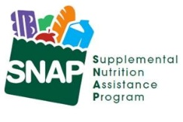  DTA Serves 1 in 6 MA Residents |  | Households Served  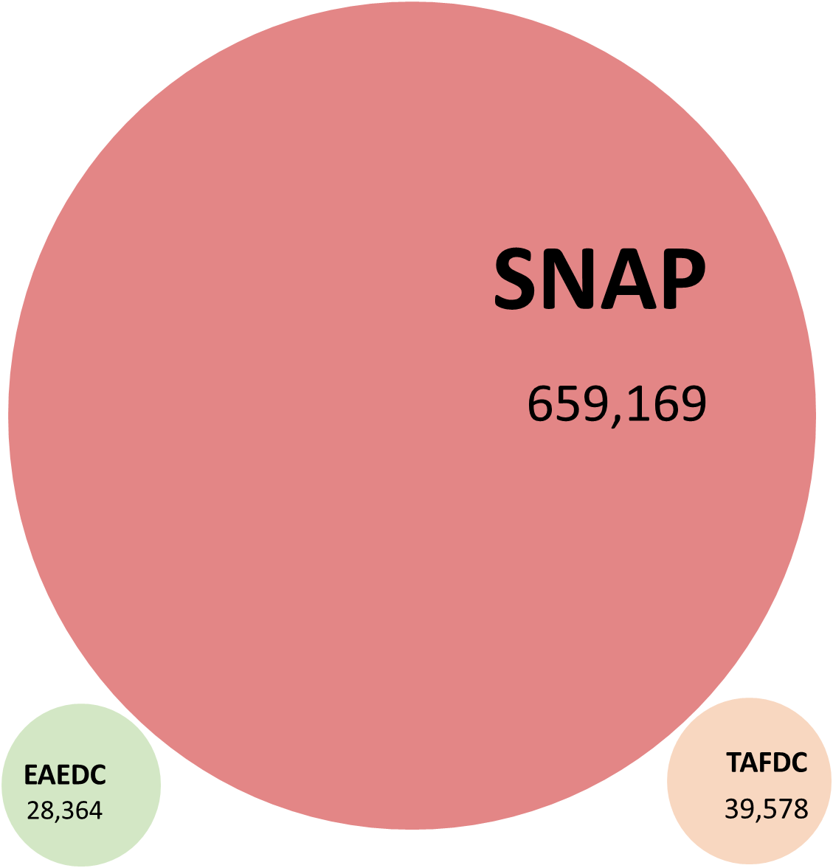  Each bubble’s size reflects the relative size of each program’s caseload
Statewide Facts
- 69% of SNAP households in Massachusetts have gross countable income of less than 100% of the Federal Poverty Level – that’s $19,720 for a household of two
- 26% of SNAP households have at least one child
- 22% of Massachusetts SNAP recipients are age 60 or older
- SNAP clients live in every city & town across the Commonwealth.
- 39,560 DTA clients are due for recertification or reevaluation next month.
- 1,054 SNAP applications from MassHealth were approved in June.

COVID-19 Facts  - Including state-funded emergency allotments supplements the average SNAP benefit is $320 per household at the rate of $11 per household per day.  - The average monthly TAFDC grant is $706, and the average monthly EAEDC grant is $441. |  | Client Demographics  - After English, the top 5 languages/language families among clients are Spanish, Haitian Creole, Chinese, Portuguese, and Russian.  - 44% of all clients identify as White, 14% as Black, 5% as Asian, 4% more than 1 race, 33% report no race  - 25% of clients across racial groups identify as Hispanic or Latino.
SNAP ENROLLMENT & QUALITY
SNAP Recipients 1,089,280
SNAP Applications Received
DTA received 28% more SNAP applications from Massachusetts residents in June 2023 compared to the same period in 2022.
SNAP Households 659,169
Recipients Aged 60+  241,970 | Recipients With a Disability  310,419 |  | Recipients Aged 18 or under  347,897
Monthly SNAP Caseload
The number of households receiving SNAP benefits each month in the last four years.
Annual SNAP Caseload
The number of households receiving SNAP benefits in the last five years.
LOCAL OFFICES
Monthly Walk-ins Visits
The number of people who visited at our offices each month to use our services.
Reason for Office Visits
The number and percent of reason clients visited our local offices in the month.
Note: ‘Combo Applications’ refer to reason of visit related to applications for all three DTA’s programs.
ASSISTANCE LINE
Monthly Call Volume
Average daily calls broken down by how the call resolved.
Average Caller Wait Time
The average length of time callers wait to speak to an agent.
Note: The Average Caller Wait Time was recently updated from the prior version which had an error in the calculation
PROCESSING
Average Processing Days for New SNAP Applications
The average number of days to approve a new SNAP application.
Monthly SNAP Churn
The percentage of applicants that were active clients 90 days prior.

Note: The Monthly SNAP Churn rate was recently updated due to a computational error.
PROCESSING
Monthly SNAP Applications Received |  |  |  | 38,620
Monthly TAFDC Applications Received |  |  |  | 5,252
Monthly EAEDC Applications Received |  |  |  | 3,930
Please note that MassHealth applications received include counts from the online Checkbox and Scanned Document.
 | EAEDC ENROLLMENT
 | EAEDC Recipients 28,625 |  |  | EAEDC Households 28,364
 | People receiving EAEDC due to Aged (60+)  12,075 |  | People receiving EAEDC due to Disability  18,402 |  | Children (under aged 18) receiving EAEDC  448
Monthly EAEDC Caseload
The number of households receiving EAEDC benefits in the last four years.
Annual EAEDC Caseload
The number of households receiving EAEDC benefits in the last 5 years.
TAFDC ENROLLMENT
TAFDC Recipients 102,789 |  | TAFDC Households 39,578
Recipients Aged 18 or under  68,076 | Child Only Grants  3,615 |  | Recipients who are working  4,987
Monthly TAFDC Caseload
The number of households receiving TAFDC benefits in the last four years.

Annual TAFDC Caseload
The number of households receiving TAFDC benefits in the last five years.

ADDITIONAL INFORMATION
Background |  | Measure |  | Description
 |  | SNAP Recipients |  | This is the number of Massachusetts residents in households that receive Supplemental Nutrition Assistance Program benefits each month.
 |  | SNAP Households |  | This is the number of Massachusetts households that receive SNAP benefits each month.
 |  | Monthly Walk-in Visits |  | This is the number of people who visited our local offices each month to use our services.
 |  | Reason for Office Visit |  | The number and percent of reason clients visited our local offices in the month.
 |  | Monthly Call Volume |  | Average daily calls broken down by how the call resolved.
 |  | Calls Completed in IVR |  | Average calls that exited at a point in our Interactive Voice Response (IVR) or self-service menu. Likely exit reasons: client self-served successfully; client hung up.
 |  | Calls Unable to Connect |  | Average number of calls that heard a high-volume message and were unable to wait for a live agent.
 |  | Connected to Call Center |  | Average number of calls connected to a live agent.
 |  | Average Caller Wait Time |  | The average length of time callers wait to speak to an agent.
 |  | Average Processing Days for New SNAP Applications |  | The average number of days to approve a new SNAP application.
 |  | SNAP Churn |  | The SNAP program has always and will always realize some level of client churn. However, reducing churn eliminates disruptions in benefits and improves operational efficiency. This is measured by analyzing new applications against the active caseload 90 days previous.
 |  | Recipients with a Disability |  | Active clients who have identified as having any disability.
 |  | EAEDC Caseload |  | This is the number of Massachusetts households that receive Emergency Aid to the Elderly, Disabled, and Children (EAEDC) cash benefits each month.
 |  | TAFDC Caseload |  | This is the number of Massachusetts households that receive Transitional Aid to Families with Dependent Children (TAFDC) cash benefits each month.

