PERSONAL PROTECTIVE EQUIPMENT

The following equipment is required in this department: SCHOOL CUSTODIAN
This hazard assessment was conducted by: Date:

Task | Safety glasses | Goggles | 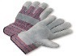  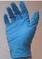  Gloves | 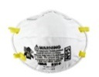  Disposable N95 Masks | Ear plugs | Closed-toe shoes | Slip-resistant  Overboots | 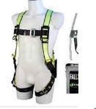  Fall protection
Cleaning floors, Cleaning bathrooms, Cleaning classrooms
Cleaning science labs, custodian does not handle open containers of science chemicals
Cleaning blood spills, vomit, feces, or urine |  |  | Disposable | as needed for odor
Mix cleaning products in janitor closet
Floor machine |  |  | as needed
Bring trash to dumpster |  |  | as needed
Move furniture |  |  | as needed
Task | Safety glasses | Goggles | Gloves | Disposable N95 Masks | Ear plugs | Closed-toe shoes | Slip-resistant  Overboots | Fall protection
Floor stripping with a product that has a corrosive pH |  |  | Nitrile or neoprene
Floor treatment with a product that is neutral pH
Change light bulbs, ceiling tiles
Pickup syringes left in fields, playgrounds, etc. |  |  | Puncture resistant
Lawn mowing, weed whacking, snow blowing, poison ivy and weed removal, wasp nest removal |  |  | Work gloves  as needed
Table saws, chain saws, woodchipper, and other power equipment |  |  | Work gloves  as needed
Going onto roof |  |  | Work gloves as needed |  |  |  |  | Harness, railing, or perimeter

