Massachusetts Department of Public Health
Bureau of Infectious Disease and Laboratory Sciences
Massachusetts HIV Epidemiologic Profile: Data as of 1/1/2022
Population Report: Persons Who Inject Drugs, Accessible Version, optimized for screen reader use
Please note that while the content of this report is the same as the PDF version, the format and pagination have been modified significantly to optimize use with screen readers to ensure access for blind or visually impaired audiences.
Suggested citation:
Massachusetts Department of Public Health, Bureau of Infectious Disease and Laboratory Sciences. Massachusetts HIV Epidemiologic Profile: Data as of 1/1/2022, Population Report: Persons Who Inject Drugs, https://www.mass.gov/lists/hivaids-epidemiologic-profiles Published April 2023. Accessed [date].
Bureau of Infectious Disease and Laboratory Sciences
Massachusetts Department of Public Health
Jamaica Plain Campus/State Public Health Laboratory
305 South Street
Jamaica Plain, MA 02130
Questions about this report
Tel: (617) 983-6560
To reach the Reporting and Partner Services Line
Tel: (617) 983-6999
To speak to the on-call epidemiologist
Tel: (617) 983-6800
Questions about infectious disease reporting
Tel: (617) 983-6801
Requests for additional data
https://www.mass.gov/lists/infectious-disease-data-reports-and-requests
Slide sets for HIV Epidemiologic Profile Reports
https://www.mass.gov/lists/hivaids-epidemiologic-profiles

OUTBREAKS AMONG persons who inject drugs (PWID)
An outbreak of HIV infection was identified in the northeastern cities of Lawrence and Lowell among PWID, involving 129 individuals diagnosed with HIV infection during January 1, 2015–June 30, 2018. Following an intensive and targeted public health response, the number of HIV infection diagnoses attributed to injection drug use (IDU) in the Northeast Health Service Region (HSR) of Massachusetts has decreased. However, in early 2019, a new cluster of HIV infection was identified in Boston among PWID who are experiencing or have experienced recent homelessness, renewing concerns about ongoing transmission among PWID statewide. As of December 31, 2021, a total of 164 cases diagnosed since November 2018 have been investigated and identified as part of the Boston cluster. As it is an active cluster of concern, additional cases will continue to be investigated and added. Emerging trends among those newly diagnosed in the Boston cluster (N=66 cases diagnosed in 2020) include an increase in polysubstance and methamphetamine use.
PWID AT A GLANCE
N=228, 14% of 1,635 new diagnoses from 2018–2020 were among individuals who reported IDU as their primary exposure mode
N=3,624, 16% of 23,368 persons living with HIV infection in MA as of 12/31/2020 reported IDU as their primary exposure mode
FIGURE 1. Individuals diagnosed with HIV infection by exposure mode, Massachusetts 2011–2020
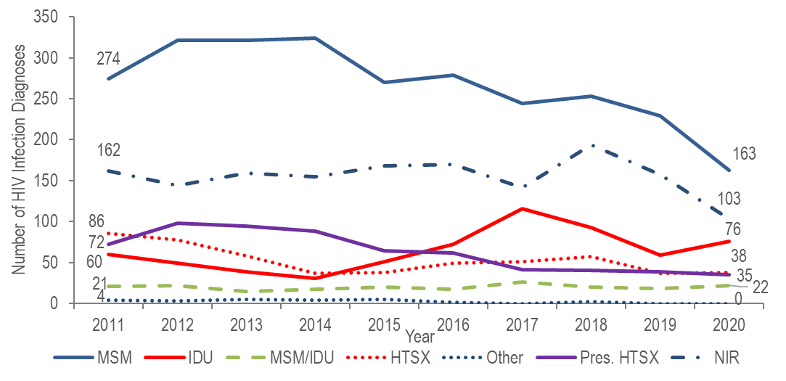
Figure 1 note: MSM=male-to-male sex; IDU=injection drug use; HTSX=heterosexual sex; Pres. HTSX=presumed heterosexual exposure, includes individuals assigned female at birth with a negative history of injection drug use who report having sex with an individual that identifies as male of unknown HIV status and risk; NIR=no identified risk

KEY FINDING
- After declining by 48% from 2011 (N=60) to 2014 (N=31), the number of reported cases with IDU as the primary exposure mode peaked at 116 in 2017, decreased to 59 in 2019, and then increased again to 76 in 2020.
FIGURE 2. Deaths among individuals reported with HIV by exposure mode, Massachusetts 2020 (N=314)
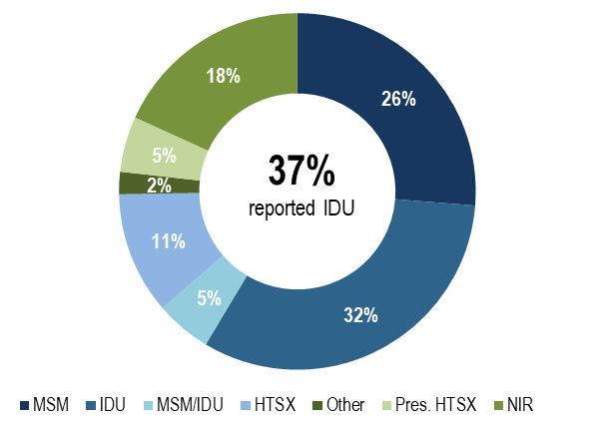
KEY FINDING
- Individuals with IDU exposure mode accounted for the largest proportion of deaths among individuals reported with HIV. In 2020, 32% of deaths among individuals with HIV were among individuals who reported IDU as their mode of exposure and an additional 5% who reported MSM/IDU as their mode of exposure, compared to 17% and 5%, respectively, of 2020 HIV infection diagnoses.

RACE/ETHNICITY
- Sixty-eight percent of 228 individuals diagnosed with HIV infection attributed to IDU during 2018–2020 were white (non-Hispanic), 20% were Hispanic/Latino, 11% were black (non-Hispanic), and 1% were of other or unknown race/ethnicity.
- Among 3,624 persons living with HIV infection on 12/31/2020 that was attributed to IDU, 41% were Hispanic/Latino, 36% were white (non-Hispanic), 21% were black (non-Hispanic), and 2% were of other or unknown race/ethnicity.
FIGURE 3. Number of individuals diagnosed with HIV infection with IDU exposure mode by race/ethnicity and year of diagnosis, Massachusetts 2011–2020

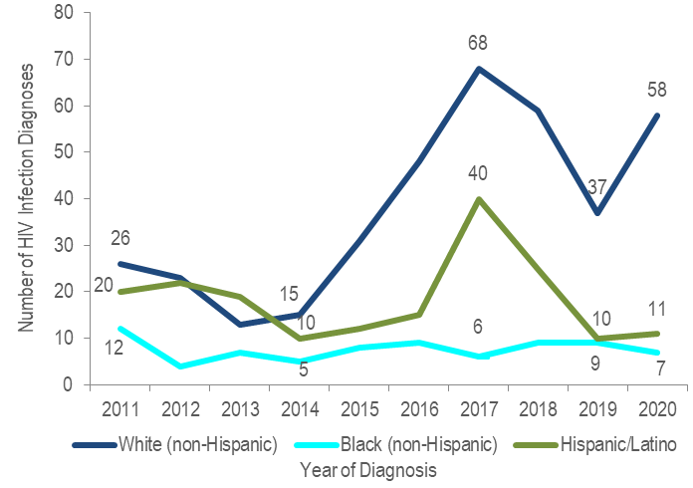

KEY FINDING
- The number of HIV infection diagnoses with IDU exposure mode among white (non-Hispanic) individuals quadrupled from 2014 to 2017, decreased by 46% in 2019 and then increased by 57% in 2020. The number of HIV infection diagnoses with IDU exposure mode among Hispanic/Latino individuals quadrupled from 2014 to 2017, decreased by 75% in 2019 and then remained relatively stable through 2020. The number of HIV infection diagnoses with IDU exposure mode among black (non-Hispanic) individuals remained relatively stable from 2014 to 2020.

SEX ASSIGNED AT BIRTH
- Sixty-one percent of 228 individuals diagnosed with HIV infection attributed to IDU during 2018 to 2020 were assigned male at birth (AMAB) and 39% were assigned female at birth (AFAB).
- Similarly, 65% of 3,624 persons living with HIV infection on 12/31/2020 that was attributed to IDU were AMAB and 35% were AFAB.
FIGURE 4. HIV diagnoses among individuals with IDU exposure mode by sex assigned at birth, Massachusetts 2011–2020
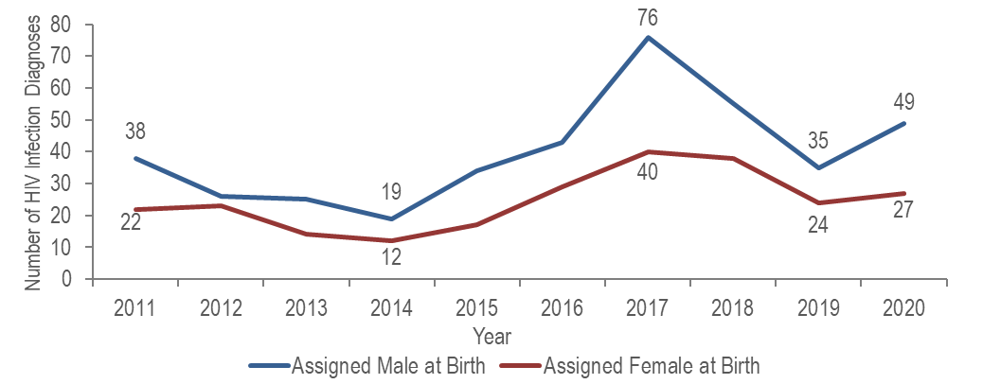
- The number of HIV infection diagnoses with IDU exposure mode among individuals AMAB quadrupled from 2014 to 2017, decreased by 54% in 2019, and then increased by 40% in 2020. The number of diagnoses with IDU exposure mode among individuals AFAB more than tripled from 2014 to 2017, decreased by 40% in 2019, and then increased by 13% in 2020.

SEX ASSIGNED AT BIRTH BY RACE/ETHNICITY
FIGURE 5. Individuals AMAB and diagnosed with HIV infection with IDU exposure mode by race/ethnicity and year of diagnosis, Massachusetts 2011–2020

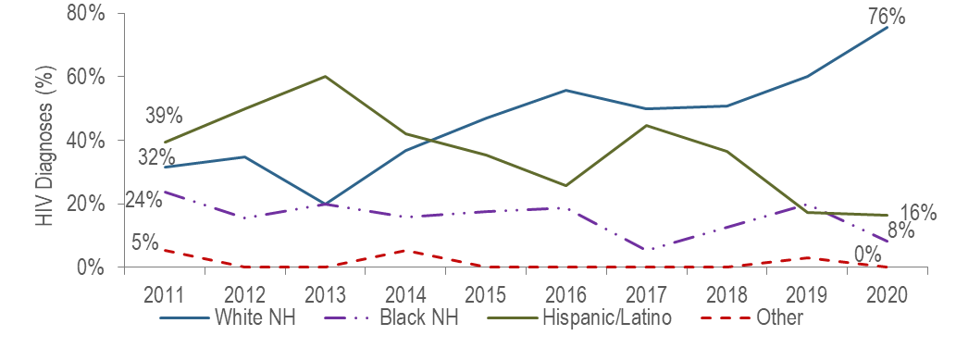
Figure 5 note: Individuals AMAB diagnosed with HIV infection with IDU exposure mode 2011–2020: N=400, NH=non-Hispanic
- From 2011 to 2020, the proportion of individuals AMAB diagnosed with HIV infection with IDU exposure mode who identified as white (non-Hispanic) increased from 32% to 76%, while the proportion who identified as Hispanic/Latino decreased from 39% to 16%, and as black (non-Hispanic) from 24% to 8%.
FIGURE 6. Individuals AFAB and diagnosed with HIV infection with IDU exposure mode by race/ethnicity and year of diagnosis, Massachusetts 2011–2020
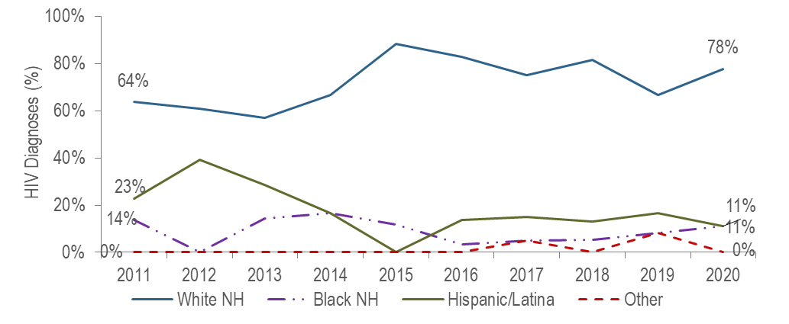
Figure 6 note: Individuals AFAB diagnosed with HIV infection with IDU exposure mode 2011–2020: N=246, NH=non-Hispanic
- From 2011 to 2020, the proportion of individuals AFAB diagnosed with HIV infection with IDU exposure mode who identified as white (non-Hispanic) increased from 64% to 78%, while the proportion who identified as Hispanic/Latina decreased from 23% to 11%.
FIGURE 7. Percentage distribution of individuals diagnosed with HIV infection with IDU exposure mode by sex assigned at birth and race/ethnicity, Massachusetts 2018–2020
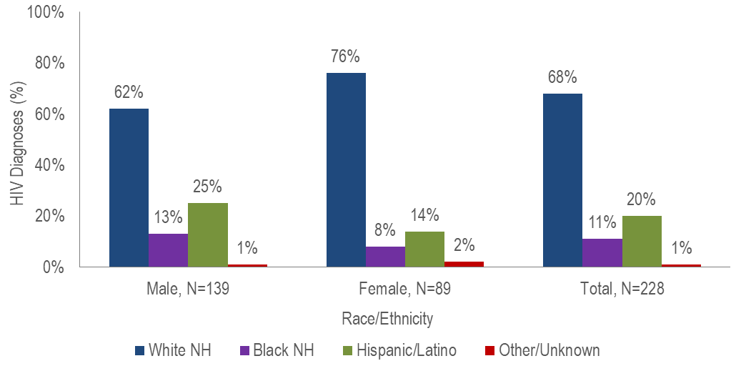
- Seventy-six percent of individuals AFAB diagnosed with HIV infection with IDU exposure mode during 2018 to 2020 were white (non-Hispanic), 14% were Hispanic/Latina, and 8% were black (non-Hispanic), compared to 62%, 25%, and 13% of individuals AMAB, respectively.

AGE
FIGURE 8. HIV diagnoses among individuals with IDU exposure mode by age at diagnosis, Massachusetts 2011–2020 (N=646)
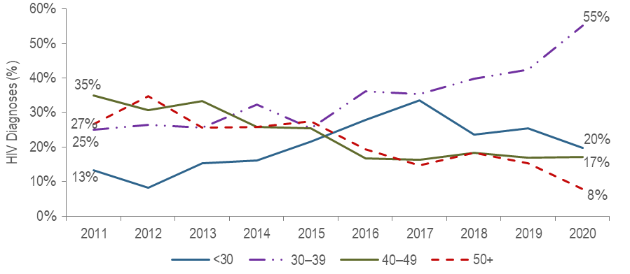
- The percentage of HIV infection diagnoses with IDU exposure mode among individuals under 30 years of age increased from 13% in 2011 to 34% in 2017 and then decreased to 20% in 2020.
- The percentage of HIV infection diagnoses with IDU exposure mode among individuals 30–39 years of age increased from 25% in 2011 to 55% in 2020. It has been the largest percentage for the past five years (2016 to 2020).

AREA OF RESIDENCE
TABLE 1. Massachusetts cities/towns with the highest percentage of HIV diagnoses attributed to IDU, 2018–2020
 | HIV Diagnoses Attributed to IDU (N) | HIV Diagnoses Attributed to IDU as Percent of Total HIV Diagnoses in City/Town (%)
Massachusetts Total | 228 | 14%
Top Cities/Towns
Lowell | 21 | 32%
Lawrence | 14 | 27%
New Bedford | 6 | 21%
Boston | 70 | 19%
Brockton | 10 | 12%
Worcester | 11 | 12%
All Other Cities/Towns | 96 | 10%

- Among areas with at least five individuals diagnosed with HIV infection attributed to IDU and at least 20 total HIV diagnoses during 2018 to 2020, Lowell and Lawrence had the highest percentages at 32% and 27%, respectively. Both cities were involved in an outbreak of HIV infection among PWID in the northeastern part of the state from 2015 through 2018.

INFORMATION FROM ADDITIONAL DATA SOURCES
Opioid Statistics
Opioids include heroin, opioid-based prescription painkillers, and other unspecified opioids that may or may not be injected.
Opioid-Related Overdose Deaths
- After reaching a 20-year high of 2,102 in 2016, the number of confirmed and estimated opioid-related overdose deaths in Massachusetts remained relatively stable through 2020, when there were an estimated 2,104 deaths. The opioid-related overdose death rate also remained relatively stable during this time period and was 30.2 per 100,000 in 2020.
- The percentage of confirmed opioid-related overdose deaths with fentanyl present increased from 42% in 2014 to 92% in 2020.
Data Source: MDPH Registry of Vital Records and Statistics, Data Brief: Opioid-Related Overdose Deaths Among Massachusetts Residents, Posted: May 2021, available at https://www.mass.gov/lists/current-opioid-statistics
Emergency Medical Services (EMS) Data:
- The percentage of EMS incidents that were considered opioid-related increased on average 14% biannually from 2013 until mid-2016 and then began decreasing 2% bi-annually through the end of 2020. The number of all EMS incidents involving naloxone administration increased on average 17% biannually from 2013 until mid-2016 and then began decreasing 1% bi-annually through the end of 2020. In 2020, the greatest number of suspected opioid-related incidents treated by EMS continued to be among individuals AMAB aged 25-34 years, accounting for 22% of opioid-related incidents with a known age and sex.
Data Source: MDPH Bureau of Health Care Safety and Quality, MA Opioid-Related EMS Incidents 2013-2020, Posted: May 2021, available at https://www.mass.gov/lists/current-opioid-statistics

MDPH Services Provided to Individuals Who Inject Drugs:
Syringe Services Program (SSP) Participants
- Among 936 clients who received HIV testing at state-funded SSPs in 2020:
  - 64% were men, 35% were women, and 1% were transgender or another gender;
  - 13% were aged 18–24 years, 33% were 25–34 years, 32% were 35–44 years, 17% were 45–54 years, 7% were 55–64 years, 3% were 65 years and older, and 1% were of unknown age;
  - 61% were white (non-Hispanic), 23% were Hispanic/Latino, 12% were black (non-Hispanic), 2% were other or more than one race/ethnicity, and 2% were of unknown race/ethnicity.
Data Source: MDPH, BIDLS, Office of Health Care Planning; data as of 10/11/2021. Please note: the total number of clients is less than previous years due to impact of COVID-19.
Substance Use Disorder Treatment Admissions
- The percentage of clients admitted to state-licensed substance use disorder treatment programs reporting the use of a needle to inject drugs within a year of admission increased from 42% (N=43,123/102,573) in state fiscal year 2012 to 50% (N=53,052/105,632) in state fiscal year 2014, and then decreased to 41% (N=32,890/79,846) in state fiscal year 2021.
- The percentage of admissions to state-licensed substance use disorder treatment programs for heroin use treatment increased from 43% (N=44,277/102,555) of total admissions in state fiscal year 2012 to 54% (53,413/98,094) in state fiscal year 2016, and then decreased to 48% (N=38,037/80,070) in state fiscal year 2021.
- Seventy-eight percent of individuals admitted to state-funded substance use disorder treatment programs in fiscal year 2021 who reported needle use within the past year were unemployed (N=8,554/10,974), compared to 55% of those admitted who did not report needle use (N=10,886/19,965); 45% (N=10,690/23,566) were homeless, compared to 27% (N=9,748/36,267) of those who did not report needle use.
Note: Total number of admissions excludes missing/unknown values for each variable and therefore differs depending on the variable. Please note: the total number of clients is less than previous years due to the impact of COVID-19.
Data Source: MDPH, Bureau of Substance Addiction Services, Office of Statistics and Evaluation, Data are current as of 11/7/2022 and may be subject to change; Based on EISM submissions through: 9/30/2022

Providers may use this number to report individuals newly diagnosed with a notifiable sexually transmitted infection, including HIV, or request partner services. Partner services is a free and confidential service for individuals recently diagnosed with a priority infection. The client-centered program offers counseling, linkage to other health and social services, anonymous notification of partners who were exposed, and assistance with getting testing and treatment. For more information, see: https://www.mass.gov/service-details/partner-services-program-information-for-healthcare-providers)
For more information, see: Charles Alpren et al. “Opioid Use Fueling HIV Transmission in an Urban Setting: An Outbreak of HIV Infection Among People Who Inject Drugs—Massachusetts, 2015–2018”, American Journal of Public Health 110, no. 1 (January 1, 2020): pp. 37-44. https://doi.org/10.2105/AJPH.2019.305366
Please consider the impact of the COVID-19 pandemic on infectious disease screening, treatment, and surveillance in the interpretation of 2020 and 2021 data.
For more information, see: Joint MDPH and BPHC Clinical Advisory: Increase in newly diagnosed HIV infections among persons who inject drugs in Boston, March 15, 2021, available at: https://www.mass.gov/doc/joint-mdph-and-bphc-clinical-advisory-hiv-transmission-through-injection-drug-use-in-boston-march-15-2021/download
Please consider the impact of the COVID-19 pandemic on infectious disease screening, treatment, and surveillance in the interpretation of 2020 data
Please consider the impact of the COVID-19 pandemic on infectious disease screening, treatment, and surveillance in the interpretation of 2020 data
Please consider the impact of the COVID-19 pandemic on infectious disease screening, treatment, and surveillance in the interpretation of 2020 data
Please consider the impact of the COVID-19 pandemic on infectious disease screening, treatment, and surveillance in the interpretation of 2020 data
Please consider the impact of the COVID-19 pandemic on infectious disease screening, treatment, and surveillance in the interpretation of 2020 data
Please consider the impact of the COVID-19 pandemic on infectious disease screening, treatment, and surveillance in the interpretation of 2020 data
City/town is based on residence at HIV infection diagnosis
All Other Cities/Towns includes individuals diagnosed in a correctional facility
Please consider the impact of the COVID-19 pandemic on infectious disease screening, treatment, and surveillance in the interpretation of 2020 data

