Massachusetts Department of Public Health
Bureau of Infectious Disease and Laboratory Sciences
Massachusetts HIV Epidemiologic Profile: Data as of 7/1/2024
Population Report: Persons Who Inject Drugs, Accessible Version, optimized for screen reader use
Please note that while the content of this report is the same as the PDF version, the format and pagination have been modified significantly to optimize use with screen readers to ensure access for audiences who are blind or visually impaired.
Suggested citation:
Massachusetts Department of Public Health, Bureau of Infectious Disease and Laboratory Sciences. Massachusetts HIV Epidemiologic Profile: Data as of 7/1/2024, Population Report: Persons Who Inject Drugs, https://www.mass.gov/lists/hivaids-epidemiologic-profiles Published June 2025. Accessed [date].
Bureau of Infectious Disease and Laboratory Sciences
Massachusetts Department of Public Health
Jamaica Plain Campus/State Public Health Laboratory
305 South Street
Jamaica Plain, MA 02130
Questions about this report
Tel: (617) 983-6560
To reach the Reporting and Partner Services Line
Tel: (617) 983-6999
To speak to the on-call epidemiologist
Tel: (617) 983-6800
Questions about infectious disease reporting
Tel: (617) 983-6801
HIV Data Dashboard
https://www.mass.gov/info-details/hiv-data-dashboard
Requests for additional data
https://www.mass.gov/lists/infectious-disease-data-reports-and-requests
Slide sets for HIV Epidemiologic Profile Reports
https://www.mass.gov/lists/hivaids-epidemiologic-profiles
HIV INCIDENCE AND PREVALENCE AMONG PWID
N=164, 11% of 1,435 new diagnoses from 2021–2023 were among individuals who reported IDU as their primary exposure mode
N=3,375, 14% of 24,119 persons living with HIV infection in MA as of 12/31/2023 reported IDU as their primary exposure mode
FIGURE 1. Individuals diagnosed with HIV infection by exposure mode, Massachusetts 2014–2023
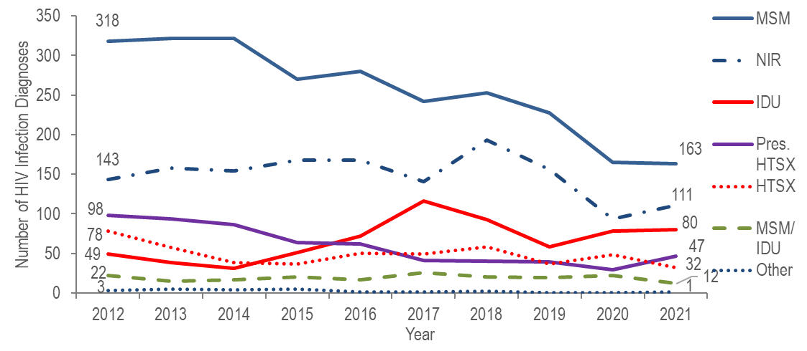
Figure 1 note: MSM=male-to-male sex; IDU=injection drug use; HTSX=heterosexual sex; Pres. HTSX=presumed heterosexual exposure, includes individuals assigned female at birth with a negative history of injection drug use who report having sex with an individual that identifies as male of unknown HIV status and risk; NIR=no identified risk

OUTBREAKS AMONG persons who inject drugs (PWID)
- The number of reported cases with injection drug use (IDU) as the primary exposure mode increased from a low of 31 in 2014 to a peak of 116 in 2017, and then decreased to 59 in 2019. The increase in 2017 was primarily due to an outbreak among persons who inject drugs (PWID) in the northeast part of the state between 2016 and 2018. Following a focused public health response, the number of HIV infection diagnoses attributed to IDU in the northeast has decreased. However, in early 2019, a new cluster of HIV infection was identified in Boston among PWID who were experiencing or had experienced recent homelessness, and the total statewide number of reported cases with IDU as the primary exposure increased to 82 in 2021. Following another focused public health response, the number of HIV infection diagnoses attributed to IDU decreased by 54% to 38 cases in 2023.
- As of July 1, 2024, a total of 213 cases diagnosed since November 2018 have been investigated and identified as part of the Boston cluster. As it is an active cluster of concern, additional cases will continue to be investigated and added. Emerging trends among those newly diagnosed in the Boston cluster (N=15 cases diagnosed in 2023) include an increase in polysubstance and methamphetamine use.
FIGURE 2. Deaths among individuals reported with HIV by exposure mode, Massachusetts 2023 (N=307)
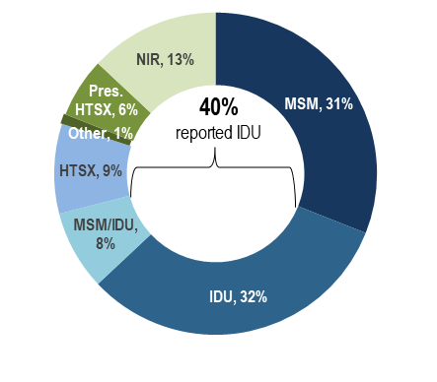
KEY FINDING

Individuals with IDU exposure mode accounted for the largest proportion of deaths among individuals reported with HIV. In 2023, 32% of deaths among individuals with HIV were reported with an exposure mode of IDU and an additional 8% were reported with an exposure mode of MSM/IDU, compared to 7% and 3%, respectively, of 2023 HIV infection diagnoses. The leading causes of death among individuals reported with HIV infection with IDU and IDU/MSM exposure mode who died in 2022 (with a known cause) were external causes of injuries and poisonings (which includes opioid overdoses) which accounted for 36% (N=53/147) of deaths, HIV which accounted for 16% (N=23/147) of deaths, cancer which accounted for 11% (N=16/147) of deaths, and heart disease which accounted for 8% (N=12/147) (final cause of death is not yet available for all 2023 deaths among individuals with HIV as of 7/1/2024).

RACE/ETHNICITY
- Sixty-eight percent of 164 individuals diagnosed with HIV infection attributed to IDU during 2021–2023 were White (non-Hispanic), 18% were Hispanic/Latinx, 10% were Black (non-Hispanic), and 4% were of other or unknown race/ethnicity.
- Among 3,375 persons living with HIV infection on 12/31/2023 that was attributed to IDU, 41% were Hispanic/Latinx, 37% were White (non-Hispanic), 20% were Black (non-Hispanic), and 2% were of other or unknown race/ethnicity.
FIGURE 3. Number of individuals diagnosed with HIV infection with IDU exposure mode by race/ethnicity and year of diagnosis, Massachusetts 2014–2023
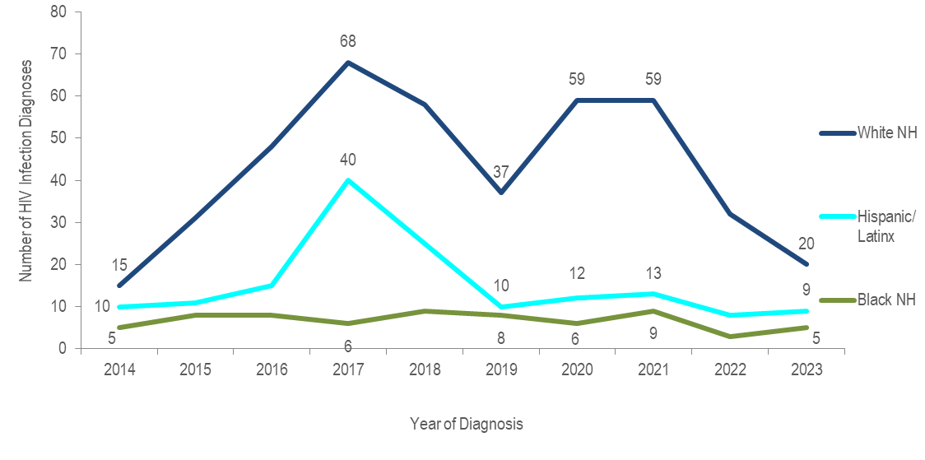
KEY FINDING
- The number of HIV infection diagnoses with IDU exposure mode among White (non-Hispanic) individuals quadrupled from 2014 to 2017, decreased by 46% in 2019, increased by 59% in 2021, and then decreased by 66% in 2023. The number of HIV infection diagnoses with IDU exposure mode among Hispanic/Latinx individuals quadrupled from 2014 to 2017, decreased by 75% in 2019 and then remained relatively stable through 2023. The outbreak of HIV infection in the northeastern cities of Lawrence and Lowell among PWID may have contributed to the increase and subsequent decrease among Hispanic/Latinx individuals. The number of HIV infection diagnoses with IDU exposure mode among Black (non-Hispanic) individuals remained relatively stable from 2014 to 2023.

SEX ASSIGNED AT BIRTH
- Sixty-eight percent of 164 individuals diagnosed with HIV infection attributed to IDU during 2021 to 2023 were assigned male at birth (AMAB) and 32% were assigned female at birth (AFAB).
- Similarly, 64% of 3,375 persons living with HIV infection on 12/31/2023 that was attributed to IDU were AMAB and 36% were AFAB.

TRANSGENDER INDIVIDUALS AND INJECTION DRUG USE
- Less than five of 18 individuals diagnosed with HIV infection from 2021 to 2023 and reported to be transgender had an exposure mode of sex with men and injection drug use, none had injection drug use exposure mode alone.
- Eleven percent (N=14/128) of persons living with HIV infection on 12/31/2023 and reported to be transgender had an exposure mode of sex with men and injection drug use, none had injection drug use exposure mode alone.
FIGURE 4. HIV diagnoses among individuals with IDU exposure mode by sex assigned at birth, Massachusetts 2014–2023
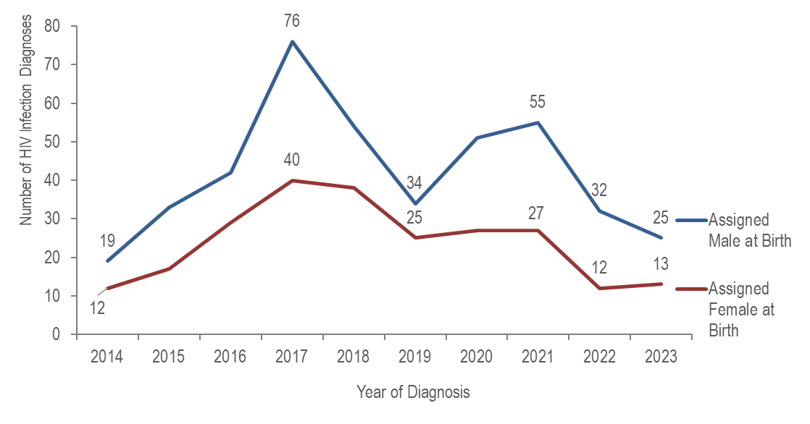
- The number of HIV infection diagnoses with IDU exposure mode among individuals AMAB quadrupled from 2014 to 2017, decreased by 55% in 2019, increased by 62% in 2021, and decreased by 55% in 2023. The number of diagnoses with IDU exposure mode among individuals AFAB more than tripled from 2014 to 2017, decreased by 38% in 2019, remained relatively stable through 2021, and then decreased by 52% in 2023.

SEX ASSIGNED AT BIRTH BY RACE/ETHNICITY
FIGURE 5. Individuals AMAB and diagnosed with HIV infection with IDU exposure mode by race/ethnicity and year of diagnosis, Massachusetts 2014–2023
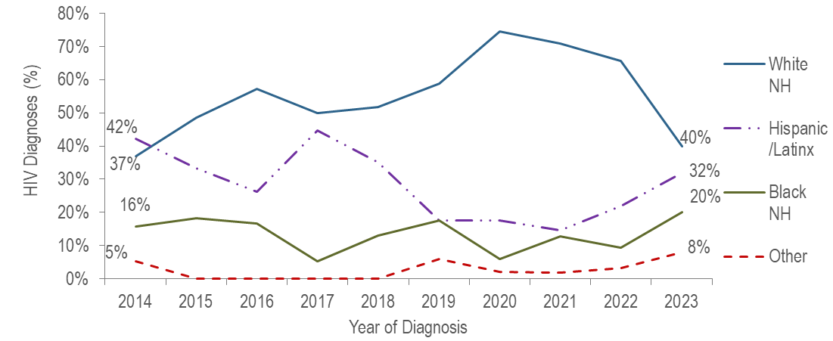
Figure 5 note: Individuals AMAB N=421, NH=non-Hispanic
- From 2014 to 2020, the proportion of individuals AMAB diagnosed with HIV infection with IDU exposure mode who identified as White (non-Hispanic) increased from 37% to 75%, while the proportion who identified as Hispanic/Latinx decreased from 42% to 18%, and as Black (non-Hispanic) from 16% to 6%. In 2023, the proportion among White individuals decreased to 40%, while the proportion among Hispanic/Latinx and Black (non-Hispanic) individuals increased to 32% and 20%, respectively.
FIGURE 6. Individuals AFAB and diagnosed with HIV infection with IDU exposure mode by race/ethnicity and year of diagnosis, Massachusetts 2014–2023
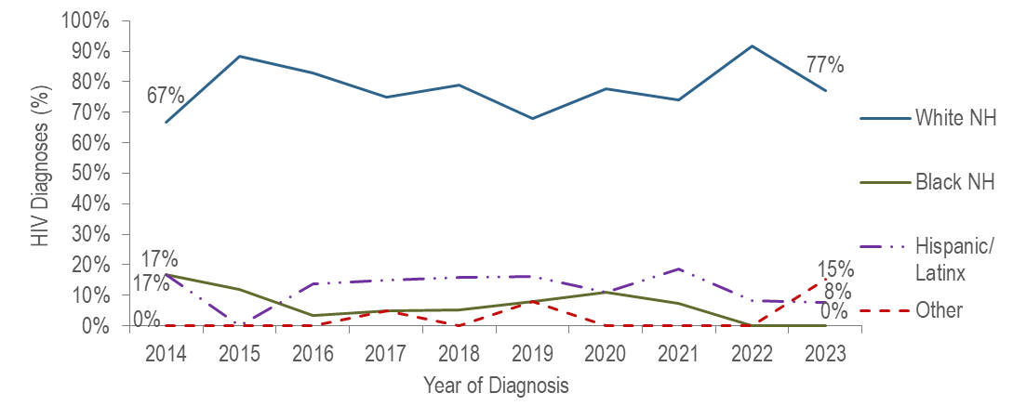
Figure 6 note: Individuals AFAB N=240, NH=non-Hispanic
- Each year from 2014 to 2023, the majority of individuals AFAB diagnosed with HIV infection with IDU exposure mode have been White (non-Hispanic).
FIGURE 7. Percentage distribution of individuals diagnosed with HIV infection with IDU exposure mode by sex assigned at birth and race/ethnicity, Massachusetts 2021–2023
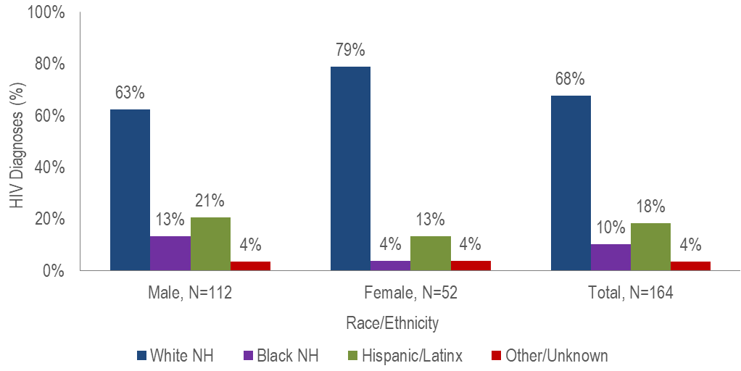
- A larger percentage of individuals AFAB (79%) than individuals AMAB (63%) diagnosed with HIV infection during 2021 to 2023 with IDU exposure mode was White (non-Hispanic).

AGE
FIGURE 8. HIV diagnoses among individuals with IDU exposure mode by age at diagnosis, Massachusetts 2014–2023 (N=661)
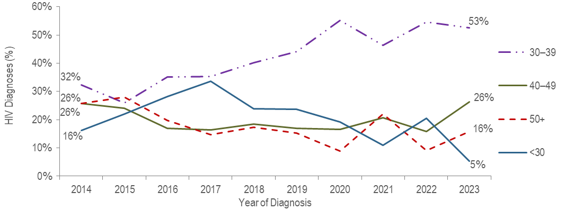
- The percentage of HIV infection diagnoses with IDU exposure mode among individuals under 30 years of age increased from 16% in 2014 to 34% in 2017 and then decreased to 5% in 2023.
- The percentage of HIV infection diagnoses with IDU exposure mode among individuals 30–39 years of age increased from 32% in 2014 to 53% in 2023.

PLACE OF RESIDENCE
TABLE 1. Massachusetts cities/towns with the highest percentage of HIV diagnoses attributed to IDU, 2021–2023
 | HIV Diagnoses Attributed to IDU (N) | HIV Diagnoses Attributed to IDU as Percent of Total HIV Diagnoses in City/Town (%)
Massachusetts Total | 164 | 11%
Top Cities/Towns
Boston | 60 | 17%
Worcester | 12 | 17%
Brockton | 5 | 7%
All Other Cities/Towns | 87 | 9%

- Among cities/towns with at least 20 total HIV diagnoses during 2021 to 2023, only three had at least five diagnoses attributed to IDU: Boston, Worcester, and Brockton. Boston and Worcester had the highest percentage of cases attributed to IDU, both at 17%. Boston has been involved in an active cluster of concern among PWID who are experiencing or have experienced recent homelessness since November 2018.

INFORMATION FROM ADDITIONAL DATA SOURCES
Opioid Statistics
Use of opioids and other substances is associated with transmission of HIV and other sexually transmitted diseases. Injection drug use (IDU) can be a direct route of HIV transmission if people share needles, syringes, or other injection materials that are contaminated with HIV. Ingesting, smoking, or inhaling drugs is also associated with increased risk for HIV. These substances alter judgment, which can lead to sexual behaviors that can make people more likely to get and transmit HIV (e.g., having sex without a condom, having multiple partners, etc.). Among people with HIV, substance use is associated with more rapid disease progression, barriers to accessing and receiving HIV care and treatment, lower adherence to antiretroviral therapy, and worse clinical outcomes. As such, opioid statistics and trends can inform understanding of rates of injection drug use and HIV transmission.
Opioids include heroin, opioid-based prescription painkillers, and other unspecified opioids that may or may not be injected.
Opioid-Related Overdose Deaths
  - In 2023, there were 2,104 confirmed opioid-related deaths, and DPH estimates that there will be an additional 13 to 32 deaths, yielding approximately 2,125 confirmed and estimated opioid-related overdose deaths. In 2023, there were 232 fewer confirmed and estimated deaths than 2022, marking the largest year-to-year decrease in the past 20 years. The opioid-related overdose death rate also decreased during this time period from 33.5 per 100,000 in 2022 to 30.2 per 100,000 in 2023, which is a statistically significant decline.
  - In 2023, there were 1,971 opioid-related overdose deaths where a toxicology screen was also available. Among these deaths, fentanyl was present in 90%, cocaine in 54%, benzodiazepines in 25%, amphetamines in 11%, xylazine in 9%, prescription opioids in 7%, and heroin in 5%.
Data Source: MDPH Registry of Vital Records and Statistics, Data Brief: Opioid-Related Overdose Deaths Among Massachusetts Residents, Posted: June 2024, available at https://www.mass.gov/lists/current-opioid-statistics
Emergency Medical Services (EMS) Data:
- Between 2018 and 2023, the total number of suspected opioid-related incidents has been slowly decreasing. However, the percentage of these incidents that are in the most severe categories (dead on arrival and acute overdose) has been increasing each year. In 2018, 54.6% of all opioid related incidents were acute opioid overdoses and 1.2% were dead on arrival of an opioid overdose; by 2023, 58.7% of all opioid related incidents were acute opioid overdoses and 1.7% were dead on arrival of an opioid overdose. In 2023, the greatest number of suspected opioid-related incidents treated by EMS was among individuals AMAB aged 35-44, accounting for 20.4% of opioid-related incidents with a known age and sex.
Data Source: MDPH Bureau of Health Care Safety and Quality, MA Opioid-Related EMS Incidents 2018-2023, Posted: June 2024, available at https://www.mass.gov/lists/current-opioid-statistics
MDPH Services Provided to Individuals Who Inject Drugs:
MDPH service data are presented to assess the numbers and demographics of clients who inject drugs and receive services through funded programs. This information is an important part of data-driven programmatic decision making and can also offer insight into rates of injection drug use among a subset of the Massachusetts population that accesses funded services.
Syringe Services Program (SSP) Participants

  - Among 3,108 clients who received HIV testing at state-funded SSPs in 2023:
    - 62% were men, 34% were women, and 4% were transgender or another gender;
    - 12% were aged 18–24 years, 29% were 25–34 years, 29% were 35–44 years, 17% were 45–54 years, 11% were 55–64 years, 3% were 65 years and older, and <1% were of unknown age;
    - 51% were White (non-Hispanic), 26% were Hispanic/Latinx, 15% were Black (non-Hispanic), 3% were Asian (non-Hispanic), 2% were other or more than one race/ethnicity, and 3% were of unknown race/ethnicity.

Data Source: MDPH, BIDLS, Office of Health Care Planning; data as of 10/29/2024.

Substance Use Disorder Treatment Admissions
- The percentage of clients admitted to state-licensed substance use disorder treatment programs reporting the use of a needle to inject drugs within a year of admission decreased from 50% (N=53,052/105,632) in state fiscal year 2014 to 31% (N=25,108/80,028) in state fiscal year 2023.
- The percentage of admissions to state-licensed substance use disorder treatment programs for heroin use treatment decreased from 53% (N=56,163/105,626) of total admissions in state fiscal year 2014 to 24% (N=19,942/82,995) in state fiscal year 2023.
- Sixty-nine percent of individuals admitted to state-funded substance use disorder treatment programs in fiscal year 2023 who reported needle use within the past year were unemployed (N=6,064/8,840), compared to 46% of those admitted who did not report needle use (N=11,313/24,781); 48% (N=8,576/18,037) were homeless, compared to 27% (N=11,263/42,075) of those who did not report needle use.
Note: Total number of admissions excludes missing/unknown values for each variable and therefore differs depending on the variable.
Data Source: MDPH, Bureau of Substance Addiction Services, Office of Statistics and Evaluation, Data are current as of 10/10/2024 and may be subject to change; Based on EISM submissions through: 8/31/2024
HIV Surveillance Data Source: MDPH Bureau of Infectious Disease and Laboratory Sciences, data are current as of 7/1/2024 and may be subject to change

Providers may use this number to report individuals newly diagnosed with a notifiable sexually transmitted infection, including HIV, or request partner services. Partner services is a free and confidential service for individuals recently diagnosed with a priority infection. The client-centered program offers counseling, linkage to other health and social services, anonymous notification of partners who were exposed and assistance with getting testing and treatment. For more information, see: https://www.mass.gov/service-details/partner-services-program-information-for-healthcare-providers)
Please consider the impact of the COVID-19 pandemic on infectious disease screening, treatment, and surveillance in the interpretation of data from 2020 to 2023
For more information, see: Charles Alpren et al. “Opioid Use Fueling HIV Transmission in an Urban Setting: An Outbreak of HIV Infection Among People Who Inject Drugs—Massachusetts, 2015–2018”, American Journal of Public Health 110, no. 1 (January 1, 2020): pp. 37-44. https://doi.org/10.2105/AJPH.2019.305366
Please consider the impact of the COVID-19 pandemic on infectious disease screening, treatment, and surveillance in the interpretation of data from 2020 to 2023
For more information, see: Joint MDPH and BPHC Clinical Advisory: Increase in newly diagnosed HIV infections among persons who inject drugs in Boston, March 15, 2021, available at: https://www.mass.gov/doc/joint-mdph-and-bphc-clinical-advisory-hiv-transmission-through-injection-drug-use-in-boston-march-15-2021/download
Please consider the impact of the COVID-19 pandemic on infectious disease screening, treatment, and surveillance in the interpretation of data from 2020 to 2023
Please consider the impact of the COVID-19 pandemic on infectious disease screening, treatment, and surveillance in the interpretation of data from 2020 to 2023
Please consider the impact of the COVID-19 pandemic on infectious disease screening, treatment, and surveillance in the interpretation of data from 2020 to 2023
Please consider the impact of the COVID-19 pandemic on infectious disease screening, treatment, and surveillance in the interpretation of data from 2020 to 2023
Please consider the impact of the COVID-19 pandemic on infectious disease screening, treatment, and surveillance in the interpretation of data from 2020 to 2023
City/town is based on residence at HIV infection diagnosis
Among cities/towns with at least 20 total HIV diagnoses and at least five HIV diagnoses attributed to IDU
All Other Cities/Towns includes individuals diagnosed in a correctional facility
Centers for Disease Control and Prevention and Health Resources and Services Administration. Integrated Guidance for Developing Epidemiologic Profiles: HIV Prevention and Ryan White HIV/AIDS Program Planning. Atlanta, Georgia: Centers for Disease Control and Prevention; 2022. The guidance is available at http://www.cdc.gov/hiv/guidelines/ and at http://hab.hrsa.gov/

