Massachusetts Department of Public Health
Bureau of Infectious Disease and Laboratory Sciences
Massachusetts HIV Epidemiologic Profile: Data as of 1/1/2023
Population Report: Persons Who Inject Drugs, Accessible Version, optimized for screen reader use
Please note that while the content of this report is the same as the PDF version, the format and pagination have been modified significantly to optimize use with screen readers to ensure access for audiences who are blind or visually impaired.
Suggested citation:
Massachusetts Department of Public Health, Bureau of Infectious Disease and Laboratory Sciences. Massachusetts HIV Epidemiologic Profile: Data as of 1/1/2023, Population Report: Persons Who Inject Drugs, https://www.mass.gov/lists/hivaids-epidemiologic-profiles Published April 2024. Accessed [date].
Bureau of Infectious Disease and Laboratory Sciences
Massachusetts Department of Public Health
Jamaica Plain Campus/State Public Health Laboratory
305 South Street
Jamaica Plain, MA 02130
Questions about this report
Tel: (617) 983-6560
To reach the Reporting and Partner Services Line
Tel: (617) 983-6999
To speak to the on-call epidemiologist
Tel: (617) 983-6800
Questions about infectious disease reporting
Tel: (617) 983-6801
HIV Data Dashboard
https://www.mass.gov/info-details/hiv-data-dashboard
Requests for additional data
https://www.mass.gov/lists/infectious-disease-data-reports-and-requests
Slide sets for HIV Epidemiologic Profile Reports
https://www.mass.gov/lists/hivaids-epidemiologic-profiles

OUTBREAKS AMONG persons who inject drugs (PWID)
An outbreak of HIV infection was identified in the northeastern cities of Lawrence and Lowell among PWID, involving 129 individuals diagnosed with HIV infection during January 1, 2015–June 30, 2018. Following a focused public health response, the number of HIV infection diagnoses attributed to injection drug use (IDU) in the Northeast Health Service Region (HSR) of Massachusetts has decreased. However, in early 2019, a new cluster of HIV infection was identified in Boston among PWID who were experiencing or have experienced recent homelessness, renewing concerns about ongoing transmissions among PWID statewide. As of December 31, 2022, a total of 188 cases diagnosed since November 2018 have been investigated and identified as part of the Boston cluster. As it is an active cluster of concern, additional cases will continue to be investigated and added. Emerging trends among those newly diagnosed in the Boston cluster (N=65 cases diagnosed in 2021) include an increase in polysubstance and methamphetamine use.
HIV INCIDENCE AND PREVALENCE AMONG PWID
N=216, 15% of 1,419 new diagnoses from 2019–2021 were among individuals who reported IDU as their primary exposure mode
N=3,550, 15% of 23,398 persons living with HIV infection in MA as of 12/31/2021 reported IDU as their primary exposure mode
FIGURE 1. Individuals diagnosed with HIV infection by exposure mode, Massachusetts 2012–2021
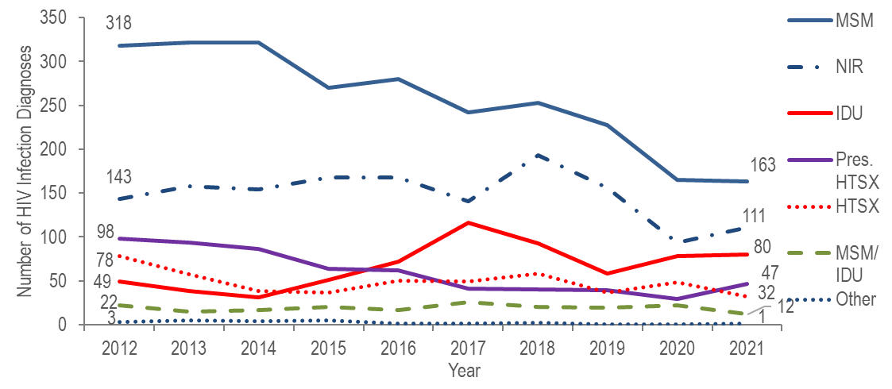
Figure 1 note: MSM=male-to-male sex; IDU=injection drug use; HTSX=heterosexual sex; Pres. HTSX=presumed heterosexual exposure, includes individuals assigned female at birth with a negative history of injection drug use who report having sex with an individual that identifies as male of unknown HIV status and risk; NIR=no identified risk

KEY FINDING
- After declining by 37% from 2012 (N=49) to 2014 (N=31), the number of reported cases with injection drug use (IDU) as the primary exposure mode peaked at 116 in 2017, decreased to 58 in 2019, and then increased again to 80 in 2021.
FIGURE 2. Deaths among individuals reported with HIV by exposure mode, Massachusetts 2021 (N=345)
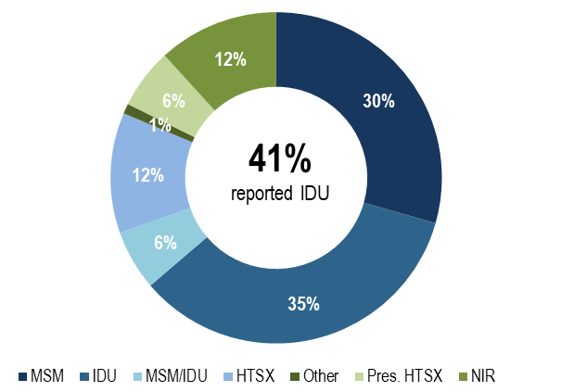
KEY FINDING
- Individuals with IDU exposure mode accounted for the largest proportion of deaths among individuals reported with HIV. In 2021, 35% of deaths among individuals with HIV were reported with an exposure mode of IDU and an additional 6% were reported with an exposure mode of MSM/IDU, compared to 18% and 3%, respectively, of 2021 HIV infection diagnoses.

RACE/ETHNICITY
- Seventy-two percent of 216 individuals diagnosed with HIV infection attributed to IDU during 2019–2021 were white (non-Hispanic), 16% were Hispanic/Latinx, 10% were black (non-Hispanic), and 2% were of other or unknown race/ethnicity.
- Among 3,550 persons living with HIV infection on 12/31/2021 that was attributed to IDU, 41% were Hispanic/Latinx, 37% were white (non-Hispanic), 21% were black (non-Hispanic), and 1% was of other or unknown race/ethnicity.
FIGURE 3. Number of individuals diagnosed with HIV infection with IDU exposure mode by race/ethnicity and year of diagnosis, Massachusetts 2012–2021
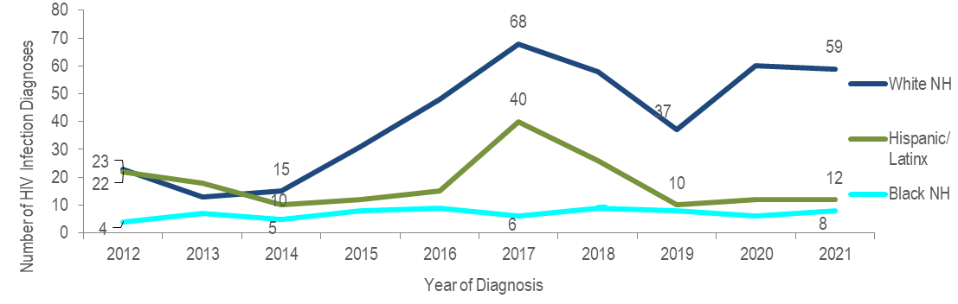
KEY FINDING
- The number of HIV infection diagnoses with IDU exposure mode among white (non-Hispanic) individuals quadrupled from 2014 to 2017, decreased by 46% in 2019 and then increased by 59% in 2021. The number of HIV infection diagnoses with IDU exposure mode among Hispanic/Latinx individuals quadrupled from 2014 to 2017, decreased by 75% in 2019 and then remained relatively stable through 2021. The outbreak of HIV infection in the northeastern cities of Lawrence and Lowell among PWID may have contributed to the increase and subsequent decrease among Hispanic/Latinx individuals. The number of HIV infection diagnoses with IDU exposure mode among black (non-Hispanic) individuals remained relatively stable from 2014 to 2021.

SEX ASSIGNED AT BIRTH
- Sixty-four percent of 216 individuals diagnosed with HIV infection attributed to IDU during 2019 to 2021 were assigned male at birth (AMAB) and 36% were assigned female at birth (AFAB).
- Similarly, 65% of 3,550 persons living with HIV infection on 12/31/2021 that was attributed to IDU were AMAB and 35% were AFAB.
FIGURE 4. HIV diagnoses among individuals with IDU exposure mode by sex assigned at birth, Massachusetts 2012–2021
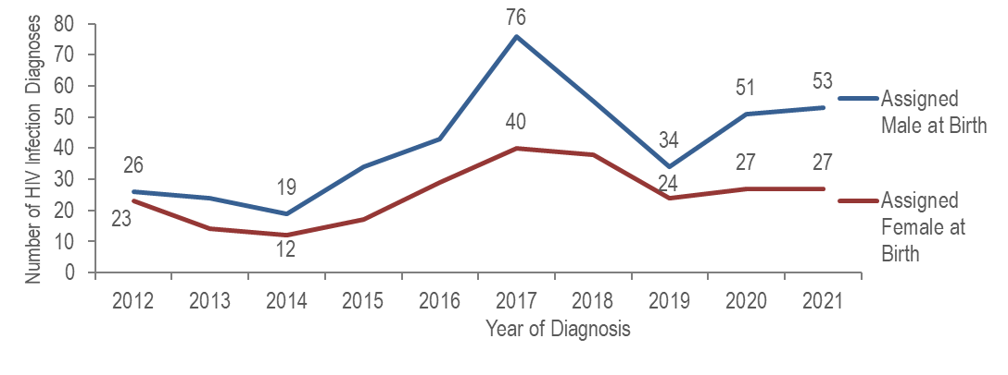
- The number of HIV infection diagnoses with IDU exposure mode among individuals AMAB quadrupled from 2014 to 2017, decreased by 55% in 2019, and then increased by 56% in 2021. The number of diagnoses with IDU exposure mode among individuals AFAB more than tripled from 2014 to 2017, decreased by 40% in 2019, and then increased by 13% in 2021.

SEX ASSIGNED AT BIRTH BY RACE/ETHNICITY
FIGURE 5. Individuals AMAB and diagnosed with HIV infection with IDU exposure mode by race/ethnicity and year of diagnosis, Massachusetts 2012–2021
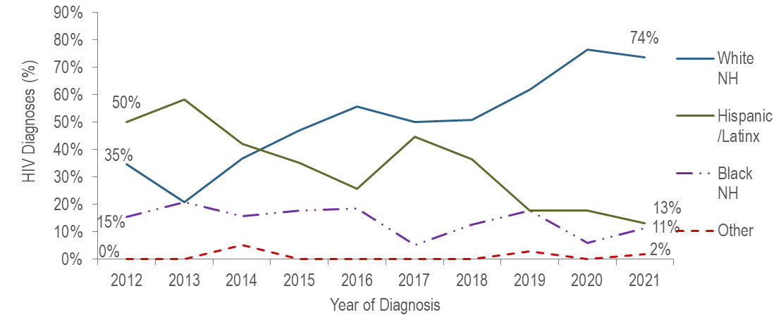
Figure 5 note: Individuals AMAB N=415, NH=non-Hispanic
- From 2012 to 2021, the proportion of individuals AMAB diagnosed with HIV infection with IDU exposure mode who identified as white (non-Hispanic) increased from 35% to 74%, while the proportion who identified as Hispanic/Latinx decreased from 50% to 13%, and as black (non-Hispanic) from 15% to 11%.
FIGURE 6. Individuals AFAB and diagnosed with HIV infection with IDU exposure mode by race/ethnicity and year of diagnosis, Massachusetts 2012–2021
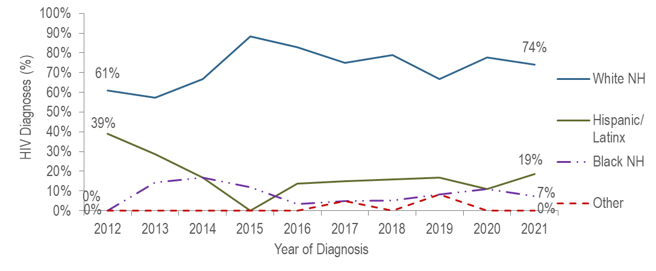
Figure 6 note: Individuals AFAB N=251, NH=non-Hispanic
- From 2012 to 2021, the proportion of individuals AFAB diagnosed with HIV infection with IDU exposure mode who identified as white (non-Hispanic) increased from 61% to 74%, while the proportion who identified as Hispanic/Latinx decreased from 39% to 19%.
FIGURE 7. Percentage distribution of individuals diagnosed with HIV infection with IDU exposure mode by sex assigned at birth and race/ethnicity, Massachusetts 2019–2021
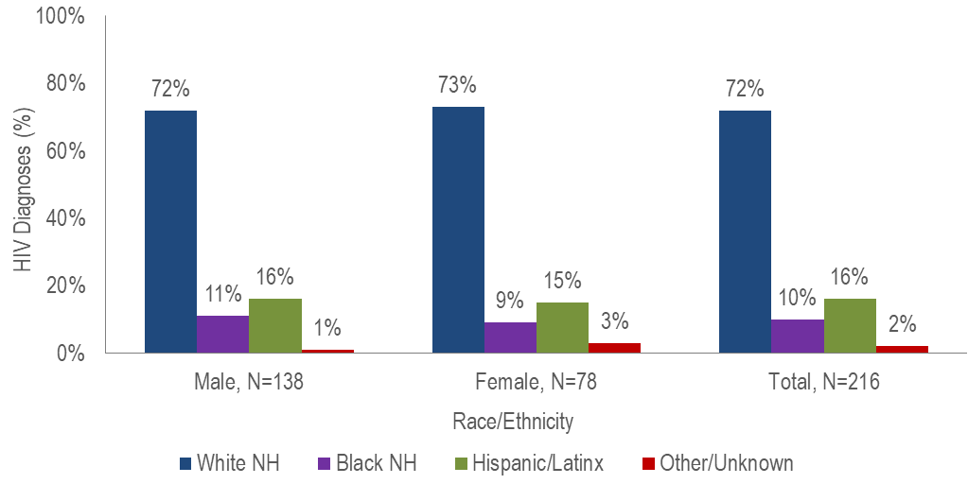
- The distribution by race/ethnicity was similar for individuals AFAB and individuals AMAB diagnosed with HIV infection with IDU exposure mode during 2019 to 2021; both were predominantly white (non-Hispanic).

AGE
FIGURE 8. HIV diagnoses among individuals with IDU exposure mode by age at diagnosis, Massachusetts 2012–2021 (N=666)
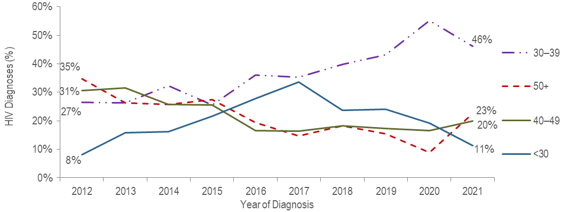
- The percentage of HIV infection diagnoses with IDU exposure mode among individuals under 30 years of age increased from 8% in 2012 to 34% in 2017 and then decreased to 11% in 2021.
- The percentage of HIV infection diagnoses with IDU exposure mode among individuals 30–39 years of age increased from 27% in 2012 to 55% in 2020 and then decreased to 46% in 2021.

PLACE OF RESIDENCE
TABLE 1. Massachusetts cities/towns with the highest percentage of HIV diagnoses attributed to IDU, 2019–2021
 | HIV Diagnoses Attributed to IDU (N) | HIV Diagnoses Attributed to IDU as Percent of Total HIV Diagnoses in City/Town (%)
Massachusetts Total | 216 | 15%
Top Cities/Towns
New Bedford | 7 | 26%
Boston | 89 | 26%
Lowell | 7 | 18%
Lawrence | 7 | 17%
Worcester | 12 | 15%
Brockton | 8 | 13%
All Other Cities/Towns | 86 | 10%

- Among cities/towns with at least five individuals diagnosed with HIV infection attributed to IDU and at least 20 total HIV diagnoses during 2019 to 2021, Boston and New Bedford had the highest percentage, both 26%. Boston has been involved in an active cluster of concern among PWID who are experiencing or have experienced recent homelessness since November 2018.

INFORMATION FROM ADDITIONAL DATA SOURCES
Opioid Statistics
Use of opioids and other substances is associated with transmission of HIV and other sexually transmitted diseases. Injection drug use (IDU) can be a direct route of HIV transmission if people share needles, syringes, or other injection materials that are contaminated with HIV. Ingesting, smoking, or inhaling drugs is also associated with increased risk for HIV. These substances alter judgment, which can lead to sexual behaviors that can make people more likely to get and transmit HIV (e.g., having sex without a condom, having multiple partners, etc.). Among people with HIV, substance use is associated with more rapid disease progression, barriers to accessing and receiving HIV care and treatment, lower adherence to antiretroviral therapy, and worse clinical outcomes. As such, opioid statistics and trends can inform understanding of rates of injection drug use and HIV transmission.
Opioids include heroin, opioid-based prescription painkillers, and other unspecified opioids that may or may not be injected.
Opioid-Related Overdose Deaths
- After reaching a 20-year high of 2,111 in 2016, and then remaining relatively stable through 2020, the number of confirmed opioid-related overdose deaths in Massachusetts increased to 2,283 in 2021. The opioid-related overdose death rate also increased during this time period from 30.7 per 100,000 in 2016 to 32.7 per 100,000 in 2021.
  - In 2021, there were 2,156 opioid-related overdose deaths where a toxicology screen was also available. Among these deaths, on average, fentanyl was present in 93%, cocaine in 52%, benzodiazepines in 31%, alcohol in 28%, prescription opioids in 14%, heroin in 10%, and amphetamines in 10%.
Data Source: MDPH Registry of Vital Records and Statistics, Data Brief: Opioid-Related Overdose Deaths Among Massachusetts Residents, Posted: December 2023 and December 2022, available at https://www.mass.gov/lists/current-opioid-statistics
Emergency Medical Services (EMS) Data:
- The percentage of EMS incidents that are considered opioid-related increased on average 25.6% per year from 2013 until 2016 and then began decreasing 3.3% per year through the end of 2021. The number of all EMS incidents involving naloxone administration increased on average 31.1% per year from 2013 until 2016 and then began decreasing 1.8% per year through the end of 2021. In 2021, the greatest number of suspected opioid-related incidents treated by EMS continued to be among individuals AMAB aged 25-34, accounting for 21% of opioid-related incidents with a known age and sex.
Data Source: MDPH Bureau of Health Care Safety and Quality, MA Opioid-Related EMS Incidents 2013-2021, Posted: June 2022, available at https://www.mass.gov/lists/current-opioid-statistics
MDPH Services Provided to Individuals Who Inject Drugs:
MDPH service data are presented to assess the numbers and demographics of clients who inject drugs and receive services through funded programs. This information is an important part of data-driven programmatic decision making and can also offer insight into rates of injection drug use among a subset of the Massachusetts population that accesses funded services.
Syringe Services Program (SSP) Participants

  - Among 2,030 clients who received HIV testing at state-funded SSPs in 2021:
    - 64% were men, 33% were women, and 2% were transgender or another gender;
    - 10% were aged 18–24 years, 31% were 25–34 years, 30% were 35–44 years, 16% were 45–54 years, 9% were 55–64 years, 2% were 65 years and older, and 1% was of unknown age;
    - 54% were white (non-Hispanic), 21% were Hispanic/Latinx, 19% were black (non-Hispanic), 3% were other or more than one race/ethnicity, and 3% were of unknown race/ethnicity.

Data Source: MDPH, BIDLS, Office of Health Care Planning; data as of 10/11/2022.

Substance Use Disorder Treatment Admissions
- The percentage of clients admitted to state-licensed substance use disorder treatment programs reporting the use of a needle to inject drugs within a year of admission increased from 42% (N=43,123/102,573) in state fiscal year 2012 to 50% (N=53,052/105,632) in state fiscal year 2014, and then decreased to 41% (N=32,890/79,846) in state fiscal year 2021.
- The percentage of admissions to state-licensed substance use disorder treatment programs for heroin use treatment increased from 43% (N=44,277/102,555) of total admissions in state fiscal year 2012 to 54% (53,413/98,094) in state fiscal year 2016, and then decreased to 48% (N=38,037/80,070) in state fiscal year 2021.
- Seventy-eight percent of individuals admitted to state-funded substance use disorder treatment programs in fiscal year 2021 who reported needle use within the past year were unemployed (N=8,554/10,974), compared to 55% of those admitted who did not report needle use (N=10,886/19,965); 45% (N=10,690/23,566) were homeless, compared to 27% (N=9,748/36,267) of those who did not report needle use.
Note: Total number of admissions excludes missing/unknown values for each variable and therefore differs depending on the variable. Please note: the total number of clients is less than previous years due to the impact of COVID-19.
Data Source: MDPH, Bureau of Substance Addiction Services, Office of Statistics and Evaluation, Data are current as of 11/7/2022 and may be subject to change; Based on EISM submissions through: 9/30/2022
HIV Surveillance Data Source: MDPH Bureau of Infectious Disease and Laboratory Sciences, data are current as of 1/1/2023 and may be subject to change

Providers may use this number to report individuals newly diagnosed with a notifiable sexually transmitted infection, including HIV, or request partner services. Partner services is a free and confidential service for individuals recently diagnosed with a priority infection. The client-centered program offers counseling, linkage to other health and social services, anonymous notification of partners who were exposed and assistance with getting testing and treatment. For more information, see: https://www.mass.gov/service-details/partner-services-program-information-for-healthcare-providers)
For more information, see: Charles Alpren et al. “Opioid Use Fueling HIV Transmission in an Urban Setting: An Outbreak of HIV Infection Among People Who Inject Drugs—Massachusetts, 2015–2018”, American Journal of Public Health 110, no. 1 (January 1, 2020): pp. 37-44. https://doi.org/10.2105/AJPH.2019.305366
Please consider the impact of the COVID-19 pandemic on infectious disease screening, treatment, and surveillance in the interpretation of 2020 and 2021 data
For more information, see: Joint MDPH and BPHC Clinical Advisory: Increase in newly diagnosed HIV infections among persons who inject drugs in Boston, March 15, 2021, available at: https://www.mass.gov/doc/joint-mdph-and-bphc-clinical-advisory-hiv-transmission-through-injection-drug-use-in-boston-march-15-2021/download
Please consider the impact of the COVID-19 pandemic on infectious disease screening, treatment, and surveillance in the interpretation of 2020 and 2021 data
Please consider the impact of the COVID-19 pandemic on infectious disease screening, treatment, and surveillance in the interpretation of 2020 and 2021 data
Please consider the impact of the COVID-19 pandemic on infectious disease screening, treatment, and surveillance in the interpretation of 2020 and 2021 data
Please consider the impact of the COVID-19 pandemic on infectious disease screening, treatment, and surveillance in the interpretation of 2020 and 2021 data
Please consider the impact of the COVID-19 pandemic on infectious disease screening, treatment, and surveillance in the interpretation of 2020 and 2021 data
City/town is based on residence at HIV infection diagnosis
Please consider the impact of the COVID-19 pandemic on infectious disease screening, treatment, and surveillance in the interpretation of 2020 and 2021 data
All Other Cities/Towns includes individuals diagnosed in a correctional facility
Centers for Disease Control and Prevention and Health Resources and Services Administration. Integrated Guidance for Developing Epidemiologic Profiles: HIV Prevention and Ryan White HIV/AIDS Program Planning. Atlanta, Georgia: Centers for Disease Control and Prevention; 2022. The guidance is available at http://www.cdc.gov/hiv/guidelines/ and at http://hab.hrsa.gov/

