|  |
| --- |
| **INDOOR AIR QUALITY**  **ASSESSMENT**  **Peru Town Hall**  **3 East Main Road**  **Peru, Massachusetts**  Exterior view of Peru Town Hall  Prepared by:  Massachusetts Department of Public Health  Bureau of Climate and Environmental Health  Indoor Air Quality Program  October 2024 |

**BACKGROUND**

|  |  |
| --- | --- |
| **Building:** | Peru Town Hall (PTH) |
| **Address:** | 3 East Main Road, Peru, MA |
| **Reason for Request:** | Mold odor in kitchen/meeting hall |
| **Date of Assessment:** | July 30, 2024 |
| **Massachusetts Department of Public Health/Bureau of Climate and Environmental Health (MDPH/BCEH) Staff Conducting Assessment:** | Michael Feeney, Director, and Stefanie Santora, Environmental Analyst, Indoor Air Quality (IAQ) Program |
| **Building Description:** | The PTH was constructed as a school that had a one-story over a dirt floor cellar. An addition was made to the building that included a two-story wing with a kitchen/cafeteria at ground level. |
| **Building Population:** | Approximately ~10 employees |
| **Year of Construction:** | 1950s |
| **Windows:** | Openable |

**INTRODUCTION**

At the request of Mr. Sam Haupt, Peru Town Administrator, the MDPH/BCEH provided assistance and consultation regarding indoor air quality concerns at the PTH. On July 30, 2024, MDPH/BCEH staff, Michael Feeney and Stefanie Santora, visited the building to conduct an assessment. The request was prompted by concerns about intermittent odors and potential mold growth in the kitchen and adjacent meeting hall on the ground floor of the building**.** The building was not open to the public on the day of the assessment and there were three employees present.

Please note that a previous report was issued on September 3, 2024, which addressed issues of mold odors in the meeting hall and is included as Appendix A. This report is a comprehensive IAQ assessment with air sampling throughout the PTH.

# METHODS

Please refer to the IAQ Manual for methods, sampling procedures, and interpretation of results (MDPH, 2015).

# RESULTS AND DISCUSSION

The following is a summary of indoor air testing results (Table 1).

* ***Carbon dioxide*** measurements were below the MDPH recommended guideline of 800 parts per million (ppm) in all areas surveyed.
* ***Temperature*** was within the MDPH recommended range of 70°F to 78°F in all areas tested at the time of assessment.
* ***Relative humidity*** was within the MDPH recommended range of 40 to 60% in most areas tested, with the exception of three rooms which were slightly above. These conditions are typical during hot humid weather.
* ***Carbon monoxide*** was not detected (ND) in all areas tested.
* ***Particulate matter (PM2.5)*** concentrations measured were below the National Ambient Air Quality (NAAQS) level of 35 μg/m3 in all areas tested.

## Ventilation

It can be seen from Table 1 that carbon dioxide levels were below 800 parts per million (ppm) in all areas tested, indicating adequate air exchange at the time of the assessment. Heated air is provided by air-handling units (AHUs) located in sheds (west furnace shed and east furnace shed) attached to the PTH exterior walls (Pictures 1 and 2) that are attached to ductwork located in the crawlspace beneath the building. Once air is filtered, it is heated and delivered to occupied areas via ducted supply diffusers (Picture 3). Return air is drawn through floor return vents (Picture 4). No fresh air supply for the AHU could be located. Air within the building is recirculated only. The sole source of fresh air is opening windows.

Window-style air conditioners were mounted in the windows of several office spaces (Picture 5). These units can supply some amount of fresh air while operating. They are equipped with filters that need to be cleaned periodically. When these air conditioners are operating, windows should be closed in addition to closing interior doors to individual office spaces.

To maximize air exchange, the MDPH recommends that both supply and exhaust ventilation operate continuously during periods of occupancy. In order to have proper ventilation with a mechanical supply and exhaust system, the systems must be balanced to provide an adequate amount of fresh air to the interior of a room while removing stale air from the room. It is recommended that HVAC systems be re-balanced every five years to ensure adequate air systems function (SMACNA, 1994). The last system balancing date was unknown at the time of the assessment.

Return ducts to the AHUs have filters. The slot where the filter is inserted is missing its cover. In this configuration, basement air can bypass the filter and be distributed to occupied areas.

The AHUs also have furnace components that combust propane to provide heat. The AHU furnace has flues that terminate through the exterior wall of each shed (Pictures 6 and 7). Each AHU has two PVC pipes, one that serves as the combustion exhaust flue and the other being the source of combustion air. Both PVC pipes are joined for a single pipe-inside-a-pipe configuration (Picture 8) that terminates outside the AHU shed. Typically, the combustion air pipe and exhaust flue would be separated to prevent the draw of combustion air into the furnace. If combustion air has reduced oxygen levels, products of incomplete combustion may occur when the furnace is operating during certain wind conditions. In addition, exhaust vents for combustion are normally configured to terminate above the roof peak, such as a typical house chimney. Since these flues are below the roof edge, products of combustion may be directed towards exterior walls during certain wind conditions. If any gaps exists in the exterior wall, such as around window frames, this may allow for products of combustion to enter the PTH.

## Microbial/Moisture Concerns

Hot humid summers are becoming more frequent due to climate change. Massachusetts has experienced hot, humid, and rainy summers in 2018, 2021, and 2023. July of 2021 was the wettest ever recorded in Massachusetts, and the three-month period from June through August, known as the meteorological summer, was the fourth wettest on record, according to the National Oceanic and Atmospheric Administration’s (NOAA) Centers for Environmental Information (NOAA, 2021). The summer of 2023 was also hot, and wet, being measured as the second rainiest on record (WBUR, 2023). The summer of 2024 has also had significant stretches of hot, humid weather. These conditions are challenging for buildings, particularly those without central air conditioning.

Under these weather conditions, public buildings experienced extended periods of water vapor exposure from high relative humidity. When exposed to these conditions, porous materials such as gypsum wallboard, cardboard, carpeting, and other materials may become moistened and colonized with mold, particularly if located in areas that are prone to developing condensation, such as floors and walls in contact with the ground (e.g., below grade space).

The guideline “Preventing Mold Growth In Schools During Hot, Humid Weather” <https://www.mass.gov/info-details/preventing-mold-growth-in-massachusetts-schools-during-hot-humid-weather> should be used to minimize the impact of such weather on porous materials. This includes the use of air conditioning and dehumidifiers, ensuring exhaust vents are on and operable, keeping windows closed, and ensuring air can circulate around porous materials.

The humidity inside the PTH ranged from 53-68%, which is higher than the comfort range recommended by the IAQ program for relative humidity. When relative humidity is elevated, the air can feel uncomfortably damp, clammy, or sticky. Excess humidity for a significant period of time can also lead to water damage in porous materials, particularly in areas with a lower temperature, such as ventilation equipment, or exterior windows or walls, due to condensation. In addition, high relative humidity will cause paper to absorb moisture, which in turn cause paper jams in photocopiers and computer printers (Fisher, N., 2024).

There is significant water accumulation around the exterior of the building which leads to water infiltration of the PTH. Due to the lack of gutters and downspouts on roof edges to capture water, water sheds off the roof edge to impact the base of the exterior walls. Signs of chronic moisture can be seen from the dark staining, accumulation of moss, and erosion to the brick and mortar on the front of the PTH (Picture 9) and the dark staining and accumulation of moss in the rear of the building under the fire escape (Picture 10). The lack of gutters and downspouts along the roof edge of the PTH causes water to penetrate into the sheds that contain the furnaces/AHUs (Pictures 1 and 2). Water from the main roof empties directly onto the roof of the west furnace shed (Picture 11), which in time can damage roof shingles and result in water penetration. Water runoff from the fire escape corner of the PTH travels downhill to impact the exterior walls of the east furnace shed (Picture 2). This condition causes the eastern furnace shed to become moistened (Picture 12) with possible standing water after rainstorms.

Water infiltration impacts the PTH building interior as well as areas on the perimeter of the PTH. Water-damaged ceiling tiles were found in various locations including the storage room and the men’s bathroom. This can indicate current/historic/roof leaks or other water infiltration/ Water-damaged ceiling tiles can provide a source of mold and should be replaced and repaired after a water leak is discovered.

The interior wall of the community room downstairs shows signs of efflorescence (Pictures 13 and 14). Efflorescence results when rainwater penetrates into brick and mortar. A suspension of water and salts forms in the brick and mortar, which then travels to wall surface. As the water evaporates, a white, powdery material is formed (efflorescence). While efflorescence is a sign of water exposure to brick, it is not mold growth.

## Other Conditions

The PTH has wall-to-wall carpeting in its office space. Aging carpet can produce fibers that can be irritating to the respiratory system. In addition, lifting carpet can create tripping hazards. Carpets should be cleaned annually (or semi-annually in soiled/high traffic areas) in accordance with Institute of Inspection, Cleaning and Restoration Certification (IICRC) recommendations, (IICRC, 2012). Regular cleaning with a high efficiency particulate air (HEPA) filtered vacuum in combination with an annual cleaning will help to reduce accumulation and potential aerosolization of materials from carpeting.

# CONCLUSIONS AND RECOMMENDATIONS

In view of the findings at the time of the visit, the following recommendations are made:

## Short Term Recommendations

### Ventilation Recommendations

1. Install carbon monoxide detectors in the main office as well as both floors of the PTH.
2. Examine the feasibility of separating the AHU flue and combustion air vents. It is

recommended that the furnace exhaust flue terminate at a level above the roof peak to

prevent combustion air from entering the roof via soffit vents.

### Water Damage Recommendations

1. Install gutters and downspouts to reduce water accumulation on building exterior and gutters on the roof edge above the west furnace shed to reduce water impact.
2. Install weatherstripping around exterior doors to seal doors from water infiltration, unconditioned air, and pests.
3. Seal around window-mounted air conditioners to prevent water infiltration.
4. Replace water-damaged ceiling tiles. Repeated water damage to ceiling tiles indicates leaks from the roof or plumbing system which should be repaired.
5. Address drainage around the exterior of the building by re-grading the apron around the PTH to direct water away from exterior walls.
6. Reduce rainwater impacts on the interior of both furnace sheds by regrading ground uphill from the east furnace shed to drain away from exterior walls.
7. Continue to work on remaining recommendations from the previous report (Appendix A).
8. For more information on mold consult with the US EPA’s “Mold Remediation in Schools and Commercial Buildings”. Available at: <http://www.epa.gov/mold/mold-remediation-schools-and-commercial-buildings-guide> (US EPA, 2008).

### Other Recommendations

1. Consideration should be given to replacing carpeting with a different type of floor covering that can be readily cleaned. Until that time, clean high traffic areas frequently in accordance with IICRC recommendations (IICRC, 2012).

# REFERENCES

Fisher, N. 2024. How Humidity Affects Your Copier and Paper Quality. Cobb Technologies, Richmond, VA. <https://www.cobbtechnologies.com/blog/how-humidity-affects-your-copier-and-paper-quality>.

IICRC. 2012. Carpet Cleaning FAQ 4 Institute of Inspection, Cleaning and Restoration Certification. Institute of Inspection Cleaning and Restoration, Vancouver, WA.

MDPH. 2015. Massachusetts Department of Public Health. Indoor Air Quality Manual: Chapters I-III. Available at: <https://www.mass.gov/lists/indoor-air-quality-manual-and-appendices#indoor-air-quality-manual->.

US EPA. 2008. “Mold Remediation in Schools and Commercial Buildings”. Office of Air and Radiation, Indoor Environments Division, Washington, DC. EPA 402-K-01-001. September 2008. Available at: <http://www.epa.gov/mold/mold-remediation-schools-and-commercial-buildings-guide>.

NOAA. 2021. Summer 2021 neck and neck with Dust Bowl summer for hottest on record. National Oceanic and Atmospheric Administration, 1401 Constitution Avenue NW, Room 5128, Washington, DC 20230 <https://www.noaa.gov/news/summer-2021-neck-and-neck-with-dust-bowl-summer-for-hottest-on-record>.

SMACNA. 1994. HVAC Systems Commissioning Manual. 1st ed. Sheet Metal and Air Conditioning Contractors’ National Association, Inc., Chantilly, VA.

WBUR. 2023. “It's been a summer of rain and flooding misery in Mass.” WBUR local news. September 12, 2023. <https://www.wbur.org/news/2023/09/12/summer-flooding-rain-massachusetts>

**Picture 1**

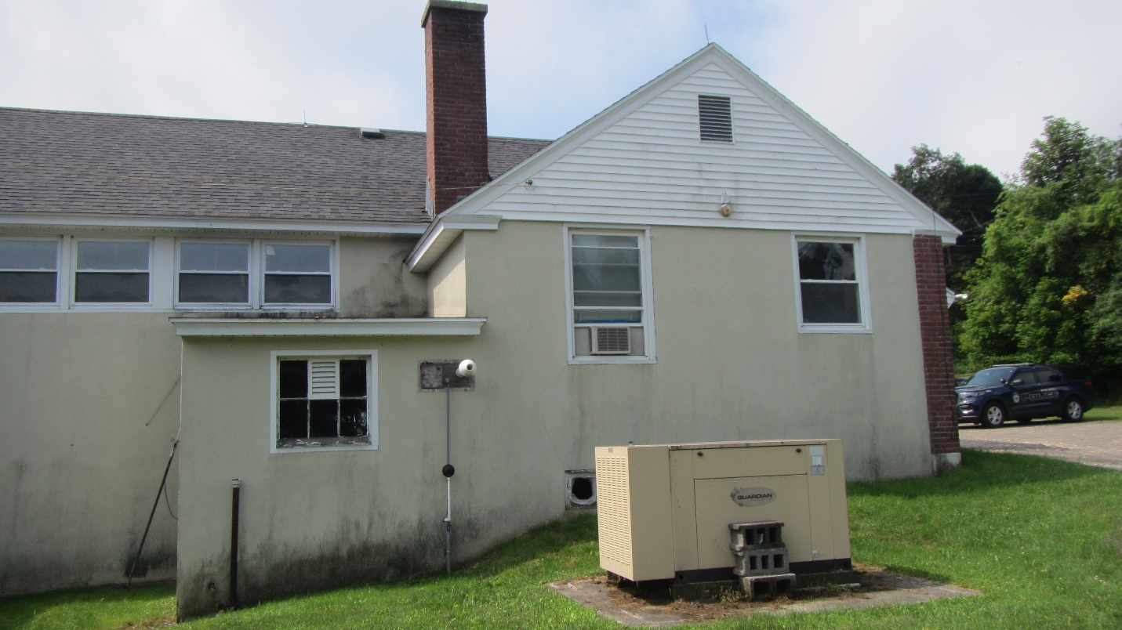

**North AHU shed, note gable attic vent above furnace exhaust**

**Picture 2**

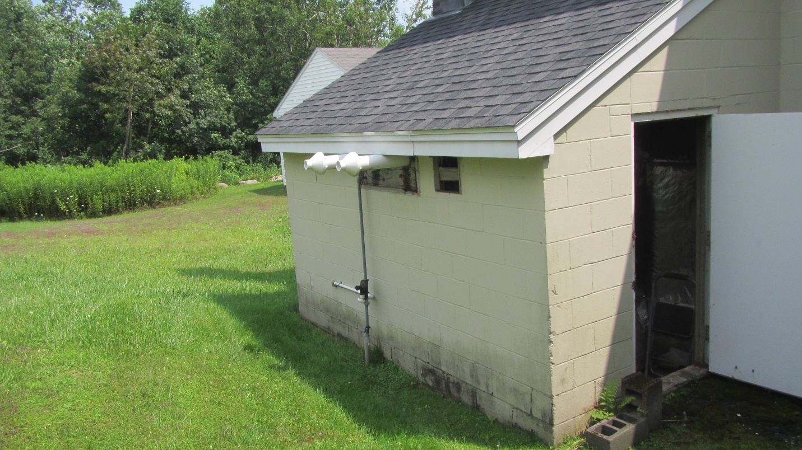

**South AHU shed that contains two furnaces/AHUs**

**Picture 3**

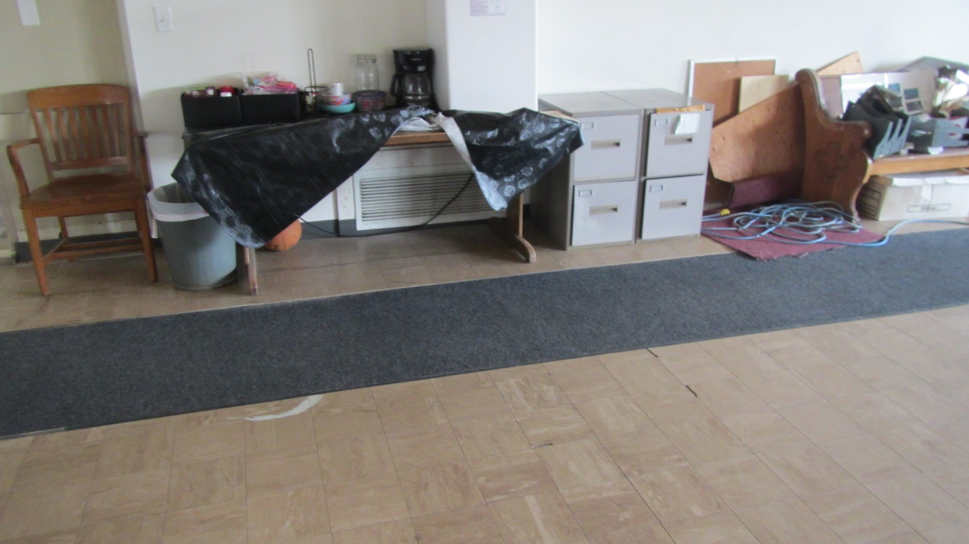

**Fresh air supply vent**

**Picture 4**

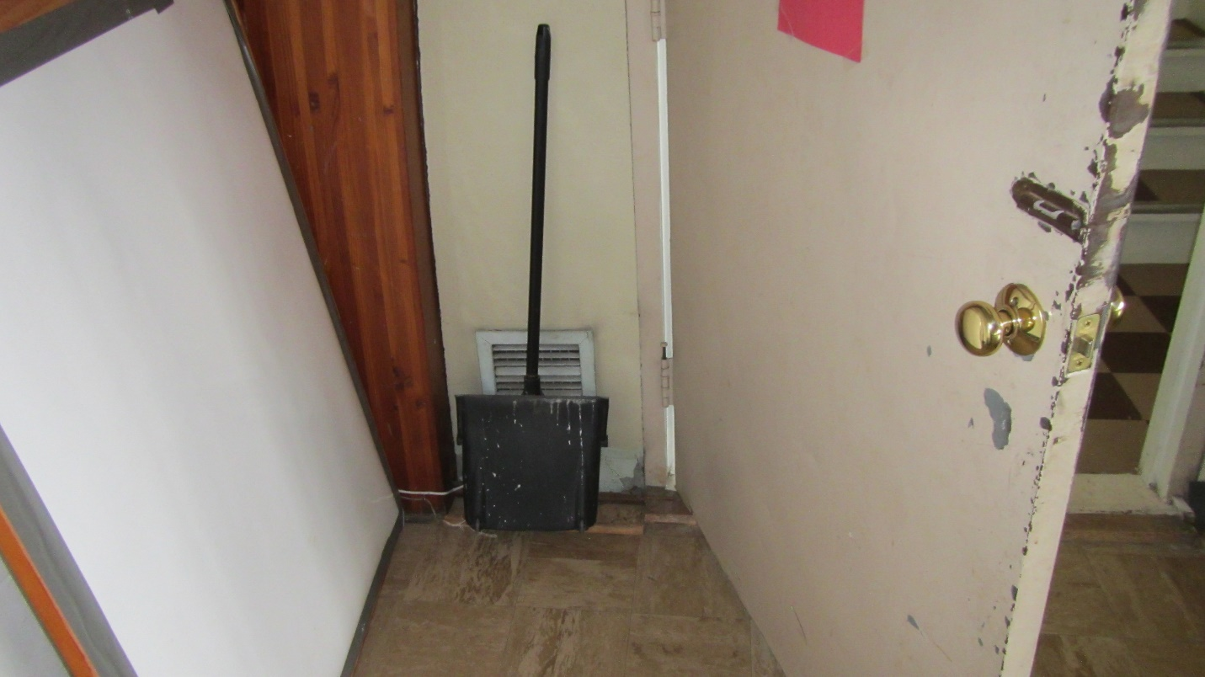

**Return air vent**

**Picture 5**

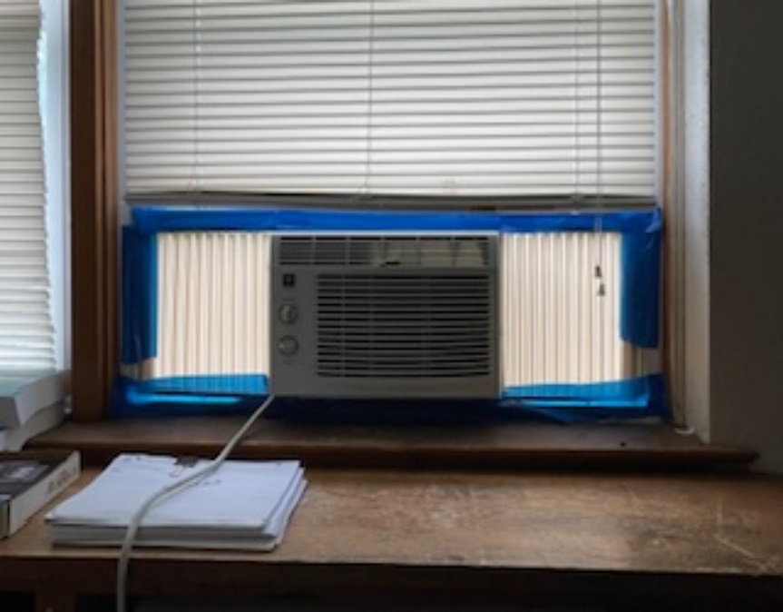

**Window-mounted air conditioner**

**Picture 6**

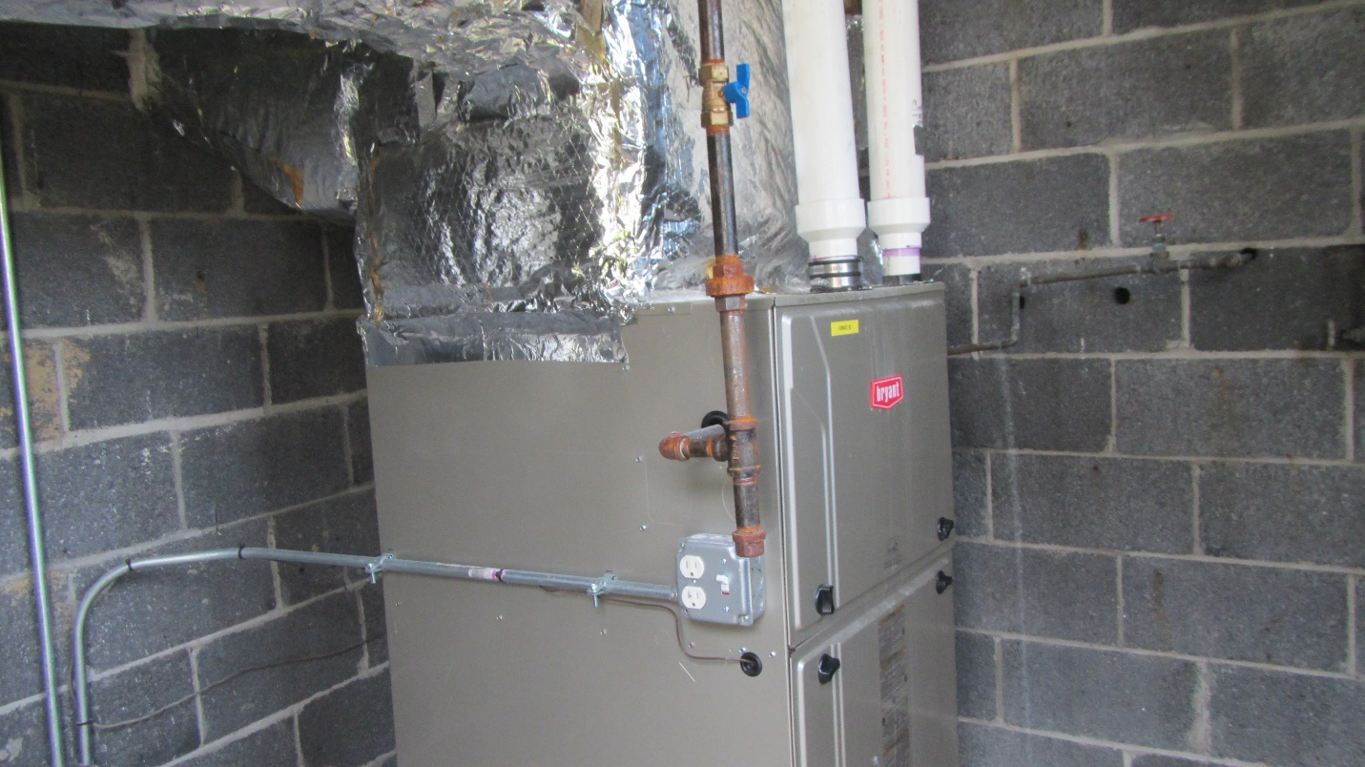

**PVC pipes that are combustion air and combustion exhaust vent**

**Picture 7**

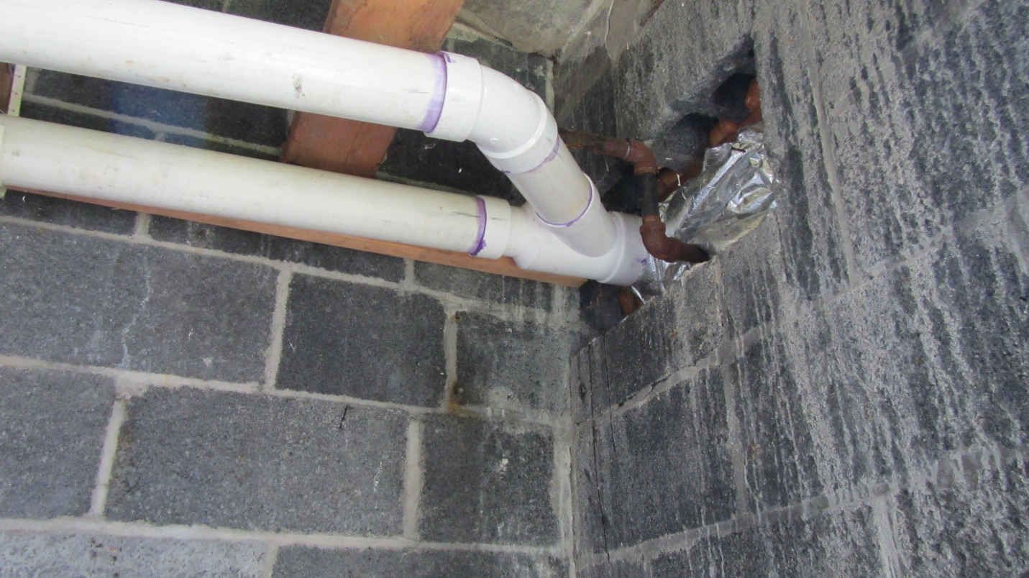

**Joined PVC pipes that are combustion air and combustion exhaust vent**

**Picture 8**

**Combination flue terminus with Combustion air intake.
Black arrow indicates likely combustion air intake, blue arrow indicates likely furnace exhaust flue.
**

**Combination flue terminus with combustion air intake. Black arrow indicates likely combustion air intake, blue arrow indicates likely furnace exhaust flue.**

**Picture 9**

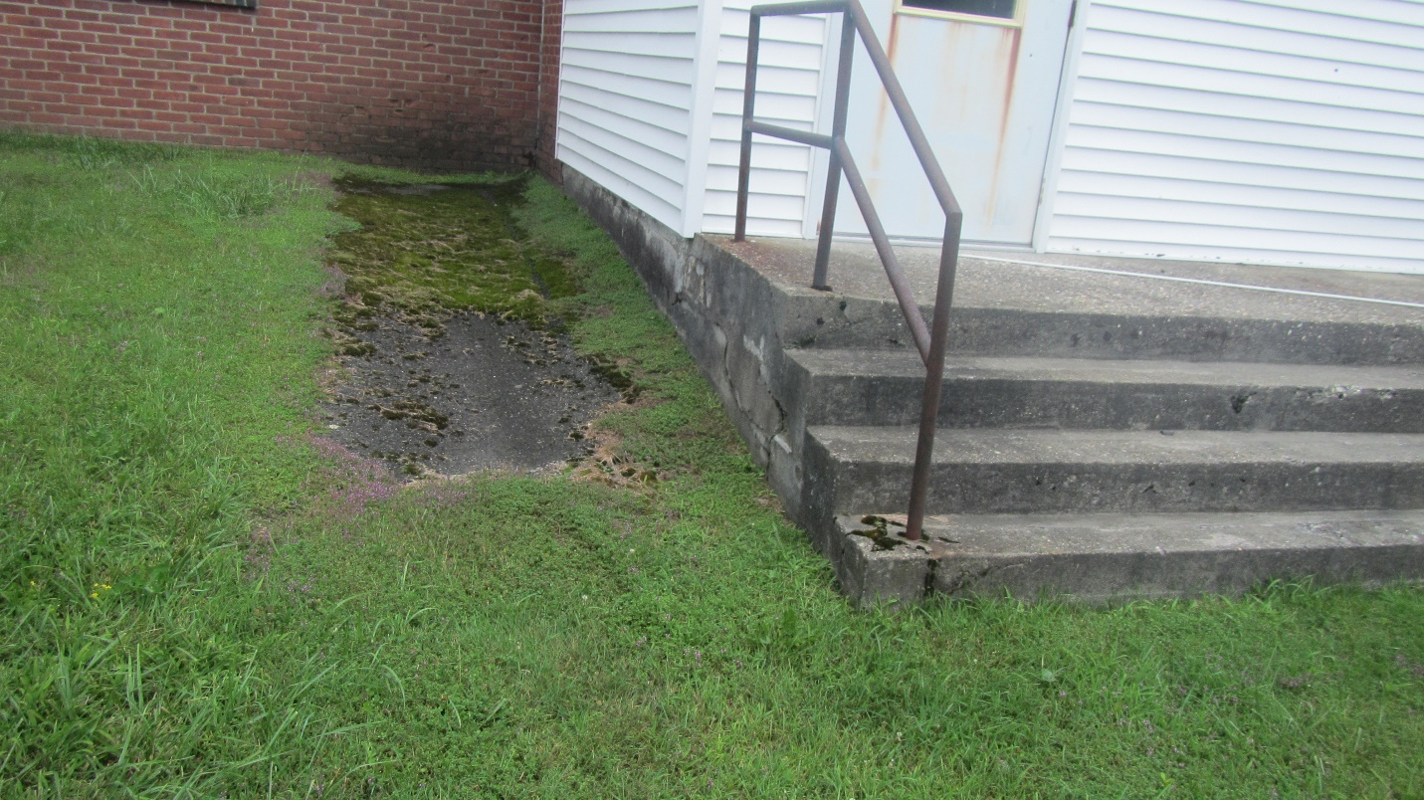

**Water accumulation on exterior of front of PTH indicated by dark staining, moss growth, and erosion to brick and mortar**

**Picture 10**

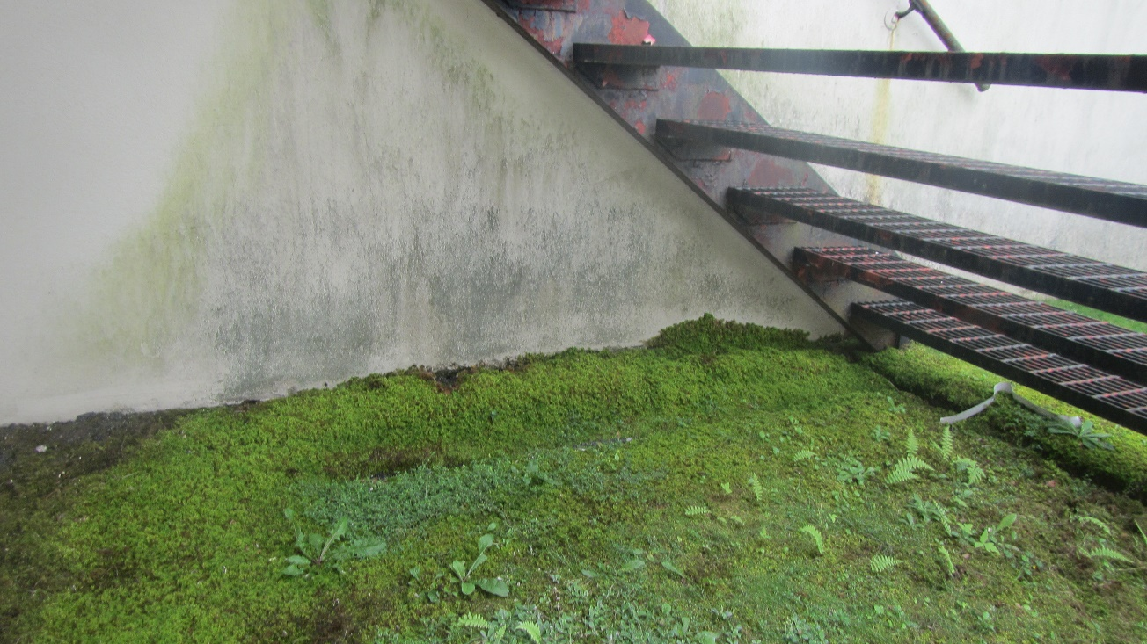

**Water accumulation on exterior of rear of PTH indicated by dark staining and moss growth.**

**Picture 11**

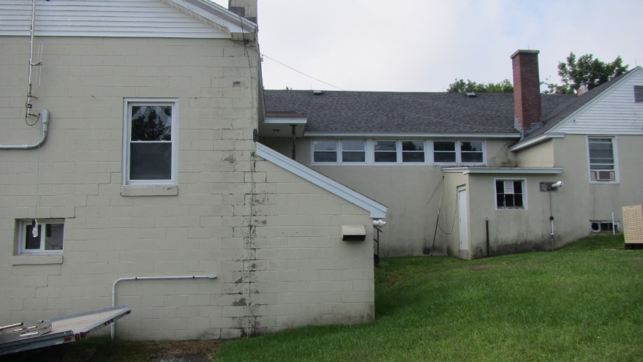

**Water from the main roof empties directly onto the roof of both east and west furnace sheds. Note dark stains at the base of both furnace sheds, indicating chronic water exposure and possible water penetration**

**Picture 12**

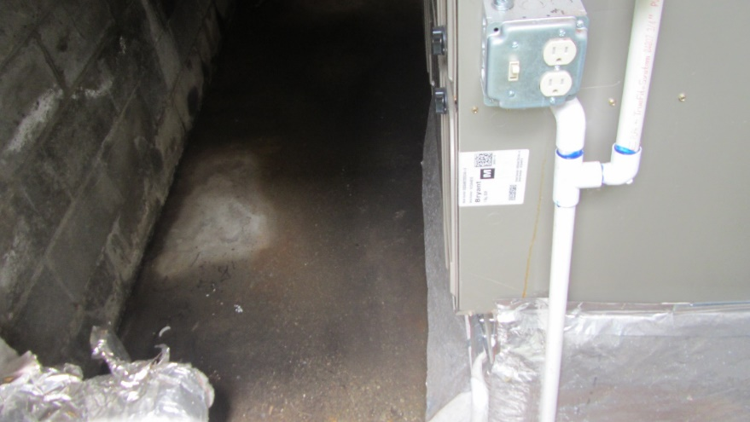

**Moistened cement floor of east furnace shed**

**Picture 13**

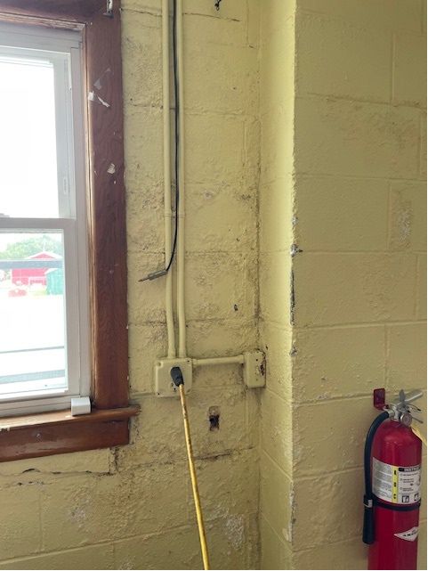

**Efflorescence on interior wall of community room**

**Picture 14**

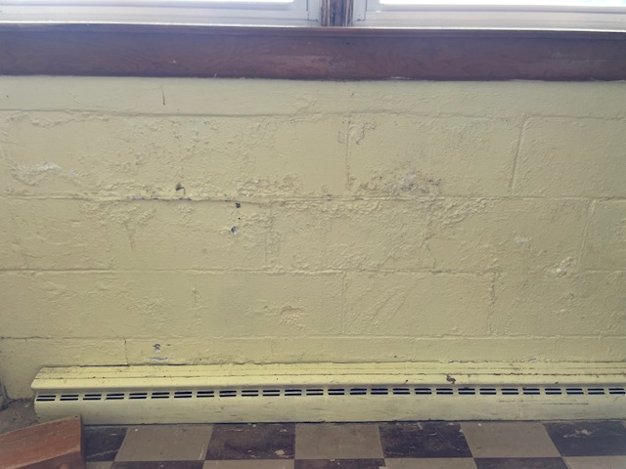

**Efflorescence on interior wall of community room**

| **Location/ Room** | **Carbon**  **Dioxide**  **(ppm)** | **Carbon Monoxide**  **(ppm)** | **Temp**  **(°F)** | **Relative**  **Humidity**  **(%)** | **Dew Point** | **PM2.5**  **(µg/m3)** | **Occupants**  **in Room** | **Windows**  **Openable** | **Ventilation** | | **Remarks** |
| --- | --- | --- | --- | --- | --- | --- | --- | --- | --- | --- | --- |
| **Supply** | **Exhaust** |
| Background (outdoors) | 340 | ND | 82 | 62 | 68 | 22 |  |  |  |  | Sunny, warm |
| Gym | 467 | ND | 77 | 55 | 60 | 14 | 0 | Y | N | N | Tile floor |
| Storage Closet | 462 | ND | 76 | 56 | 60 | 16 | 0 | N/A | N | N |  |
| Entrance (next to storage closet) | 463 | ND | 77 | 56 | 60 | 16 | 0 | N/A | N | N | Book storage, ceiling WD, efflorescence |
| Board of Selectmen | 484 | ND | 78 | 59 | 62 | 18 | 0 | N | N | N | WAC, W2W |
| Cube 1 Area | 509 | ND | 78 | 59 | 62 | 18 | 0 | Y | N | N |  |
| Cube 3 Area | 484 | ND | 77 | 62 | 63 | 21 | 2 | Y | N | N | WAC, W2W |
| Tax Collector | 414 | ND | 75 | 68 | 64 | 19 | 0 | N | N | N | WAC, W2W, clutter |
| Health Agent | 420 | ND | 76 | 64 | 62 | 18 | 0 | Y | N | N | W2W |
| Common Room (downstairs) | 434 | ND | 75 | 58 | 60 | 19 | 0 | Y | N | N | Tile floor |
| Police Department | 444 | ND | 77 | 53 | 58 | 20 | 1 | Y | N | N | WAC, vinyl flooring |

|  |
| --- |
| **MOLD/WATER DAMAGE**  **ASSESSMENT**  **Peru Town Hall**  **3 East Main Road**  **Peru, Massachusetts**  Exterior view of Peru Town Hall  Prepared by:  Massachusetts Department of Public Health  Bureau of Climate and Environmental Health  Indoor Air Quality Program  September 2024 |

**BACKGROUND**

|  |  |
| --- | --- |
| **Building:** | Peru Town Hall (PTH) |
| **Address:** | 3 East Main Road, Peru, MA |
| **Reason for Request:** | Mold odor in kitchen/meeting hall |
| **Date of Assessment:** | July 30, 2024 |
| **Massachusetts Department of Public Health/Bureau of Climate and Environmental Health (MDPH/BCEH) Staff Conducting Assessment:** | Michael Feeney, Director, and Stefanie Santora, Environmental Analyst, Indoor Air Quality (IAQ) Program |
| **Building Description:** | The PTH was constructed as a school that had a one-story over a dirt floor cellar. An addition was made to the building that included a two-story wing with a kitchen/cafeteria at ground level. |
| **Building Population:** | Approximately ~10 employees |
| **Year of Construction:**  **Windows:** | 1950s  Openable |

**INTRODUCTION**

At the request of Mr. Sam Haupt, Peru Town Administrator, the MDPH/BCEH provided assistance and consultation regarding indoor air quality concerns at the PTH. On July 30, 2024, MDPH/BCEH staff, Michael Feeney and Stefanie Santora, visited the building to conduct an assessment. The request was prompted by concerns about intermittent odors and potential mold growth in the kitchen and adjacent meeting hall on the ground floor of the building**.** The building was not open for business on the day of the assessment and there were three employees present.

This report addresses the issues of mold associated odors in the meeting hall. A full IAQ assessment with air sampling throughout the PTH will be the subject of a separate report.

**METHODS**

Please refer to the IAQ Manual for methods, sampling procedures, and interpretation of results (MDPH, 2015).

**RESULTS AND DISCUSSION**

The PTH was originally constructed as a one-story school that had a two-story wing containing a gymnasium on the top floor with a kitchen and a cafeteria below. The cafeteria now serves as the meeting hall in the building. A door in the west wall opens to a room that was reported to be formerly occupied by the Peru Police Department (PPD). Inside the former PPD space is a door that opens into a cellar area that has a stone foundation and dirt floor with exposed ledge outcrops. It was noted windows are openable throughout the building.

MDPH/BCEH staff performed a visual inspection of building materials for water damage and/or microbial growth. As previously mentioned, the assessment was prompted by concerns of odors and possible mold growth in the meeting hall. The door leading to the former PPD was closed and had its seams sealed with painter’s tape (Picture 1). At the time of this visit a dehumidification unit was operating in the former PPD area (Picture 2). A plastic tube (Picture 3) was attached to the dehumidifier to vent exhaust air through the basement window and then to the outside of the building (Pictures 4 and 5). As reported, the mold odor associated with the dirt cellar was reported in the meeting hall.

A series of ducts with air diffusers exist in the meeting hall. The ducts enter the former PPD space and the dirt cellar to connect to air handling units that exist in sheds attached to the exterior walls of the building. Both fresh air supply and exhaust vent ducts were observed in the cellar, former PPD office and the meeting hall (Picture 6). The meeting hall did not appear to have seams sealed with mastic or permanent foil tape. Accumulated dust and debris were noted along duct seams in the meeting hall (Picture 7). Without the sealing of duct seams, air and water vapor in the crawlspace may enter the interior of ducts which may in turn exit the HVAC system through diffusers and duct seams in the hall. Use an appropriate material to seal seams in the ductwork in the meeting hall. Please note that duct tape is a temporary sealing solution, since its adhesive will dry out and loose adhesion over times. A fire-rated mastic or foil tape to permanently seal the duct seams is recommended.

**CONCLUSIONS AND RECOMMENDATIONS**

In view of the findings at the time of the visit, the following recommendations are made:

1. Seal all seams between the cellar meeting hall door as well as the doorframe and wall seams to eliminate cellar odors from entering. Placing polyethylene tape over the entire door and its frame would provide a temporary seal.
2. In order to permanently seam the cellar from the meeting hall, installing an outdoor entrance door/frame outfitted with weatherstripping and solid door sweep is recommended.
3. Use an appropriate material to seal seams in the ductwork in the meeting hall. Please note that duct tape is a temporary sealing solution, since its adhesive will dry out and loose adhesion over times. A fire-rated mastic or foil tape to permanently seal the duct seams is recommended.
4. Continue to operate the dehumidifier. If possible, relocate this equipment as close to the cellar window to maximize the draw of the dehumidifier to eject air directly outdoors.
5. Identify all fresh air supply and exhaust vent openings in the meeting hall and temporarily seal with plastic and tape in a similar manner as the cellar access door.
6. The use of box fans to direct outdoor air into the meeting hall will pressurize this space to force air into any open seams in walls that may serve as a cellar air migration pathway. Use of box fans may be rendered impractical due to weather conditions, but they could be used during temperate/low relative humidity weather.
7. Consider replacing plastic tubes used for dehumidifier exhaust air with a more durable material.
8. For more information on mold consult with the US EPA’s “Mold Remediation in Schools and Commercial Buildings”. Available at: <http://www.epa.gov/mold/mold-remediation-schools-and-commercial-buildings-guide> (US EPA, 2008).

**REFERENCES**

MDPH. 2015. Massachusetts Department of Public Health. Indoor Air Quality Manual: Chapters I-III. Available at: <https://www.mass.gov/lists/indoor-air-quality-manual-and-appendices#indoor-air-quality-manual->.

US EPA. 2008. “Mold Remediation in Schools and Commercial Buildings”. Office of Air and Radiation, Indoor Environments Division, Washington, DC. EPA 402-K-01-001. September 2008. Available at: <http://www.epa.gov/mold/mold-remediation-schools-and-commercial-buildings-guide>.

**Picture 1**

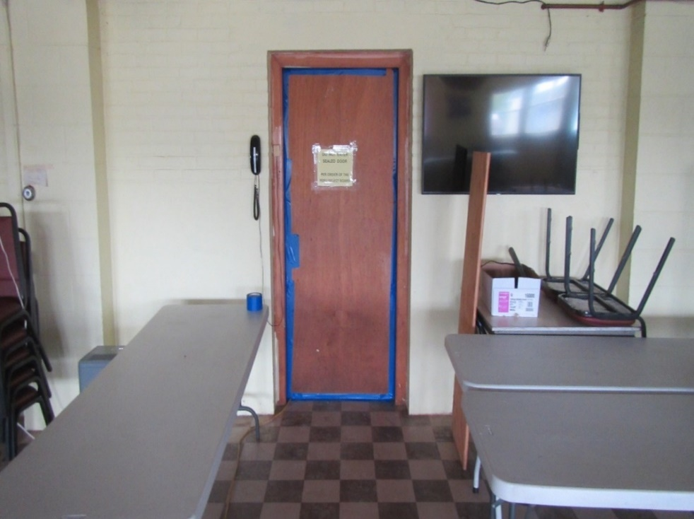

**Cellar access door in meeting hall**

**Picture 2**

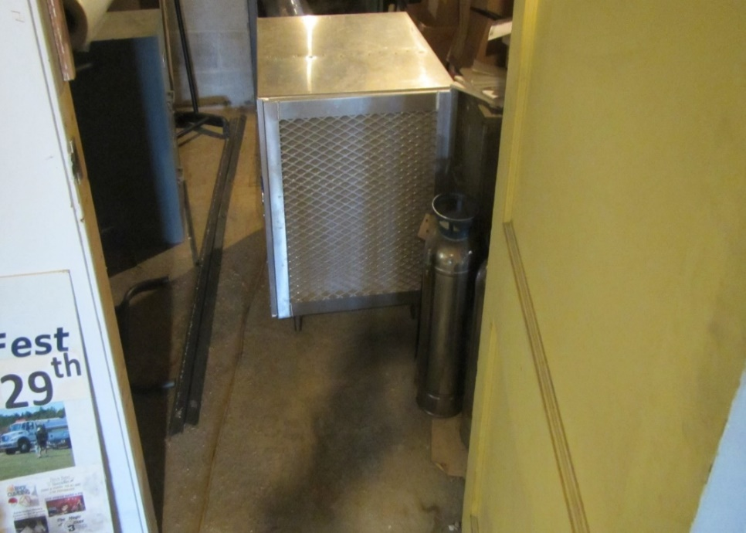

**Dehumidification unit in cellar**

**Picture 3**

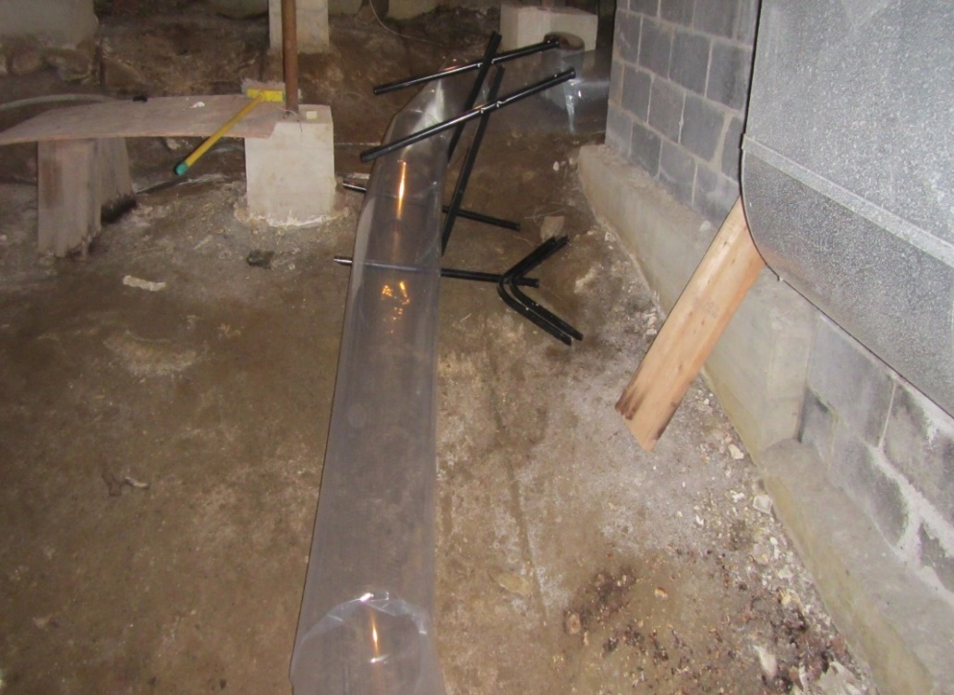

**Plastic tube used to vent exhaust air from dehumidifier**

**Picture 4**

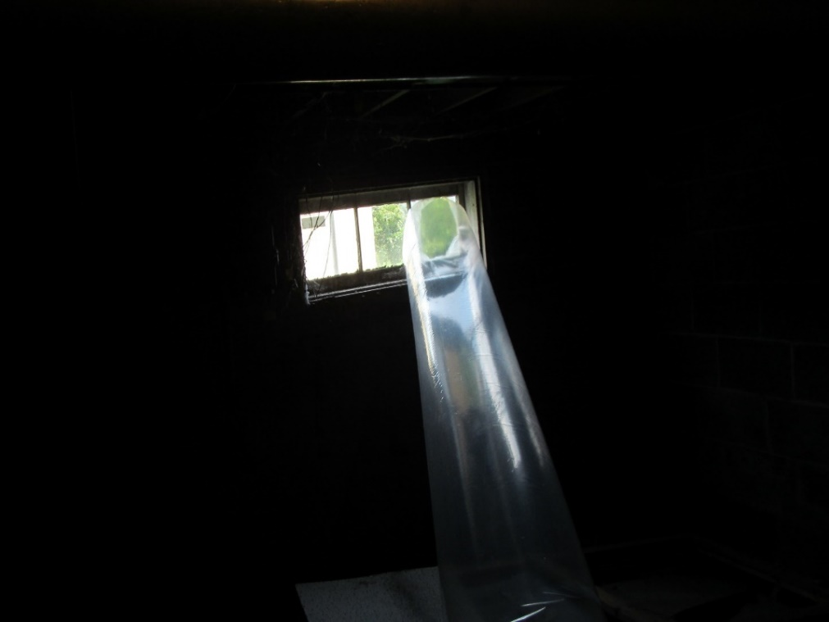

**Plastic tube used to vent exhaust air from dehumidifier connected to cellar window**

**Picture 5**

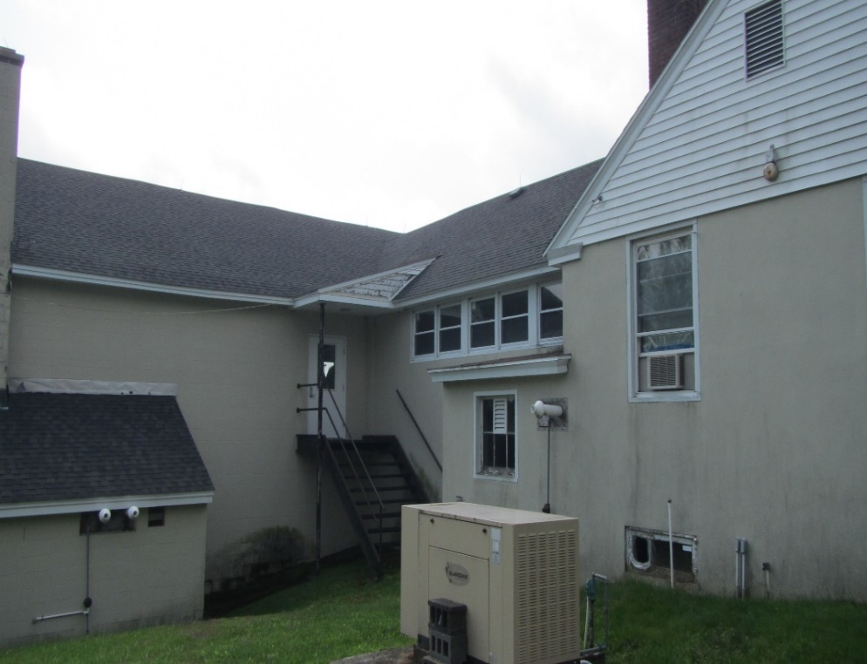

**Exterior view of cellar window, (blue arrow pointing to plastic tube in window)**

**Picture 6**

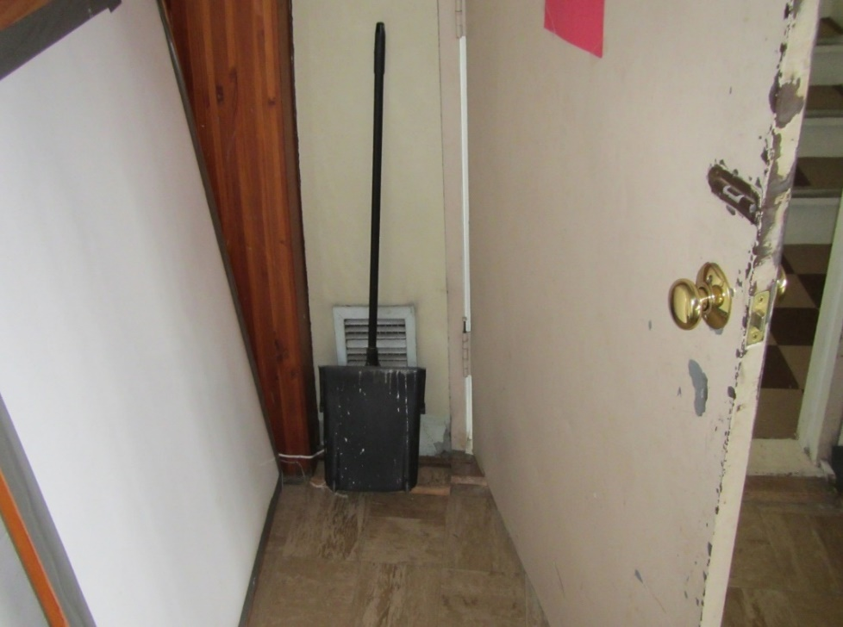

**Vent opening in meeting hall**

**Picture 7**

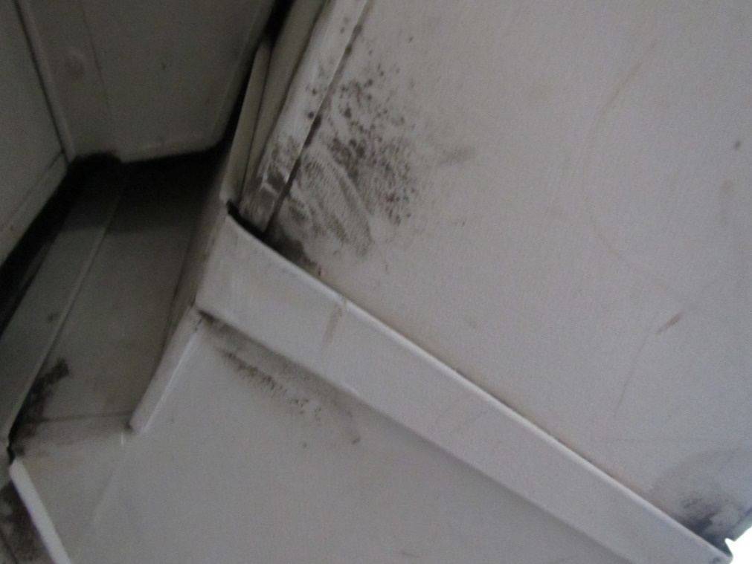

**Seam with debris, indicating an opening in meeting hall**