|  |
| --- |
| **MOLD/WATER DAMAGE**  **ASSESSMENT**  **Peru Town Hall**  **3 East Main Road**  **Peru, Massachusetts**  Exterior view of Peru Town Hall  Prepared by:  Massachusetts Department of Public Health  Bureau of Climate and Environmental Health  Indoor Air Quality Program  September 2024 |

**BACKGROUND**

|  |  |
| --- | --- |
| **Building:** | Peru Town Hall (PTH) |
| **Address:** | 3 East Main Road, Peru, MA |
| **Reason for Request:** | Mold odor in kitchen/meeting hall |
| **Date of Assessment:** | July 30, 2024 |
| **Massachusetts Department of Public Health/Bureau of Climate and Environmental Health (MDPH/BCEH) Staff Conducting Assessment:** | Michael Feeney, Director, and Stefanie Santora, Environmental Analyst, Indoor Air Quality (IAQ) Program |
| **Building Description:** | The PTH was constructed as a school that had a one-story over a dirt floor cellar. An addition was made to the building that included a two-story wing with a kitchen/cafeteria at ground level. |
| **Building Population:** | Approximately ~10 employees |
| **Year of Construction:**  **Windows:** | 1950s  Openable |

**INTRODUCTION**

At the request of Mr. Sam Haupt, Peru Town Administrator, the MDPH/BCEH provided assistance and consultation regarding indoor air quality concerns at the PTH. On July 30, 2024, MDPH/BCEH staff, Michael Feeney and Stefanie Santora, visited the building to conduct an assessment. The request was prompted by concerns about intermittent odors and potential mold growth in the kitchen and adjacent meeting hall on the ground floor of the building**.** The building was not open for business on the day of the assessment and there were three employees present.

This report addresses the issues of mold associated odors in the meeting hall. A full IAQ assessment with air sampling throughout the PTH will be the subject of a separate report.

# METHODS

Please refer to the IAQ Manual for methods, sampling procedures, and interpretation of results (MDPH, 2015).

# RESULTS AND DISCUSSION

The PTH was originally constructed as a one-story school that had a two-story wing containing a gymnasium on the top floor with a kitchen and a cafeteria below. The cafeteria now serves as the meeting hall in the building. A door in the west wall opens to a room that was reported to be formerly occupied by the Peru Police Department (PPD). Inside the former PPD space is a door that opens into a cellar area that has a stone foundation and dirt floor with exposed ledge outcrops. It was noted windows are openable throughout the building.

MDPH/BCEH staff performed a visual inspection of building materials for water damage and/or microbial growth. As previously mentioned, the assessment was prompted by concerns of odors and possible mold growth in the meeting hall. The door leading to the former PPD was closed and had its seams sealed with painter’s tape (Picture 1). At the time of this visit a dehumidification unit was operating in the former PPD area (Picture 2). A plastic tube (Picture 3) was attached to the dehumidifier to vent exhaust air through the basement window and then to the outside of the building (Pictures 4 and 5). As reported, the mold odor associated with the dirt cellar was reported in the meeting hall.

A series of ducts with air diffusers exist in the meeting hall. The ducts enter the former PPD space and the dirt cellar to connect to air handling units that exist in sheds attached to the exterior walls of the building. Both fresh air supply and exhaust vent ducts were observed in the cellar, former PPD office and the meeting hall (Picture 6). The meeting hall did not appear to have seams sealed with mastic or permanent foil tape. Accumulated dust and debris were noted along duct seams in the meeting hall (Picture 7). Without the sealing of duct seams, air and water vapor in the crawlspace may enter the interior of ducts which may in turn exit the HVAC system through diffusers and duct seams in the hall. Use an appropriate material to seal seams in the ductwork in the meeting hall. Please note that duct tape is a temporary sealing solution, since its adhesive will dry out and loose adhesion over times. A fire-rated mastic or foil tape to permanently seal the duct seams is recommended.

# CONCLUSIONS AND RECOMMENDATIONS

In view of the findings at the time of the visit, the following recommendations are made:

1. Seal all seams between the cellar meeting hall door as well as the doorframe and wall seams to eliminate cellar odors from entering. Placing polyethylene tape over the entire door and its frame would provide a temporary seal.
2. In order to permanently seam the cellar from the meeting hall, installing an outdoor entrance door/frame outfitted with weatherstripping and solid door sweep is recommended.
3. Use an appropriate material to seal seams in the ductwork in the meeting hall. Please note that duct tape is a temporary sealing solution, since its adhesive will dry out and loose adhesion over times. A fire-rated mastic or foil tape to permanently seal the duct seams is recommended.
4. Continue to operate the dehumidifier. If possible, relocate this equipment as close to the cellar window to maximize the draw of the dehumidifier to eject air directly outdoors.
5. Identify all fresh air supply and exhaust vent openings in the meeting hall and temporarily seal with plastic and tape in a similar manner as the cellar access door.
6. The use of box fans to direct outdoor air into the meeting hall will pressurize this space to force air into any open seams in walls that may serve as a cellar air migration pathway. Use of box fans may be rendered impractical due to weather conditions, but they could be used during temperate/low relative humidity weather.
7. Consider replacing plastic tubes used for dehumidifier exhaust air with a more durable material.
8. For more information on mold consult with the US EPA’s “Mold Remediation in Schools and Commercial Buildings”. Available at: <http://www.epa.gov/mold/mold-remediation-schools-and-commercial-buildings-guide> (US EPA, 2008).

# REFERENCES

MDPH. 2015. Massachusetts Department of Public Health. Indoor Air Quality Manual: Chapters I-III. Available at: <https://www.mass.gov/lists/indoor-air-quality-manual-and-appendices#indoor-air-quality-manual->.

US EPA. 2008. “Mold Remediation in Schools and Commercial Buildings”. Office of Air and Radiation, Indoor Environments Division, Washington, DC. EPA 402-K-01-001. September 2008. Available at: <http://www.epa.gov/mold/mold-remediation-schools-and-commercial-buildings-guide>.

**Picture 1**

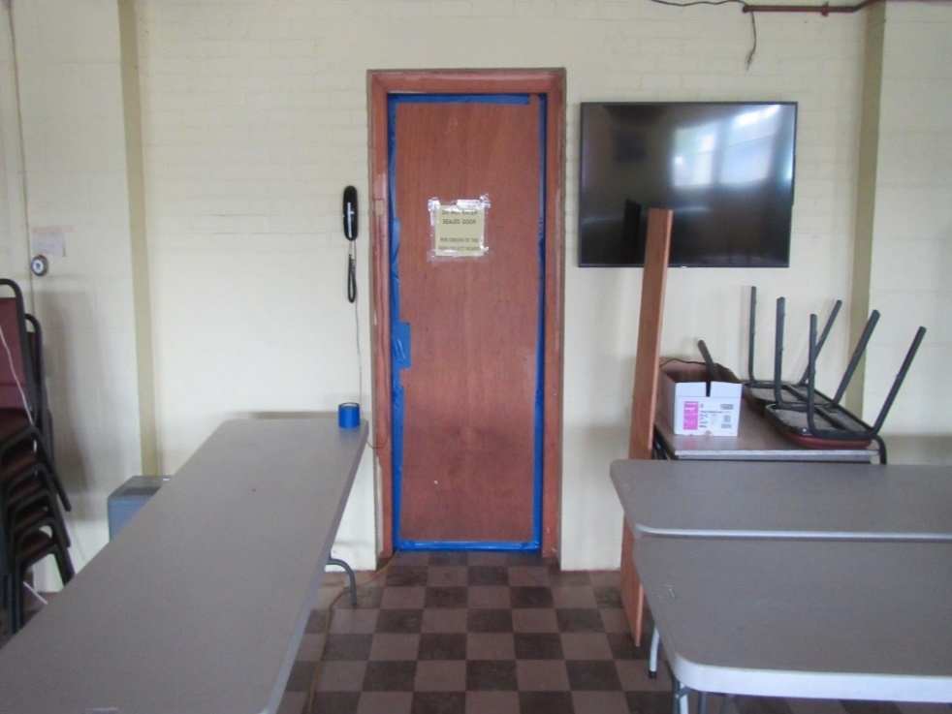

**Cellar access door in meeting hall**

**Picture 2**

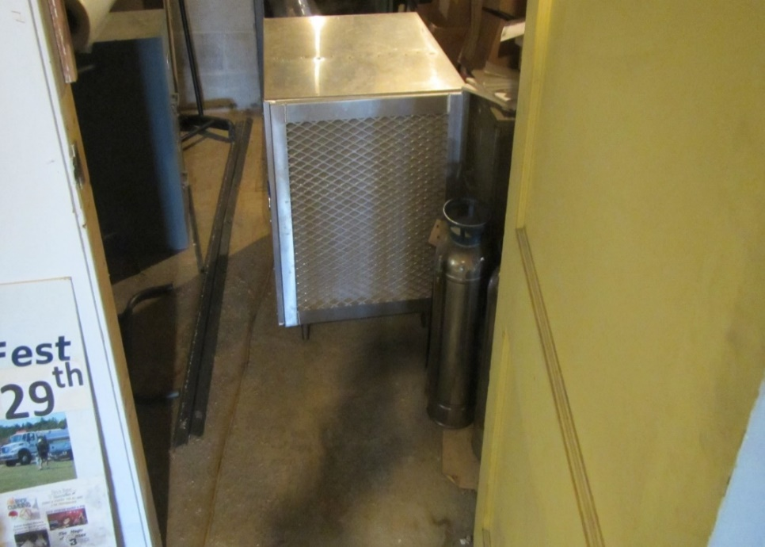

**Dehumidification unit in cellar**

**Picture 3**

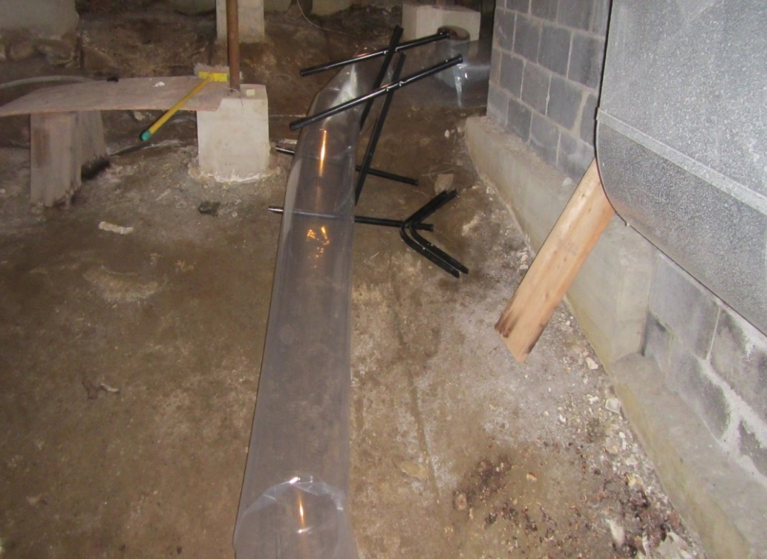

**Plastic tube used to vent exhaust air from dehumidifier**

**Picture 4**

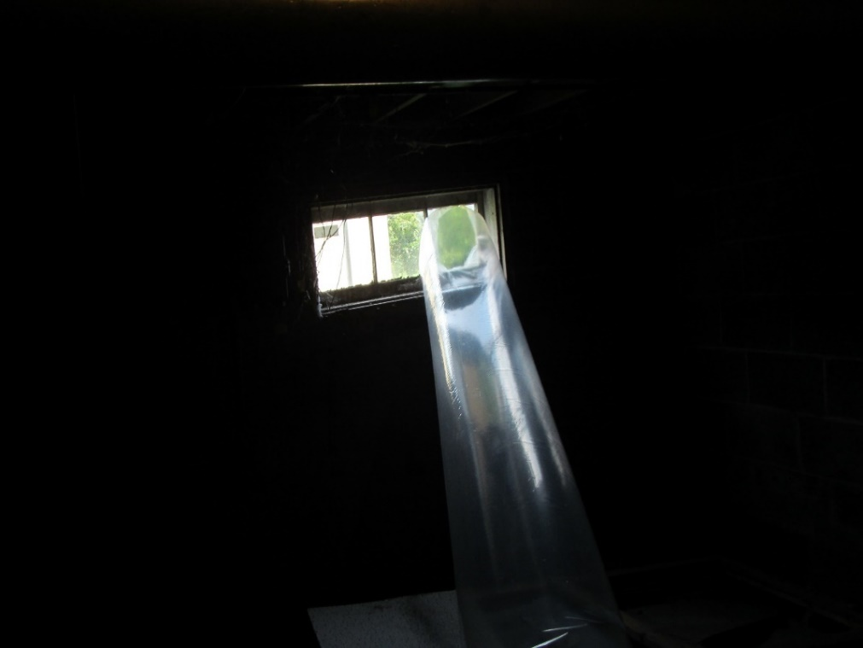

**Plastic tube used to vent exhaust air from dehumidifier connected to cellar window**

**Picture 5**

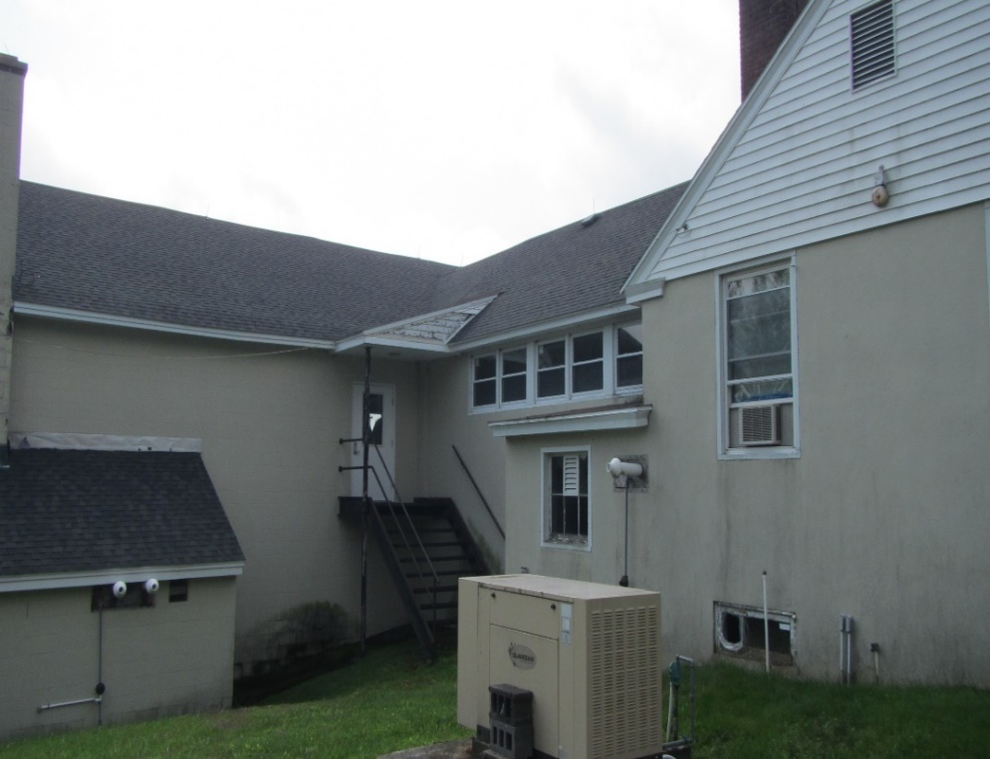

**Exterior view of cellar window, (blue arrow pointing to plastic tube in window)**

**Picture 6**

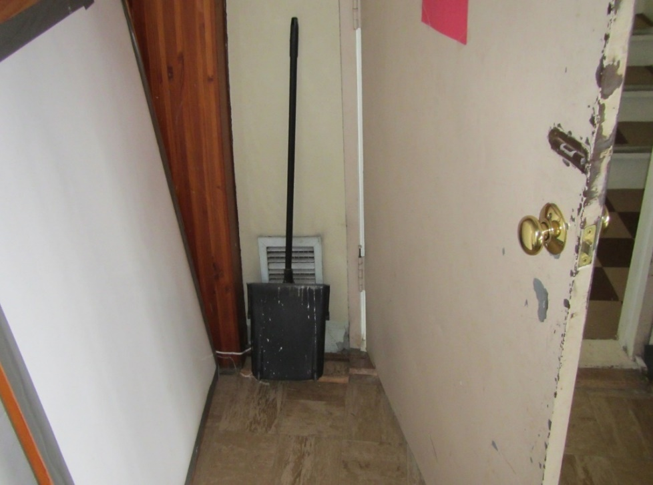

**Vent opening in meeting hall**

**Picture 7**

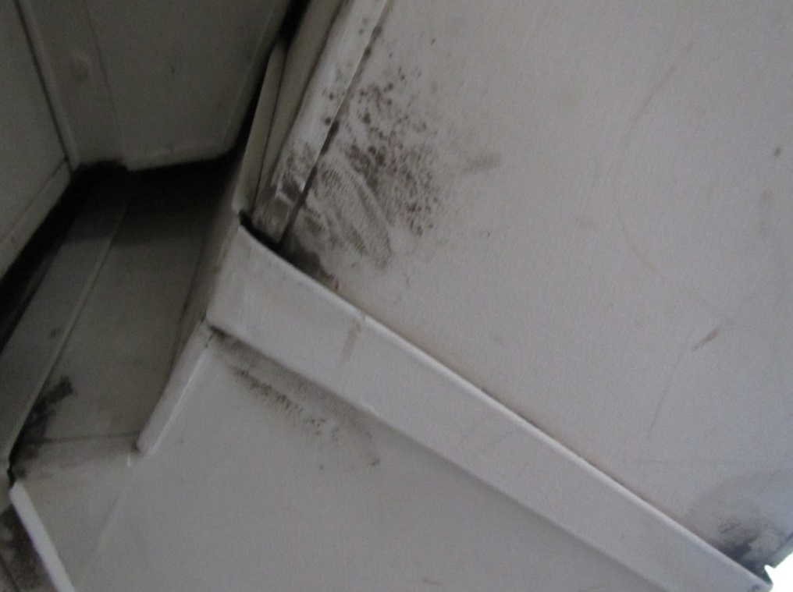

**Seam with debris, indicating an opening in meeting hall**