Do You Rent Your Home?
Look Out for Pests!
Pests like cockroaches, bedbugs, and rodents can carry diseases that can make people sick. Owners and renters need to work together to prevent pests, or, if you already have pests, to get rid of them and keep them away. Sometimes pesticides or other kinds of extermination are used to kill pests. You must be given at least 48 hours’ notice before any kind of extermination is done.
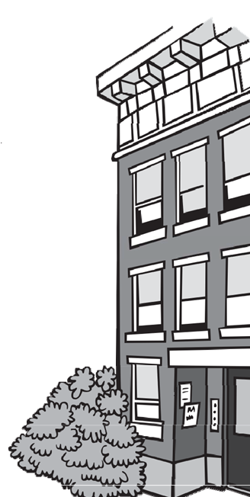

Help, I have pests in my home!
- Tell the owner right away if you see pests like cockroaches or rodents.
- Just like people, pests need food and water to live. Don't make it easy for them!
  - Keep a tight lid on trash cans. Compost carefully and cover food scraps.
  - Clean up left over food and crumbs immediately.
  - Wash dirty dishes right away; don't leave them on the counter or in the sink. When you are done, dry them and drain the sink.
  - Store food like pasta, rice, flour, and cereal in tightly covered containers.
  - Always clean up standing water right away and tell the owner if there is a leaky faucet or pipe in your home.
  - Don't let water sit in, or leak out of, flowerpots or plants.
- Pests also like places to hide:
  - Keep your home clean and free from clutter. Don't store piles of paper bags, newspapers, or cardboard boxes.
  - Check bags and boxes before you bring them into your home.
  - If you see pests in certain places, show your landlord and ask them to seal up cracks, holes, and hiding places.

Pest control takes TEAMWORK.
If you are doing your part, but the owner hasn't helped, call your local health authority and ask for a housing inspection.
Pest Control Guidance for Renters
The EPA says the best way to control pests is to:
Dry them out, Starve them out, and Keep them out!

Does a professional need to apply pesticides?
If you live in an owner occupied 2 or 3 family home, then the owner can use baits, traps, or pesticides themselves. If the owner doesn't live there or if you live in a building with 4 or more units, then a professional pesticide applicator must place the baits, traps, and/or apply the pesticides. Many pesticides are poison and should not be touched. If they are not used carefully, they can hurt people and pets too. Make sure traps are placed where children and pets can’t reach them.

If you or someone else is applying pesticides, beware and prepare!
Look at the Label:
- Read and follow the important safety information on the label.
- Ask the owner to give you the information on the label. Professional pesticide applicators will leave you product information.
- To learn about pesticide labels, visit: http://npic.orst.edu/outreach/labelinfographic.jpg
You should know:
- Where the pesticides will be applied inside and outside your home.
- Who will apply the pesticides.
- When the appointment is scheduled. The owner should provide you at least 48 hours' notice.
How to Prepare:
- If you have young children, put their toys away, especially toys they put in their mouths. Food, dishes, and pet food and bowls should be put away, so that the pesticide doesn’t get on them.
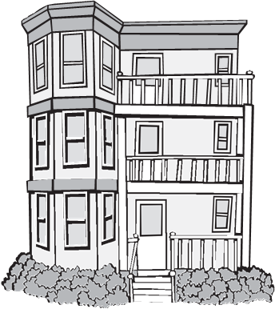
- Make sure that the person applying the pesticide can easily get to areas where you see pests. You may need to clear out areas under sinks, in closets, or in sheds.
- You may have to leave your home during the
Application; take your pets with you.

What do I do if there is a problem with
the pesticide application?
If you think the pesticide is making you or your family sick, you should:
- Get fresh air.
- If the application was inside, go outside, open windows, or turn on fans.
- Talk to your doctor.
- Let the owner know there may be a problem.
If you think the pesticide was applied incorrectly or not in compliance with state or local laws, contact your local health authority or the Community Sanitation Program
EPA Pesticide hotline
(800) 858-7378

Massachusetts Poison Information Center: 1 (800) 222-1222

If a professional pesticide applicator was used, contact Massachusetts Pesticide Enforcement to ask about the license for the Company (617) 626-1781
2023

Massachusetts Department of Public Health
Bureau of Climate and Environmental Health

Community Sanitation Program (CSP)
Call: 1-617-624-5757
TTY: 1-617-624-5286
Email: communitysanitation@mass.gov
On the web: www.mass.gov/community-sanitation

