Pest Control Guidance for Landlords

Information for Rental Property Owners and Managers
Look Out for Pests!
Pests like cockroaches, bedbugs, and rodents can carry diseases that can make people sick. Owners and renters need to work together to prevent pests, or, if the property already has pests, to get rid of them and keep them away. Sometimes, pesticides or other kinds of extermination are used to kill pests. Occupants must be given at least 48 hours’ notice before any kind of extermination is done.
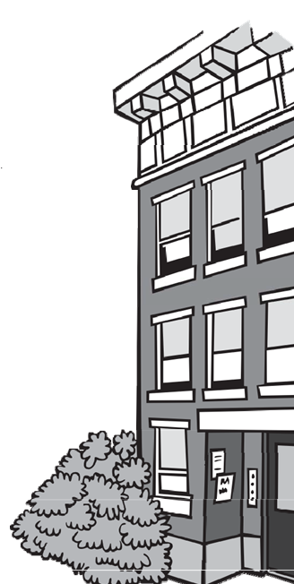

How can I prevent or get rid of pests?
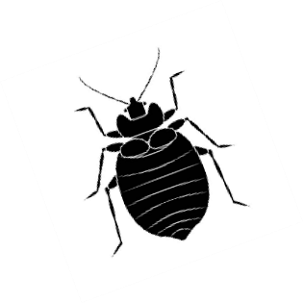
You are required to conduct, or have a professional conduct, a pre-occupancy pest inspection. You must keep records of when you inspected, repairs you made, products you used, where they were used, and dates of reinspection. If you receive a call from a tenant about pests in their home, you should inspect the property or have a professional inspect the property as soon as possible. Develop and implement a property specific plan that includes both chemical and non-chemical ways to prevent and control pests. Non-chemical prevention and control includes:
Keeping them outside:
- Trim any low or overhanging branches that are close to the house.
- Seal any cracks, holes, or other entry points around the outside of the home.
- Seal gaps under doors by installing door sweeps.
- Repair damaged screens on windows and doors.
- Seal any gaps around plumbing, electrical, oil, and gas pipes that may come into the residence through the walls, floors, and ceilings.
Keeping them out of the yard:
- Keep the grass short; rodents like tall grass.
- Provide tenants with rodent proof trash bins with covers to help eliminate
sources of food.
- If there are dumpsters, be sure they are kept closed and in good repair. Make sure trash is put inside dumpsters — not left on the ground nearby, where pests can easily access it.
- Restrict occupants from using bird feeders that are close to the house, since these feed rodents as well as birds.
Don't give them food or water:
- Repair water leaks right away. Encourage tenants to report leaks and explain why.
- Repair gutters and downspouts so that water drains away from the home.
- Encourage occupants to store their food in airtight containers, clean up crumbs right away, and cover garbage.

The EPA says the best way to control pests is to:
Dry them out, Starve them out, and Keep them out!

Can I apply pesticides?
If you do not live in the property, or if the property has 4 or more units, you are required to hire a licensed pesticide applicator to get rid of the pests. If you own a rental property that has 2 or 3 units AND you live in one of the units, then you may place traps, baits, and apply pesticides. Many pesticides are poison. If they are not used carefully, they can hurt you, your tenants, and pets too. When applying any pesticides:
- Give occupants at least 48 hours’ notice and include any safety preparations they need to make.
- Read the label and follow the manufacturer's instructions. Do not use more than is recommended.
- Protect yourself. Wear clothing that protects your skin (long sleeve shirt and long pants) and Personal Protective Equipment (PPE), like a face mask, eye protection, and appropriate gloves.
- Store pesticide chemicals in a secure, dry, and safe place.
- Tell the occupants where you have applied pesticides and if any safety precautions are necessary.
- Keep records of when you inspected, repairs you made, products you used, where they were used, and dates of reinspection.
- Place traps and bait where children and pets can’t reach them.
- Prevent accidentally poisoning wildlife and pets that might eat a dead animal; promptly remove and dispose of dead rodent carcasses.
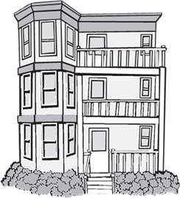
When is it time to hire a professional?

- If you have tried and failed to get the infestation under control, or if the problem reoccurs, you should consider hiring a professional.
- If you have asthma, respiratory issues, or chemical sensitivities, you should hire a professional to apply the pesticides.
- You are required to hire a professional if you don't live in the home or if it has more than 3 units.
What should you expect from a professional exterminator?
- They must be licensed and familiar with the pesticide application regulations.
- They will come to the property, inspect to see what the problem is, identify conditions that contribute to the infestation, and determine the best pesticides or traps to kill the pests. They will give you records about their inspections, applications, and reinspections.
- It may take several visits to get rid of the problem.
- They may need access to both common areas and specific units. You must give the occupants 48 hours’ notice of the extermination. Make sure the occupants are prepared and will allow access to the unit and any specified areas (e.g., closets).
Problems? Contact:

EPA Pesticide hotline:
(800) 858-7378

Massachusetts Poison Information Center: 1 (800) 222-1222

If a professional pesticide applicator was used, contact Massachusetts Pesticide Enforcement to ask about the license for the company:
(617) 626-1781
Ask to see:
• The current license for the exterminator.
• The label for the product they will use.
- Go to http://npic.orst.edu/outreach/labelinfographic.jpg to learn about labels.
You should know:
- Where the pesticides will be applied inside and outside of the house.
- Who to call if there is a problem (see blue box, to the right).

Massachusetts Department of Public Health
Bureau of Climate and Environmental Health

Community Sanitation Program (CSP)
Call: 1-617-624-5757
TTY: 1-617-624-5286
Email: communitysanitation@mass.gov
On the web: www.mass.gov/community-sanitation

