Peter DeMarco’s DPH presentation on Laura’s story

# SLIDE: LAURA’S PHOTO



As you can imagine, it’s never easy for me to review the tragic sequence of events that led to Laura’s death. She died because of a complete breakdown in both our emergency 911 system and our emergency healthcare system. But I will try to be succinct today and focus on those hospital elements that we as a workgroup have the ability to address by creating regulations to make sure this never happens again.

Regulations that will make everything as simple as possible for people in a medical crisis. People who are likely panicking, and at a much greater risk of making wrong choices when access elements are not clear. People who need help even before they get inside the hospital.

Dr. Sayah and I have presented Laura’s story together in the past, so I’m sure he will augment whatever I say.

Laura collapsed steps from the Emergency Department door of Somerville Hospital on Sept. 16, 2016. It seems incredible that anyone could die this way, but it happened. The most simple way I can explain this is by saying that Laura had 10 coin flips that morning, and she lost every one.

If just one, single thing had gone right for her, I think she’d be alive today. Instead, last Wednesday, I marked the 5th anniversary of her death. Five years without her in my life.

# CAMERA ON PETER

So what were those 10 coin flips? If you read Losing Laura, the Boston Globe story I wrote, then you know most of them. But I’ll go over them again so they’re more fresh in our minds.

Laura was alone when she had her attack about 4 a.m. She was staying just a few blocks from Somerville Hospital, so she figured it would be quicker to walk there than to call for help. It was a mistake on her part, she should have called for help. But she also had no idea of the difficulties that laid ahead.

Somerville Hospital cascades down the slope of Spring Hill. At the bottom of the hill are doctors daytime offices along a flat, main street called Highland Avenue. The ER and main hospital entrance are at the top of the hill along a different street.

NEW SLIDE: ER sign on Highland Ave

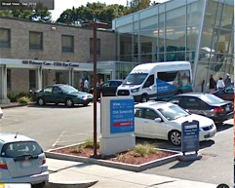

Laura got to the hospital by walking along the main street. There was a red and white “Emergency” sign on that main street. It gave no indication that the ER was up a steep hill, some 500 feet away. There was an arrow on that sign, but it pointed towards the doors Laura saw right in front of her, those daytime office doors. Because of this sign Laura might have thought those doors led to the emergency room. Struggling to breathe, she also just wanted to just get inside the hospital as fast as possible.

When Laura got to the door she found it locked, however. Wording on the door glass said ER patients had to enter the building through the Main Entrance. The sign didn’t say where the

Main Entrance was, so Laura had no idea how far away she was from safety. Somerville Hospital is a big series of buildings. To any patient seeing that that wording on the door, the Main Entrance could have been anywhere.

If you read Losing Laura, you know that the hospital security desk was left unattended all night long, with no one assigned to watch any hospital security camera. It was a major factor in her death. There was a security camera overlooking the parking lot in this area which picked up Laura as she walked from the sidewalk to the doctors office doors, but it lost sight of her once she walked under an overhang. If a camera had been placed directly outside those doors, and was being monitored when she got there, security would have seen Laura confused outside that door, and they could have sent someone to help her right then and there.

# SLIDE: ER PANIC BUTTON

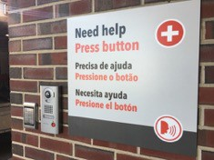

The other problem with this locked door was that there was no way for Laura to tell anyone that she was there. There was no intercom, no panic button, no 2-way video monitor, no “blue light” tower connected to 911 that you often see at college campuses. She was completely on her own.

This is part of our charge, to establish rules on the security monitoring of doors so that they are watched, and to mandate that hospitals don’t leave patients who mistakenly choose the wrong door panicked and confused and alone.

So Laura continued on. She returned to the main street and soon found another Emergency sign that pointed up the hill, up Tower Street. But she had no idea how far up she’d have to walk. She couldn’t see any hospital entrance when she looked up the street. The entrance could have been 100 feet away; it could have been 1,000 feet away. She didn’t know.

# SLIDE: TOWER STREET

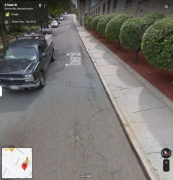

When I was writing Laura’s story I bought a 100-foot tape measure and measured the distance from where Laura saw that sign all the way up to the door of the emergency room. It was about 375 feet. To help you conceptualize 375 feet, it’s the distance a home run travels at Fenway Park. It’s an incredibly long way to walk for someone in a medical crisis when they are on flat ground, let along climbing up a hill.

But Laura had no indication of this. As she started up the hill, there were no signs along the way saying that she was still on the right path.

This is part of our charge, to establish rules on wayfinding, which is the science of placing signs so that people never get confused or have doubts about the direction they’re taking to get to their final destination. Laura walked up that hill in the darkness on blind faith that she’d find the emergency room somewhere. I’m sure she was very scared.

# SLIDE: DARKNESS

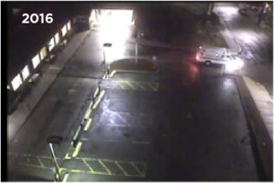

When Laura finally made it to the top of the hill she saw one sign at the entrance of the parking lot that said Emergency. It pointed toward the building. But that was the last sign of any help that she saw. As you know, one of the main reasons we are here today is because Somerville Hospital didn’t have a single sign above any door that indicated it was the emergency room.

Just blank facades. Laura saw two main entrances to the hospital, one on the left and one on the right, separated by about 100 feet between them. One was more brightly lighted, so she went to it instinctively, I believe.

When she got there she could see the ER waiting room through plate glass windows, so it made even more sense that she was in the right place. But she wasn’t in the right place. She walked up to the sliding doors, and they didn’t open. She had no idea she’d approached the ambulance bay entrance because there’s wasn’t appropriate signage.

# SLIDE: LAURA’S PATH

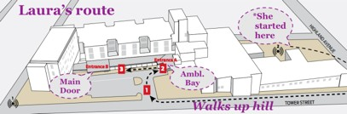

On a glass panel next to the sliding door there was wording indicating that the door was for ambulances only and that visitors needed to use the main entrance. I’m not sure whether Laura saw this or not - it was pretty innocuous, just white letters on glass. It didn’t say where the Main Entrance was.

A security camera was pointed directly at Laura. If anyone had been watching they would have seen her and seen how much trouble she was in. Again, there was no way for Laura to communicate to anyone that she was outside this locked door and near death. No intercom, no panic button, no two-way video monitor.

So Laura began walking in the only direction left—- down the pathway in front of the hospital that led to the second entrance, the entrance she had not chosen.

Again, that entrance just had a blank facade. It didn’t say Emergency. And it didn’t say Main Entrance, from any angle. The facade was completely blank.

So I’ve come to the hardest part of the story: the part where Laura can no longer breath, and she collapses.

The ambulance bay entrance was approximately 100 feet away from the hospital’s Main Entrance. But Laura’s attack had intensified, in part I believe because signage and the path she had to take to the ER was so confusing, and in part because she kept running into doors she couldn’t get into. When someone is suffering an asthma attack the very last thing you want them to do is panic even more. She couldn’t make it the whole 100 feet, so she sat down on a waiting bench, stopped breathing, and collapsed.

# SLIDE: LAURA’S BENCH

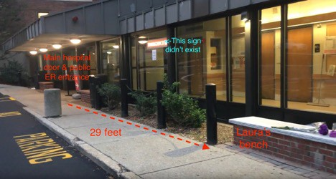

Laura was 29 feet from the Main Entrance door. That’s an incredibly short distance - about two parked cars. She was so close to safety, but she couldn’t get there.

And unfortunately, there were still more coin flips for Laura to lose.

The ambulance bay entrance was brightly lighted, as I told you. The Main Entrance was not brightly lighted. And the 100 feet between those two entrances was not at all well lighted. Laura had the bad luck of collapsing on a bench that was not lighted. She was almost in darkness, even though she was just 29 feet from the main door of the hospital.

One of our charges is to create regulations that address lighting outside Emergency Departments and hospital entrances. If there had just been a few extra light bulbs lighting the bench where Laura collapsed, she might have been seen by hospital staff when they peeked out the door. But they did not see her.

Again, Laura was on surveillance camera this whole time. If anyone had been watching the camera they would have seen Laura approach the ambulance bay, and then seen her walking towards the Main Entrance. But the bench where she collapsed was so dark, and the camera system so inadequate, that I’m not sure anyone would have seen her on camera at that point.

I won’t go into the details of Laura’s 911 call from that bench. If you read Losing Laura, you know that a nurse in the ER was eventually told that someone with an asthma attack was outside the hospital and could not get in.

That nurse never told hospital security about Laura even though two guards were standing steps away from her in the ER. It was a total failure in the emergency communication chain. We are charged with making regulations that will guarantee hospital security will fulfill their role, which in part requires working in conjunction with hospital staff whenever a patient is having difficulty getting inside an Emergency Department. Routine training and protocols across hospital departments should be part of our requirements.

I’ll end with a few more coin flips that Laura lost, and some closing thoughts.

SLIDE: SOMERVILLE HOSPITAL IN 2016

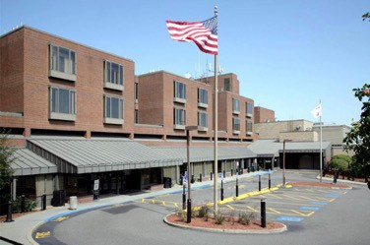

After Laura called 911, responders were sent to the hospital’s default address on that main street. They were sent to a spot that was nowhere near the Emergency Department because no one had ever bothered to assign a specific address to the Emergency Department. At the time Laura died, anyone who called an Uber to take them to the Somerville Hospital emergency room would also have ended up at those locked, daytime doctor’s offices. Cambridge Health Alliance has since changed that, and it’s really imperative that other hospitals do the same.

Some hospitals make sure there is a clear physical separation between their patient walk-in entrance and the entrance assigned to ambulances. But there are no regulations regarding this. At Somerville Hospital both entrances were along a contiguous stretch in front of the hospital, easily accessible by anyone either walking to the hospital or anyone driving to the main entrance to drop someone off. There need to be regulations calling for the separation of these entrances so that no one mistakes one for the other.

The way a hospital looks during the day is far different than how it looks at night. We are charged with creating regulations that address all conditions — or more accurately, the worst of all conditions, such as approaching a hospital alone on foot in the middle of the night. Dr. Sayah and his processor at Cambridge Health Alliance, Patrick Wardell, told me they’d just never considered the situation Laura found herself in. That is why regulations and oversight and period reviews of emergency access are so necessary. They are needed to help hospitals see what they might never consider on their own, or might be missing. That is part of our charge as well.

# SLIDE: LAURA FINAL

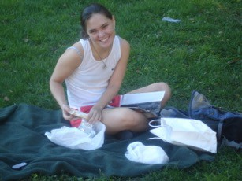

You have between three and six minutes to live once you stop breathing. It’s an impossibly short amount of time that goes by in a flash. Any impediment to getting as fast as you can inside an Emergency Room could mean life or death if you’re having a heart attack, a stroke, if you’re suffering from a drug overdose, or you’re in the midst of an asthma attack.

Just think of all time Laura lost —did she lose a minute going to those daytime doctors office doors? Did she pause 30 seconds at the bottom of Tower Street staring up that big, dark hill? Would she have made it inside the Main Entrance if she hadn’t wasted a minute trying to get into the Ambulance Bay? Every single delay mattered to her life.

This is why we need to make sure we eliminate as many obstacles as we can through clear regulations that address signage, wayfinding, lighting, the security monitoring of doors and security protocols. At the very least we need to address all of the safety failures that contributed to Laura’s death, because we just can’t let anyone else in Massachusetts lose the coins flips that she did.

I look forward to hearing all of your ideas today and to sharing several of my own towards this goal.

[END]