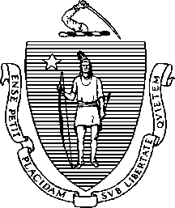
The Commonwealth of Massachusetts
Executive Office of Health and Human Services Department of Public Health
Bureau of Health Care Safety and Quality Office of Emergency Medical Services Mobile Integrated Health Care Program 67 Forest Street, Marlborough MA 01752

CHARLES D. BAKER
Governor
KARYN E. POLITO
Lieutenant Governor
MARYLOU SUDDERS
Secretary
MARGRET R. COOKE
Acting Commissioner

Petition for Addition of, or Exclusion from, the

Tel: 617-624-6000
www.mass.gov/dph

List of Pre-Approved Community EMS Program Services

Community EMS is a system of collaborative care in which EMS Personnel of a primary ambulance service partner with a local public health authority to support illness or injury prevention efforts through high-value public health services. The Department of Public Health (Department) has defined a list of approved Community EMS Program services which programs may apply to provide, based on the needs of the community that they serve.

Pursuant to 105 CMR 173.060(B), Community EMS Programs may also request that the Department add to, or exclude from, the list of pre-approved services that the individual Community EMS applicants can apply for or request an exclusion.

Please complete and submit this form to petition for the addition of (or exclusion from) the List of Pre-Approved Community EMS Services. Please attach and submit additional documents, program descriptions, and letters of support to support this petition

Name of Additional (or Excluded) Service:
*If new service proposed, description of Proposed Service:

Supporting Evidence

* Description, at a minimum, should outline how proposed service is consistent with community health needs, population to be served, and resource(s) that will provide service.

Please identify a point of contact for your organization.

Name:

Title:

Organization:

Phone Number:

Email:

Please email completed form and additional documentation to MIH@mass.gov. Questions should be directed to the MIH Program at MIH@mass.gov or 781-675-0478.

