This fact sheet provides information about PFAS in fish from freshwater locations in

Massachusetts and how to minimize exposure by following DPH Fish Consumption Advisories.

**Massachusetts Department of Public Health**

**PFAS (Per- and Polyfluoroalkyl Substances) in Recreationally Caught Fish**

**Guidance on how to minimize exposure to PFAS in local fish**

**What are PFAS?**



Per- and polyfluoroalkyl substances (PFAS) are a group of chemicals used since the 1950s to manufacture stain-resistant, water-resistant, and non-stick products. PFAS are widely used in common consumer products such as food packaging, outdoor clothing, coatings, carpets, leather goods, and other products. They have also been used in firefighting foam, as well is in other industrial processes. Perfluorooctanoic acid (PFOA) and perfluorooctane sulfonate (PFOS) have been the most extensively produced and studied of these chemicals.

**How can PFAS affect my health?**

Studies of laboratory animals and people indicate that exposure to PFAS can cause adverse health effects. In humans, PFAS have been associated with increased levels of cholesterol and liver enzymes, increased risk of high blood pressure or pre-eclampsia during pregnancy, slightly decreased birth weights, and decreased response to vaccines in children. There is also evidence that long-term exposure to elevated levels of PFOA may increase the risk of both kidney and testicular cancer in humans.

It’s important to keep in mind that the likelihood of experiencing health effects associated with PFAS increases with the amount of PFAS that a person has been exposed to. It’s also important to keep in mind that health effects associated with PFAS are not specific to PFAS – they can also be caused by many other factors. As a result, it is not possible to link a person’s PFAS exposure to any previous, current, or future health effects. If you have specific health concerns, you should consult with your medical provider.

Despite extensive research, there are still some gaps in scientists’ understanding of PFAS toxicity. Currently, scientists are still learning about the health effects of exposures to mixtures of types of PFAS and about differences in how laboratory animals and humans respond to PFAS.

**How are people exposed to PFAS?**

While most people are exposed through consumption of food and use of consumer products, drinking water can also be a source in communities where these chemicals have contaminated the water supplies. Such contamination is typically localized and associated with a specific facility (e.g. an industrial facility where these chemicals were produced or used to manufacture other products or where firefighting foam was used). Eating fish from surface waterbodies that are contaminated with PFAS can also be a source of exposure.

**Why is the Department of Public Health (DPH) testing fish for PFAS?**

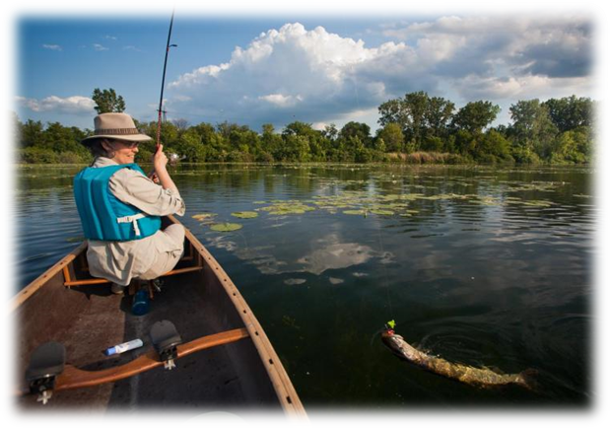

Since 2015 PFAS have been detected in groundwater, surface water, and residential drinking water wells associated with contaminated sites in Massachusetts.  Recent surveillance of surface water by the Massachusetts Department of Environmental Protection (MassDEP) and the US Geological Survey indicates that PFAS may be present in Massachusetts waterbodies at concentrations as high as 109 parts per trillion (ppt).  As this PFAS may not always be associated with any known point-source or site-related contamination, it is important to determine if these locations are safe for recreational activities such as swimming and fishing.

Given that PFAS are chemicals of health concern with widespread occurrence in the environment, DPH conducts routine monitoring of surface water and fish in Massachusetts waterbodies, to evaluate whether they are safe for recreational activities such as swimming, and whether fish are safe for eating.

For information about PFAS fish consumption advisories see:

<https://www.mass.gov/lists/fish-consumption-advisories>

**How are PFAS fish consumption advisories established?**

When chemicals such as PFAS are identified in food, such as fish, health agencies conduct a safety assessment to evaluate whether levels present in food present a possible human health concern.  The DPH approach for evaluating PFAS in food considers several factors, including whether there is an established state or federal “action level”, how much of the specific food people eat, the level measured in the food, and the potential toxicity of the chemical.

Fish Consumption Advisories are risk-based recommendations on the number of fish from a specific waterbody that is safe to eat (e.g., servings per day, week, month, or year). The recommendation is informed by the measured concentration of chemicals in a sample of fish that are representative of a specific waterbody. As the concentration of chemicals in fish increases, the amount of fish you should eat decreases. Fish consumption advisories apply to the consumption of all native game fish but do not apply to stocked trout at a waterbody. Stocked fish are raised in fish hatcheries and then released. Therefore, they are unlikely to spend enough time in a waterbody to become contaminated.

The underlying basis for the recommendation is an established toxicity criterion, which represents the amount of chemical that an individual can be exposed to every day without experiencing adverse health effects. Consistent with the US Food and Drug Administration, DPH uses the “minimal risk levels” (MRLs) from the federal Agency for Toxic Substances and Disease Registry’s May 2021 Toxicological Profile for Perfluoroalkyls to evaluate a safe level of exposure to PFAS.

**How long are PFAS fish consumption advisories in effect?**

Fish consumption advisories are recommendations based on the state of the science that is available at the time they are issued. The advisories may be updated as new information becomes available that changes our understanding of the relationship between exposure to PFAS and the potential for human health effects.

The best way to limit your exposure to PFAS in fish is to observe posted fish advisory signage

and check the latest recreational fish consumption advisories online at

<https://www.mass.gov/lists/fish-consumption-advisories>.

**If I ate more fish than the recommended consumption advisory, would it harm my health?**

Eating more fish than the recommended consumption advisory does not necessarily mean that you have been harmed or will get sick. This is because the advisory is very conservative and designed to ensure that the most sensitive individuals are protected. The DPH fish consumption advisories assume that all recreationally caught fish from the waterbody are contaminated with PFAS, and that these fish would be consumed for several months. Any potential health risks would only be expected if an individual continuously ate fish with high levels of PFAS at a rate of consumption significantly higher than the DPH advisory.

**Is there a way of cleaning or cooking the fish to get rid of the PFAS?**

No. If a fish contains PFAS, there is no way to remove it. It cannot be cut, cleaned, or cooked out.

**Is it safe to still go fishing if I don’t eat the fish?**

Yes, fishing for recreation is safe in these waterbodies if you don’t eat the fish.

**Can I safely swim, wade, or boat in waterbodies that have PFAS fish consumption advisories?**

Yes, potential exposure to PFAS associated with swimming, wading, and boating would be much less than exposure from drinking water or eating fish containing PFAS. These recreational activities are considered safe because they would not result in significant exposure over a long period of time, and because very little PFAS are absorbed through the skin.



**What can I do to limit my exposure to PFAS?**

PFAS are found at low levels in the environment, consumer products, and food, so it is nearly impossible to eliminate all exposure. Drinking water can also be an additional source of exposure in communities where PFAS have contaminated water supplies.

To limit your exposure to PFAS in fish, consider eating stocked trout at a waterbody. Stocked fish are raised in fish hatcheries and then released. Therefore, they are unlikely to spend enough time in a waterbody to become contaminated. For all other fish, DPH recommends following fish consumption advisories at tested waterbodies and eating a variety of fish from safe sources.

**Where can I find out more information about PFAS?**

Please visit the ATSDR website (<https://www.atsdr.cdc.gov/pfas/index.html>)

**Where can I find out more information about Recreational Fish Consumption Advisories?**

<https://www.mass.gov/lists/fish-consumption-advisories>

**Where can I find out more information about PFAS in food?**

<https://www.fda.gov/food/chemical-contaminants-food/questions-and-answers-pfas-food>

**Who can I contact if I have more questions about this issue in Massachusetts?**

Please contact the Environmental Toxicology Program at the Massachusetts Department of Public Health at 617-624-5757.



April 2019

February 2023

Massachusetts Department of Public Health

Bureau of Environmental Health

250 Washington Street, 7th Floor, Boston, MA 02108

Phone: 617-624-5757 | Fax: 617-624-5777 | TTY: 617-624-5286

Website <https://www.mass.gov/orgs/bureau-of-environmental-health>

