Massachusetts Department of Environmental Protection APP-1
Bureau of Water Resources – Drinking Water Program
PFAS Initial Monitoring Waiver Application
COM & NTNC
310 CMR 22.07G(5)(c)

See source protection materials here: https://www.mass.gov/doc/land-use-pollution-potential-matrix/download | C. Source Protection (Complete a separate Section C for each of your sources)
 | By signing this form, I attest that I have reviewed the Zone A, Zone I, Zone II and/or IWPA for a source identified in Section B for the potential land uses/situations listed below and have both demonstrated and determined that there is no known or suspected PFAS contamination in the vicinity of the PWS or its sources of water.
Important: When filling out forms on the computer, use only the tab key to move your cursor - do not use the return key.  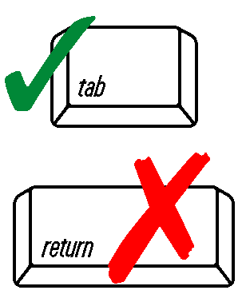 | Source Name and #
 | Land Use | Check one for  each land use |  |  |  | Indicate the Source Protection area used for this review; Zone A, Zone I, Zone II, and/or IWPA. | Information source/documentation
 |  | Present | Absent | Unknown/Not Evaluated |  |  | e.g., septic systems are residential only; information provided by [Name] Fire Dept.; etc.
 | Regulated landfills
 | Dumps
 | Manufacturing facilities
 | Fire-fighting foam usage, based on Fire Dept. Information
 | Fire training area
 | Fire Department location
 | Agriculture with biosolids application
 | Wastewater treatment facilities or on-site discharge (septic) systems
 | Hazardous waste site(s) under the MCP
 | Airports
 | Car Washes
 | Military use
 | Incinerators
 | Other
 | D. Certification
 | I submit this PFAS Initial Monitoring Waiver Application in accordance with 310 CMR 22.07G(5)(c) and I certify under penalty of law that I am the person authorized to fill out this form and the information contained herein is true, accurate, and complete to the best of my knowledge and belief.
 | Name: |  |  |  | Signature:
 | Position/Title:

