MA DPH has selected Appriss as the vendor for the new PMP solution. The Appriss solution provides both a new data collection tool (PMP Clearinghouse) and a new online PMP tool (Massachusetts Prescription Awareness Tool (MassPAT)). This document highlights what pharmacies need to know for the implementation of the new system. For more information, please visit: www.mass.gov/dph/dcp/pmp

Contents
Implementation Timeline 2
PMP Clearinghouse Compliance 3
Pharmacy Delinquency Reporting Trend 3
Zero Reporting 4
Data Submission Waivers in lieu of submitting daily zero reports 6
Data Quality 7
Follow-up 7

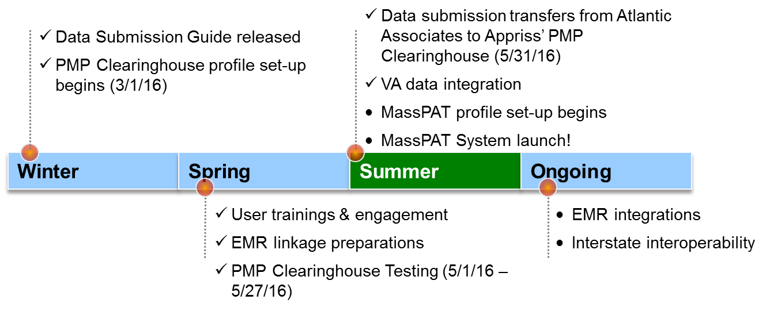
Implementation Timeline

Winter
- Dispensation Guide released
- PMP Clearinghouse profile set-up began 3/1/16
Spring
- User trainings & engagement
- EMR linkage preparations
- PMP Clearinghouse Testing (5/1/16 – 5/27/16)

Summer
- Data submission transfers from Atlantic Associates to Appriss’ PMP Clearinghouse (5/31/16)
- VA data integration
- MassPAT profile set-up begins
- MassPAT system launch!
Ongoing
- EMR integrations
- Interstate interoperability

PMP Clearinghouse Compliance
All data required within M.G.L. C. 94c, section 24a must be reported to the Prescription Monitoring Program on the next business day following the most recent transmission.

Pharmacy Delinquency Reporting Trend
As a reminder, pharmacies must submit dispensation data daily. If there are no dispensations to report, the pharmacy must submit a Zero Report to be compliant. If a pharmacy is regularly closed on Sunday, for example, the pharmacy is eligible to request a days of operations waiver.

Zero Reporting
If on any given day you have no dispensations to report, you must submit a zero report. To submit a report:
1. Navigate to Zero Reports in the PMP Clearinghouse menu bar.
2. Select Mass from the available states listed in the drop-down.
3. Enter the start date and end date for the report and click on the “Submit” button. (NCPDP and DEA number are optional)
4. The request will be submitted to PMP Clearinghouse.
For more information, including how to submit a zero report via sFTP, please see page 40 of the Data Submitters’ Guide.
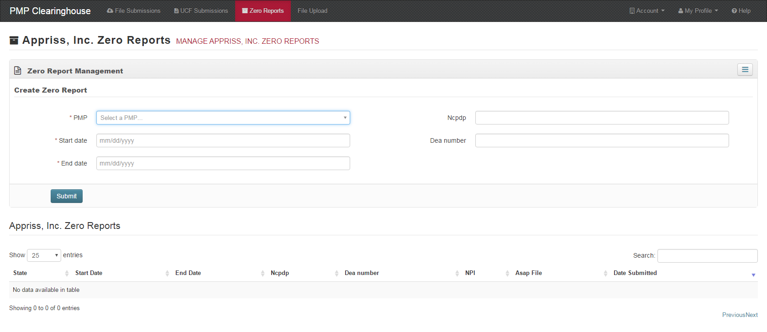
Screenshot of the Zero Report screen in PMP Clearinghouse.

Zero Report Specification
For more information, including how to submit a zero report via sFTP, please see page 40 of the Data Submitters’ Guide.
Element ID | Element Name | Requirement
TH – Transaction Header - Required
TH01 | 4.2 | R
TH02 | 123456 | R
TH05 | 20150101 | R
TH06 | 223000 | R
TH07 | P | R
TH09 | \\ | R
IS – Information Source – Required
IS01 | 6175555555 | R
IS02 | PHARMACY NAME | R
IS03 | #20160101#-#20160107# | O
PHA – Pharmacy Header – Required
PHA03 | ZZ1234567 | R
PAT – Patient Information – Required
PAT07 | REPORT | R
PAT08 | ZERO | R
DSP – Dispensing Record – Required
DSP05 | 20150101 | R
PRE – Prescriber Information
CDI – Compound Drug Ingredient Detail
AIR – Additional Information Reporting
TP – Pharmacy Trailer – Required
TP01 | 7 | R
TT – Transaction Trailer – Required
TT01 | 123456 | R
TT02 | 10 | R

Data Submission Waivers in lieu of submitting daily zero reports
- Annual Data Submission Waiver Request Form
  - Pharmacies that do not dispense Controlled Substances in Schedules II-V or any additional drugs that the Department has determined must be reported to the PMP may complete this form to request a waiver of the requirements that pharmacies must report to the PMP. Please submit the waiver to the Department by July 1st of each year via email to: mapmp.dph@State.MA.US
- Annual Days of Operation Data Submission Waiver Request Form
  - Pharmacies that are not open 7 days a week to dispense Controlled Substances in Schedules II-V or any additional drugs that the Department has determined must be reported to the PMP may complete this form to request a waiver of the requirements that pharmacies must report to the PMP every day. Pharmacies must indicate which days of the week they are open and will report to the PMP. Please submit the waiver to the Department by July 1st of each year via email to: mapmp.dph@State.MA.US
- Temporary Data Submission Waiver Request Form
  - Pharmacies that are not able to submit dispensing data to the Department due to unforeseen or emergency/disaster situations, must submit the completed form via email to: mapmp.dph@State.MA.US in order to remain in compliance with reporting obligations to the PMP. (M.G.L. c. 94C,,§24A).
Waiver request forms are available on the PMP website: www.mass.gov/dph/dcp/pmp

Data Quality
Pharmacies are critical partners in ensuring data accuracy. The program has started to notice trends in data quality. The most common errors are:
- Prescriber Information:
  - Drug Enforcement Administration (DEA) number (PRE 02)
  - Name (PRE 05 & 06)
- Patient Address
- Pick-up/Drop-off Relationship to Patient
- Payment Type
Please work with your pharmacists to ensure they are entering the correct information.

Follow-up
If we can be of any other assistance, please don’t hesitate to get in touch:
PMP general inbox: mapmp.dph@state.ma.us
PMP Clearinghouse helpdesk: 1-855-562-4767
DPH PMP helpdesk: 617-753-7310

Next Pharmacy Webinar
August 2; 1pm
https://attendee.gotowebinar.com/register/8220077947276771844

