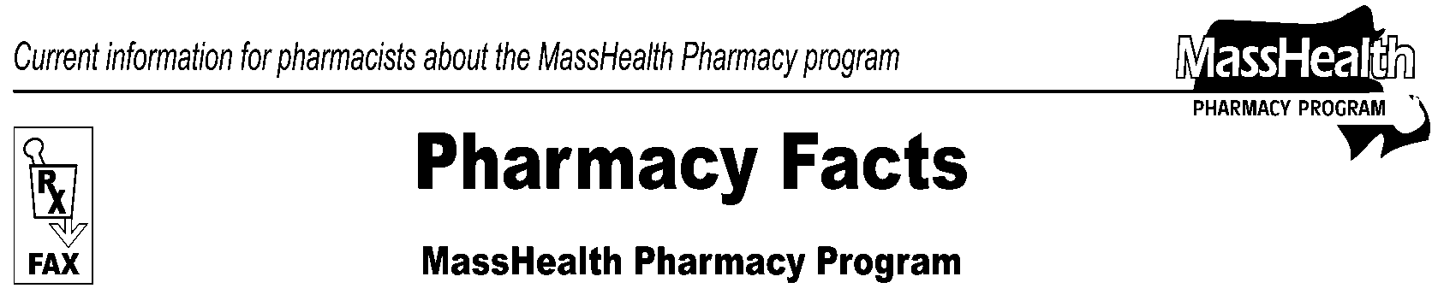
Page 1 of 2
Number 100
February 23, 2017
www.mass.gov/masshealth/pharmacy
• Editor: Vic Vangel • Contributors: Paul Jeffrey, Kim Lenz, James Monahan, Nancy Schiff, Vic Vangel •
MHDL Update  - Additions  Effective March 6, 2017, the following newly marketed drugs have been added to the MassHealth Drug List.  Adlyxin (lixisenatide) – PA  Basaglar (insulin glargine 100 units/mL prefilled syringe) – PA  Bromsite (bromfenac 0.075%) – PA  Inflectra (infliximab-dyyb) – PA  Lartruvo (olaratumab) – PA  Rayaldee (calcifediol) – PA  Soliqua (insulin glargine/lixisenatide) – PA  Sustol (granisetron extended-release injection) – PA > 2 units/ 28 days  Vemlidy (tenofovir alafenamide) – PA  Xultophy (insulin degludec/liraglutide) – PA  Yosprala (aspirin/omeprazole) – PA  Zinplava (bezlotoxumab) – PA  - Change in Prior Authorization Status  - Effective March 6, 2017, the following vitamin D analog agents will require prior authorization.  Hectorol (doxercalciferol capsule) – PA  Zemplar (paricalcitol capsule) – PA  - Effective March 6, 2017, the following vitamin D analog agents will be restricted to the health care professional who administers the drug. MassHealth will not pay for these drugs to be dispensed through a retail pharmacy.  Hectorol (doxercalciferol injection)^  Zemplar (paricalcitol injection)^  - Effective March 6, 2017, the following smoking cessation agents will no longer require prior authorization.  Nicotrol Inhaler (nicotine inhalation system)  Nicotrol NS (nicotine nasal spray)  - Effective March 6, 2017, the following smoking cessation agent will no longer require prior authorization for exceeding duration of therapy limits.  Chantix (varenicline)  - Effective March 6, 2017, the following scabicide agent will require prior authorization.  Eurax (crotamiton) – PA | - MassHealth Brand Name Preferred Over Generic Drug List  - Effective March 6, 2017, the following anti-acne dermatological agents will be added to the Brand Name Preferred Over Generic Drug List.  Differin (adapalene) ^{BP} – PA  Retin-A (tretinoin) ^{BP} – PA ≥ 22 years  - Effective March 6, 2017, the following inhaled respiratory agents will be added to the Brand Name Preferred Over Generic Drug List.  Advair (fluticasone/salmeterol) ^{BP} – PA  Proair HFA (albuterol inhaler) ^{BP}  - Effective March 6, 2017, the following lipid lowering agent will be added to the Brand Name Preferred Over Generic Drug List.  Vytorin (ezetimibe/simvastatin) ^{BP} – PA  - Effective March 6, 2017, the following antidepressant agent will be added to the Brand Name Preferred Over Generic Drug List.  Pristiq (desvenlafaxine succinate extended-release) ^{BP} – PA  - Effective March 6, 2017, the following Attention-Deficit/ Hyperactivity Disorder agent will be added to the Brand Name Preferred Over Generic Drug List.  Strattera (atomoxetine) ^{BP} – PA < 6 years  ^{PA} Prior authorization is required. The prescriber must obtain prior authorization for the drug in order for the pharmacy to receive payment. Note: Prior authorization applies to both the brand-name and the FDA “A”-rated generic equivalent of listed product.  # This designates a brand-name drug with FDA “A”-rated generic equivalents. Prior authorization is required for the brand, unless a particular form of that drug (for example, tablet, capsule, or liquid) does not have an FDA “A”-rated generic equivalent.  ^{BP} Brand Preferred over generic equivalents. In general, MassHealth requires a trial of the preferred drug or clinical rationale for prescribing the non-preferred drug generic equivalent.  * The generic OTC and, if any, generic prescription versions of the drug are payable under MassHealth without prior authorization.  ^ This drug is available through the health care professional who administers the drug. MassHealth does not pay for this drug to be dispensed through a retail pharmacy.

Cost of Dispensing Survey
Many MassHealth Pharmacy Providers participated in a cost of dispensing survey performed by Myers and Stauffer LC, beginning in September 2016. A summary of that survey has been posted on the MassHealth Pharmacy Web Site.

To view the summary, go to www.mass.gov/masshealth/pharmacy and click on the link for MassHealth Cost of Dispensing Survey Report.
Please direct any questions or comments (or to be taken off of this fax distribution) to
Victor Moquin of ACS at 617-423-9830.
Pharmacy Facts, Number 100
Page 2 of 2

