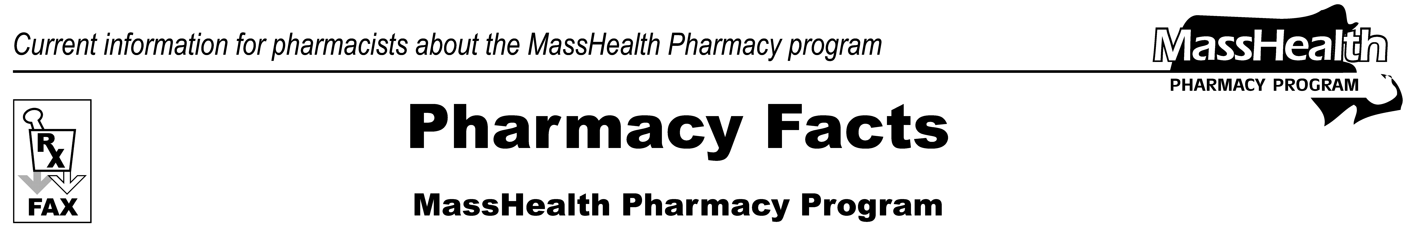
www.mass.gov/masshealth/pharmacy
Number 102
April 24, 2017
Page 1 of 2
• Editor: Vic Vangel • Contributors: Paul Jeffrey, Kim Lenz, James Monahan, Nancy Schiff •

MHDL Update
Below are some updates to the MassHealth Drug List (MHDL). For a complete updated listing, see the MHDL.
Additions
Effective April 24, 2017, the following newly marketed drugs have been added to the MassHealth Drug List.
Rubraca (rucaparib) – PA
Spinraza (nusinersen) – PA
Triferic (ferric pyrophosphate citrate) ^
Changes in Prior Authorization Status
Effective April 24, 2017, the following opioid agent requires prior authorization for all doses.
levorphanol tablet – PA
Effective April 24, 2017, the following antihistamine agent no longer requires prior authorization.
Xyzal # (levocetirizine tablet)
Effective April 24, 2017, the following intranasal antihistamine agent no longer requires prior authorization within quantity limits.
azelastine 137 mcg nasal spray – PA > 1 inhaler/month
Effective April 24, 2017, the following anticholinergic agent requires prior authorization.
Robinul (glycopyrrolate injection) – PA
Effective April 24, 2017, the following thyroid preparation agent no longer requires prior authorization.
Tirosint (levothyroxine)

MassHealth Brand Name Preferred Over Generic Drug List
Effective April 24, 2017, the following Attention-Deficit/Hyperactivity Disorder agent has been added to the MassHealth Brand Name Preferred Over Generic Drug List.

Kapvay (clonidine extended-release tablet) ^{BP} – PA

Effective April 24, 2017, the following topical immune suppressant has been added to the MassHealth Brand Name Preferred Over Generic Drug List.

Protopic (tacrolimus topical) ^{BP} – PA

Effective April 24, 2017, the following topical nonsteroidal anti-inflammatory agent has been added to the MassHealth Brand Name Preferred Over Generic Drug List.

Voltaren Gel (diclofenac 1% gel) ^{BP} – PA >100 grams/month

Effective April 24, 2017, the following dermatological agent has been added to the MassHealth Brand Name Preferred Over Generic Drug List.

Tazorac (tazarotene) ^{BP} – PA

Legend
PA Prior authorization is required. The prescriber must obtain prior authorization for the drug in order for the pharmacy to receive payment. Note: Prior authorization applies to both the brand-name and the FDA “A”-rated generic equivalent of listed product.
# This designates a brand-name drug with FDA “A”-rated generic equivalents. Prior authorization is required for the brand, unless a particular form of that drug (for example, tablet, capsule, or liquid) does not have an FDA “A”-rated generic equivalent.

^{BP} Brand Preferred over generic equivalents. In general, MassHealth requires a trial of the preferred drug or clinical rationale for prescribing the non-preferred drug generic equivalent.

* The generic OTC and, if any, generic prescription versions of the drug are payable under MassHealth without prior authorization.
̂ This drug is available through the health care professional who administers the drug. MassHealth does not pay for this drug to be dispensed through a retail pharmacy.

Please direct any questions or comments (or to be taken off this fax distribution) to Victor Moquin of Xerox at 617-423-9830.

