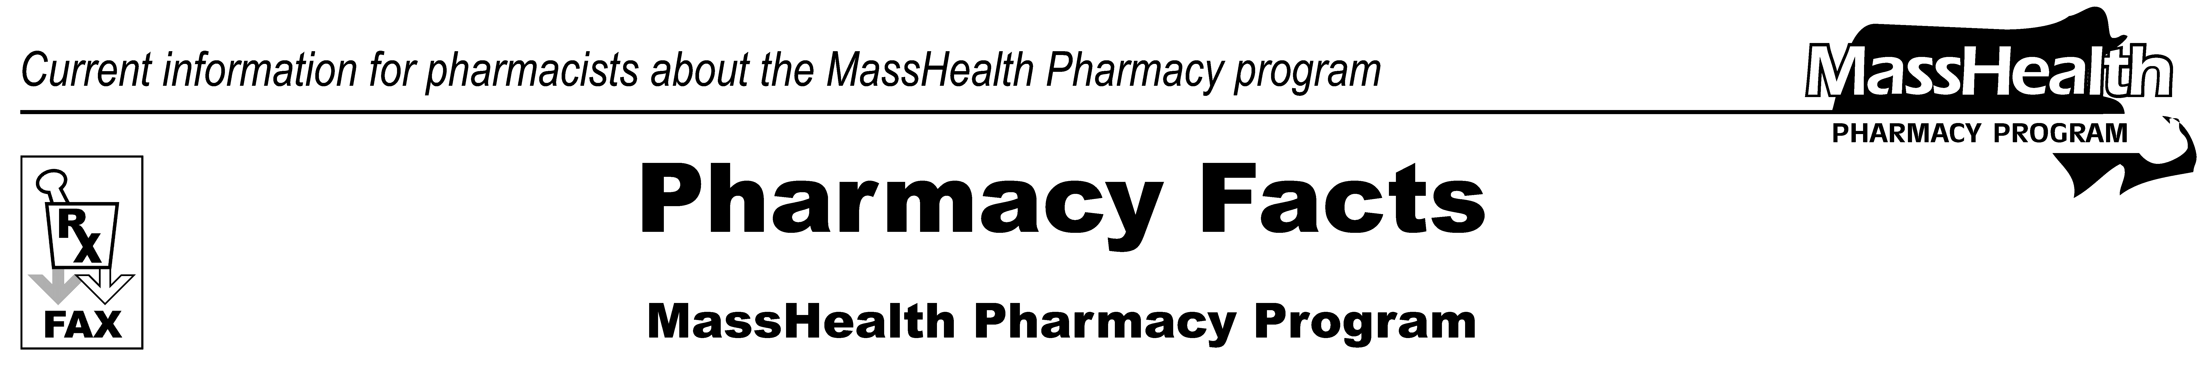
www.mass.gov/masshealth/pharmacy
Number 103
May 26, 2017
• Editor: Vic Vangel • Contributors: Paul Jeffrey, Kim Lenz, James Monahan, Nancy Schiff, Vic Vangel •
MHDL Updates  - Additions  Effective May 30, 2017, the following newly marketed drugs have been added to the MassHealth Drug List.  Arymo ER (morphine extended-release tablet) – PA  ergotamine – PA  Eucrisa (crisaborole) – PA  Siliq (brodalumab) – PA  Trulance (plecanatide) – PA  - Change in Prior-Authorization Status  - Effective May 30, 2017, the following gastrointestinal anti-inflammatory agents will require prior authorization.  Dipentum (olsalazine) – PA  Pentasa (mesalamine controlled-release) – PA  - Effective May 30, 2017, the following ergot alkaloid agents will require prior authorization.  D.H.E. 45 (dihydroergotamine injection) – PA  ergotamine/caffeine tablet – PA  ergotamine/caffeine suppository – PA  - Effective May 30, 2017, the following kinase inhibitor will require prior authorization.  Votrient (pazopanib) – PA | Footnotes:  ^{PA} Prior authorization is required. The prescriber must obtain prior authorization for the drug in order for the pharmacy to receive payment. Note: Prior authorization applies to both the brand-name and the FDA “A”-rated generic equivalent of listed product.  # This designates a brand-name drug with FDA “A”-rated generic equivalents. Prior authorization is required for the brand, unless a particular form of that drug (for example, tablet, capsule, or liquid) does not have an FDA “A”-rated generic equivalent.  ^{BP} Brand Preferred over generic equivalents. In general, MassHealth requires a trial of the preferred drug or clinical rationale for prescribing the non-preferred drug generic equivalent.  * The generic OTC and, if any, generic prescription versions of the drug are payable under MassHealth without prior authorization.  ^ This drug is available through the health care professional who administers the drug. MassHealth does not pay for this drug to be dispensed through a retail pharmacy.
Please direct any questions or comments (or to be taken off of this fax distribution) to
Victor Moquin of Xerox at 617-423-9830.

