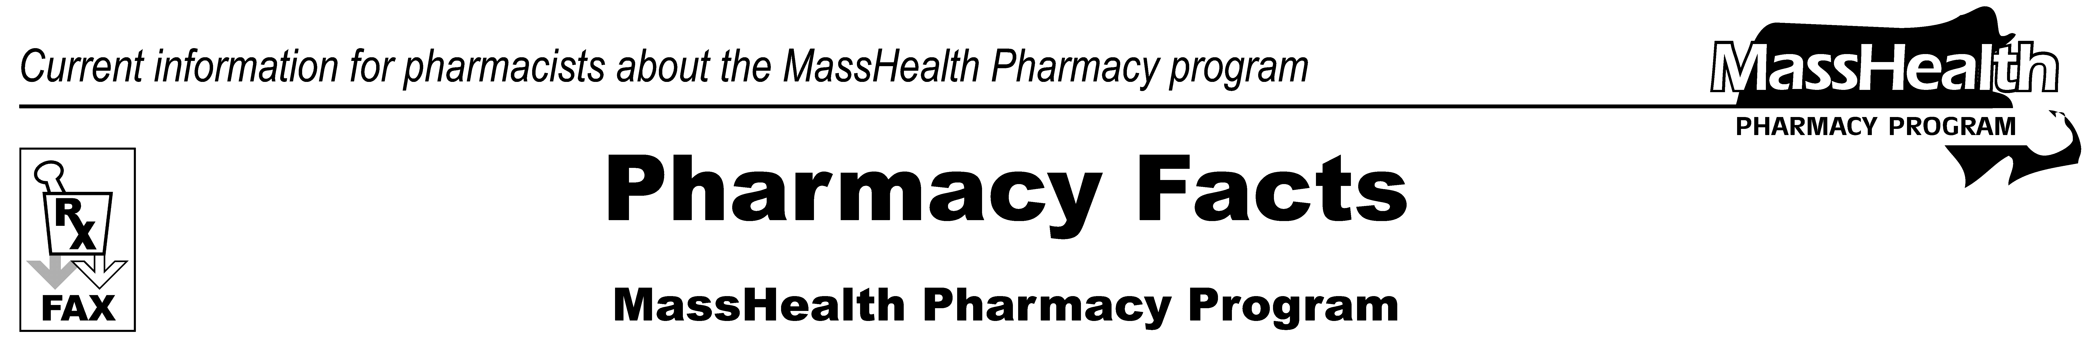
www.mass.gov/masshealth/pharmacy
Number 104
June 28, 2017
• Editor: Vic Vangel • Contributors: Paul Jeffrey, Kim Lenz, James Monahan, Nancy Schiff, Vic Vangel •
MHDL Updates  Below are certain updates to the MassHealth Drug List (MHDL). See the MHDL for a complete listing of updates.  Please pay close attention to addition of Concerta to MassHealth Brand Name Preferred Over Generic Drug List as noted below.  - Additions  Effective July 5, 2017, the following newly marketed drugs have been added to the MassHealth Drug List.  Bavencio (avelumab) – PA  Dupixent (dupilumab) – PA  Kisqali (ribociclib) – PA  Kisqali-Femara Co-Pack (ribociclib/letrozole) – PA  Ocrevus (ocrelizumab) – PA  Rhofade (oxymetazoline cream) – PA  Stamaril (yellow fever vaccine, live)  Synjardy XR (empagliflozin/metformin extended-release) – PA  Xermelo (telotristat ethyl) – PA  - New FDA “A”-Rated Generics  Effective July 5, 2017, the following FDA “A”-rated generic drugs have been added to the MassHealth Drug List. The brand name is listed with a # symbol, to indicate that prior authorization is required for the brand.  New FDA “A”-Rated  Generic Drug Generic Equivalent of  clofarabine Clolar #  trimipramine – PA < 6 years Surmontil #  - Change in Prior-Authorization Status  - Effective July 5, 2017, the following topical agent will require prior authorization.  Prudoxin (doxepin cream) – PA  Zonalon (doxepin cream) – PA  - Effective July 5, 2017, the following epinephrine auto-injection products will require prior authorization.  Epipen (epinephrine 0.3 mg auto-injection) – PA  Epipen Jr (epinephrine 0.15 mg auto-injection) – PA  - Effective July 5, 2017, the following epinephrine auto-injection product will no longer require prior authorization  epinephrine auto-injection | - Updated MassHealth Brand Name Preferred Over Generic (BNPOG) Drug List  - Effective July 5, 2017, the following antiviral agent will be removed from the MassHealth BNPOG Drug List  Epzicom # (abacavir/lamivudine)  - Effective July 5, 2017, the following cerebral stimulant will be added to the MassHealth BNPOG Drug List.  Concerta (methylphenidate extended-release) ^{BP} – PA < 3 years and PA > 60 units/month  - Effective July 5, 2017, the following opioid analgesic will be added to the MassHealth BNPOG Drug List.  Butrans (buprenorphine transdermal) ^{BP} – PA  - Effective July 5, 2017, the following ophthalmic mast cell stabilizer will be added to the MassHealth BNPOG Drug List  Pataday (olopatadine 0.2% eye drops) ^{BP} – PA  - Effective July 5, 2017, the following phosphate binder will be added to the MassHealth BNPOG Drug List.  Renvela (sevelamer carbonate) ^{BP}  - Updated MassHealth Supplemental Rebate/ Preferred Drug List  Effective July 5, 2017, the following epinephrine auto-injection products will be removed from the MassHealth Supplemental Rebate/Preferred Drug List.  Epipen (epinephrine 0.3 mg auto-injection)  Epipen Jr (epinephrine 0.15 mg auto-injection)  ^{PA} Prior authorization is required. The prescriber must obtain prior authorization for the drug in order for the pharmacy to receive payment. Note: Prior authorization applies to both the brand-name and the FDA “A”-rated generic equivalent of listed product.  # This designates a brand-name drug with FDA “A”-rated generic equivalents. Prior authorization is required for the brand, unless a particular form of that drug (for example, tablet, capsule, or liquid) does not have an FDA “A”-rated generic equivalent.  ^{BP} Brand Preferred over generic equivalents. In general, MassHealth requires a trial of the preferred drug or clinical rationale for prescribing the non-preferred drug generic equivalent.  * The generic OTC and, if any, generic prescription versions of the drug are payable under MassHealth without prior authorization.  ^ This drug is available through the health care professional who administers the drug. MassHealth does not pay for this drug to be dispensed through a retail pharmacy.
Please direct any questions or comments (or to be taken off of this fax distribution) to
Victor Moquin of Conduent at 617-423-9830.

