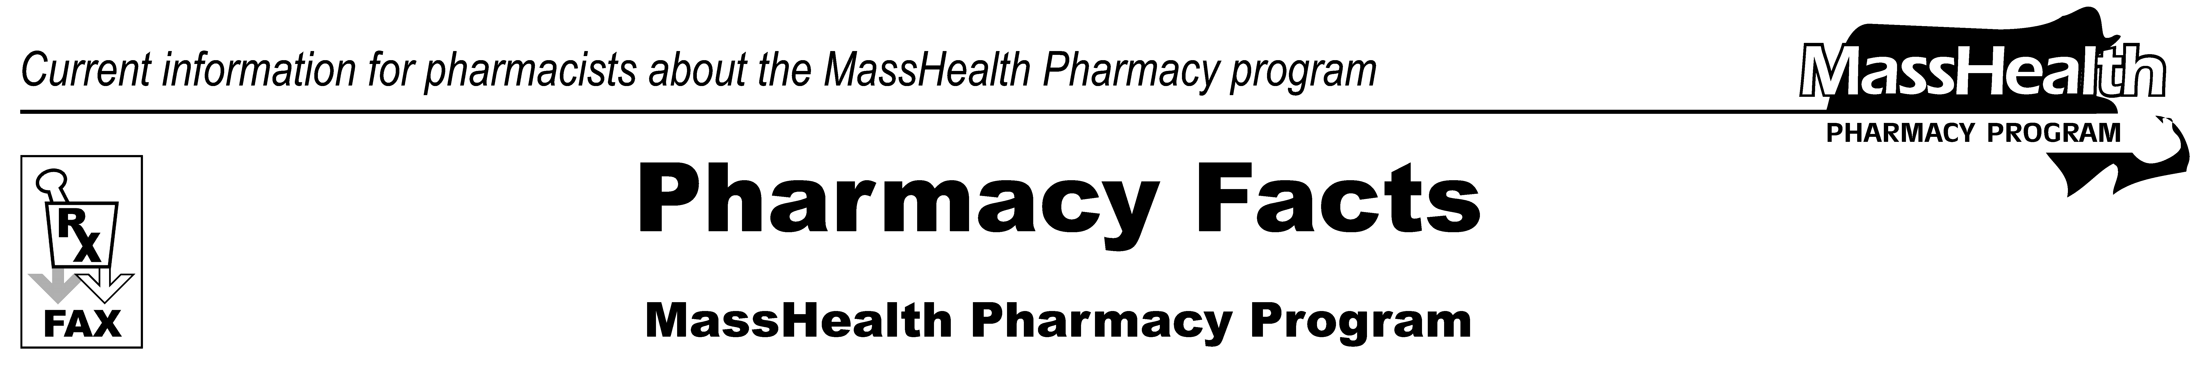
www.mass.gov/masshealth/pharmacy
Number 105
August 14, 2017
• Editor: Vic Vangel • Contributors: Paul Jeffrey, Kim Lenz, James Monahan, Nancy Schiff, Vic Vangel •

MHDL Updates
Below are certain updates to the MassHealth Drug List (MHDL). See the MHDL for a complete listing of updates.

All changes are effective August 14, 2017.
- Additions
The following newly marketed drugs have been added to the MassHealth Drug List.
Airduo (fluticasone/salmeterol inhalation powder) – PA
Austedo (deutetrabenazine) – PA
Imfinzi (durvalumab) – PA
Ingrezza (valbenazine) – PA
Morphabond ER (morphine extended-release tablet) – PA
Xatmep (methotrexate oral solution) – PA
Zejula (niraparib) – PA

- Change in Prior Authorization Status
The following newly marketed drugs have been added to the MassHealth Drug List.
- Effective August 14, 2017, the following analgesics will require prior authorization with updated age limits.
codeine – PA < 12 years and PA > 360 mg/day
Tylenol/Codeine # (acetaminophen/codeine) – PA < 12 years and PA > 4 grams of acetaminophen/day and PA > 360 mg of codeine/day
- Effective August 14, 2017, the following analgesic will require prior authorization for members < 12 years old.
Ultram # (tramadol) – PA < 12 years
- Effective August 14, 2017, the following topical corticosteroid will require prior authorization.
clobetasol propionate gel – PA
- Effective August 14, 2017, the following butalbital agents will require prior authorization with updated age limits and quantity limits.
butalbital 50 mg/acetaminophen 325 mg/caffeine 40 mg – PA < 18 years and PA > 20 units/month
butalbital 50 mg/acetaminophen 325 mg/caffeine 40 mg/codeine 30 mg – PA < 18 years and PA > 20 units/month

- Effective August 14, 2017, the following topical corticosteroid will no longer require prior authorization.

Temovate # (clobetasol propionate cream, ointment)

- Effective August 14, 2017, the following insulin product will no longer require prior authorization.
Humulin R (insulin regular prefilled syringe)

- Updated MassHealth Brand Name Preferred Over Generic Drug List

  - Effective August 14, 2017, the following serotonin 5-HT₁ receptor agonist will be added to the MassHealth Brand Name Preferred Over Generic Drug List.

Relpax (eletriptan) ^{BP} – PA

  - Effective August 14, 2017, the following inflammatory bowel disease agent will be added to the MassHealth Brand Name Preferred Over Generic Drug List.

Lialda (mesalamine delayed-release) ^{BP}

  - Effective August 14, 2017, the following atypical antipsychotic agent will be removed from the MassHealth Brand Name Preferred Over Generic Drug List.

Seroquel XR # (quetiapine extended-release 150 mg, 200 mg) – PA < 6 years or ≥ 18 years old and PA > 30 units/month

Seroquel XR # (quetiapine extended-release 50 mg, 300 mg and 400 mg) – PA < 6 years or
≥ 18 years and PA > 60 units/month

Legend
PA Prior authorization is required. The prescriber must obtain prior authorization for the drug in order for the pharmacy to receive payment. Note: Prior authorization applies to both the brand name and the FDA “A”-rated generic equivalent of listed product.
# This designates a brand-name drug with FDA “A”-rated generic equivalents. Prior authorization is required for the brand, unless a particular form of that drug (for example, tablet, capsule, or liquid) does not have an FDA “A”-rated generic equivalent.
BP Brand Preferred over generic equivalents. In general, MassHealth requires a trial of the preferred drug or clinical rationale for prescribing the nonpreferred drug generic equivalent.
* The generic OTC and, if any, generic prescription versions of the drug are payable under MassHealth without prior authorization.
^ This drug is available through the health care professional who administers the drug. MassHealth does not pay for this drug to be dispensed through a retail pharmacy.

If you have questions or comments, or want to be removed from this fax distribution,
please contact Victor Moquin at Conduent at 617-423-0830.

