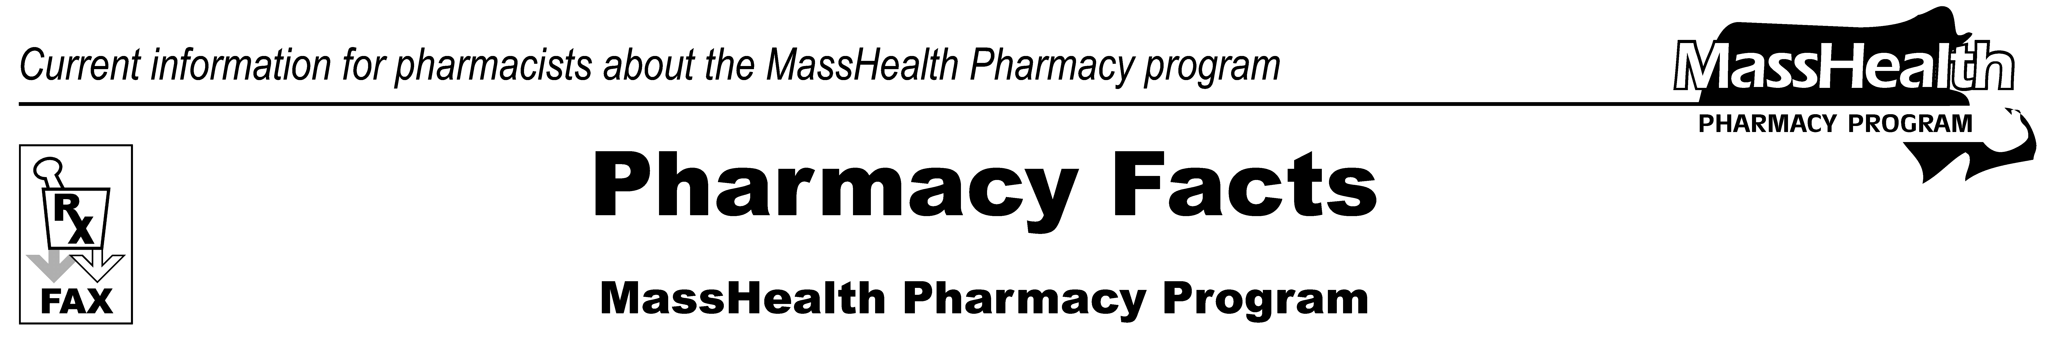
www.mass.gov/masshealth/pharmacy

Number 106
September 21, 2017
Page 1 of 2
• Editor: Vic Vangel • Contributors: Paul Jeffrey, Kim Lenz, Nancy Schiff, Vic Vangel •
MHDL Update  Below are certain updates to the MassHealth Drug List (MHDL). See the MHDL for a complete list of updates.  - Additions  Effective September 25, 2017, the following newly marketed drugs have been added to the MassHealth Drug List.  - Alunbrig (brigatinib) – PA  - Kevzara (sarilumab) – PA  - Renflexis (infliximab-abda) – PA  - Rituxan Hycela (rituximab/hyaluronidase human) – PA  - Rydapt (midostaurin) – PA  - Totect (dexrazoxane)  - Xadago (safinamide) – PA  - Change in Prior-Authorization Status  - Effective September 25, 2017, the following Alzheimer’s agents will require prior authorization for all quantities.  - Exelon (rivastigmine patch) – PA  - galantamine solution – PA  - Namenda (memantine solution) – PA  - Effective September 25, 2017, the following Alzheimer’s agents will require prior authorization when used outside of newly established age limits.  - Aricept # (donepezil 10 mg tablet) – PA < 18 years and PA > 60 units/month  - Aricept # (donepezil 5 mg tablet) – PA < 18 years and PA > 30 units/month  - donepezil orally disintegrating tablet – PA < 18 years and PA > 30 units/ month  - Namenda # (memantine tablet) – PA < 18 years and PA > 60 units/month | - Namenda (memantine titration pack) – PA < 18 years and PA > 49 units/ month  - Razadyne # (galantamine tablet) – PA < 18 years and PA > 60 units/month  - Razadyne ER # (galantamine extended-release capsule) – PA < 18 years and PA > 30 units/month  - rivastigmine capsule – PA < 18 years and PA > 60 units/month  - Effective September 25, 2017, the following thalidomide analogue will require prior authorization for all quantities.  - Revlimid (lenalidomide) – PA  - Effective September 25, 2017, the following anesthetic will no longer require prior authorization and will no longer be restricted to the health care professional who administers the drug. This anesthetic will be available only in an inpatient hospital setting.  - Ketalar (ketamine injection) ^{H}  - Effective September 25, 2017, the following ophthalmic anti-allergy and anti-inflammatory agent will no longer require prior authorization.  - azelastine ophthalmic solution  - Effective September 25, 2017, the following Monoamine Oxidase (MAO) Type-B Inhibitor will no longer require prior authorization.  - selegiline capsule  - Effective September 25, 2017, the following skeletal muscle relaxant agents will require prior authorization when used outside of newly established age limits.  - cyclobenzaprine 5 mg, 10 mg – PA < 15 years  - orphenadrine – PA < 18 years  - Parafon Forte DSC # (chlorzoxazone 500 mg) – PA < 18 years  - Robaxin # (methocarbamol) – PA < 16 years

- Updated MassHealth Brand Name Preferred Over Generic Drug List  - Effective September 25, 2017, the following antiplatelet agent will be added to the MassHealth Brand Name Preferred Over Generic Drug List.  - Effient (prasugrel) ^{BP} – PA  - Effective September 25, 2017, the following anticonvulsant agent will be added to the MassHealth Brand Name Preferred Over Generic Drug List.  - Sabril (vigabatrin) ^{BP} – PA  - Effective September 25, 2017, the following phosphate binding agent will be added to the MassHealth Brand Name Preferred Over Generic Drug List.  - Fosrenol (lanthanum) ^{BP}  - Effective September 25, 2017, the following benzodiazepine agent will be removed from the MassHealth Brand Name Preferred Over Generic Drug List.  - Diastat (diazepam rectal gel) – PA > 5 kits (10 syringes)/month  - Effective September 25, 2017, the following antiprotozoal agent will be removed from the MassHealth Brand Name Preferred Over Generic Drug List.  - Mepron # (atovaquone)  - Effective September 25, 2017, the following antidepressant agent will be removed from the MassHealth Brand Name Preferred Over Generic Drug List.  - Pristiq (desvenlafaxine succinate extended-release) – PA  - Effective September 25, 2017, the following nonstimulant ADHD agent will be removed from the MassHealth Brand Name Preferred Over Generic Drug List.  - Strattera # (atomoxetine) – PA < 6 years | Legend  PA Prior authorization is required. The prescriber must obtain prior authorization for the drug in order for the pharmacy to receive payment. Note: Prior authorization applies to both the brand-name and the FDA “A”-rated generic equivalent of listed product.  # This designates a brand-name drug with FDA “A”-rated generic equivalents. Prior authorization is required for the brand, unless a particular form of that drug (for example, tablet, capsule, or liquid) does not have an FDA “A”-rated generic equivalent.  ^{BP} Brand Preferred over generic equivalents. In general, MassHealth requires a trial of the preferred drug or clinical rationale for prescribing the nonpreferred drug generic equivalent.  ^{H} Available only in an inpatient hospital setting. MassHealth does not pay for this drug to be dispensed through the retail pharmacy or physician's office.  * The generic OTC and, if any, generic prescription versions of the drug are payable under MassHealth without prior authorization.  ̂ This drug is available through the health care professional who administers the drug. MassHealth does not pay for this drug to be dispensed through a retail pharmacy.
Page 2 of 2
Pharmacy Facts, Number 106
If you have questions or comments, or want to be removed from this fax distribution,
please contact Victor Moquin at Conduent at 617-423-9830.

