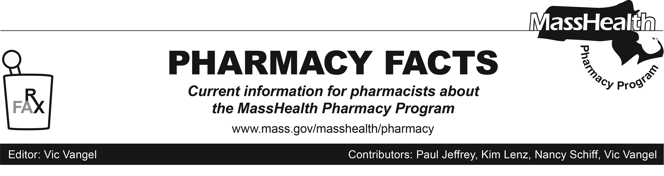
Number 107
November 3, 2017

MHDL Update

Below are certain updates to the MassHealth Drug List (MHDL). See the MHDL for a complete listing of updates.

Effective November 6, 2017, the following newly marketed drugs have been added to the MassHealth Drug List.
- Aristada (aripiprazole lauroxil 1,064 mg) – PA < 6 years and PA > 1 injection/2 months
- Carospir (spironolactone suspension) – PA
- Cotempla XR-ODT (methylphenidate extended-release orally disintegrating tablet) – PA
- Haegarda (c1 esterase inhibitor, human) – PA
- Idhifa (enasidenib) – PA
- Mydayis (amphetamine salts extended-release) – PA
- Nerlynx (neratinib) – PA
- Radicava (edaravone) – PA
- Tremfya (guselkumab) – PA

Change in Prior-Authorization Status
- Effective November 6, 2017, the following cardiovascular agents will no longer require prior authorization.
- Exforge # (amlodipine/valsartan)
- Lotrel # (amlodipine/benazepril)
- Effective November 6, 2017, the following cardiovascular agents will require prior authorization.
- Edecrin (ethacrynic acid) – PA
- Isordil (isosorbide dinitrate 40 mg tablet) – PA
- Effective November 6, 2017, the following long-acting stimulants will require prior authorization for all ages and quantities.
- Aptensio XR (methylphenidate extended-release) – PA
- Daytrana (methylphenidate transdermal) – PA
- Metadate CD (methylphenidate extended-release) – PA
- Quillichew ER (methylphenidate extended-release chewable tablet) – PA
- Ritalin LA (methylphenidate extended-release) – PA
- Effective November 6, 2017, the following atypical antipsychotic agent will no longer require prior authorization within updated age limits.
- Abilify # (aripiprazole tablet) – PA < 6 years and PA > 30 units/month
- Effective November 6, 2017, the following chemotherapy agent will be available only in an inpatient hospital setting.
- Thiotepa ^{H}
Updated MassHealth Brand Name Preferred Over Generic Drug List
- Effective November 6, 2017, the following long-acting amphetamine cerebral stimulant agent will be added to the MassHealth Brand Name Preferred Over Generic Drug List.
- Adderall XR (amphetamine salts extended-release) ^{BP PD} – PA < 3 years and PA > 60 units/month
- Effective November 6, 2017, the following antiretroviral agents will be added to the MassHealth Brand Name Preferred Over Generic Drug List.
- Lexiva (fosamprenavir) ^{BP}
- Prezista (darunavir) ^{BP}
- Reyataz (atazanavir) ^{BP}
- Sustiva (efavirenz) ^{BP}
- Truvada (emtricitabine/tenofovir disoproxil fumarate) ^{BP}
- Effective November 6, 2017, the following ammonia inhibitor agent will be added to the MassHealth Brand Name Preferred Over Generic Drug List.
- Buphenyl (sodium phenylbutyrate tablet) ^{BP}
- Effective November 6, 2017, the following multiple sclerosis agents will be added to the MassHealth Brand Name Preferred Over Generic Drug List.
- Copaxone (glatiramer 40 mg) ^{BP}
- Effective November 6, 2017, the following lipid lowering agent will be removed from the MassHealth Brand Name Preferred Over Generic Drug List.
- Zetia (ezetimibe) – PA
- Effective November 6, 2017, the following dermatological agent will be added to the MassHealth Brand Name Preferred Over Generic Drug List.
- Aczone (dapsone gel) ^{BP}– PA
Updated MassHealth Supplemental Rebate/Preferred Drug List
- Effective November 6, 2017, the following long-acting amphetamine cerebral stimulant agents will be added to the MassHealth Supplemental Rebate/Preferred Drug List.
- Adderall XR (amphetamine salts extended-release) ^{PD} – PA < 3 years and PA > 60 units/month
- Vyvanse (lisdexamfetamine) ^{PD} – PA < 3 years and PA > 60 units/month
- Effective November 6, 2017, the following long-acting methylphenidate cerebral stimulant agent will be added to the MassHealth Supplemental Rebate/ Preferred Drug List.
- Focalin XR (dexmethylphenidate extended-release) ^{BP PD} – PA < 3 years and PA > 60 units/month
c. Effective November 6, 2017, the following Anti-TNF agents will be added to the MassHealth Supplemental Rebate/ Preferred Drug List.
- Enbrel (etanercept) ^{PD} – PA
- Humira (adalimumab) ^{PD} – PA
d. Effective November 6, 2017, the following antiretroviral agents will be added to the MassHealth Supplemental Rebate/ Preferred Drug List.
- Descovy (emtricitabine/tenofovir alafenamide) ^{PD}
- Genvoya (elvitegravir/cobicistat/ emtricitabine/tenofovir alafenamide) ^{PD}
- Norvir (ritonavir) ^{BP} ^{PD}
- Odefsey (emtricitabine/rilpivirine/ tenofovir alafenamide) ^{PD}

____________________________________
Legend

PA Prior authorization is required. The prescriber must obtain prior authorization for the drug in order for the pharmacy to receive payment. Note: PA applies to both the brand-name and the FDA “A”-rated generic equivalent of listed product.

# Designates a brand-name drug with FDA “A”-rated generic equivalents. Prior authorization is required for the brand, unless a particular form of that drug (for example, tablet, capsule, or liquid) does not have an FDA “A”-rated generic equivalent.

^{BP} Brand preferred over generic equivalents. In general, MassHealth requires a trial of the preferred drug or clinical rationale for prescribing the nonpreferred drug generic equivalent.

^{H} Available only in an inpatient hospital setting. MassHealth does not pay for this drug to be dispensed through the retail pharmacy or physician's office.

^{PD} In general, MassHealth requires a trial of the preferred drug (PD) or a clinical rationale for prescribing a nonpreferred drug within a therapeutic class.

