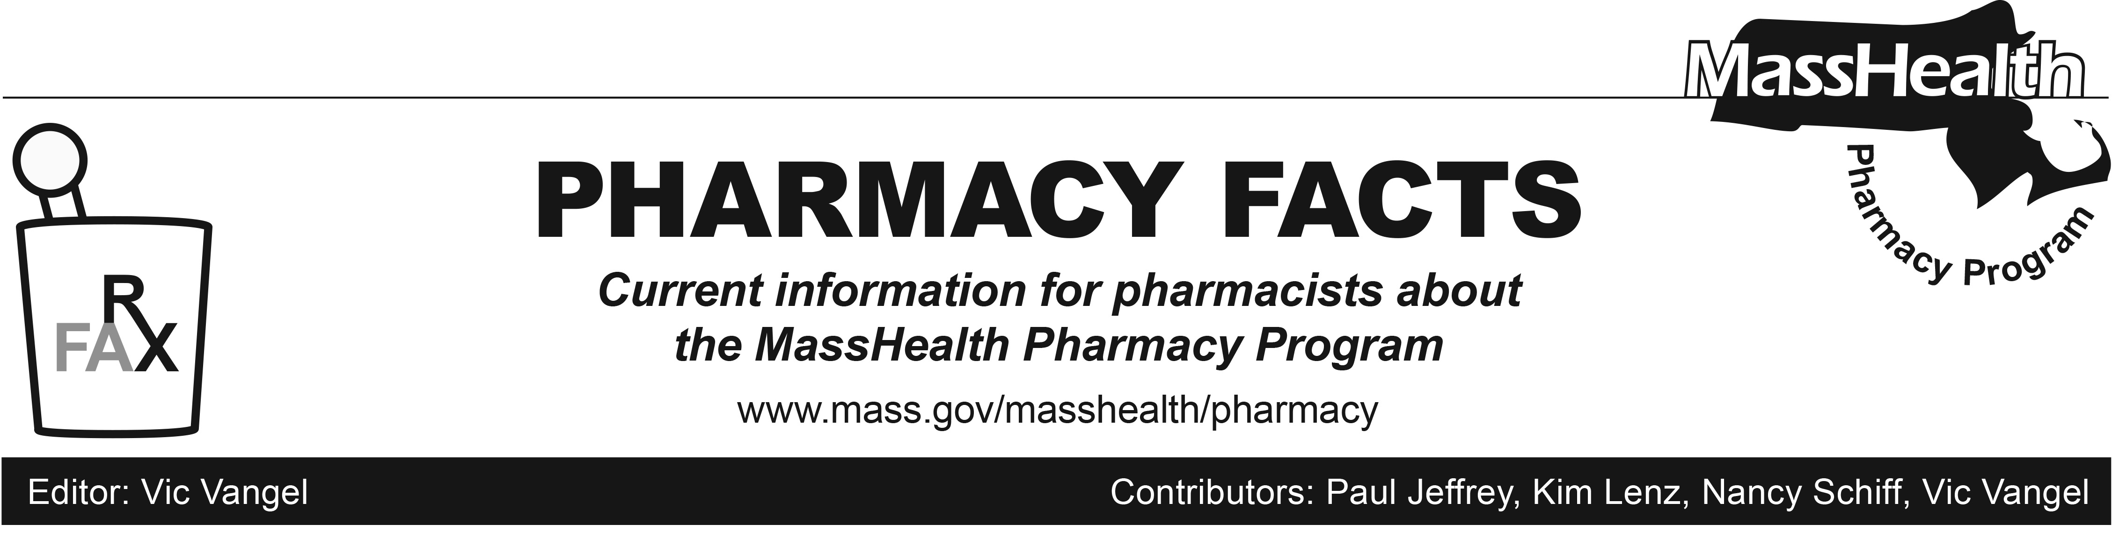
Number #108, Dec. 27, 2017

MHDL Update

Below are certain updates to the MassHealth Drug List (MHDL). For a complete listing of updates, please see the MHDL.

Effective January 8, 2018, the following newly marketed drugs have been added to the MassHealth Drug List.
- Armonair (fluticasone propionate inhalation powder) – PA
- Besponsa (inotuzumab ozogamicin) – PA
- Mavyret (glecaprevir/pibrentasvir) – PA
- Mylotarg (gemtuzumab ozogamicin) – PA
- Syndros (dronabinol solution) – PA
- Tymlos (abaloparatide) – PA
- Vabomere (meropenem/vaborbactam)
– PA
- Vosevi (sofosbuvir/velpatasvir/voxilaprevir) – PA

Change in Prior-Authorization Status

Effective January 8, 2018, the following inhaled respiratory agents will require prior authorization.
- Aerospan (flunisolide inhalation aerosol) – PA
- Arnuity (fluticasone furoate inhalation powder) – PA

Effective January 8, 2018, the following topical vitamin D analogue will be covered within newly established quantity limits.
- Dovonex # (calcipotriene cream) – PA > 60 grams/month

Updated MassHealth Brand Name Preferred Over Generic Drug List

Effective January 8, 2018, the following agents will be added to the MassHealth Brand Name Preferred Over Generic Drug List.
- Coreg CR (carvedilol extended-release) ^{BP} – PA
- Efudex (fluorouracil 5% cream) ^{BP} – PA
- Emend (aprepitant trifold pack) ^{BP} – PA > 2 packs/28 days
- Istalol (timolol) ^{BP} – PA
- Transderm-Scop (scopolamine transdermal patch) ^{BP} – PA

Effective January 8, 2018, the following agents will be removed from the MassHealth Brand Name Preferred Over Generic Drug List.
- Kapvay (clonidine extended-release tablet) – PA
- Prezista (darunavir)
- Reyataz (atazanavir)
- Truvada (emtricitabine/tenofovir disoproxil fumarate)

Updated MassHealth Supplemental Rebate/Preferred Drug List

Effective January 8, 2018, the following hepatitis antiviral agents will be added to the MassHealth Supplemental Rebate/Preferred Drug List.
- Mavyret (glecaprevir/pibrentasvir) ^{PD} – PA
- Vosevi (sofosbuvir/velpatasvir/
voxilaprevir) ^{PD} – PA

(cont.)
Corrections / Clarifications

The following drugs have been added to the MassHealth Drug List. They were previously omitted in error.
- amitriptyline powder – PA
- clonidine powder – PA
- gabapentin powder – PA
- lidocaine powder – PA
- ondansetron 24 mg tablet – PA
____________________________________

LEGEND

# Designates a brand-name drug with FDA “A”-rated generic equivalents. Prior authorization is required for the brand, unless a particular form of that drug (for example, tablet, capsule, or liquid) does not have an FDA “A”-rated generic equivalent.

PA Prior authorization is required. The prescriber must obtain prior authorization for the drug in order for the pharmacy to receive payment. Note: PA applies to both the brand-name and the FDA “A”-rated generic equivalent of listed product.

^{BP} Brand preferred over generic equivalents. In general, MassHealth requires a trial of the preferred drug or clinical rationale for prescribing the nonpreferred drug generic equivalents.

^{PD} Preferred drug. In general, MassHealth requires a trial of the preferred drug or clinical rationale for prescribing a nonpreferred drug within a therapeutic class.

^ This drug is available through the health care professional who administers the drug. MassHealth does not pay for this drug to be dispensed through a retail pharmacy.

____________________________________

