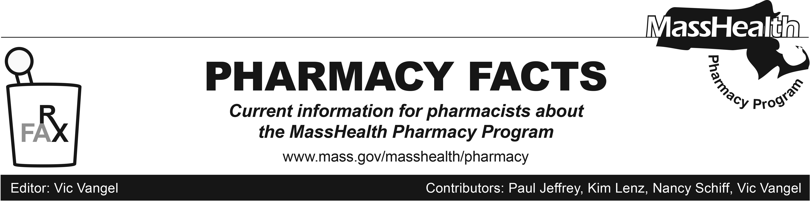
Number 109, February 06, 2018

MHDL Update

Below are certain updates to the MassHealth Drug List (MHDL). For a complete listing of updates, see the MHDL.

Effective February 12, 2018, the following newly marketed drugs have been added to the MassHealth Drug List.
- Clenpiq (sodium picosulfate/magnesium oxide/anhydrous citric acid) – PA
- Durolane (hyaluronate) – PA
- Duzallo (lesinurad/allopurinol) – PA
- Fiasp (insulin aspart) – PA
- Fibryga (fibrinogen)
- Gocovri (amantadine extended-release capsule) – PA
- Heplisav-B (hepatitis B recombinant vaccine, adjuvanted) ¹
- Kymriah (tisagenlecleucel) ^ – PA
- Nityr (nitisinone)
- Qtern (dapagliflozin/saxagliptin) – PA
- Shingrix (zoster vaccine recombinant, adjuvanted) – PA < 50 years
- Trelegy (fluticasone furoate/umeclidinium/ vilanterol) – PA
- Varubi (rolapitant injection) – PA > 2 vials/28 days
- Verzenio (abemaciclib) – PA
- Visco-3 (hyaluronate) – PA
- Vyxeos (daunorubicin/cytarabine) – PA
- Ximino (minocycline extended-release capsule) – PA
- Yescarta (axicabtagene ciloleucel) ^ – PA
- Zilretta (triamcinolone extended-release injectable suspension) – PA

Change in Prior-Authorization Status

Effective February 12, 2018, the following opioid agent will no longer require prior authorization when used within dose and quantity limits.
- Butrans (buprenorphine transdermal) ^{BP} – PA > 20 mcg/hr and PA > 4 patches/28 days
Effective February 12, 2018, the following oral antibiotic agents will require prior authorization.
- Augmentin (amoxicillin/clavulanate 125/31.25 mg/5 mL suspension) – PA
- ofloxacin tablet – PA
Effective February 12, 2018, the following topical NSAID agent will no longer require prior authorization for exceeding quantity limits.
- Voltaren Gel (diclofenac 1% gel) ^{BP}
Effective February 12, 2018, the following long-acting atypical antipsychotic agent will require prior authorization for all ages and quantities.
- Abilify Maintena (aripiprazole extended-release injection) – PA

Updated MassHealth Brand Name Preferred Over Generic Drug List

Effective February 12, 2018, the following agents will be added to the MassHealth Brand Name Preferred Over Generic Drug List.
- Estrace (estradiol cream) ^{BP}
- Reyataz (atazanavir) ^{BP}
- Sensipar (cinacalcet) ^{BP}
- Viread (tenofovir disoproxil fumarate tablet) ^{BP} – PA > 30 units/month

(cont.)
Effective February 12, 2018, the following agents will be removed from the MassHealth Brand Name Preferred Over Generic Drug List.
- Effient (prasugrel) – PA
- Pataday (olopatadine 0.2% eye drops) – PA
- Relpax (eletriptan) – PA
- Valcyte # (valganciclovir tablet)

Updated MassHealth Supplemental Rebate/Preferred Drug List

Effective February 12, 2018, the following long-acting aripiprazole agents will be added to the MassHealth Supplemental Rebate/Preferred Drug List.
- Aristada (aripiprazole lauroxil 441 mg, 662 mg, 882 mg) ^{PD} – PA < 6 years and PA > 1 injection/month
- Aristada (aripiprazole lauroxil 1,064 mg) ^{PD} – PA < 6 years and PA > 1 injection/2 months

Legend

PA Prior authorization is required. The prescriber must obtain prior authorization for the drug in order for the pharmacy to receive payment. Note: PA applies to both the brand-name and the FDA “A”-rated generic equivalent of listed product.

# Designates a brand-name drug with FDA “A”-rated generic equivalents. Prior authorization is required for the brand, unless a particular form of that drug (for example, tablet, capsule, or liquid) does not have an FDA “A”-rated generic equivalent.

^{BP} Brand preferred over generic equivalents. In general, MassHealth requires a trial of the preferred drug or clinical rationale for prescribing the nonpreferred drug generic equivalent.

^{PD} In general, MassHealth requires a trial of the preferred drug (PD) or a clinical rationale for prescribing a nonpreferred drug within a therapeutic class.

^ Available through the health care professional who administers the drug. MassHealth does not pay for this drug to be dispensed through a retail pharmacy.

¹ Product may be available through the Massachusetts Department of Public Health (DPH). Please check with DPH for availability. MassHealth does not pay for immunizing biologicals (i.e., vaccines) and tubercular (TB) drugs that are available free of charge through local boards of public health or through the Massachusetts DPH without prior authorization (130 CMR 406.413(C)). In cases where free vaccines are available to providers for specific populations (e.g., children, high risk, etc.), MassHealth will reimburse the provider only for individuals not eligible for the free vaccines. Notwithstanding the above, MassHealth will pay pharmacies for seasonal flu vaccine serum without prior authorization, if the vaccine is administered in the pharmacy.

___________________________________________________

