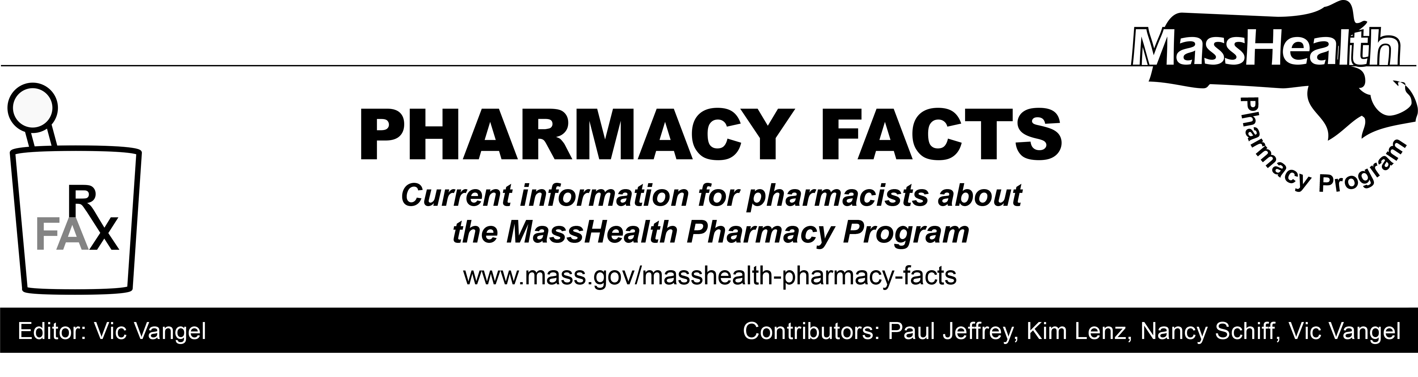
Number 114, March 19, 2018

MHDL Update
Below are certain updates to the MassHealth Drug List (MHDL). See the MHDL for a complete listing of updates.
Additions
Effective March 26, 2018, the following newly marketed drugs have been added to the MassHealth Drug List.
• Baxdela (delafloxacin injection) – PA
• Baxdela (delafloxacin tablet) – PA
• bortezomib
• Calquence (acalabrutinib) – PA
• cephalexin 333 mg capsule – PA
• Hemlibra (emicizumab-kxwh)
• Triptodur (triptorelin) – PA
• Vyzulta (latanoprostene) – PA
• Xhance (fluticasone propionate 93 mcg nasal spray) – PA
Change in Prior-Authorization Status
a. Effective March 26, 2018, the following anticonvulsant will no longer require prior authorization when used within age limits.
• phenytoin unit dose suspension – PA < 6 years
b. Effective March 26, 2018, the following anticonvulsant will require prior authorization for all ages.
• Gabitril (tiagabine) – PA
Updated MassHealth Brand Name Preferred Over Generic Drug List
a. Effective March 26, 2018, the following agents will be added to the MassHealth Brand Name Preferred Over Generic Drug List.
• Namenda XR (memantine extended-release) ^{BP} – PA
• Syprine (trientine) ^{BP}
• Treximet (sumatriptan/naproxen) ^{BP} – PA
b. Effective March 26, 2018, the following agents will be removed from the MassHealth Brand Name Preferred Over Generic Drug List.
• Coreg CR (carvedilol extended-release) – PA
• Fosrenol # (lanthanum)

MassHealth Chimeric Antigen Receptor (CAR)-T Immunotherapies Monitoring Program

MassHealth will perform outreach to prescribers to inform them of the CAR-T Immunotherapies Monitoring Program and provide information to assist reporting member outcomes following CAR-T infusion at ongoing intervals.
____________________________________

Legend

PA Prior authorization is required. The prescriber must obtain prior authorization for the drug in order for the pharmacy to receive payment. Note: PA applies to both the brand-name and the FDA “A”-rated generic equivalent of listed product.

# Designates a brand-name drug with FDA “A”-rated generic equivalents. Prior authorization is required for the brand, unless a particular form of that drug (for example, tablet, capsule, or liquid) does not have an FDA “A”-rated generic equivalent.

^{BP} Brand preferred over generic equivalents. In general, MassHealth requires a trial of the preferred drug or clinical rationale for prescribing the nonpreferred drug.

^{PD} In general, MassHealth requires a trial of the preferred drug (PD) or a clinical rationale for prescribing a nonpreferred drug within a therapeutic class.

^ Available through the health care professional who administers the drug. MassHealth does not pay for this drug to be dispensed through a retail pharmacy.

