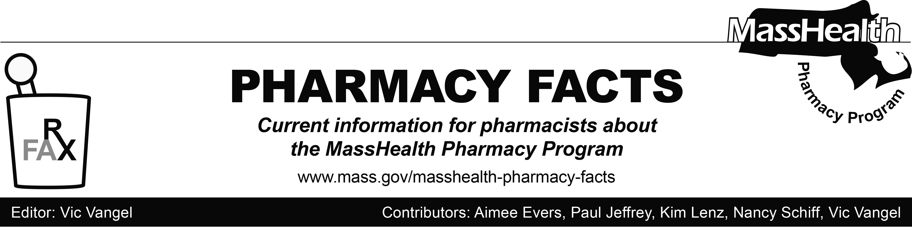
Number 115 – May 03, 2018

MHDL Update

Below are certain updates to the MassHealth Drug List (MHDL). See the MHDL for a complete listing of updates.

Additions

Effective May 7, 2018, the following newly marketed drugs have been added to the MHDL.
- Aliqopa (copanlisib) – PA
- benznidazole
- Endari (l-glutamine) – PA
- Fasenra (benralizumab) – PA
- Mepsevii (vestronidase alfa-vjbk) – PA
- Parsabiv (etelcalcetide) ^
- Qvar Redihaler (beclomethasone MDI, breath-actuated) – PA
- Solosec (secnidazole) – PA
- Sublocade (buprenorphine extended-release injection) – PA
- Symdeko (tezacaftor/ivacaftor) – PA

Updated MassHealth Brand Name Preferred Over Generic Drug List

Effective May 7, 2018, the following agents will be added to the MassHealth Brand Name Preferred Over Generic Drug List.
- Prevacid Solutab (lansoprazole orally disintegrating tablet) ^{BP} – PA ≥ 2 years
- Remodulin (treprostinil injection) ^{BP} – PA
- Zavesca (miglustat) ^{BP} – PA

Legend

PA Prior authorization is required. The prescriber must obtain prior authorization for the drug in order for the pharmacy to receive payment. Note: PA applies to both the brand-name and the FDA “A”-rated generic equivalent of listed product.

^{BP} Brand preferred over generic equivalents. In general, MassHealth requires a trial of the preferred drug or clinical rationale for prescribing the nonpreferred drug generic equivalent.

^ Available through the health care professional who administers the drug. MassHealth does not pay for this drug to be dispensed through a retail pharmacy.

