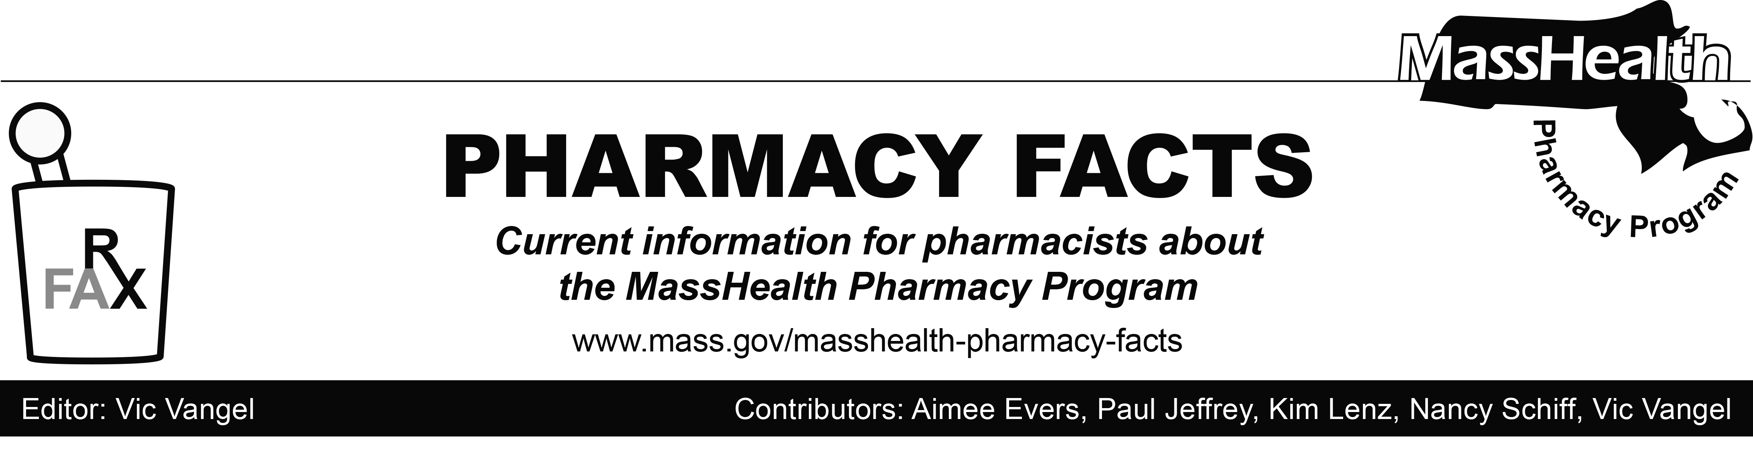
Number 116, June 14, 2018

MHDL Update
Below are certain updates to the MassHealth Drug List (MHDL). See the MHDL for a complete listing of updates.
Additions
Effective June 18, 2018, the following newly marketed drugs have been added to the MassHealth Drug List.
- Adzenys ER (amphetamine extended-release oral suspension) – PA
- Akynzeo (fosnetupitant/palonosetron injection) – PA > 2 vials/28 days
- Balcoltra (levonorgestrel/ethinyl estradiol/ferrous bisglycinate)
- Biktarvy (bictegravir/emtricitabine/tenofovir alafenamide) ^{PD}
- Cinvanti (aprepitant injectable emulsion)
- Dekas Bariatric (multivitamins/minerals/folic acid/coenzyme Q10) – PA
- Lyrica CR (pregabalin extended-release) – PA
- methylphenidate extended-release 72 mg tablet – PA
- Noctiva (desmopressin) – PA
- Norvir (ritonavir packet)
- Ozempic (semaglutide) – PA
- palonosetron 0.25 mg/2 mL injection – PA > 2 vials/28 days
- Prevymis (letermovir) – PA
- Segluromet (ertugliflozin/metformin) – PA
- Steglatro (ertugliflozin) – PA
- Steglujan (ertugliflozin/sitagliptin) – PA
- Symproic (naldemedine) – PA

Change in Prior-Authorization Status
Effective June 18, 2018, the following ophthalmic antibiotics will no longer require prior authorization.
- levofloxacin ophthalmic solution
- Vigamox # (moxifloxacin ophthalmic solution)
Updated MassHealth Brand Name Preferred Over Generic Drug List
Effective June 18, 2018, the following agents will be added to the MassHealth Brand Name Preferred Over Generic Drug List.
- Biltricide (praziquantel) ^{BP}
- Mephyton (phytonadione) ^{BP}
- Welchol (colesevelam) ^{BP} – PA
- Zyflo CR (zileuton extended-release) ^{BP} – PA
Updated MassHealth Supplemental Rebate/Preferred Drug List
Effective June 18, 2018, the following antiretroviral/HIV agent will be added to the MassHealth Supplemental Rebate/Preferred Drug List.
- Biktarvy (bictegravir/emtricitabine/tenofovir alafenamide) ^{PD}

____________________________________
Legend

PA Prior authorization is required. The prescriber must obtain prior authorization for the drug in order for the pharmacy to receive payment. Note: PA applies to both the brand-name and the FDA “A”-rated generic equivalent of listed product.

# Designates a brand-name drug with FDA “A”-rated generic equivalents. Prior authorization is required for the brand, unless a particular form of that drug (for example, tablet, capsule, or liquid) does not have an FDA “A”-rated generic equivalent.

^{BP} Brand preferred over generic equivalents. In general, MassHealth requires a trial of the preferred drug or clinical rationale for prescribing the nonpreferred drug generic equivalent.
^{PD} In general, MassHealth requires a trial of the preferred drug (PD) or a clinical rationale for prescribing a nonpreferred drug within a therapeutic class.

^ Available through the health care professional who administers the drug. MassHealth does not pay for this drug to be dispensed through a retail pharmacy.

