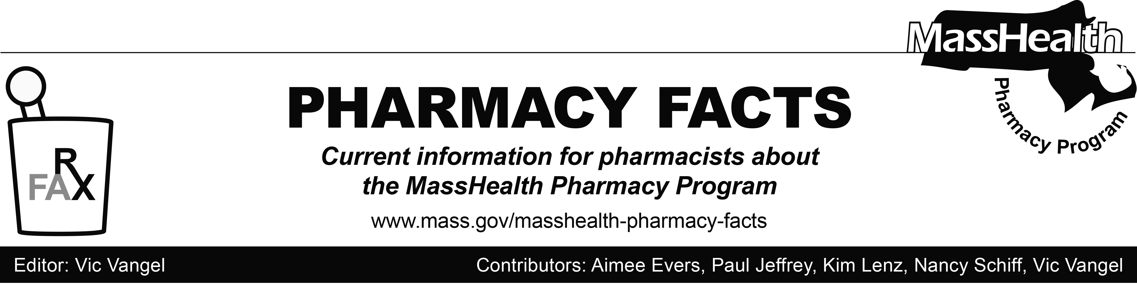
Number 117, August 1, 2018

MHDL Update

Below are certain updates to the MassHealth Drug List (MHDL). See the MHDL for a complete listing of updates.

- Additions
Effective July 12, 2018, the following drug has been added to the MassHealth Drug List.
- Emflaza (deflazacort) – PA

Effective July 30, 2018, the following newly marketed drugs have been added to the MassHealth Drug List.
- Admelog (insulin lispro) – PA
- Aimovig (erenumab-aooe) – PA
- Bonjesta (doxylamine/pyridoxine extended-release) – PA
- Erleada (apalutamide) – PA
- Firvanq (vancomycin oral solution)
- Sinuva (mometasone sinus implant) – PA
- Trogarzo (ibalizumab-uiyk) – PA

- Change in Prior Authorization Status
Effective July 30, 2018, the following oral antibiotic will no longer require prior authorization.
- Vancocin # (vancomycin capsule)

- Updated MassHealth Brand Name Preferred Over Generic Drug List
- Effective July 30, 2018, the following agents will be added to the MassHealth Brand Name Over Generic Drug List.
- Makena (hydroxyprogesterone caproate injection) ^{BP} – PA
- Suboxone (buprenorphine/naloxone film) ^{BP PD} – PA > 180 days (> 16 mg/day and ≤ 24 mg/day)

Updated MassHealth Brand Name Preferred Over Generic Drug List, continued
- Suboxone (buprenorphine/naloxone film) ^{BP PD} – PA > 32 mg/day
- Suboxone (buprenorphine/naloxone film) ^{BP PD} – PA > 90 days (> 24 mg/day and ≤ 32 mg/day)
- Suboxone (buprenorphine/naloxone film ≤ 16 mg/day) ^{BP PD}
- Uceris (budesonide extended-release tablet) ^{BP} – PA
- Effective July 30, 2018, the following agents will be removed from the MassHealth Brand Name Preferred Over Generic Drug List.
- Viread # (tenofovir disoproxil fumarate tablet) – PA > 30 units/month

- Corrections / Clarifications
The following drugs have been added to the MassHealth Drug List. They were omitted in error.
- baclofen powder – PA
- ibuprofen powder – PA

Legend

PA Prior authorization is required. The prescriber must obtain prior authorization for the drug in order for the pharmacy to receive payment. Note: PA applies to both the brand-name and the FDA “A”-rated generic equivalent of listed product.
# Designates a brand-name drug with FDA “A”-rated generic equivalents. Prior authorization is required for the brand, unless a particular form of that drug (for example, tablet, capsule, or liquid) does not have an FDA “A”-rated generic equivalent.
^{BP} Brand preferred over generic equivalents. In general, MassHealth requires a trial of the preferred drug or clinical rationale for prescribing the nonpreferred drug generic equivalent.
^{PD} In general, MassHealth requires a trial of the preferred drug (PD) or a clinical rationale for prescribing a nonpreferred drug within a therapeutic class.

