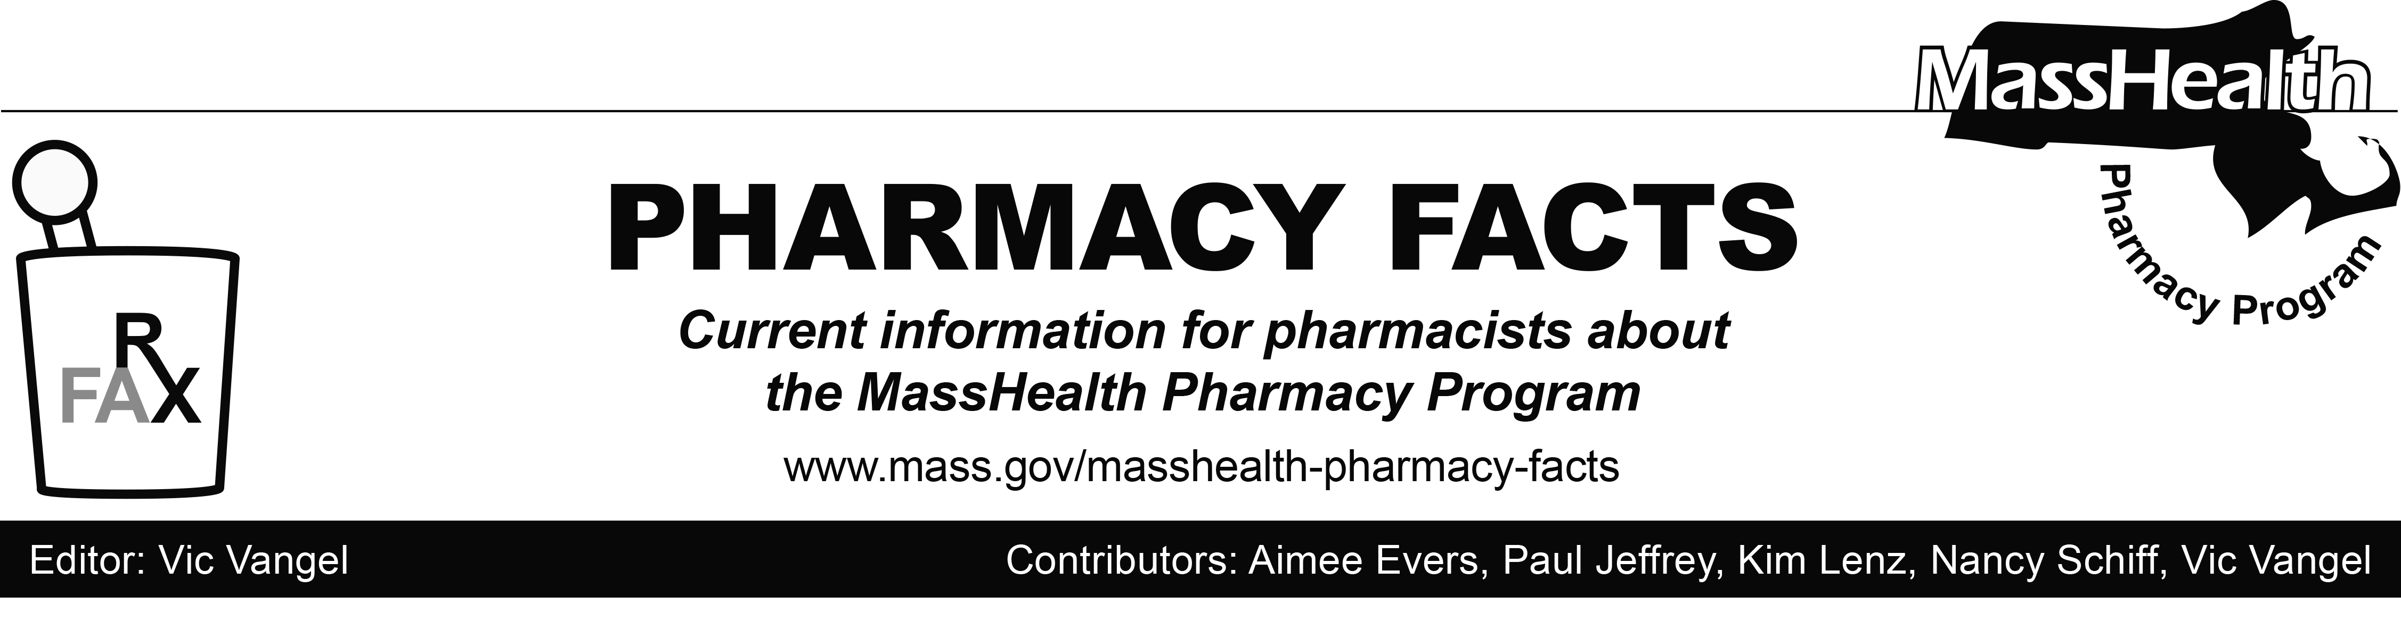
Number 118 – Aug. 7, 2018

Claims Processing Reminders
Over-the-Counter Drugs
As a reminder to pharmacies, MassHealth covers certain over-the-counter (OTC) products as listed on the MassHealth Over-the-Counter Drug List. Sometimes when submitting a claim for an OTC drug through the Pharmacy Online Processing System (POPS), a pharmacy may see a claim rejection that reads as follows:

M7 - Host Drug File Error, with text message, “Please submit for a different NDC (National Drug Code). Necessary drug pricing information is not available in the FDB (First Databank) drug record for the submitted NDC.”

This does not mean that the OTC drug is not covered; it means that the manufacturer of the drug does not publish pricing information that is necessary for MassHealth to process and pay for the claim. If a pharmacy encounters this type of rejection, the pharmacy should dispense the same drug from a different manufacturer that does publish the necessary price information and submit a new claim.

Brand Name Preferred Over Generic

MassHealth prefers certain brand name drugs over generics as listed on the MassHealth Brand Name Preferred Over Generic Drug List. When submitting a claim for the generic version of a brand name drug that appears on the MassHealth Brand Name Preferred Over Generic Drug List, a pharmacy may see a claim rejection that reads as follows:

75 - Prior Authorization Required, with text message, “Drug is on MH brand preferred list. DAW 9 for preferred brand submission. Non-preferred brand or generic drugs would require DUR (Drug Utilization Review) certification.”

If a pharmacy encounters this rejection, the pharmacy should resubmit the claim for the preferred brand name drug using a DAW 9. Brand name drugs appearing on the MassHealth Brand Name Preferred Over Generic Drug List are not preferred when MassHealth is the secondary insurer and another payer is the primary insurer. If this type of rejection is encountered on a claim where MassHealth is the secondary payer and the primary insurer prefers the generic, please contact the MassHealth DUR unit at (800) 745-7318 for assistance.

.

