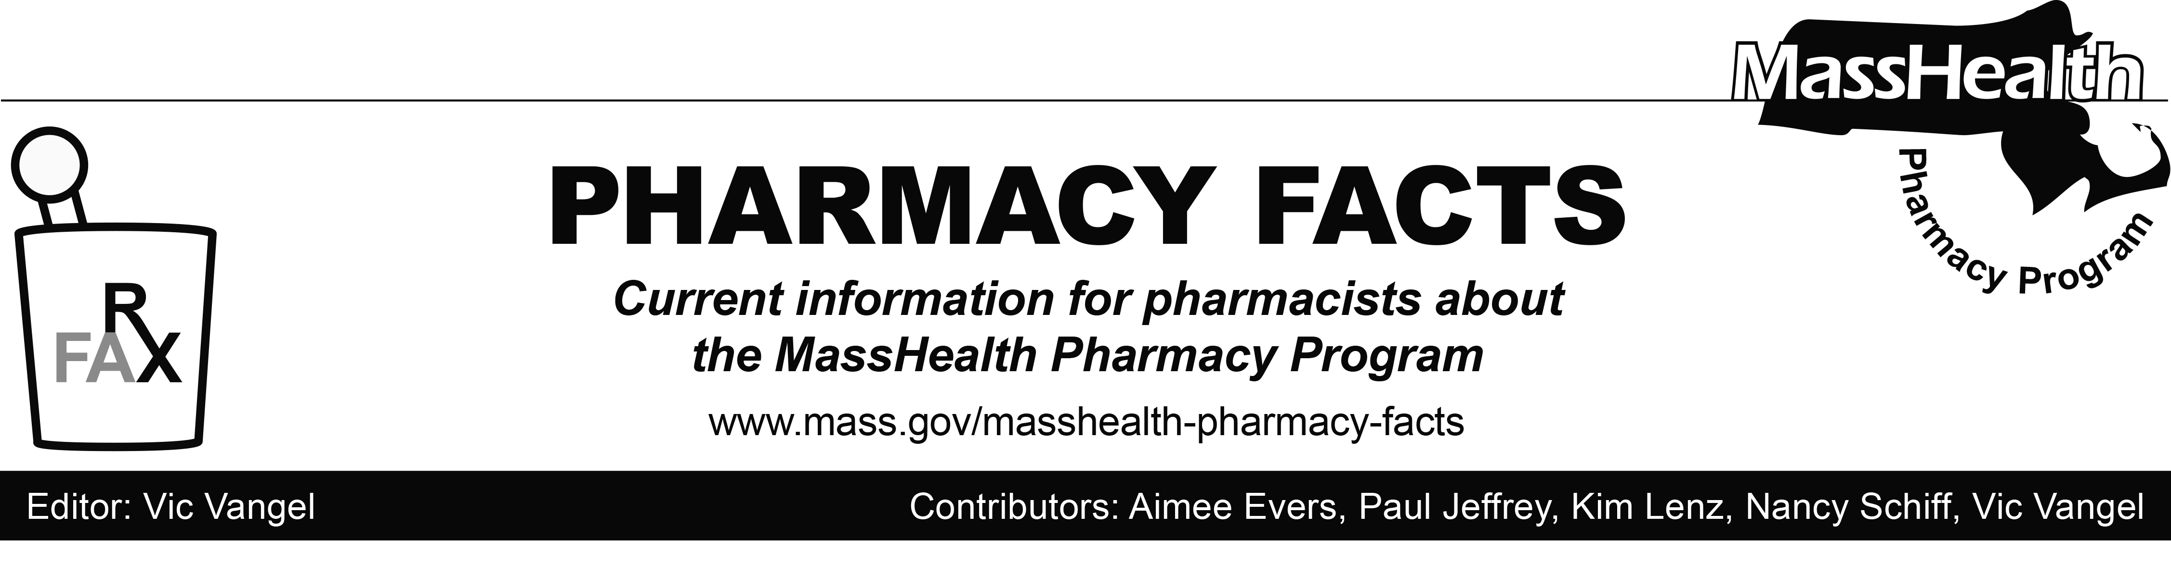
Number 119—September 7, 2018

MHDL Update

Below are certain updates to the MassHealth Drug List (MHDL). See the MHDL for a complete listing of updates.

Additions
Effective September 10, 2018, the following newly marketed drugs have been added to the MassHealth Drug List.
- Cimduo (lamivudine/tenofovir disoproxil fumarate) – PA
- Crysvita (burosumab-twza) – PA
- Juluca (dolutegravir/rilpivirine) – PA
- Kedrab (rabies immune globulin IM, human)
- Lonhala (glycopyrrolate inhalation solution) – PA
- Rhopressa (netarsudil) – PA
- Symfi (efavirenz/lamivudine/tenofovir disoproxil fumarate) – PA
- Symfi Lo (efavirenz/lamivudine/tenofovir disoproxil fumarate) – PA

Change in Prior-Authorization Status
- Effective September 10, 2018, the following multiple sclerosis agents will require prior authorization.
- Extavia (interferon beta-1b) – PA
- Plegridy (peginterferon beta-1a) – PA
- Effective September 10, 2018, the following anticonvulsant agents will no longer require prior authorization for age < 6 years. Pediatric Behavioral Health
Medication Initiative polypharmacy criteria
will still apply. For additional information,

please see the Pediatric Behavioral Health Medication Initiative documents found at www.mass.gov/druglist.
  - Celontin (methsuximide)
  - Dilantin # (phenytoin extended 30 mg and 100 mg capsule)
  - Dilantin-125 # (phenytoin suspension)
  - Dilantin Infatab # (phenytoin chewable tablet)
  - Felbatol # (felbamate)
  - Keppra # (levetiracetam injection, solution, tablet)
  - Mysoline # (primidone)
  - Peganone (ethotoin)
  - phenytoin extended 200 mg and 300 mg capsule
  - Zarontin # (ethosuximide)
  - Zonegran # (zonisamide)
- Effective September 10, 2018, the following otic antibiotic agents will no longer require prior authorization.
  - acetic acid/hydrocortisone
  - Cipro HC (ciprofloxacin/hydrocortisone)
  - Coly-Mycin S (colistin/neomycin/thonzonium/hydrocortisone)
- Effective September 10, 2018, the following glaucoma agents will no longer require prior authorization.
- Alphagan P # (brimonidine 0.1%, 0.15% eye drops)
- Betoptic S (betaxolol 0.25%)
- Combigan (brimonidine/timolol, ophthalmic)
- Istalol (timolol) ^{BP}
- Travatan Z (travoprost 0.004% eye drop)

Updated MassHealth Brand Name Preferred Over Generic Drug List
- Effective September 10, 2018, the following agents will be added to the MassHealth Brand Name Preferred Over Generic Drug List.
- Adcirca (tadalafil) ^{BP} – PA
- Riomet (metformin solution) ^{BP} – PA ≥ 13 years
- Zyclara (imiquimod 2.5%, 3.75 % cream) ^{BP} – PA
b. Effective September 10, 2018, the following
agent will be removed from the MassHealth
Brand Name Preferred Over Generic Drug
List.
- Reyataz # (atazanavir)

Updated MassHealth Over-the-Counter Drug List
Effective September 10, 2018, the following nutrient product will be added to the MassHealth Over-the-Counter Drug List.
- glucose products < 19 years

Abbreviations, Acronyms, and Symbols

# This designates a brand-name drug with FDA “A”-rated generic equivalents. Prior authorization is required for the brand, unless a particular form of that drug (for example, tablet, capsule, or liquid) does not have an FDA “A”-rated generic equivalent.
PA Prior authorization is required. The prescriber must obtain prior authorization for the drug in order for the pharmacy to receive payment. Note: Prior authorization applies to both the brand-name and the FDA “A”-rated generic equivalent of listed product.
^{BP} Brand Preferred over generic equivalents. In general, MassHealth requires a trial of the preferred drug or clinical rationale for prescribing the non-preferred drug generic equivalent.
^{PD} Preferred Drug. In general, MassHealth requires a trial of the preferred drug or clinical rationale for prescribing a non-preferred drug within a therapeutic class.

