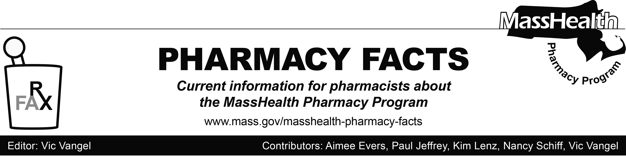
Number 120, October 19, 2018

MHDL Update

Below are certain updates to the MassHealth Drug List (MHDL). See the MHDL for a complete listing of updates.

- Additions
Effective October 22, 2018, the following newly marketed drugs have been added to the MassHealth Drug List.
- Aristada Initio (aripiprazole lauroxil 675 mg) ^{PD} – PA < 6 years and PA > 1 injection/month
- Braftovi (encorafenib) – PA
- Jynarque (tolvaptan) – PA
- Mektovi (binimetinib) – PA
- Olumiant (baricitinib) – PA
- Retacrit (epoetin alfa-epbx) – PA
- Siklos (hydroxyurea)
- Symtuza (darunavir/cobicistat/emtricitabine/ tenofovir alafenamide) – PA
- Tavalisse (fostamatinib) – PA
- Yonsa (abiraterone) – PA

- Change in Prior Authorization Status
- Effective October 22, 2018, the following prefilled insulin syringes will no longer require prior authorization.
- Apidra (insulin glulisine prefilled syringe)
- Humalog (insulin lispro prefilled syringe)
- Humalog (insulin lispro 50/50 prefilled syringe)
- Humalog (insulin lispro 75/25 prefilled syringe)
- Humulin (insulin NPH/regular insulin 70/30 prefilled syringe)
- Humulin N (insulin NPH prefilled syringe)
- Lantus (insulin glargine 100 units/mL prefilled syringe)
- Levemir (insulin detemir prefilled syringe)
- Novolog (insulin aspart prefilled syringe)
- Novolog (insulin aspart 70/30 prefilled syringe)
- Toujeo (insulin glargine 300 units/mL prefilled syringe)
- Tresiba (insulin degludec prefilled syringe)
- Effective October 22, 2018, the following topical immune suppressants will no longer require prior authorization.
  - Elidel (pimecrolimus)
  - Protopic (tacrolimus topical) ^{BP}
Updated MassHealth Brand Name Preferred Over Generic Drug List
- Effective October 22, 2018, the following agents will be added to the MassHealth Brand Name Preferred Over Generic Drug List.
- Albenza (albendazole) ^{BP}
- Forfivo XL (bupropion hydrochloride extended-release 450 mg tablet) ^{BP} – PA
- Effective October 22, 2018, the following agents will be removed from the MassHealth Brand Name Preferred Over Generic Drug List. Please note, Copaxone (glatiramer 20 mg) ^{BP} will remain on the MassHealth Brand Name Preferred Over Generic Drug List.
- Copaxone # (glatiramer 40 mg)
- Suboxone (buprenorphine/naloxone film) ^{PD} – PA > 180 days (> 16 mg/day and ≤ 24 mg/day)
- Suboxone (buprenorphine/naloxone film) ^{PD} – PA > 32 mg/day
- Suboxone (buprenorphine/naloxone film) ^{PD} – PA > 90 days (> 24 mg/day and ≤ 32 mg/day)
- Suboxone (buprenorphine/naloxone film ≤ 16 mg/day) ^{PD}

Legend

^{PA} Prior authorization is required. The prescriber must obtain prior authorization for the drug in order for the pharmacy to receive payment. Note: PA applies to both the brand-name and the FDA “A”-rated generic equivalent of listed product.

# Designates a brand-name drug with FDA “A”-rated generic equivalents. Prior authorization is required for the brand, unless a particular form of that drug (for example, tablet, capsule, or liquid) does not have an FDA “A”-rated generic equivalent.

^{BP} Brand preferred over generic equivalents. In general, MassHealth requires a trial of the preferred drug or clinical rationale for prescribing the nonpreferred drug generic equivalent.

^{PD} In general, MassHealth requires a trial of the preferred drug (PD) or a clinical rationale for prescribing a nonpreferred drug within a therapeutic class.

^{H} Available only in an inpatient hospital setting. MassHealth does not pay for this drug to be dispensed through the retail pharmacy or physician's office.

* The generic OTC and, if any, generic prescription versions of the drug are payable under MassHealth without prior authorization.

^ Available through the health care professional who administers the drug. MassHealth does not pay for this drug to be dispensed through a retail pharmacy.

¹ Product may be available through the Massachusetts Department of Public Health (DPH). Please check with DPH for availability. MassHealth does not pay for immunizing biologicals (i.e., vaccines) and tubercular (TB) drugs that are available free of charge through local boards of public health or through the Massachusetts DPH without prior authorization (130 CMR 406.413(C)). In cases where free vaccines are available to providers for specific populations (e.g., children, high risk, etc.), MassHealth will reimburse the provider only for individuals not eligible for the free vaccines. Notwithstanding the above, MassHealth will pay pharmacies for seasonal flu vaccine serum without prior authorization, if the vaccine is administered in the pharmacy.

