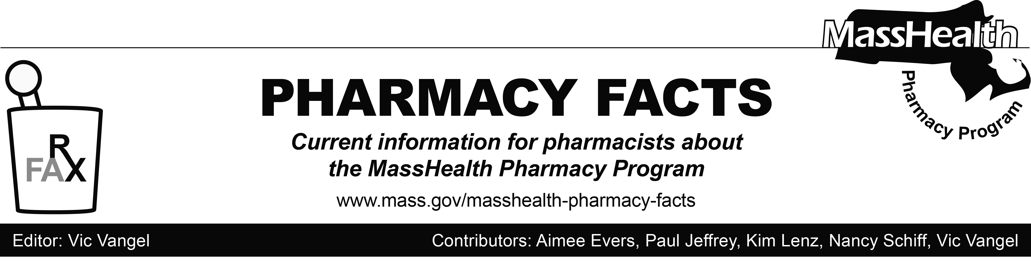
Number 122, December 6, 2018

MHDL Update

Below are certain updates to the MassHealth Drug List (MHDL). See the MHDL for a complete listing of updates.

Additions

Effective December 10, 2018, the following newly marketed drugs have been added to the MHDL.

- Altreno (tretinoin 0.05% lotion) – PA
- Epidiolex (cannabidiol) – PA
- Fulphila (pegfilgrastim-jmdb) – PA
- Jivi (antihemophilic factor, recombinant pegylated-aucl)
- Lokelma (sodium zirconium cyclosilicate) – PA > 30 units/month
- Lucemyra (lofexidine) – PA
- Macrilen (macimorelin) ^
- Nivestym (filgrastim-aafi) – PA
- Orilissa (elagolix) – PA
- Palynziq (pegvaliase-pqpz) – PA
- Poteligeo (mogamulizumab-kpkc) – PA
- Tibsovo (ivosidenib) – PA
- Trivisc (hyaluronate) – PA

Change in Prior-Authorization Status

- Effective December 10, 2018, the following antidiabetic agents will no longer require prior authorization.
- Bydureon (exenatide extended-release pen, vial)
- Byetta (exenatide)
- Farxiga (dapagliflozin)

Change in Prior-Authorization Status (cont.)

- Invokamet (canagliflozin/metformin)
- Invokana (canagliflozin)
- Janumet (sitagliptin/metformin)
- Janumet XR (sitagliptin/metformin extended-release)
- Januvia (sitagliptin)
- Jardiance (empagliflozin)
- Jentadueto (linagliptin/metformin)
- Kombiglyze XR (saxagliptin/metformin extended-release)
- Onglyza (saxagliptin)
- Tradjenta (linagliptin)
- Xigduo XR (dapagliflozin/metformin extended-release)

- Effective December 10, 2018, the following hematopoietic agents will require prior authorization.
Granix (TBO-filgrastim) – PA
Zarxio (filgrastim-sndz) – PA

- Effective December 10, 2018, the following enzyme cofactor agent will require prior authorization.
Kuvan (sapropterin) – PA

(cont.)

Updated MassHealth Brand Name Preferred Over Generic Drug List

- Effective December 10, 2018, the following agents will be added to the MassHealth Brand Name Preferred Over Generic Drug List.
- Androgel (testosterone 1.62% gel packet, pump) ^{BP} – PA
- Androgel (testosterone 1% gel packet) ^{BP} – PA
- Byetta (exenatide) ^{BP}
- Canasa (mesalamine suppository) ^{BP}
- Epclusa (sofosbuvir/velpatasvir) ^{BP} – PA
- Finacea (azelaic acid gel) ^{BP} – PA
- Harvoni (ledipasvir/sofosbuvir) ^{BP} – PA
- Latuda (lurasidone) ^{BP} – PA
- Rapaflo (silodosin) ^{BP} – PA
- Zytiga (abiraterone) ^{BP} – PA

- Effective December 10, 2018, the following agents will be removed from the MassHealth Brand Name Preferred Over Generic Drug List.
- Renvela # (sevelamer carbonate)
- Tazorac (tazarotene) – PA

______________________________
Legend

# Designates a brand-name drug with FDA “A”-rated generic equivalents. Prior authorization is required for the brand, unless a particular form of that drug (for example, tablet, capsule, or liquid) does not have an FDA “A”-rated generic equivalent.

PA Prior authorization is required. The prescriber must obtain prior authorization for the drug in order for the pharmacy to receive payment. Note: PA applies to both the brand-name and the FDA “A”-rated generic equivalent of listed product.

^{BP} Brand preferred over generic equivalents. In general, MassHealth requires a trial of the preferred drug or clinical rationale for prescribing the nonpreferred drug generic equivalent.

^{PD} Preferred drug. In general, MassHealth requires a trial of the preferred drug (PD) or a clinical rationale for prescribing a nonpreferred drug within a therapeutic class.

^ Drug available through the health care professional who administers the drug. MassHealth does not pay for this drug to be dispensed through a retail pharmacy.

_______________________________

