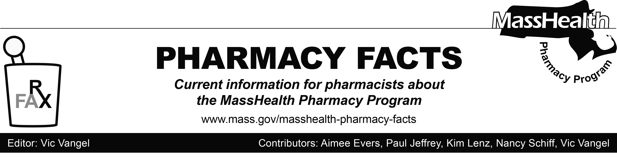
Number 125, January 22, 2019

MHDL Update
Below are certain updates to the MassHealth Drug List (MHDL). See the MHDL for a complete listing of updates.

Additions
Effective January 28, 2019, the following newly marketed drugs have been added to the MassHealth Drug List.
- Azedra (iobenguane I 131) ^
- Delstrigo (doravirine/lamivudine/tenofovir disoproxil fumarate)
- Doptelet (avatrombopag) – PA
- Galafold (migalastat) – PA
- Lexette (halobetasol foam) – PA
- Mulpleta (lusutrombopag) – PA
- Nocdurna (desmopressin) – PA
- Onpattro (patisiran) – PA
- Pifeltro (doravirine)
- Qbrexza (glycopyrronium cloth) – PA
- Tegsedi (inotersen) – PA
- Xofluza (baloxavir) – PA
Updated MassHealth Brand Name Preferred Over Generic Drug List
- Effective January 28, 2019, the following agents will be added to the MassHealth Brand Name Preferred Over Generic Drug List.
- Alphagan P (brimonidine 0.1%, 0.15%
eye drops) ^{BP}
- Amicar (aminocaproic acid) ^{BP}
- Elidel (pimecrolimus) ^{BP}
- Gilenya (fingolimod) ^{BP} – PA
- Ranexa (ranolazine) ^{BP} – PA
- Solodyn (minocycline extended-
release tablet) ^{BP} – PA
- Suboxone (buprenorphine/naloxone
film ≤ 16 mg/day) ^{BP} ^{PD}
- Suboxone (buprenorphine/naloxone film) ^{BP} ^{PD} – PA > 180 days (> 16 mg/day and ≤ 24 mg/day)
- Suboxone (buprenorphine/naloxone film) ^{BP} ^{PD} – PA > 90 days (> 24 mg/day and ≤ 32 mg/day)
- Suboxone (buprenorphine/naloxone film) ^{BP} ^{PD} – PA > 32 mg/day

- Effective January 28, 2019, the following agent will be removed from the MassHealth Brand Name Preferred Over Generic Drug List.
- Makena (hydroxyprogesterone caproate injection) – PA
____________________________________
Legend
PA Prior authorization is required. The prescriber must obtain prior authorization for the drug in order for the pharmacy to receive payment. Note: PA applies to both the brand-name and the FDA “A”-rated generic equivalent of listed product.

# Designates a brand-name drug with FDA “A”-rated generic equivalents. Prior authorization is required for the brand, unless a particular form of that drug (for example, tablet, capsule, or liquid) does not have an FDA “A”-rated generic equivalent.

^{BP} Brand preferred over generic equivalents. In general, MassHealth requires a trial of the preferred drug or clinical rationale for prescribing the nonpreferred drug generic equivalent.

^{H} Available only in an inpatient hospital setting. MassHealth does not pay for this drug to be dispensed through the retail pharmacy or physician's office.

^{PD} In general, MassHealth requires a trial of the preferred drug (PD) or a clinical rationale for prescribing a nonpreferred drug within a therapeutic class.

* The generic OTC and, if any, generic prescription versions of the drug are payable under MassHealth without prior authorization.

^ Available through the health care professional who administers the drug. MassHealth does not pay for this drug to be dispensed through a retail pharmacy.

¹ Product may be available through the Massachusetts Department of Public Health (DPH). Please check with DPH for availability. MassHealth does not pay for immunizing biologicals (i.e., vaccines) and tubercular (TB) drugs that are available free of charge through local boards of public health or through the Massachusetts DPH without prior authorization (130 CMR 406.413(C)). In cases where free vaccines are available to providers for specific populations (e.g., children, high risk, etc.), MassHealth will reimburse the provider only for individuals not eligible for the free vaccines. Notwithstanding the above, MassHealth will pay pharmacies for seasonal flu vaccine serum without prior authorization, if the vaccine is administered in the pharmacy.

