Number 127, March 12, 2019
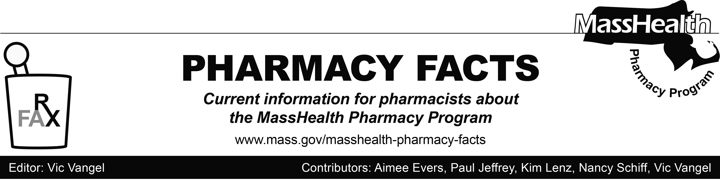

MHDL Update
Below are certain updates to the MassHealth Drug List (MHDL). See the MHDL for a complete listing of updates.

Additions
Effective March 11, 2019, the following newly marketed drugs have been added to the MassHealth Drug List.
- Ajovy (fremanezumab-vfrm) – PA
- Bryhali (halobetasol lotion) – PA
- Copiktra (duvelisib) – PA
- Emgality (galcanezumab-gnlm) – PA
- Ilumya (tildrakizumab-asmn) – PA
- Libtayo (cemiplimab-rwlc) – PA
- Osmolex ER (amantadine extended-release tablet) – PA
- Perseris (risperidone extended-release subcutaneous injection) – PA
- Takhzyro (lanadelumab-flyo) – PA
- Tiglutik (riluzole suspension) – PA
- Tolsura (itraconazole 65 mg capsule) – PA
- Udenyca (pegfilgrastim-cbqv) – PA
- Xelpros (latanoprost emulsion) – PA
- Zemdri (plazomicin) – PA
- Ztlido (lidocaine 1.8% patch) – PA

Change in PA Status
Effective March 11, 2019, the following benzodiazepine and anti-anxiety agents will no longer require PA within newly established quantity limits and/or age limits. Pediatric Behavioral Health Medication Initiative criteria will still apply. For additional information, please see the
Pediatric Behavioral Health Medication Initiative documents found at www.mass.gov/druglist.
- buspirone 30 mg – PA < 6 years
- clonazepam orally disintegrating 0.5 mg, 1 mg tablet – PA < 6 years and PA > 90 units/month
- Restoril # (temazepam 7.5 mg) – PA < 6 years and PA > 30 units/month
- Xanax XR # (alprazolam extended-release) – PA < 6 years and PA > 60 units/month

Updated MassHealth Brand Name Preferred Over Generic Drug List
a. Effective March 11, 2019, the following agents will be added to the MassHealth Brand Name Preferred Over Generic Drug List.
- Azasite (azithromycin ophthalmic solution) ^{BP} – PA
- Exjade (deferasirox 125 mg, 250 mg, 500 mg) ^{BP}
- Renagel (sevelamer hydrochloride) ^{BP}
- Vesicare (solifenacin) ^{BP} – PA
- Zovirax (acyclovir cream) ^{BP} – PA
b. Effective March 11, 2019, the following agent will be removed from the MassHealth Brand Name Preferred Over Generic Drug List.
- Latuda (lurasidone) – PA

Abbreviations, Acronyms, and Symbols
Face-to-face encounters are not required for repairs.

MassHealth Website
^ This drug is available through the health care professional who administers the drug. MassHealth does not pay for this drug to be dispensed through a retail pharmacy.
PA Prior authorization is required. The prescriber must obtain PA for the drug in order for the pharmacy to receive payment. Note: PA applies to both the brand-name and the FDA “A”-rated generic equivalent of listed product.
^{BP} Brand Preferred over generic equivalents. In general, MassHealth requires a trial of the preferred drug or clinical rationale for prescribing the non-preferred drug generic equivalent.
^{PD} Preferred Drug. In general, MassHealth requires a trial of the preferred drug or clinical rationale for prescribing a non-preferred drug within a therapeutic class.

