Number 129, April 18, 2019
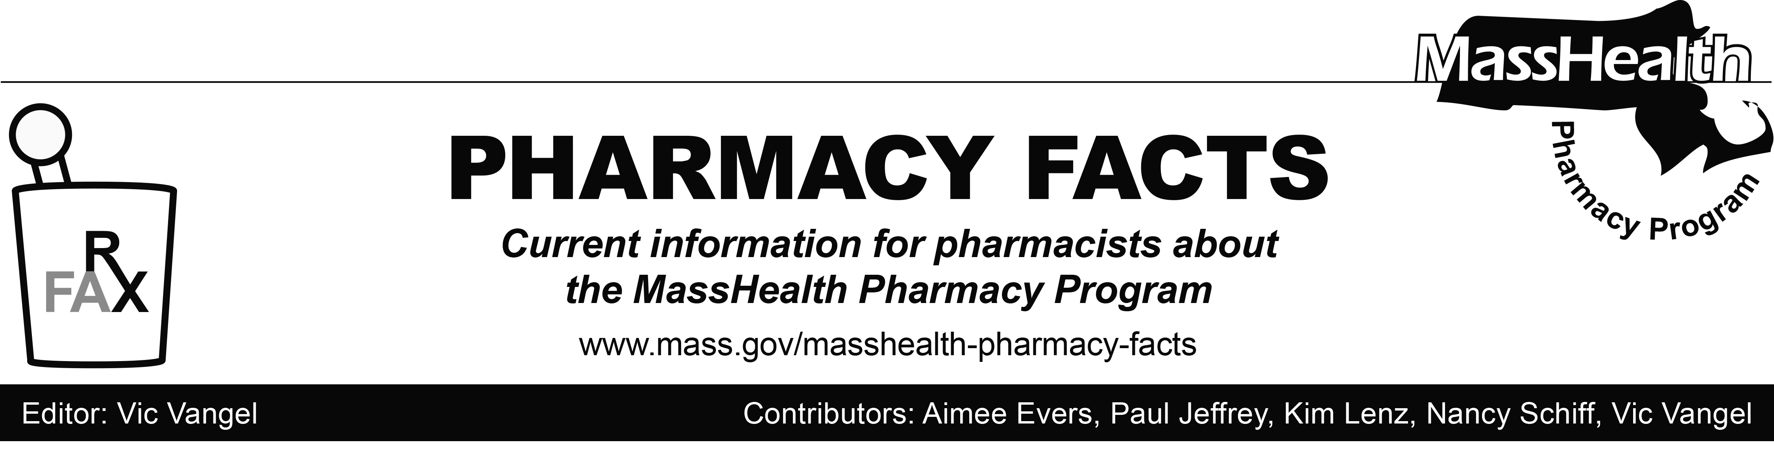

MHDL Update
Below are certain updates to the MassHealth Drug List (MHDL). See the MHDL for a complete listing of updates.

Background
Effective April 22, 2019, the following newly marketed drugs have been added to the MassHealth Drug List.
- Arikayce (amikacin liposome inhalation) – PA

- Firdapse (amifampridine) – PA

- Lorbrena (lorlatinib) – PA

- Lumoxiti (moxetumomab pasudotox-tdfk) – PA

- Revcovi (elapegademase-lvlr) – PA

- Talzenna (talazoparib) – PA

- Ultomiris (ravulizumab-cwvz) – PA

- Vitrakvi (larotrectinib) – PA

- Vizimpro (dacomitinib) – PA

- Xarelto (rivaroxaban 2.5 mg) – PA

- Xerava (eravacycline) – PA

- Xyosted (testosterone enanthate) – PA

- Yupelri (revefenacin) – PA

Updated MassHealth Brand Name Preferred Over Generic Drug List
a. Effective April 22, 2019, the following agents will be added to the MassHealth Brand Name Preferred Over Generic Drug List.
- Catapres-TTS (clonidine patch) ^{BP} – PA

- Flector (diclofenac topical patch) ^{BP} – PA

- Humalog (insulin lispro) ^{BP}

- Rapamune (sirolimus solution) ^{BP}

- Sporanox (itraconazole solution) ^{BP}

- Tekturna (aliskiren) ^{BP} – PA

- Uloric (febuxostat) ^{BP} – PA

b. Effective April 22, 2019, the following agents will be removed from the MassHealth Brand Name Preferred Over Generic Drug List.
- Aczone (dapsone gel) – PA

- Lialda # (mesalamine delayed-release)

- Pulmicort # (budesonide inhalation suspension)

- Zyclara (imiquimod 2.5%, 3.75% cream) – PA

Abbreviations, Acronyms, and Symbols
^ This drug is available through the health care professional who administers the drug. MassHealth does not pay for this drug to be dispensed through a retail pharmacy.
PA Prior authorization is required. The prescriber must obtain PA for the drug in order for the pharmacy to receive payment. Note: PA applies to both the brand-name and the FDA “A”-rated generic equivalent of listed product.
^{BP} Brand Preferred over generic equivalents. In general, MassHealth requires a trial of the preferred drug or clinical rationale for prescribing the non-preferred drug generic equivalent.
^{PD} Preferred Drug. In general, MassHealth requires a trial of the preferred drug or clinical rationale for prescribing a non-preferred drug within a therapeutic class.

MassHealth Website
This Pharmacy Facts is available on the MassHealth website at https://www.mass.gov/lists/masshealth-pharmacy-facts.
Sign up to receive email notification whenever a new Pharmacy Facts is posted on the Web. Just send the blank email as it’s addressed. No text in the body or subject line is needed.

