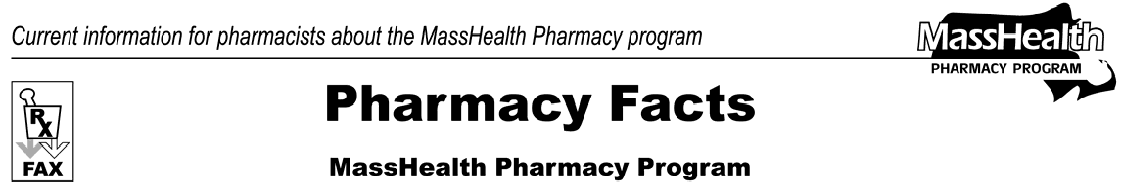
Number 13
Nov 30, 2005
- Editor: Vic Vangel • Contributors: Chris Burke, Gary Gilmore, Paul Jeffrey, James Monahan •

New Pharmacy Web Site
Another reminder that the Pharmacy Program at MassHealth has a new web site. Useful information at this site includes links to the MassHealth Drug List, pharmacy regulations, PA forms, and billing guide.
The address for this site is
www.mass.gov/masshealth/pharmacy.

30-Day Supply
MassHealth limits the day’s supply of a prescription to a 30-day supply, unless the drug is available only in a larger minimum package size. Prescriptions for methylphenidate and amphetamine products will continue to be accepted when written for a 60-day supply. This new day supply limit will be in effect for all prescriptions written on or after Dec. 1, 2005.

MassHealth Drug List
Change in Prior Authorization Status
MassHealth has changed the prior authorization requirements for the Proton Pump Inhibitors.
Effective January 2, 2006, the following drug will require prior authorization.

Protonix (pantoprazole) – PA

Update to MassHealth Nonlegend Drug List
The MassHealth Nonlegend Drug List has been updated to reflect that the following drug is available without prior authorization effective January 2, 2006.

Prilosec OTC (omeprazole)

Provider Continuing Education Events
You have received information regarding a Continuing Education program offered by MassHealth and ACS. There is still space available if you have not registered yet. A fax was sent by ACS that contained program information and a registration form. If you do not have this information you may call ACS at 617-423-9830 to reserve a space. These evening programs will take place in:
Worcester 12/6 Somerville 12/8 Springfield 12/13 Randolph 12/15

Please direct any questions or comments (or to be taken off of this fax distribution) to
Victor Moquin of ACS at 617-423-9830.

