Number 130, May 30, 2019
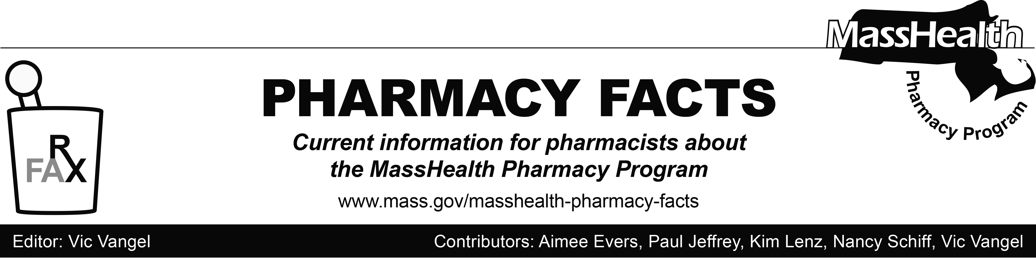

MHDL Update

Below are certain updates to the MassHealth Drug List (MHDL). See the MHDL for a complete listing of updates.

Additions
Effective June 3, 2019, the following newly marketed drugs have been added to the MassHealth Drug List.
- Daurismo (glasdegib) – PA
- Nuzyra (omadacycline injection) – PA
- Nuzyra (omadacycline tablet) – PA
- Oxervate (cenegermin-bkbj) – PA
- Panzyga (immune globulin IV, human-ifas) – PA
- Symjepi (epinephrine injection)
- Sympazan (clobazam film) – PA
- Xospata (gilteritinib) – PA
- Zypitamag (pitavastatin magnesium) – PA

Change in Prior-Authorization Status
- Effective June 3, 2019, the following antipsychotic agents will no longer require prior authorization (PA) for adult members when used within quantity limits. Pediatric Behavioral Health Medication Initiative criteria will still apply. For additional information, please see the Pediatric Behavioral Health Medication Initiative documents found at http://www.mass.gov/druglist.
  - Seroquel XR # (quetiapine extended-release 150 mg, 200 mg) – PA < 6 years and PA > 30 units/month
  - Seroquel XR # (quetiapine extended-release 50 mg, 300 mg and 400 mg) – PA < 6 years and PA > 60 units/month
- Effective June 3, 2019, the following antipsychotic agents will no longer require PA when used within quantity limits. Pediatric Behavioral Health Medication Initiative criteria will still apply. For additional information, please see the Pediatric Behavioral Health Medication Initiative documents at http://www.mass.gov/druglist.

  - Risperdal M-Tab # (risperidone 0.5 mg, 1 mg, 3 mg orally disintegrating tablet) – PA < 6 years and PA > 60 units/month
  - Risperdal M-Tab # (risperidone 2 mg orally disintegrating tablet) – PA < 6 years and PA > 240 units/month
  - Zyprexa Zydis # (olanzapine 5 mg, 10 mg, 20 mg orally disintegrating tablet) – PA < 6 years and PA > 30 units/month
  - Zyprexa Zydis # (olanzapine 15 mg orally disintegrating tablet) – PA < 6 years and PA > 60 units/month
- Effective June 3, 2019, the following lipid lowering agents will no longer require PA.
  - Antara (fenofibrate capsule 30 mg, 90 mg)
  - fenofibrate capsule 130 mg
  - Lipofen (fenofibrate capsule 150 mg)
  - Lovaza # (omega-3 acid ethyl esters)
  - Tricor # (fenofibrate tablet 145 mg)
  - Triglide (fenofibrate tablet 160 mg)
  - Welchol (colesevelam) ^{BP}
  - Zetia # (ezetimibe)
- Effective June 3, 2019, the following lipid lowering agent will no longer require PA when used within the quantity limit.
  - Vytorin (ezetimibe/simvastatin) ^{BP} – PA > 30 units/month
- Effective June 3, 2019, the following anticoagulant agent will no longer require PA for exceeding dose or quantity limits.
  - Xarelto (rivaroxaban 10 mg)
- Effective June 3, 2019, the following anticoagulant agents will no longer require PA.
  - Xarelto (rivaroxaban 15 mg, 20 mg)
  - Xarelto (rivaroxaban starter pack)
- Effective June 3, 2019, the following analgesic agent will require PA when used outside of newly established dose limits.
  - Ultram # (tramadol) – PA < 12 years and PA > 400 mg/day
h. Effective June 3, 2019, the following hypnotic agents will no longer require PA within newly established quantity limits. Pediatric Behavioral Health Medication Initiative criteria will still apply. For additional information, please see the Pediatric Behavioral Health Medication Initiative documents at http://www.mass.gov/druglist.
- Ambien CR # (zolpidem extended-release tablet) – PA < 6 years and PA > 30 units/month
- Lunesta # (eszopiclone) – PA < 6 years and PA > 30 units/month
i. Effective June 3, 2019, the following hypnotic agent will no longer require PA within newly established quantity limits.
  - Rozerem (ramelteon) – PA > 30 units/month
j. Effective June 3, 2019, the following oral antibiotic agent will no longer require PA.
- Xifaxan (rifaximin 200 mg)
Updated MassHealth Brand Name Preferred over Generic Drug List
- Effective June 3, 2019, the following agents will be added to the MassHealth Brand Name Preferred Over Generic Drug List.
- Carafate (sucralfate suspension) ^{BP}
- Cuprimine (penicillamine) ^{BP}
- Delzicol DR (mesalamine capsule) ^{BP}
- Letairis (ambrisentan) ^{BP} – PA
- Lotemax (loteprednol 0.5%) ^{BP} – PA
- Lyrica (pregabalin) ^{BP} – PA
- Proventil (albuterol inhaler) ^{BP} – PA
- Tarceva (erlotinib) ^{BP} – PA
- Toviaz (fesoterodine) ^{BP} – PA
- Tracleer (bosentan) ^{BP} – PA
- Ventolin (albuterol inhaler) ^{BP} – PA
- Effective June 3, 2019, the following agents will be removed from the MassHealth Brand Name Preferred Over Generic Drug List.
  - Adcirca (tadalafil) – PA
  - Androgel (testosterone 1.62% gel packet,
pump) – PA
  - Estrace # (estradiol cream)

____________________________________
Legend
^{PA} Prior authorization is required. The prescriber must obtain PA for the drug in order for the pharmacy to receive payment. Note: PA applies to both the brand-name and the FDA “A”-rated generic equivalent of listed product.

# Designates a brand-name drug with FDA “A”-rated generic equivalents. PA is required for the brand, unless a particular form of that drug (for example, tablet, capsule, or liquid) does not have an FDA “A”-rated generic equivalent.

^{BP} Brand preferred over generic equivalents. In general, MassHealth requires a trial of the preferred drug or clinical rationale for prescribing the nonpreferred drug generic equivalent.

^ Available through the health care professional who administers the drug. MassHealth does not pay for this drug to be dispensed through a retail pharmacy.

