Number 131, July 12, 2019
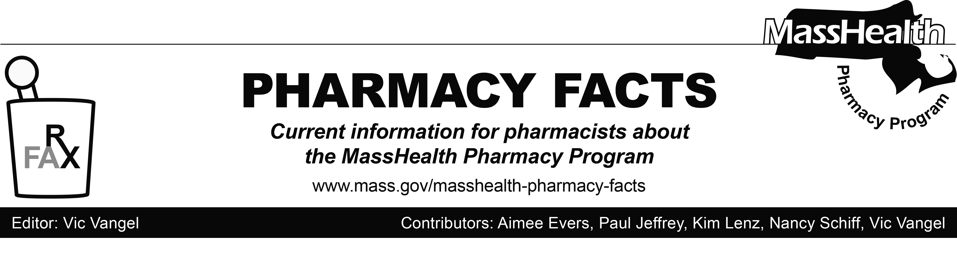

Vaccine Administration

Effective July 15, 2019 MassHealth will pay pharmacies for the administration of vaccines recommended in the Adult Immunization Schedule by the Centers for Disease Control and Prevention (CDC) to MassHealth-eligible members.

Vaccinations must be administered by properly trained and certified pharmacists and other health care professionals in accordance with Massachusetts Department of Public Health regulations at 105 CMR 700.000.

Pharmacies must provide information to the member’s primary care clinician for the administration of the vaccine. This information must include:
- the member’s name and date of birth;
- the vaccine name, quantity, and lot number;
- the injection site of administration; and
- the date of administration.

Pharmacies may bill only for vaccine administration through the Pharmacy Online Processing System
(POPS) using the following instructions.
• Include the NDC of the vaccine serum.
• Enter a zero amount in the dispensing fee field. (MassHealth will pay an administration fee to
pharmacies instead of a dispensing fee.)
• Enter “MA” in the field named “Professional Service”(440-E5).
• Enter the appropriate administration fee in the field
named “Incentive Amount Submitted” (438-E8). See the chart below.
• Include the cost of the vaccine serum, plus the
administration fee, as the gross amount due.

Payment Amount for Vaccine Administration

Service Administration Fee

Vaccine,
administered $20.25
by injection

The MassHealth Pharmacy Covered Professional Services List will be updated and is on the MassHealth website.

Effective July 15, 2019, pharmacies may receive payment for vaccine administration for the following vaccines.
  - haemophilus influenzae type b
  - hepatitis A vaccine
  - hepatitis A and hepatitis B vaccine
  - hepatitis B vaccine
  - human papillomavirus vaccine
  - influenza vaccine
  - measles, mumps, and rubella vaccine
  - meningococcal serogroups A, C, W, Y vaccine
  - meningococcal serogroup B vaccine
  - pneumococcal 13-valent conjugate vaccine
  - pneumococcal 23-valent polysaccharide vaccine
  - tetanus and diphtheria toxoids
  - tetanus and diphtheria toxoids and acellular pertussis vaccine
  - varicella vaccine
  - zoster vaccine live
  - zoster vaccine, recombinant
Brand Name Preferred Over Generic
MassHealth prefers certain brand name drugs over generics as listed on the MassHealth Brand Name Preferred Over Generic Drug List. When submitting a claim for the generic version of a brand name drug that appears on the MassHealth Brand Name Preferred Over Generic Drug List, a pharmacy may see a claim rejection that reads as follows.

75 – Prior Authorization Required, with text message, “Drug is on MH brand preferred list. DAW 9 for preferred brand submission. Non-preferred brand or generic drugs would require DUR (Drug Utilization Review) certification.”

If a pharmacy encounters this rejection, the pharmacy should resubmit the claim for the preferred brand name drug using a DAW 9. A new prescription from the provider is not needed nor should it be marked “Brand Name Medically Necessary, No Substitutions” when resubmitting for the preferred brand.

When submitting a claim where MassHealth is the secondary payer and the primary payer prefers a generic, the pharmacy should submit the claim as the generic. If a rejection is encountered on a claim where MassHealth is the secondary payer and the primary insurer prefers the generic, please contact the MassHealth DUR unit at (800) 745-7318 for assistance.
Tramadol Inclusion in Duplicate Opioid Policy
Tramadol is a centrally acting synthetic opioid analgesic exhibiting weak reuptake inhibition of norepinephrine and serotonin. Tramadol is classified by the Drug Enforcement Administration (DEA) as a schedule IV medication, indicating low potential for abuse and low risk for dependence. However, there is still concern for potential risk for abuse, addiction and overdose with tramadol.

Given the above information, MassHealth will now include tramadol in all opioid restrictions, including dose limits and duplicate long- and short-acting opioid overlap rules.
MHDL Update
Below are certain updates to the MassHealth Drug List (MHDL). See the MHDL for a complete listing of updates.
Additions
- Balversa (erdafitinib) – PA
- Belrapzo (bendamustine)
- Cutaquig (immune globulin subcutaneous injection, human-hipp) – PA
- Diacomit (stiripentol) – PA
- Duobrii (halobetasol/tazarotene lotion) – PA
- Kapspargo (metoprolol extended-release capsule) – PA
- Motegrity (prucalopride) – PA
- Plenvu (polyethylene glycol-electrolyte solution) – PA
- Spravato (esketamine) – PA
Change in Prior Authorization Status
- Effective July 15, 2019, the following bowel preparation agents will no longer require prior authorization (PA).
- Colyte with flavor packs # (polyethylene glycol-electrolyte solution)
- Moviprep (polyethylene glycol-electrolyte solution)
- Osmoprep (sodium phosphate)
- Effective July 15, 2019, the following opioid dependence agent will no longer require PA when used within updated dose limits.
- Suboxone (buprenorphine/naloxone film ≤ 24 mg/day) ^{BP PD}
- Effective July 15, 2019, the following inhaled respiratory agents will no longer require PA.
- Proair Respiclick (albuterol inhalation powder)
- Proventil (albuterol inhaler) ^{BP}
- Xopenex (levalbuterol inhaler) ^{BP}

- Effective July 15, 2019, the following oral antibiotic agent will no longer require PA.
- Solodyn (minocycline extended-release 55 mg, 65 mg, 80 mg, 105 mg, 115 mg tablet) ^{BP}
- Effective July 15, 2019, the following nonsteroidal anti-inflammatory agent will no longer require PA for use outside of the age limit.
- Celebrex # (celecoxib)
- Effective July 15, 2019, the following nonsteroidal anti-inflammatory agents will no longer require PA.
- Daypro # (oxaprozin)
- diclofenac potassium
- diflunisal
- Feldene # (piroxicam)
- indomethacin extended-release
- Naprosyn EC # (naproxen enteric coated)
- Ponstel # (mefenamic acid)
- Voltaren-XR # (diclofenac extended-release)
Updated MassHealth Brand Name Over Generic Drug List
- Effective July 15, 2019, the following agents will be added to the MassHealth Brand Name Preferred Over Generic Drug List.
- Coly-Mycin S (colistin/neomycin/thonzonium/ hydrocortisone) ^{BP}
- Diclegis (doxylamine/pyridoxine delayed-release) ^{BP} – PA
- Revatio (sildenafil oral suspension) ^{BP} – PA
- Xopenex (levalbuterol inhaler) ^{BP}
- Effective July 15, 2019, the following agents will be removed from the MassHealth Brand Name Preferred Over Generic Drug List.
- Albenza # (albendazole)
- Canasa # (mesalamine suppository)
- Gleevec # (imatinib)
- Zyflo CR (zileuton extended-release) – PA
Legend
PA Prior authorization is required. The prescriber must obtain PA for the drug in order for the pharmacy to receive payment. Note: PA applies to both the brand-name and the FDA “A”-rated generic equivalent of listed product.
# Designates a brand-name drug with FDA “A”-rated generic equivalents. PA is required for the brand, unless a particular form of that drug (for example, tablet, capsule, or liquid) does not have an FDA “A”-rated generic equivalent.
^{BP} Brand preferred over generic equivalents. In general, MassHealth requires a trial of the preferred drug or clinical rationale for prescribing the nonpreferred drug generic equivalent.
^{PD} In general, MassHealth requires a trial of the preferred drug (PD) or a clinical rationale for prescribing a nonpreferred drug within a therapeutic class.

