Number 133, August 21, 2019
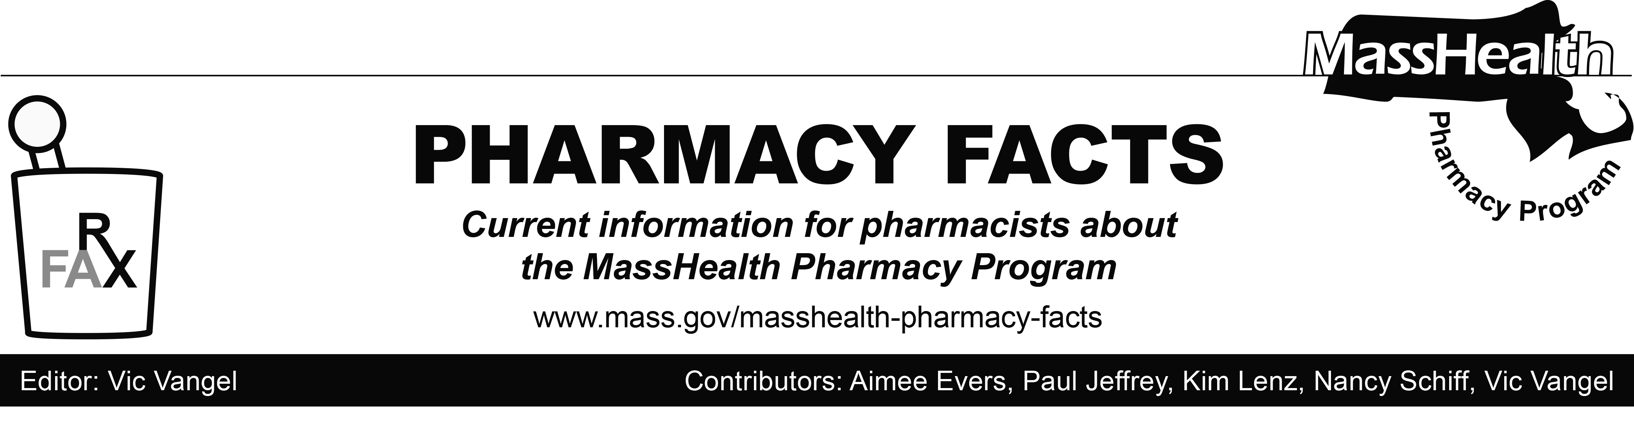

MHDL Update

Below are certain updates to the MassHealth Drug List (MHDL). See the MHDL for a complete listing of updates.
Additions
Effective August 26, 2019, the following newly marketed drugs have been added to the MassHealth Drug List.
- Cablivi (caplacizumab-yhdp) – PA
- Dextenza (dexamethasone ophthalmic insert) ^
- Elzonris (tagraxofusp-erzs) ^{CO} – PA
- Euthyrox # (levothyroxine)
- Mayzent (siponimod) – PA
- Ruzurgi (amifampridine) – PA
- Slynd (drospirenone)
Updated MassHealth Brand Name Preferred over Generic Drug List

- Effective August 26, 2019, the following agents will be added to the MassHealth Brand Name Preferred Over Generic Drug List.
  - Noxafil (posaconazole) ^{BP} – PA
  - Rozerem (ramelteon) ^{BP} – PA > 30 units/month

- Effective August 26, 2019, the following agents will be removed from the MassHealth Brand Name Preferred Over Generic Drug List.
- Advair (fluticasone/salmeterol inhalation aerosol, powder) – PA
- Ranexa (ranolazine) – PA
- Tamiflu # (oseltamivir 6 mg/mL suspension) – PA all quantities (June 1st to September 30th); PA > 180 mL/season (October 1st to May 31st)
____________________________________
Legend
^{PA} Prior authorization is required. The prescriber must obtain PA for the drug in order for the pharmacy to receive payment. Note: PA applies to both the brand-name and the FDA “A”-rated generic equivalent of listed product.

# Designates a brand-name drug with FDA “A”-rated generic equivalents. PA is required for the brand, unless a particular form of that drug (for example, tablet, capsule, or liquid) does not have an FDA “A”-rated generic equivalent.

^{BP} Brand preferred over generic equivalents. In general, MassHealth requires a trial of the preferred drug or clinical rationale for prescribing the non-preferred drug generic equivalent.

^ Available through the health care professional who administers the drug. MassHealth does not pay for this drug to be dispensed through a retail pharmacy.

^{PD} Preferred Drug. In general, MassHealth requires a trial of the preferred drug or clinical rationale for prescribing a non-preferred drug within a therapeutic class.

^{CO} Carve-Out. This agent is listed on the Acute Hospital Carve-Out Drugs List and is subject to additional monitoring and billing requirements.

