Number 134, September 25, 2019
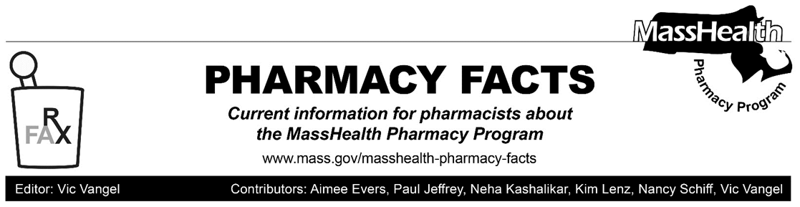
Copayments for Smoking Cessation Products
Effective September 25, 2019, MassHealth has eliminated all co-payments for smoking cessation products, including nicotine replacement therapy (NRT).
Pharmacy Copayment Poster Updated
The pharmacy copayment poster has been updated to reflect this new information and is on the MassHealth Pharmacy Web page. To download the poster, go to www.mass.gov/masshealth-pharmacy-program and click on the link for MassHealth Pharmacy Publications and Notices for Pharmacy Providers, then Sample Pharmacy Copayment Poster.
Pharmacies are required by MassHealth regulations at 130 CMR 450.130(F) to post a notice about MassHealth copayments in areas where copayments are collected. The notice must be visible to the public and easily readable; specify the exclusions from the copayment requirement listed in 130 CMR 450.130(D) and (E); and instruct members to inform providers if they believe they are excluded from the copayment requirement.
Standing Order for Nicotine Replacement Therapy
Pursuant to the September 24, 2019, order of the Commissioner of Public Health, and Governor Baker’s Declaration of a Public Health Emergency due to severe lung disease associated with the use of e-cigarettes among youths, a standing order for FDA approved, over-the-counter (OTC) nicotine replacement therapy only has been issued.

Here is a link to the standing order:

PDF of the NRT Standing Order
The standing order authorizes licensed pharmacists to dispense medically appropriate NRT products under the following conditions:

- The purchaser must be 18 years or older with proper identification.
- The pharmacy must make a reasonable effort to determine if the purchaser’s insurance covers the selected NRT product.
- The pharmacy should make available information about the Massachusetts Smokers’ Helpline at 1-800-QUIT-NOW.
- The FDA-approved, OTC NRT product should be processed under the statewide Standing Order using the manufacturer’s FDA approved dosing.
The standing order for OTC NRT products allows the pharmacist to execute a prescription for MassHealth members to obtain such products upon the request of the member.

