Number 135, October 10, 2019
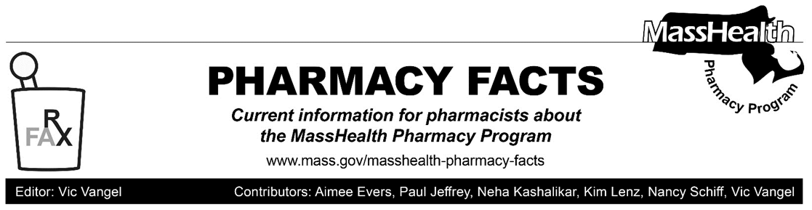
MHDL Update

Below are certain updates to the MassHealth Drug List (MHDL). See the MHDL for a complete listing of updates.

Additions
- Effective October 1, 2019, the following newly marketed drug has been added to the MassHealth Drug List.
- Dovato (dolutegravir/lamivudine) ^{PD}
- Effective October 7, 2019, the following newly marketed drugs have been added to the MassHealth Drug List.
- dexchlorpheniramine solution – PA
- Evenity (romosozumab-aqqg) – PA
- Ezallor (rosuvastatin sprinkle capsule) – PA
- Gamifant (emapalumab-lzsg) – PA
- Mavenclad (cladribine tablet) – PA
- Piqray (alpelisib) – PA
- pyridostigmine bromide 30 mg tablet – PA
- Skyrizi (risankizumab-rzaa) – PA
- Vyndaqel (tafamidis) – PA

Change in Prior Authorization Status
- Effective October 1, 2019, the following antiretroviral agent will no longer require prior authorization.
- Juluca (dolutegravir/rilpivirine) ^{PD}
- Effective October 7, 2019, the following urinary dysfunction agents will no longer require prior authorization.
  - Gelnique (oxybutynin gel)
  - Myrbetriq (mirabegron extended-release)
  - Oxytrol (oxybutynin transdermal system)
  - Toviaz (fesoterodine) ^{BP}
  - Vesicare # (solifenacin)
- Effective October 7, 2019, the following urinary dysfunction agent will no longer require prior authorization for exceeding quantity limits.
- Detrol LA # (tolterodine extended-release 2 mg)
- Effective October 7, 2019, the following urinary dysfunction agent will require prior authorization.
  - trospium extended-release – PA
- Effective October 7, 2019, the following antihistamine agent will no longer require prior authorization for use above quantity limits.
  - azelastine 137 mcg nasal spray
- Effective October 7, 2019, the following antihistamine agent will no longer require prior authorization.
  - carbinoxamine 4 mg/5mL solution, 4 mg tablet
  - Clarinex # (desloratadine syrup, tablet)
  - Dymista (azelastine/fluticasone propionate)

Updated MassHealth Brand Name Preferred Over Generic Drug List
- Effective October 1, 2019, the following agents will be removed from the MassHealth Brand Name Preferred Over Generic Drug List.
- Epclusa (sofosbuvir/velpatasvir) – PA
- Harvoni (ledipasvir/sofosbuvir) – PA
- Effective October 7, 2019, the following agent will be added to the MassHealth Brand Name Preferred Over Generic Drug List.
- Copaxone (glatiramer 40 mg) ^{BP}

- Effective October 7, 2019, the following agents will be removed from the MassHealth Brand Name Preferred Over Generic Drug List.
- Delzicol DR # (mesalamine capsule)
- Flector (diclofenac topical patch) – PA
- Letairis (ambrisentan) – PA
- Tamiflu # (oseltamivir 30mg) – PA all quantities (June 1st to September 30th); PA > 20 capsules/season (October 1st to May 31st)
- Tamiflu # (oseltamivir 45 mg and 75 mg) – PA all quantities (June 1st to September 30th); PA > 10 capsules/season (October 1st to May 31st)
- Vesicare # (solifenacin)
- Xeloda # (capecitabine)

Updated MassHealth Supplemental Rebate/Preferred Drug List
- Effective October 1, 2019, the following antiretroviral agents will be added to the MassHealth Supplemental Rebate/Preferred Drug List.
- Dovato (dolutegravir/lamivudine) ^{PD}
- Juluca (dolutegravir/rilpivirine) ^{PD}
- Triumeq (abacavir/dolutegravir/lamivudine) ^{PD}
- Effective October 1, 2019, the following hepatitis antiviral agents will be added to the MassHealth Supplemental Rebate/Preferred Drug List.
- ledipasvir/sofosbuvir ^{PD} – PA
- sofosbuvir/velpatasvir ^{PD} – PA
- Effective October 1, 2019, the following hepatitis antiviral agents will be removed from the MassHealth Supplemental Rebate/Preferred Drug List.
- Epclusa (sofosbuvir/velpatasvir) – PA
- Harvoni (ledipasvir/sofosbuvir) – PA
- Sovaldi (sofosbuvir) – PA
Updated MassHealth ACPP/MCO Uniform Preferred Drug List
- Effective January 1, 2020. the following antiretroviral agents will be added to the MassHealth ACPP/MCO Uniform Preferred Drug List.
- Dovato (dolutegravir/lamivudine)
- Juluca (dolutegravir/rilpivirine)
- Triumeq (abacavir/dolutegravir/lamivudine)

- Effective January 1. 2020, the following hepatitis antiviral agents will be added to the MassHealth ACPP/MCO Uniform Preferred Drug List.
- ledipasvir/sofosbuvir
- sofosbuvir/velpatasvir
- Effective January 1, 2020, the following hepatitis antiviral agents will be removed from the MassHealth ACPP/MCO Uniform Preferred Drug List.
- Epclusa (sofosbuvir/velpatasvir)
- Harvoni (ledipasvir/sofosbuvir)
- Sovaldi (sofosbuvir)
____________________________________
Legend

^{PA} Prior authorization is required. The prescriber must obtain prior authorization for the drug in order for the pharmacy to receive payment. Note: PA applies to both the brand-name and the FDA “A”-rated generic equivalent of listed product.

# Designates a brand-name drug with FDA “A”-rated generic equivalents. Prior authorization is required for the brand, unless a particular form of that drug (for example, tablet, capsule, or liquid) does not have an FDA “A”-rated generic equivalent.

^{BP} Brand preferred over generic equivalents. In general, MassHealth requires a trial of the preferred drug or clinical rationale for prescribing the nonpreferred drug generic equivalent.

^{PD} In general, MassHealth requires a trial of the preferred drug (PD) or a clinical rationale for prescribing a nonpreferred drug within a therapeutic class.

