Number 139, January 6, 2020
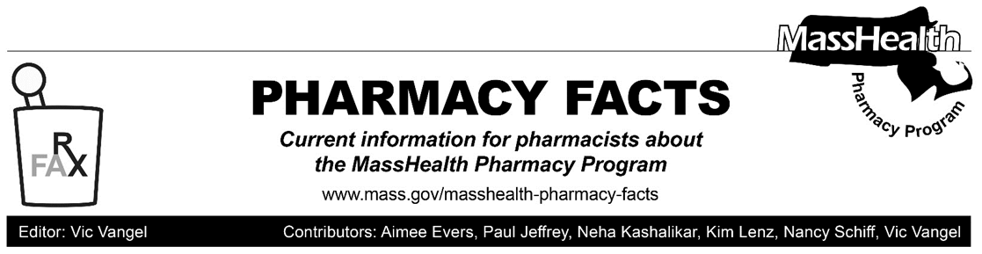
MHDL Update

Below are certain updates to the MassHealth Drug List (MHDL). See the MHDL for a complete listing of updates.

Additions
- Effective January 13, 2020, the following newly marketed drugs have been added to the MassHealth Drug List.
- Annovera (segesterone/ethinyl estradiol)
- Bijuva (estradiol/progesterone) – PA
- Cequa (cyclosporine 0.09% ophthalmic solution) – PA
- Egaten (triclabendazole) – PA
- Infugem (gemcitabine) – PA
- Inveltys (loteprednol 1% suspension) – PA
- Khapzory (levoleucovorin powder for injection) – PA
- Lotemax SM (loteprednol 0.38% gel) – PA
- Nayzilam (midazolam nasal spray) – PA > 10 units/month
- Nubeqa (darolutamide) – PA
- Rinvoq (upadacitinib) – PA
- Rocklatan (netarsudil/latanoprost) – PA
- Temixys (lamivudine/tenofovir disoproxil fumarate) – PA
- Trikafta (elexacaftor/tezacaftor/ivacaftor) – PA
- Turalio (pexidartinib) – PA
- Xpovio (selinexor) – PA
- Yutiq (fluocinolone ophthalmic implant) ^
- Zelnorm (tegaserod) – PA
- Zulresso (brexanolone) ^ – PA

Change in Prior Authorization Status
- Effective January 13, 2020, the following ophthalmic agents will no longer require prior authorization.
  - Lotemax (loteprednol 0.5% suspension) ^{BP}
  - Restasis (cyclosporine 0.05% ophthalmic emulsion) ^{BP}

Updated MassHealth Brand Name Preferred Over Generic Drug List
- Effective January 13, 2020, the following agents will be added to the MassHealth Brand Name Preferred Over Generic Drug List.
- Aczone (dapsone 7.5% gel) ^{BP}– PA
- Afinitor (everolimus) ^{BP}– PA
- Aggrenox (aspirin/extended-release dipyridamole) ^{BP}
- Apriso (mesalamine extended-release) ^{BP}
- Isordil (isosorbide dinitrate 40 mg tablet) ^{BP}– PA
- Novolog (insulin aspart 70/30) ^{BP}
- Novolog (insulin aspart) ^{BP}
- Restasis (cyclosporine 0.05% ophthalmic emulsion) ^{BP}
- Travatan Z (travoprost 0.004% eye drop) ^{BP}
- Effective January 13, 2020, the following agents will be removed from the MassHealth Brand Name Preferred Over Generic Drug List.
- Proventil (albuterol inhaler)
- Ventolin (albuterol inhaler) – PA
- Xenazine (tetrabenazine) – PA

Updated MassHealth Over-the-Counter Drug List
- Effective January 13, 2020, the following gastrointestinal agent will be added to the MassHealth Over-the-Counter Drug List.
- lactase *
_______________________________________
Legend
^{PA} Prior authorization is required. The prescriber must obtain prior authorization for the drug in order for the pharmacy to receive payment. Note: PA applies to both the brand-name and the FDA “A”-rated generic equivalent of listed product.
^{BP} Brand preferred over generic equivalents. In general, MassHealth requires a trial of the preferred drug or clinical rationale for prescribing the nonpreferred drug generic equivalent.
^ This drug is available through the health care professional who administers the drug. MassHealth does not pay for this drug to be dispensed through a retail pharmacy.
* The generic OTC and, if any, generic prescription versions of the drug are payable under MassHealth without prior authorization.

