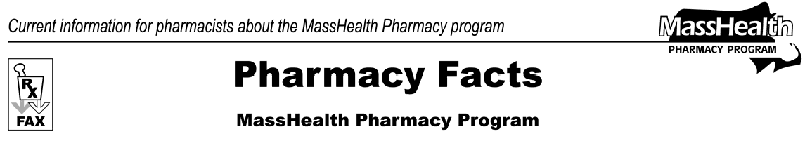
Number 14
December 29, 2005
- Editor: Vic Vangel • Contributors: Chris Burke, Gary Gilmore, Paul Jeffrey, James Monahan •

Medicare Part D Prescription Drug Coverage
As we know by now there are major changes in drug coverage for some MassHealth members. All individuals who are eligible for both Medicaid and Medicare (dually eligible) should be automatically enrolled in a Medicare drug plan by January 1, 2006. MassHealth will no longer pay for most medications for these members and the Medicare Part D plan will assume responsibility for drug coverage. Some classes of drugs are excluded by the Part D plans; however, MassHealth will continue to pay for some of these drugs for dual-eligible members. These classes are:

Benzodiazepines -There will be no change in how MassHealth pays for these drugs (for example, quantity limits on certain benzodiazepines used for sleep will continue).
Barbiturates
Over-the-Counter (OTC) Drugs - Drugs that are currently listed on the MassHealth Nonlegend Drug List.
Prescription Vitamins - Vitamins that are currently on the MassHealth Drug List, except for prenatal vitamins and fluoride containing products that are covered under Part D.

Transmit claims for these drugs for dual-eligible members to MassHealth through the Pharmacy On- line Processing System (POPS) in the same way you do now.

Some drugs used for weight gain may or may not be excluded by the Medicare Part D plans. MassHealth will accept claims for these products only if the claim is denied by the member’s Part D plan.

Medicare Part D Prescription Drug Coverage
(cont.)
You will need to submit the claims to MassHealth showing the reason for denial by the Part D plan using standard procedures for billing MassHealth as a secondary payer. Remember that some of these drugs require prior authorization (PA) according to the MassHealth Drug List.

Please continue to watch for future faxes from the MassHealth Pharmacy Program about Medicare Part
D. Currently there are discussions taking place in the Legislature that may provide additional coverage to dual-eligible members. These discussions haven’t been finalized yet.

An excellent source of information about Medicare D for pharmacists can be found at:
www.medicare.gov/ or
www.medicare.gov/pdphome.asp.

Prescriber Restrictions
MassHealth does not pay for prescriptions if the prescribing clinician has been suspended, terminated from participation, or denied admission by MassHealth. Pharmacists may see this message on denied claims from such prescribers beginning after 01/01/2006. The National Council for Prescription Drug Programs (NCPDP) reject code will be: 71- Prescriber Not Covered. MassHealth will continue to pay for refill prescriptions from these prescribers for the life of the prescription, but new Rxs will be denied.

Please direct any questions or comments (or to be taken off of this fax distribution) to
Victor Moquin of ACS at 617-423-9830.

