Number 140, February 19, 2020
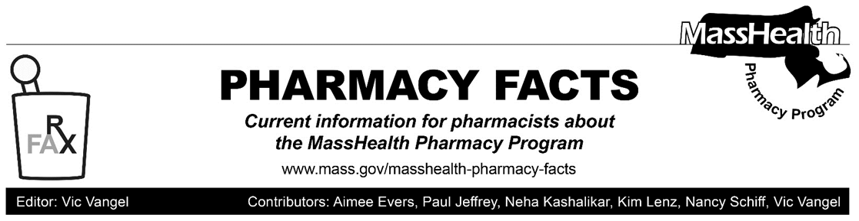

MHDL Update

Below are certain updates to the MassHealth Drug List (MHDL). See the MHDL for a complete listing of updates.

Additions

Effective February 24, 2020, the following newly marketed drugs have been added to the MassHealth Drug List.
- Adakveo (crizanlizumab-tmca) – PA
- Asceniv (immune globulin IV, human-slra) – PA
- Asparlas (calaspargase pegol-mknl) ^ – PA
- Beovu (brolucizumab-dbll) ^
- Duaklir (aclidinium/formoterol) – PA
- Gloperba (colchicine solution) – PA
- Inrebic (fedratinib) – PA
- Reblozyl (luspatercept-aamt) – PA
- Tosymra (sumatriptan 10 mg nasal spray) – PA
- Xembify (immune globulin subcutaneous injection, human-klhw) – PA
- Ziextenzo (pegfilgrastim-bmez)

Change in Prior Authorization

- Effective February 24, 2020, the following antiparasitic will no longer require prior authorization (PA).
  - Eurax (crotamiton cream)
- Effective February 24, 2020, the following antiplatelet agents will no longer require PA.
  - Brilinta (ticagrelor)
  - Effient # (prasugrel)
c. Effective February 24, 2020, the following hematinic agents will no longer require PA.
- Fulphila (pegfilgrastim-jmdb)
  - Udenyca (pegfilgrastim-cbqv)

Updated MassHealth Brand Name Preferred Over Generic Drug List

The MassHealth Brand Name Preferred Over Generic Drug List has been updated to reflect recent changes to the MassHealth Drug List.
- Effective February 24, 2020, the following agent will be added to the MassHealth Brand Name Preferred Over Generic Drug List.
- Symbicort (budesonide/formoterol)^{BP} – PA
- Effective February 24, 2020, the following agent will be removed from the MassHealth Brand Name Preferred Over Generic Drug List.
- Zytiga (abiraterone 250 mg, 500 mg) – PA
____________________________________

Legend

PA Prior authorization is required. The prescriber must obtain prior authorization for the drug in order for the pharmacy to receive payment. Note: PA applies to both the brand-name and the FDA “A”-rated generic equivalent of listed product.
# Designates a brand-name drug with FDA “A”-rated generic equivalents. Prior authorization is required for the brand, unless a particular form of that drug (for example, tablet, capsule, or liquid) does not have an FDA “A”-rated generic equivalent.
^{BP} Brand preferred over generic equivalents. In general, MassHealth requires a trial of the preferred drug or clinical rationale for prescribing the nonpreferred drug generic equivalent.
^ Available through the health care professional who administers the drug. MassHealth does not pay for this drug to be dispensed through a retail pharmacy.

